Following are the proposed provisions to be undertaken on the points you have raised:-

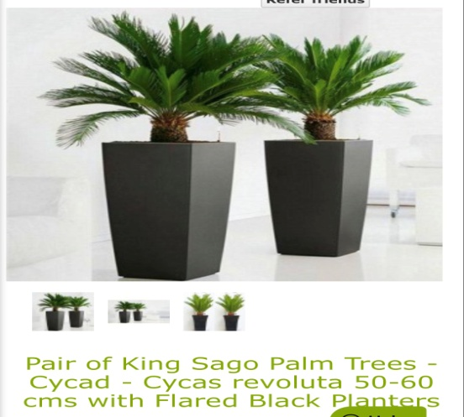
FRONT GARDEN
- Planting is required to screen the bins- We
propose to use low maintenance King sago palm trees (outdoor plant) to screen the bins. As shown in the picture.

- A suitable robust covered bin store is required to contain and conceal household waste-Please view the pictures of bin stores proposed by us.

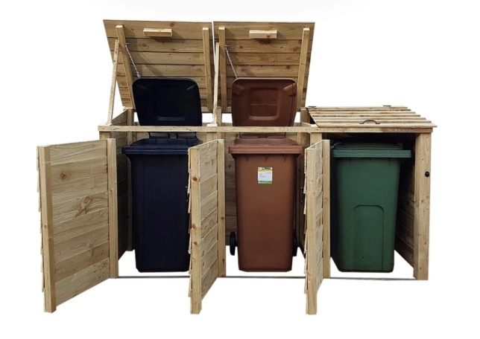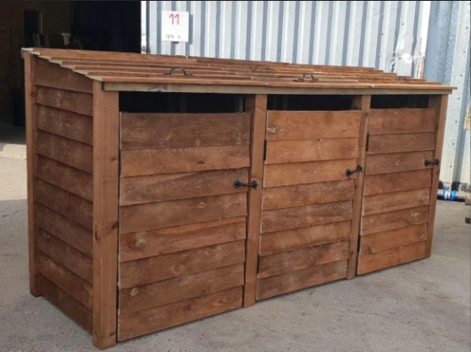

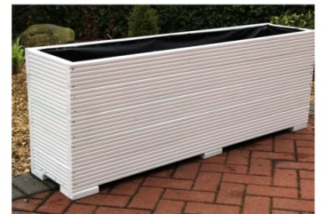
- A hedge/ornamental planting could be provided in a border in front of the house- Please view the picture of wooden planters which we propose to place in border in front of the house.

- Details are required the management and maintenance of the communal/shared areas of the external spaces- Owner takes the responsibility for the management and maintenance of the communal/shared areas of the external spaces.

- A plant schedule is required specifying the size of plants and their containers- A plant schedule will be provided at the time of planting.

REAR GARDEN
- More details required regarding the layout/materials of the private gardens to ensure that they are accessible and attractive for the users- We propose to use artificial grass and paving material made up of concrete and stone as shown in the picture.
