Land beside 30,Harvey Road Northolt, London UB5 6QT

Application for
Minor Material Amendment
Related to consent reference
67335/APP/2018/3565 for
2No 3bed dwellings

This report outlines the details of the proposed minor amendments to the approved plans for a scheme to construct two 3bed dwellings on two stories with roof level accommodation on land adjacent to No 30, Harvey Road, Northolt UB5 6QT  Design Statement : The Site  The land lies to the North of a short terrace of two storey properties containing purpose-built flats, at the end South of Harvey Road in Northolt. The plot is a tapered rectangle measuring 26m wide at its mid-point and 67m long. The flats at No 30 Harvey Road have garden space to the rear which have access to the road that runs along the North of the application site. Access to this road is currently protected by rising bollards.  The predominant housing type in the area is 2 storey semi-detached houses, with pitched, hipped roofs, many with catslide sections, with red brick or painted rendered facades. Immediately adjacent to the site are purpose-built flats built as semi-detached two storey properties, with gable end pitched roofs, and constructed from a smooth buff brick.  - Planning Approval  The current design was agreed in December 2018, and the approval was issued on 12th August 2020, following the agreement of a related s106 agreement in relation to works to the highways to allow access for parking. | Site Location Plan
- Application scheme  The scheme allows for a small dormer room at roof level for both properties. This room as approved is 8.3m².  The shape of the room as approved makes it difficult to site furniture within the room meaning that the placing of a bed and wardrobe leaves restricted access between furniture.  The client therefore wishes to apply for a small increase in the size of the dormer from 3m wide (overall) to 3.5m wide.  The approved application drawings were revised in December 2018 to change the previously designed combined rear dormer to be two discreet dormers either side of the party wall. The proposed alteration maintains this separation. The revised width allows for the improved circulation, and allows more options for placing furniture. The revised room area is 10.2m².  Photographs of the area show that a number of adjacent properties have built full width rear dormers. The developer is not proposing this size of dormer, since the immediately adjacent properties do not have any dormers. However, the rear of the property faces onto property an area of trees between it and an open area of golf course, and as such the dormers will not be a significantly conspicuous element.  Deborah Parker : June 2023 | 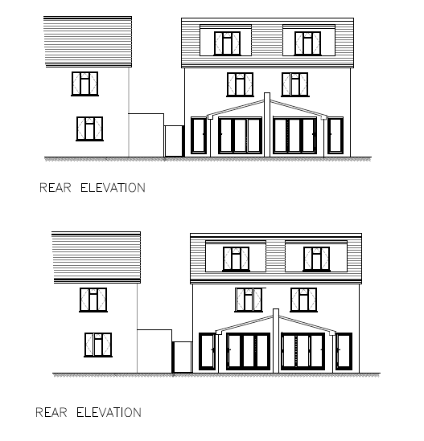  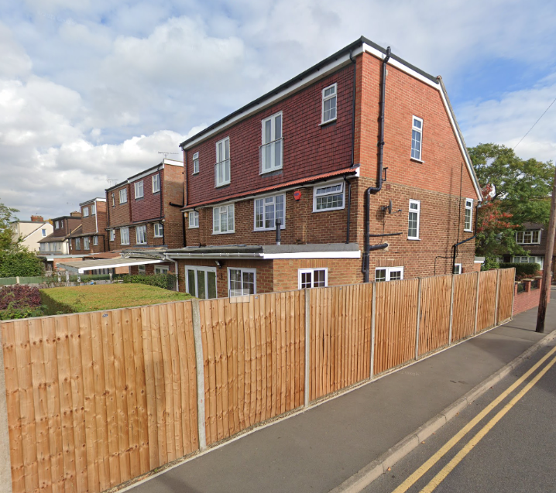 | Approved rear elevation  Proposed rear elevation  Large dormers at 41 to 47 Harvey Road

