Photograph Number 1:-

Six foot fence and concrete posts with freshly planted conifers in a flowerbed, as planted in 1990

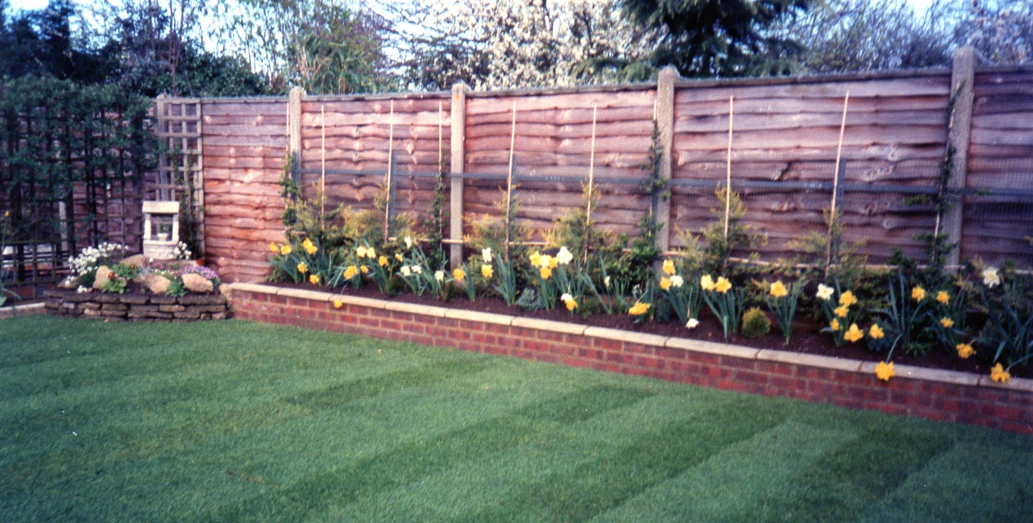

Photograph Number 2:-

As featured above, these conifers have grown to over ten foot (individual in photo is approximately five foot four inches)

