Design and Access Statement
Location: 21 Long Lane, Uxbridge UB10 8OU
The site is located on the south eastern side of Long Lane and features a single family dwelling house within the Ickenham Village Conservation Area. The house is two storey, constructed of a red London stock brick and features a front projecting bay window at both ground and first floor level. The house appears to have been kept in its original form apart from a conservatory to the rear which does appear at odds with the main dwelling. The site benefits from generous front and rear gardens.
The site is bounded to the north by the public highway in Edinburgh Drive, to the west is the parking area for the commercial and residential properties which form part of a parade of shops and to the east is No23 Long Lane.
Description of development :
Hip to gable end loft extension, rear dormer and conversion of roof space for habitable use.
Relevant policies
DMHB 4 : New development in Conservation Areas
New development, including alterations and extensions to existing buildings, within a Conservation Area or on its fringes, will be expected to preserve or enhance the character or appearance of the area. It should sustain and enhance its significance and make a positive contribution to local character and distinctiveness. In order to achieve this, the Council will:
A) Require proposals for new development, including any signage or advertisement, to be of a high quality contextual design. Proposals should exploit opportunities to restore any lost features and/or introduce new ones that would enhance the character and appearance of the Conservation Area.
B) Resist the loss of buildings, historic street patterns, important views, landscape and open spaces or other features that make a positive contribution to the character or appearance of the Conservation Area; any such loss will need to be supported with a robust justification.
C) Proposals will be required to support the implementation of improvement actions set out in relevant Conservation Area Appraisals and Management Plans.
DMHB 11: Design of new development
A) All development, including extensions, alterations and new buildings will be required to be designed to the highest standards and, incorporate principles of good design including:
i) harmonising with the local context by taking into account the surrounding:
- scale of development, considering the height, mass and bulk of adjacent structures;
- building plot sizes and widths, plot coverage and established street patterns;
- building lines and setbacks, rooflines, streetscape rhythm, for example, gaps between structures and other streetscape elements, such as degree of enclosure;
- local topography, views both from and to the site; and
- impact on neighbouring open spaces and their environment.
ii) ensuring the use of high quality building materials and finishes;
iii) ensuring that the internal design and layout of development maximises sustainability and is adaptable to different activities;
iv) protecting features of positive value within and adjacent to the site, including the safeguarding of heritage assets, designated and un-designated, and their settings; and
v) landscaping and tree planting to protect and enhance amenity, biodiversity and green infrastructure.
B) Development proposals should not adversely impact on the amenity, daylight and sunlight of adjacent properties and open space.

C) Development will be required to ensure that the design safeguards the satisfactory re-development of any adjoining sites which have development potential. In the case of proposals for major development5 sites, the Council will expect developers to prepare master plans and design codes and to agree these with the Council before developing detailed designs.

D) Development proposals should make sufficient provision for well designed internal and external storage space for general, recycling and organic waste, with suitable access for collection. External bins should be located and screened to avoid nuisance and adverse visual impacts to occupiers and neighbours

DMHD 1: Residential extensions
Policy DMHD 1: Alterations and Extensions to Residential Dwellings
A) Planning applications relating to alterations and extensions of dwellings will be required to ensure that:
i) there is no adverse cumulative impact of the proposal on the character, appearance or quality of the existing street or wider area;
ii) a satisfactory relationship with adjacent dwellings is achieved;
iii) new extensions appear subordinate to the main dwelling in their floor area, width, depth and height;
iv) new extensions respect the design of the original house and be of matching materials;
v) there is no unacceptable loss of outlook to neighbouring occupiers;
vi) adequate garden space is retained;
vii) adequate off-street parking is retained, as set out in Table 1: Parking Standards in Appendix C;
viii) trees, hedges and other landscaping features are retained; and
ix) all extensions in Conservation Areas and Areas of Special Local Character, and to Listed and Locally Listed Buildings, are designed in keeping with the original house, in terms of layout, scale, proportions, roof form, window pattern, detailed design and materials.

E) Roof Extensions
i) roof extensions should be located on the rear elevation only, be subservient to the scale of the existing roof and should not exceed more than two thirds the average width of the original roof. They should be located below the ridge tiles of the existing roof and retain a substantial element of the original roof slope above the eaves line;
ii) the Council will not support poorly designed or over-large roof extensions including proposals to convert an existing hipped roof to a gable;
iii) raising of a main roof above the existing ridgeline of a house will generally not be supported;
iv) all roof extensions should employ appropriate external materials and architectural details to match the existing dwelling; and
v) in Conservation Areas, Areas of Special Local Character and on Listed and Locally Listed Buildings, roof extensions should take the form of traditional 'dormer' windows, on the rear elevation, to harmonise with the existing building. The highest point of the dormer should be kept well within the back roof slope, away from the ridge, eaves or valleys, whilst each window should match the proportions, size and glazing pattern of the first floor windows.

Design appraisal

The application proposes a hip to gable end roof extension with a rear dormer to facilitate the conversion of the roof space to a bedroom. As with many people the family house needs to be extended to create additional space for a growing family.

Whilst this is a sensitive location the design of the loft conversion has been undertaken with the historic nature of the Conservation Area in mind. The proposal retains the existing height of the ridge which is required in the policies mentioned above. A scope of works was undertaken to review the applicants options in terms of how the space could be provided in the loft however it was not possible to provide adequate bedroom space within the existing roof line and with a small dormer to the rear. Therefore, the gable ends are an important part to delivering this much needed space.

The streetscape features a number of different style properties and therefore the roof design vary along Long Lane. The scale of the roof extension appears proportionate to the existing property and the rear dormer has been set down / set in appropriately so that it appears to be a subordinate addition. As such the loft extension would not result in a negative impact on the streetscape or the Conservation Area.
The proposed materials would match those of the existing property and the applicant would be willing to provide further details on these should you require them.
Conclusion
As stated above the loft conversion/extension is required to provide much needed bedroom space for the applicants family. The design has taken into consideration the principles of DMHD 1 (e) and in particular points (ii), (iii) (iv) and (v).
Front elevation
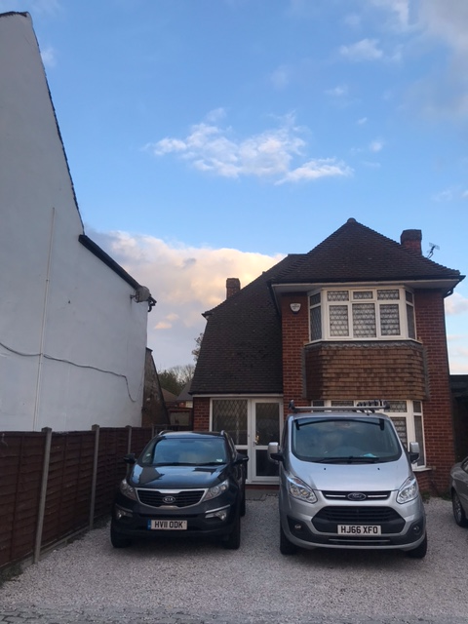
Rear elevation
