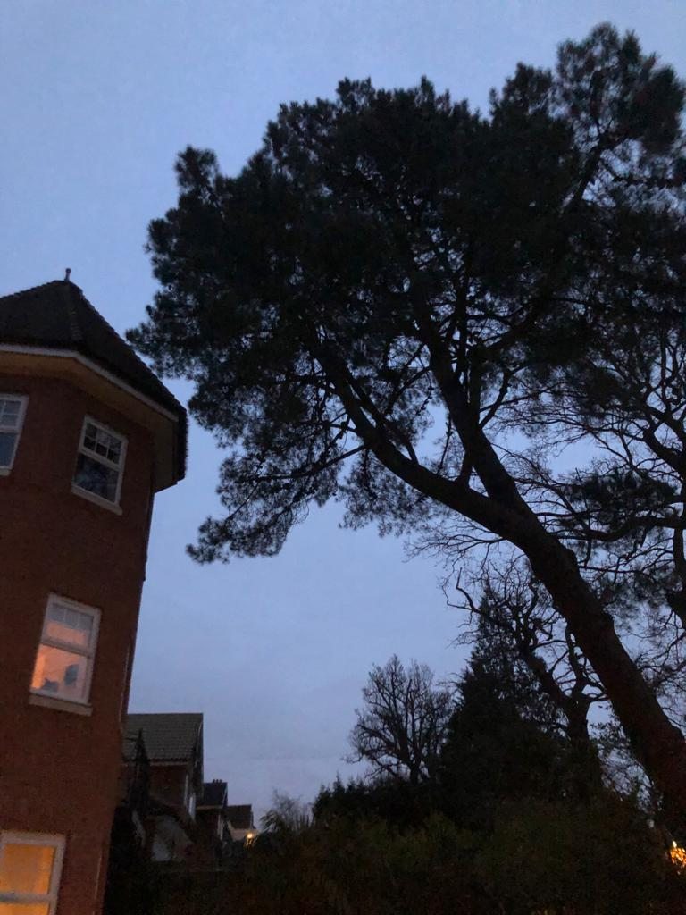
T1

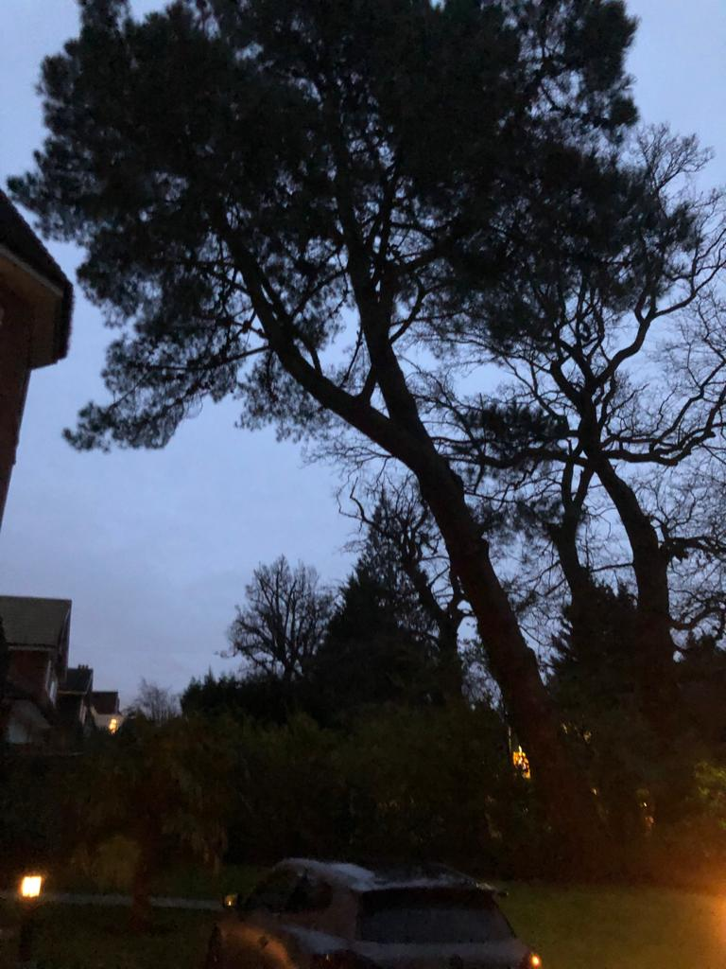
T1

T1- As you can see the heavy lean of the pine tree at the front garden of 25 Frithwood Avenue, HA6 3LY. Is approaching the house and the heavy lean on the branches and the trunk below, the roots are starting to uplift and we would deem this currently unsafe. However, if the tree was removed by rigging techniques and safely lowered to current ground level it would be a lot safer

