Technical Note
Project No: | ITL17075
Project Title: | Land to rear of 1174-1184 Uxbridge Road, Hayes
Title: | Transport Statement Scoping Note
Ref: | JN/LC/ITL17075-001 TN
Date: | 1 September 2021

INTRODUCTION

Overview
    - Mr Khosla has appointed i-Transport LLP to assist with emerging proposals on ‘Land to the rear of 1174-1184 Uxbridge Road, Hayes’. The scheme proposes four flats with no on-site car parking (i.e., a wholly car-free proposal) with an associated closure of the existing vehicular access.
    - The site is located to the rear of 1174-1184 Uxbridge Road, with a narrow access (circa 3m in width) set back from the A4020 dual carriageway. To currently access the site, vehicles are required to leave the dual carriageway at a point where they need to cross an on-road advisory cycle lane; pass in front of an access to a subway; and cross a shared footway/cycleway, as shown in Image 1.1.
Image 1.1 – Existing Site Access
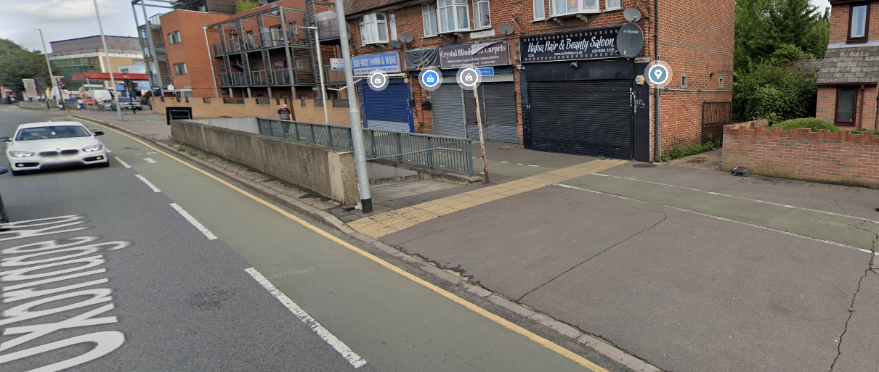
Source: Google Maps
    - The site has a PTAL 3 rating and therefore has a moderate level of accessibility to public transport. This combined with the extensive pedestrian and cyclist network in the area, provides very good opportunities for future residents of the development to travel to/from the site using non-car modes.
    - i-Transport LLP has been appointed to support and advise on the transport and highways elements of the emerging proposal. Accordingly, this Transport Statement Scoping Note (TSSN) has been prepared to inform pre-application discussions with the local highway authority, London Borough of Hillingdon (LBH), and agree the scope of the Transport Statement (TS) that will be submitted as part of the forthcoming planning application.
    - The remainder of this Scoping Note is structured as follows:
- Section 2 sets out the national, regional and local transport policy that will be reviewed within the TS;
- Section 3 provides a brief review of the existing transport conditions in the vicinity of the site;
- Section 4 sets out the emerging development proposal;
- Section 5 details the proposed total person trip generation to demonstrate the minimal impact on the capacity of local public transport services; and
- Section 6 provides a summary and conclusion.

POLICY CONTEXT
    - The following national, regional and local policy documents have been considered as part of proposed development and will be reviewed in transport terms within the TS:
- National Planning Policy Framework (NPPF) (February 2019);
- The London Plan (March 2021);
- London Borough of Hillingdon Local Plan: Part 1 – Strategic Policies (November 2012);
- London Borough of Hillingdon Local Plan: Part 2 – Development Management Policies (January 2020); and
- London Borough of Hillingdon Third Local Implementation Plan (LIP3) (March 2019).
    - LBH are asked to confirm that the above list of policy documents is acceptable and to confirm any other policy documents they consider the proposal should be assessed against.

EXISTING CONDITIONS

Overview
    - This section provides a brief review of the existing transport conditions in the vicinity of the site. The TS will provide a more detailed review of the opportunities available to future residents of the development to use sustainable modes of travel and include analysis of the most recent accident data.

Opportunities for Walking and Cycling
    - There is a wide network of good pedestrian and cyclist infrastructure in the vicinity of the site, providing opportunities for future residents of the site to travel on foot or by bicycle. Good quality footways are provided along the length of Uxbridge Road, with dropped kerbs and tactile paving in place at side roads to facilitate safe crossing, along with signalised crossings at larger junctions. In addition, a subway is located directly in front of the site access which provides a constant safe and convenient crossing for both pedestrians and cyclists, including to/from the westbound bus stop on the opposite side of the carriageway.
    - Both an off-road shared footway/cycleway and on-road advisory cycle lanes are provided, in front of the site access, on the northern side of Uxbridge Road. Advanced stop lines are also available at local junctions.

Opportunities for Public Transport

Public Transport Accessibility Level (PTAL)
    - Public Transport Accessibility Levels (PTALs) are a measure of the accessibility of any point in Greater London to the public transport network, taking into account distance to stops/stations, walking times and service frequency (albeit does not consider number/importance of destinations served). PTAL scores range from 1a (very poor) to 6a/b (excellent).
    - The site holds a PTAL 3 rating, which suggests the site has a moderate level of accessibility to public transport. A copy of the PTAL report is included as Appendix A.
    - The following paragraphs briefly summarise the public transport services available in the vicinity of the site.

Bus
    - The nearest bus stops are the Hayes End stops, with the eastbound stop located within 50m of the site and the westbound stop directly over the road (accessible via the subway, circa 200m walk). These stops provide access to four bus routes which allow connections to many key destinations, such as Uxbridge, Heathrow and Shepherd’s Bush, and to Hayes and Harlington rail station (for interchange with National Rail/Elizabeth Line services). On average, there are circa 27 buses per hour in each direction from these nearby stops, providing a good opportunity for residents to travel to/from site by bus.
    - In addition to the main services, two school bus services (697 and 698) and night bus route N207 are also available from the Hayes End stops.

Rail
    - Hayes and Harlington is the nearest rail station, circa 2.5km (as the crow flies) southeast of the site. It is on the Reading to Paddington line, with both Great Western Railway and TfL Rail services operating (the latter to be replaced and enhanced by the Elizabeth Line once it is operational). The rail services provide access to a number of key destinations such as Heathrow Airport (2 trains per hour), Reading (3-4 trains per hour) and London Paddington (7-8 trains per hour).

Local Road Network
    - Whilst not part of the TfL strategic road network, A4020 Uxbridge Road is a prominent arterial route that provides access into London from the west, connecting Uxbridge with Hayes, Southall, Ealing and Acton.
    - At the site access location, Uxbridge Road is a dual carriageway subject to a 40mph speed limit. Just over 2km to the east of the site, a signalised grade-separated roundabout (the Ossie Garvin Roundabout) connects Uxbridge Road to the A312 The Parkway, which provides access to Heathrow Airport, to the south, and the A40 to the north. To the west, the A4020 provides access to Uxbridge.

Road Safety
    - Personal Injury Accident (PIA) data will be obtained from Transport for London (TfL) for the most recent five-year period for the area shown in Image 3.1 overleaf and summarised within any subsequent TS.
Image 3.1: Personal Injury Accident Data – Study Area
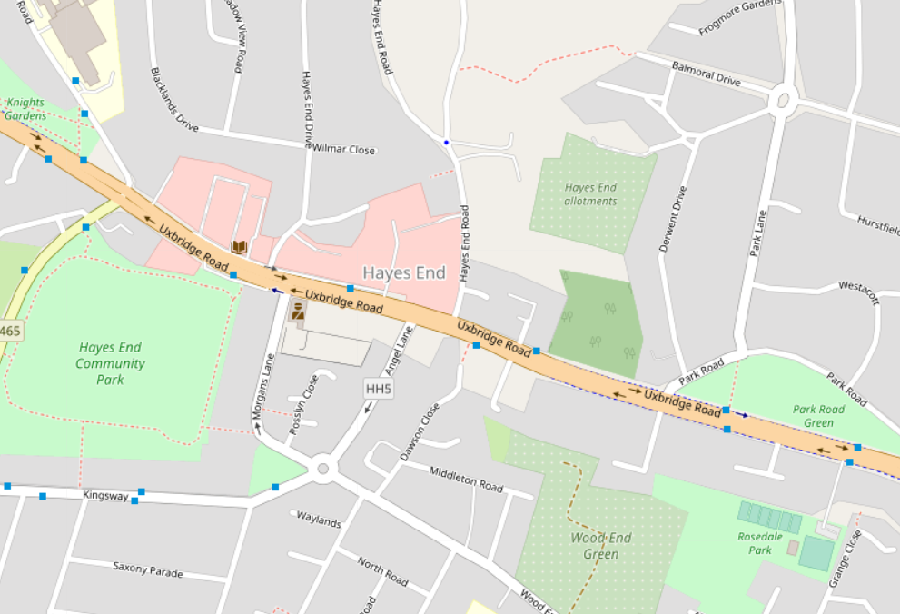
Source: OpenStreetMap

Car Ownership
    - The level of local car ownership for the Hillingdon 018 Middle Super Output Area within which the site is situated, has been obtained from 2011 Census data. The data demonstrates that 42% of households in the local area successfully live car-free.

Summary
    - The TS will provide a more detailed review of the accessibility of the site and local facilities by sustainable modes and a review of the most recent available personal injury accident (PIA) data in the vicinity of the site. However, on the basis of the above, it is considered the site is located within an area such that sustainable travel modes can be taken up.

PROPOSED DEVELOPMENT

Overview
    - This section sets out the development proposal, including the access strategy, parking and servicing arrangements.

Access Strategy
    - Pedestrian/cyclist access will continue to be taken via the existing access from Uxbridge Road. Given that the development is proposed to be wholly car-free and the unusual nature of the existing site access, the development proposes to voluntarily extinguish vehicular access rights, therefore bringing forward a notable highway safety benefit.

Parking

Car Parking
    - The development is proposed to be wholly car-free, therefore no parking is provided. This includes no dedicated blue badge parking, albeit the likelihood of a blue badge holder occupying the development is very low (given the scale of the proposal). There is also no requirement for any future mobility impaired occupier to own a car, given the available public transport (bus services) are fully accessible to the mobility impaired with low floor/wheelchair boarding ramps.
    - Local parking controls are also in place on surrounding roads which provides an effective measure against any potential overspill car parking. These operate Monday to Saturday between 8am and 6.30pm. Pay and display parking has a financial cost but is also only permitted for a maximum stay of two hours in this location.

Cycle Parking
    - Cycle parking will be provided in accordance with the prevailing standards and cycle design guidance at the time of a planning submission.

Deliveries and Servicing
    - Deliveries and servicing for the site will be undertaken on the single yellow line on Uxbridge Road, which is directly adjacent to the pedestrian access to the site. Similar activity is already occurring for the adjacent residential developments. In addition, the scale of development (four units) will result in very low levels of daily activity.

TRIP GENERATION

Overview
    - Given the proposed development is to be car-free, the number of vehicle trips generated by the site will be minimal, with deliveries and/or servicing likely to be the only vehicles arising. This section therefore sets out the total person trips combined with Census data to demonstrate that there will be a minimal impact on the capacity of the local public transport services.

Total Person Trip Generation
    - The total person trip generation has been calculated from trip rates obtained for similar sites within the TRICS database. A summary of the anticipated person trip rates for the four flats is summarised in Table 5.1.
Table 5.1: Person Trip Generation
 | AM Peak (0800-0900) |  |  | PM Peak (1700-1800)
 | Arr | Dep | 2 Way | Arr | Dep | 2 Way
Trip Rate | 0.333 | 1.51 | 1.843 | 0.745 | 0.373 | 1.118
Trip Gen | 1 | 6 | 7 | 3 | 1 | 4
Source: TRICS

Modal Split
    - The existing local travel characteristics for the area have been reviewed using 2011 Census data for the Middle Super Output Area Hillingdon 018.
    - Given that the proposed development is car-free, the car trips have been proportionally re-allocated to the other modes of transport, and the resultant trip generation is provided in Table 5.2 below.

Table 5.2: Local Residents – Method of Travel to Work
Method | Mode Share % | AM Peak (0800-0900) |  |  | PM Peak (1700-1800)
Method | Mode Share % | Arr | Dep | 2 Way | Arr | Dep | 2 Way
Driving a car | - | - | - | - | - | - | -
Bus | 45% | 1 | 3 | 4 | 1 | 1 | 2
Underground | 17% | 0 | 1 | 1 | 1 | 0 | 1
On foot | 12% | 0 | 1 | 1 | 1 | 0 | 1
Passenger in a car | 10% | 0 | 1 | 1 | 0 | 0 | 0
Train | 7% | 0 | 0 | 0 | 0 | 0 | 0
Bicycle | 4% | 0 | 0 | 0 | 0 | 0 | 0
MC | 3% | 0 | 0 | 0 | 0 | 0 | 0
Taxi | 0% | 0 | 0 | 0 | 0 | 0 | 0
Other | 0% | 0 | 0 | 0 | 0 | 0 | 0
Total | 100% | 1 | 6 | 7 | 3 | 1 | 4
Source: Census 2011 – Hillingdon 018
    - The development will generate five two-way public transport trips in the morning peak hour, and three two-way public transport tips in the evening peak hour. Based on this, the development will result in an immaterial impact on local public transport infrastructure and is unlikely to be noticeable on a day to day basis.

Summary
    - Mr Khosla has appointed i-Transport LLP to assist with emerging proposals on ‘Land to the rear of 1174-1184 Uxbridge Road, Hayes’. The scheme proposes four flats with no on-site car parking (i.e., a wholly car-free proposal) with an associated closure of the existing vehicular access.
    - This technical note sets out initial transport and highways elements for discussion and agreement with LBH.
    - The site is in an area of moderate public transport accessibility, with bus services connecting the site to many key destinations, such as Uxbridge, Heathrow and Shepherd’s Bush, and to Hayes and Harlington rail station (for interchange with National Rail/Elizabeth Line services).
    - The proposal includes the voluntary extinguishing of vehicular access rights, therefore bringing forward a notable highway safety benefit, given vehicles currently need to leave the dual carriageway at a point where they cross an on-road advisory cycle lane, pass in front of an access to a subway and cross a shared footway/cycleway.
    - LBH are requested to review and advise with regards to;
- The transport policies referred to in Section 2 of this note;
- The sustainability credentials of the site and its appropriateness for a wholly car-free development;
- The highway safety benefits with regards to extinguishing vehicular access; and
- The initial TRICS assessment for the proposal.

