Supporting documentation for planning consent for temporary signage at ACS International School in Hillingdon

Background:

ACS already has a pole mounted free standing single aspect UPVC banner facing Vine Lane and located behind the boundary wall. It is erected 8-10 times per annum to display information relating to events such as open days or graduations. As it is sited parallel to the road it is not visible to anyone unless they are directly opposite the sign.

Image 1 – View directly from Vine Lane

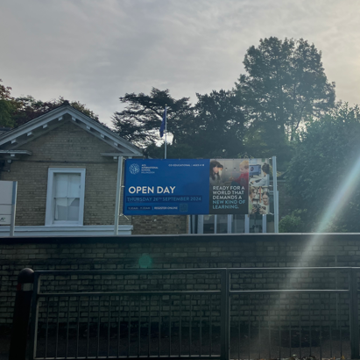

Image 2 – View from Vine Lane approaching from the South end

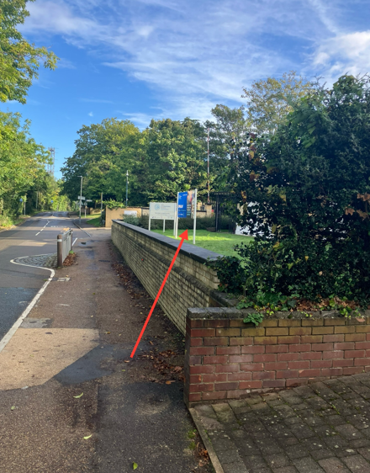

Image 2 – View from Vine Lane approaching from the North end

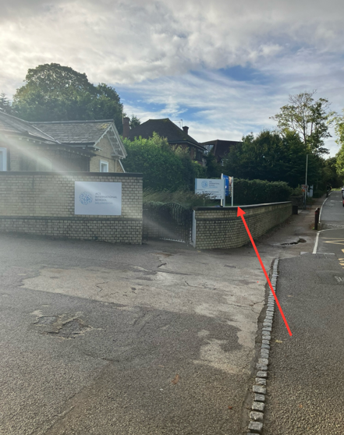

Image 4 - Close up of typical existing banner content in situ



Image 5 - Image of an alternate banner previously used

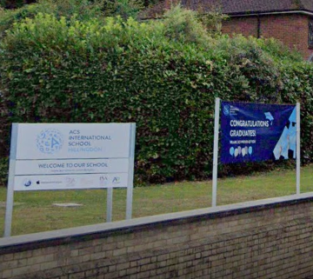

Image 6 – Existing removable pole sited in a ground socket

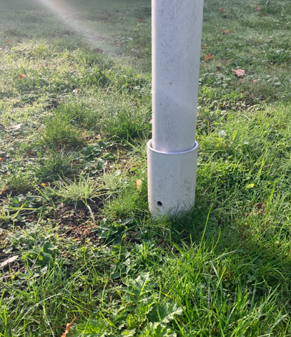

Image 7 - Banner design drawing

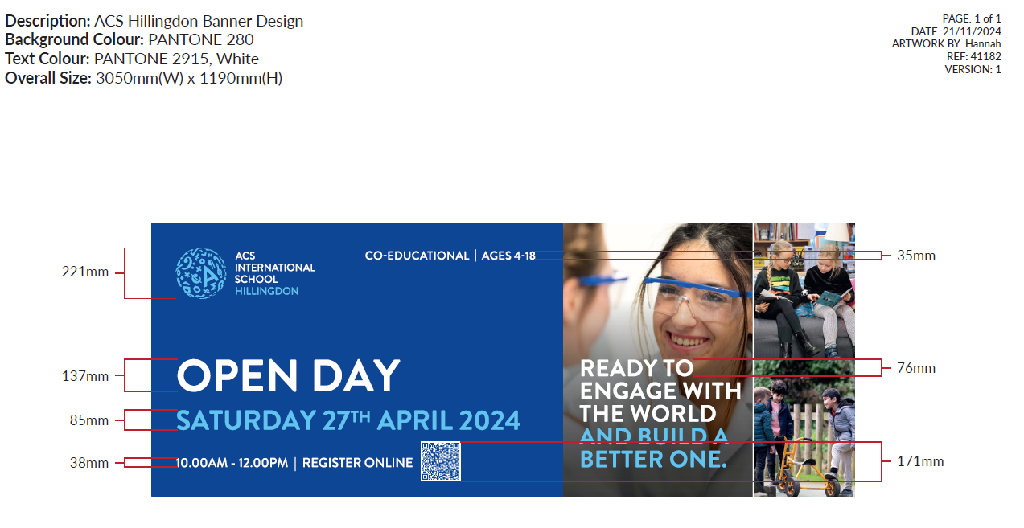

Planning Proposal

We would like to modify the existing temporary sign to a V shape that will support two banners in the same style and height of the existing one. The new sign will be visible from both directions of approach from Vine Lane.

QTY 3 - 68mm white aluminium poles mounted in white aluminium ground sockets set out in a V shape.
QTY 2 - Printed UPVC banners containing content similar to the example above relaying information about school events. They are attached to the pole using cable ties to fixed eye bolts.

Please see the plan layouts provided by our suppliers FastSigns showing the existing and proposed layout in plan view drawings and overlayed on Google Maps to show relative positioning.

As stated previously the sign is for temporary use during the year. Typically the schedule would be as below every year and the signs in place for 2-3 weeks prior to the event being advertised.

- Jan 2025 – February Open Day
- Feb 2025 – April Open Day
- May 2025 – Graduation
- August 2025 – Welcome back
- August/September 2025 – September Open Day
- October 2025 – November Open Day

There may be occasional requests to add in additional one off events or messages.

