Wrenbridge, Hayes

Contract Number: 316

Location:

84
Swallowfield Way
Hayes
UB3 1DQ

Pre-commencement Condition 4 information

Prior to the commencement of the development hereby approved (including demolition), a Demolition and Construction Logistics Plan (DLP/CLP) and a Demolition and Construction Management Plan (DMP/CMP) shall be submitted to, and approved in writing by, the Local Planning Authority, to minimise impacts to the local highway network, and to control noise, vibration and air pollutants generated as a result of the construction process. These documents shall be prepared in accordance with the London Freight Plan, 'The control of dust and emissions from construction and demolition' Supplementary Planning Guidance, BRE Pollution Control Guides 'Controlling particles and noise pollution from construction sites' and 'Controlling particles, vapour and noise pollution from construction sites'. The DLP/CLP and DMP/CMP shall include details of (but shall not necessarily be limited to):
Full Construction Phase Safety, Health, and Environmental Plan is attached to this condition 4 report, however the following information aims to simplify the requirements of condition 4, all information is extracted from the main CPP.

- a programme of works, including hours of construction;
The site working hours are 8am to 6pm, Monday to Friday and 8am to 1pm on Saturdays. However, weekend work is not envisaged at this stage. Programme of works attached as Appendix A.
- the measures for traffic management and encouragement of sustainable modes of transport for workers, including prohibition of construction vehicles parking on the local highway network within the vicinity of the application site;
Traffic management plan below, including site setup layout detailing both pedestrian/cycle access, vehicular access and onsite vehicle parking. Offsite parking will be monitored and stopped by site management daily, any offending vehicles will be moved onto site asap. There is a container situated within cabin area for secure storage of tools and cycles as required.
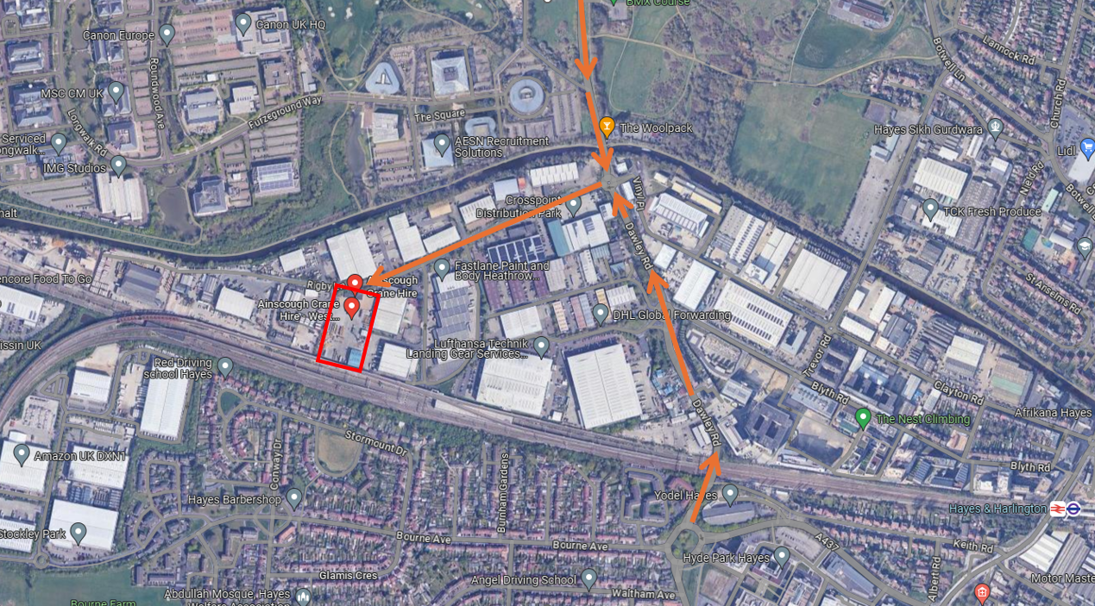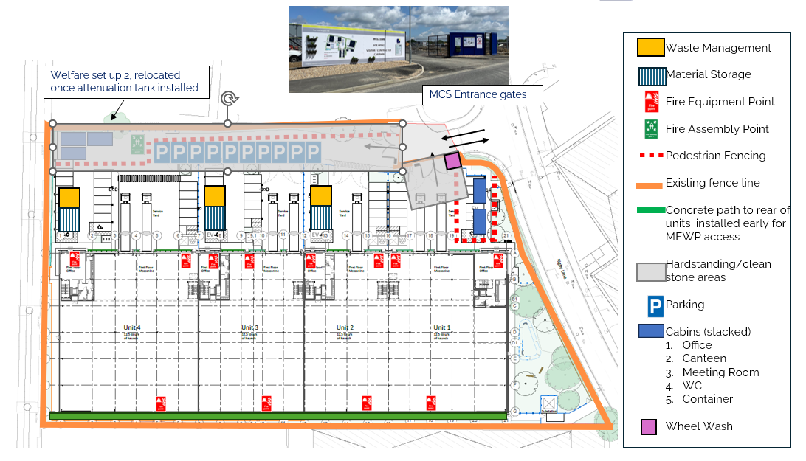
- the haulage routes and details of a vehicle booking system including use of a banksman (if applicable), ensuring construction deliveries are received outside peak hours;
Traffic management (contained within item ii) shows haulage routes into site, all large deliveries must be scheduled in with the site team via email prior to delivery to ensure no congestion build up on the nearby highways. Where possible deliveries will be scheduled to avoid rush hour periods from 7am-9am and 4pm to 6pm.
- any closures of public routes and diversions, demonstrating how time spent closed to the public has been minimised;
Both foul and storm drainage connections are to be made into the existing services within Rigby Lane outside the site entrance. This will require single lane closure to complete, with traffic light management. Works will be programmed for the shortest possible durations, utilising quieter periods (weekends and nights) if necessary.
Electricity: New HV supply to be installed from POC at substation on opposite site of Rigby Lane, to new GRP substation within site boundary. This will require single lane closure to complete, with traffic light management. Works will be programmed for the shortest possible durations, utilising quieter periods (weekends and nights) if necessary.
Both the above drainage and electricity will be programmed for April 2025 and if possible will share traffic management for a 1 week duration.
- the provision of secured restricted access as the sole means of entry to site for cyclists along with a secured turnstile entrance for pedestrians;
Site setup layout (contained within item ii) details both pedestrian/cycle access and separate vehicular access. Safe pedestrian/cycle route is detailed to the rear of the parking spaces segregated with barriers. The site has a secure existing palisade fence to the entire perimeter with pedestrian and vehicle gates to match, all gate will be locked when site is not open, we will also deploy remote monitored CCTV units which will be active when site is not open.
- a site plan identifying the location of the site entrance, exit, visibility zones, wheel washing, hard standing, hoarding (distinguishing between solid hoarding and other barriers such as heras and monarflex sheeting), stock piles, dust suppression, location of water supplies and location of nearest neighbouring receptors;
Site setup layout (contained within item ii) details the site entrance, exit, visibility zones, wheel washing, hard standing, hoarding (existing palisade fence).
Stockpiles of crushed material will be situated in the centre of site, to maximise the distance from neighbours. The closest neighbours (receptors) are directly behind out site boundary fencing to the east and West. Dust suppression with be utilised across site as required during any dusty works. this is covered by our Environmental noise, vibration and dust control measures as below.
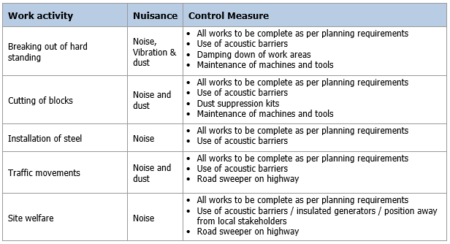
- the loading, unloading and storage of equipment, plant, fuel, oil, materials and chemicals;
Material storage locations are shown on the site logistics plan (contained within item ii), unloading will take place adjacent to the storage locations shown location to minimise the distance of material movement onsite.
- details of cranes and other tall construction equipment (including the details of obstacle lighting);
During the construction process there will be a requirement for the use of tall equipment including mobile cranes and a piling rig. This equipment will only be operated during daylight hours, nonetheless, will have the required obstacle lighting in place subject to the equipment height. Full details of equipment will be covered by the specific RAMs onsite, there will also be reviewed and agreed with Network rail due to the locality of the rail line.
- the means to prevent deposition of mud on the highway and chemical and/or fuel run-off from into nearby watercourse(s);
The site logistics plan (contained within item ii) detail’s location of wheel wash at the exit of site, along suitable hardstanding to ensure there is no runoff or alike through the site entrances. All fuel and chemical storage will be in suitable double bunded tanks, plant nappies and spill kits will also be utilised as required to catch any contamination or run-off to be properly disposed of. We will also employ a road sweeper as required to keep the entrance routs clean and clear.
- details on reducing emissions from demolition and construction , including means to monitor and control dust, noise and vibrations, following the published guidance by The Institute of Air Quality Management (IAQM) on how to assess impacts of emissions of dust from demolition and construction sites. This must demonstrate compliance (drawn up accordance with) the GLA Control of Dust and Emissions from Construction and Demolition SPG (or any successor document).
This is detailed by our Environmental noise, vibration and dust control measures as (contained within item vi)
- the likely noise levels to be generated from plant and construction works and the precautions set out to eliminate or reduce noise levels where the operational risk levels illustrated within The Control of Noise at Work Regulations 2005 could be exceeded;
This is detailed by our Environmental noise, vibration and dust control measures as (contained within item vi)
- confirmation that a mobile crusher will/won't be used on site and if so, a copy of the permit and intended dates of operation;
A mobile crusher is intended to be used onsite for processing and re-use of the existing yard slabs as construction aggregates. The relevant permit will be obtained once the equipment, date and requirement are confirmed, this will likely be in October 2024 for circa 4 weeks.
- confirmation of all Non-Road Mobile Machinery (NRMM) to be used, or a statement confirming that NRMM will not be used. All Non-Road Mobile Machinery (NRMM) and plant to be used on site of net power between 37kW and 560 kW shall comply with the emission standards set out in chapter 7 of the GLA's supplementary planning guidance "Control of Dust and Emissions During Construction and Demolition" and must be registered at http://nrmm.london/;
Confirmed, vehicles will be registered when the exact vehicles are confirmed between mcs and our supply chain.
- an asbestos survey and management plan; and
The asbestos survey is booked for 3rd September 2024, the results of which will allow the management plan to be produced by our licensed demolition contractor for any removal or alike needed.
"(xv) the arrangement for monitoring and responding to complaints relating to demolition and construction."
All complaints should be issued to the Operations Manager (George Baker, 07387 106507, george@mcs-ltd.com) who will review and collate response and actions required to deal with issue. These details will be displayed at the site entrance.

