Proposal to convert 33% of the front garden to enable off road parking is similar to that recently granted to next door – no 14 Bawtree road. If the current parking bay outside number 12 is moved across road in Bawtree Road there will be no net loss of parking spaces on Bawtree Road
Currently building work converting front garden of No 14 to allow off road parking.

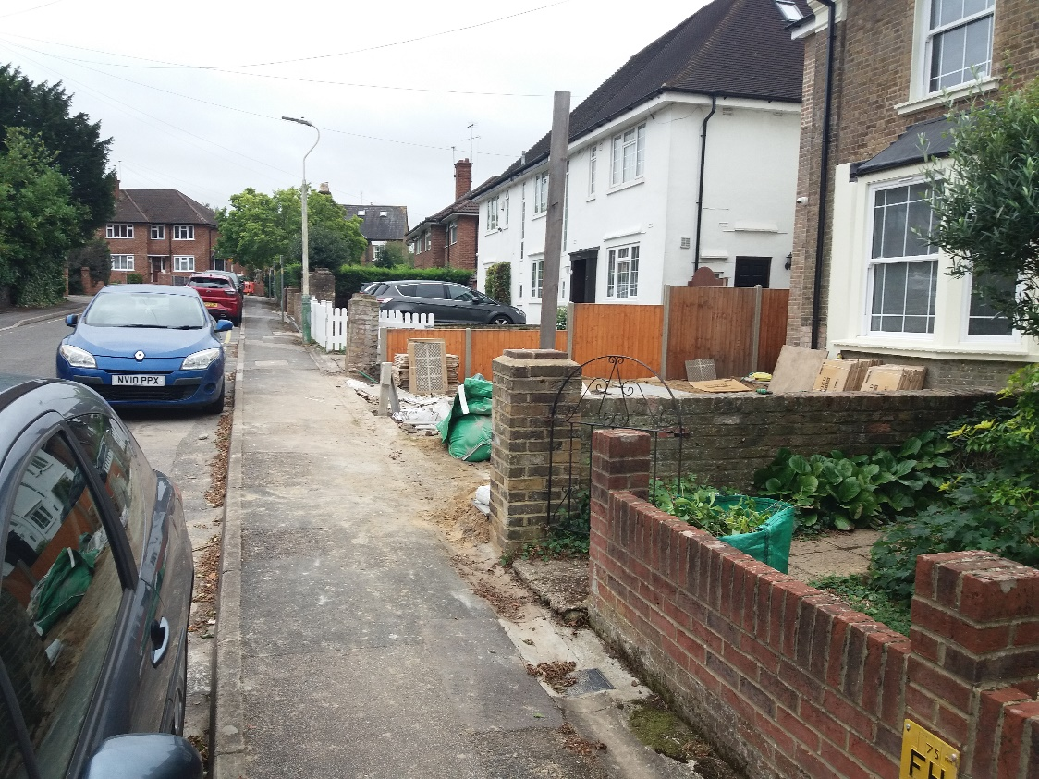

Another picture of the current construction underway on no 14.

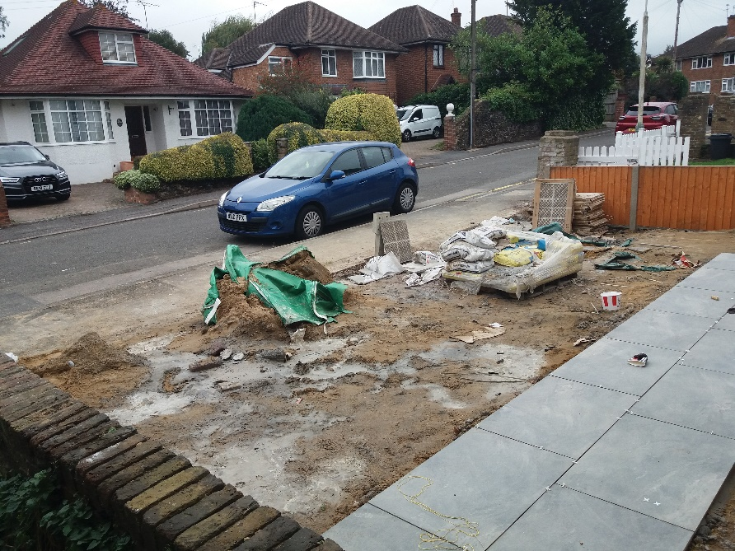

From view of the property of No 12, 33% of which to be converted to allow off road parking.
