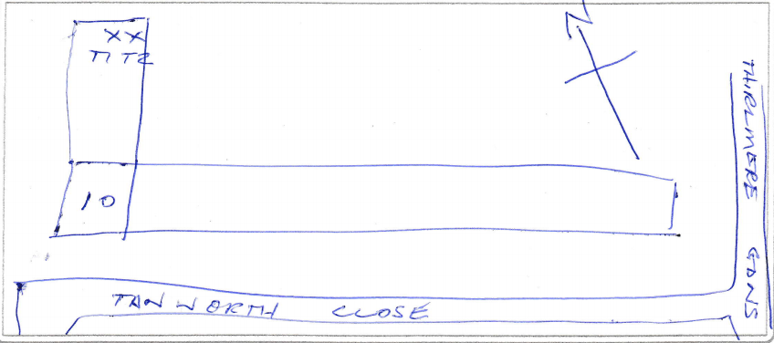
T1 + T2 = TPO 257

