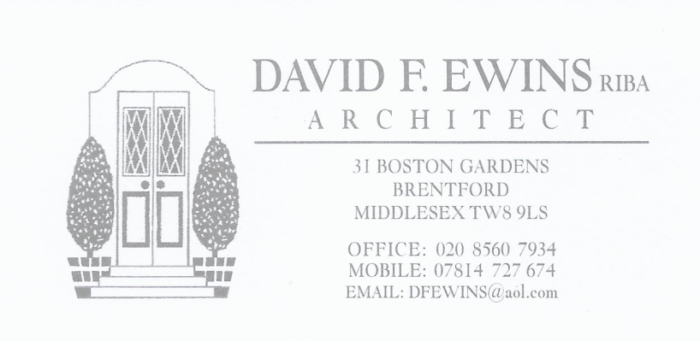

90 HATHERLEIGH ROAD, RUISLIP, HA4 6AU.
DESIGN AND ACCESS STATEMENT

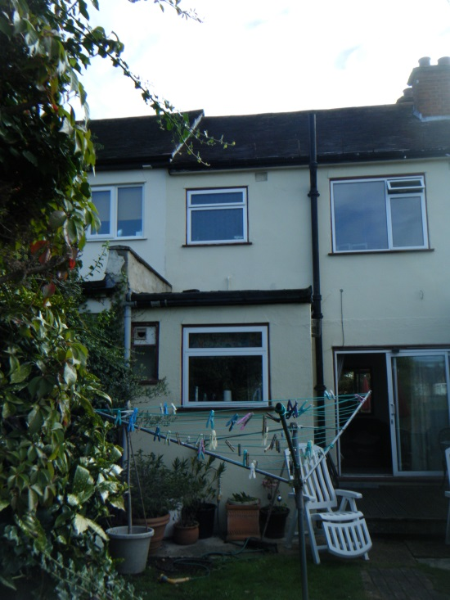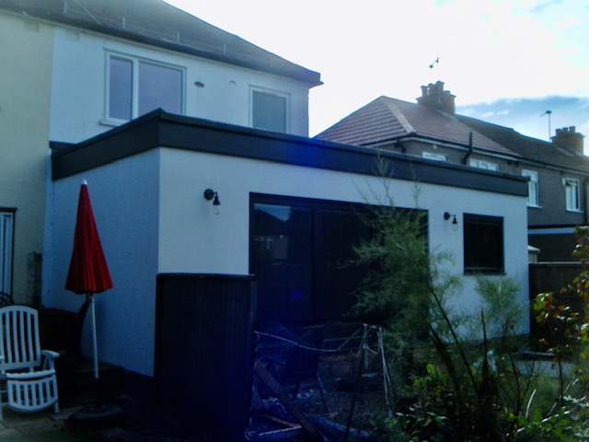

- EXISTING PROPERTY.
The property is a two storey mid-terraced single family dwelling house with an existing flat roofed rear addition.

- PROPOSED SCHEME.
The application is to build a flat roofed rear extension to the same depth as the extension to the adjoining property.

- DRAWINGS.
The drawings included with application are:

1650 / 01 AS EXISTING floor plans
1650 / 02 AS EXISTING elevations and sections
1650 / 03 LOCATION PLAN
1650 / 04 AS PROPOSED

- PREVIOUS APPLICATION.
Planning approval for the same size of extension was granted in August 2006 (ref: 61887/APP/2006/2085). See approved drawings below.

- APPROVED EXTENSION TO N0 92.
Planning approval for the same size of extension to the adjoining property, no. 9 Hatherleigh Road, was granted in 2017 (ref: 9686/APP/2017/4158).

This extension has been constructed.

- DISABLED ACCESS.
The proposed works will have no effect on the disabled access to the property.

