Name of Project:

Name of Structure:

Structure Reference Number:

- HIGHWAY DETAILS

  - Type of Highway

  - Permitted Traffic Speed

  - Existing Restrictions

- SITE DETAILS

  - Obstacles Crossed

- PROPOSED STRUCTURE
Contiguous Piled Retaining wall at Oak Grove…………… ………..
TBA

Oak Grove
30mph
None

None

  - Description of Structure and design working life.
A reinforced concrete retaining structure retaining Oak Grove as it rises from Elm Avenue over the Piccadilly and Metropolitan line tracks. The approximate length of the wall under consideration is 14m with a retained height varying from 0.0m at Elm Avenue to approximately 1.4m

The retaining wall shall be of reinforced concrete supported on a reinforced base of sufficient size and mass to resist overturning and sliding.

Design working life shall be 120 Years

  - Structural Type

  - Foundation Type

  - Span Arrangement

  - Articulation Arrangements
Contiguous piled retaining wall.
Augured piles.
N/A

Not applicable

  - Road Restraint System Type
The new structure shall have a barrier capable of resisting Nl impact loading. This is the load resulting from a 1.St vehicle impacting the barrier at 80kph at 20 degrees.

  - Proposed arrangement for Maintenance and Future inspection

    - Traffic Management Not Applicable

    - Access Access to the retaining wall shall be via landscaped area round the development. Access arrangements are shown on the attached plan. Access shall be maintained for the existing retaining wall. A general inspection shall take place at 2 years, 4 years with a principle inspection at 6 years intervals following completion on the site.

    - Intrusive or Further Investigations Proposed
N/a

  - Environment and Sustainability The economic, social and environmental aspects of this
project have been considered. The structure has been designed to have minimal impact to the environment and will withstand impact of climate change with minimal maintenance. Where possible it is proposed to use materials that are locally sourced, from renewable sources, low in embodied energy, with long life expectancy and reused or recycled easily.

  - Durability and Materials Reinforced concrete is to meet the following criteria for
sustainability. During construction, the material can be locally sourced/produced supporting local economies. Cement replacements and recycled concrete aggregates have been considered in accordance with BS 8500-2.
Concrete is to be of grade C32/40. Concrete design class is
to be DS-2 ACEC AC-2. Reinforcement is to be in accordance with BS4449:2005. Reinforcement can be recycled at the end of its life. During its life reinforced concrete is inert, requiring minimal maintenance, with low risk of contamination to groundwater.

  - Risks and Hazards considered for design, execution, maintenance and demolition.

The principle risk is the failure of temporary retaining structures during the works. This risk shall be mitigated by providing raking props to support the existing retaining structures, which shall be removed as the new structure is constructed.

  - Estimated Cost of proposed structure and alternatives considered.

Cost of the retaining structure is estimated to be £20k. Alternative arrangements considered were a sheet pile wall. Sheet piling was rejected due to constraints imposed by TfL.

  - Proposed arrangements for construction

    - Construction Sequence
1. Temporary raised piling mat installed by Main contractor (GGM Contractors).Infill crushed concrete to be used to create a level platform wide enough for safe access of the rig. No Vibration work to be carried out.
2. 350mm diameter auger bored pile installed to a designed depth of 8m
3. Piles installed in accordance with previous method statement.
4. A distance of at least 2no. piles is left before another pile is installed. Two piles will be left between concreted piles for each day of concreting.
5. Spoil removed by attendant excavator.
6. Upon completion the augers and piling rig will be cleaned and removed.

    - Traffic Management

    - Service Diversions

As all work will be within the site boundary and hoarding, minimal traffic management will be needed. The pavement Oak Grove will need to blocked off for a few minutes in order to drive the machinery onto the site and again when the machinery leaves the site.
Not Required

    - Interface with Existing Structures. None noted

- DESIGN/ASSESSMENT CRITERIA

  - Actions
    - Permanent Actions Soil and Water pressure to BS EN 1997-1 2004

    - Snow wind and thermal actions Not applicable

    - Actions relating to normal traffic AW regulations and C&U regulations
10 kN/m2

    - Actions relating to General Order Traffic under STGO regulations
20KN/m2, 37.5 units of HB Loading

    - Footway or Footbridge variable actions
Actions up to the edge of the Footway 10kN/m2 for HA loading. This loading shall be continued within our site boundary to determine the lateral load on the wall.

    - Actions relating to Special Order Traffic, provision for exceptional abnormal indivisible loads including location of vehicle track on deck cross section.
Not applicable

    - Accidental Actions Vehicle Impact with the Barrier. Loading
resulting from a 1.5T vehicle travelling at 80km/h impacting the barrier at 20 degrees.

    - Actions during construction Soil pressures

    - Any special actions not considered above. N/A

  - Heavy or high load route requirements and arrangements being made to preserve the route including and provisions for future heavier loads or future widening.
Not applicable

  - Minimum Headroom Provided No restrictions in headroom apply, and the works do
not create any restrictions.

  - Authorities Consulted and Special conditions required
Hillingdon Highways consulted.

  - Standards and Documents listed in the Technical Approval Schedule. British Standards
BS 5400 - Steel Concrete and Composite Bridges Part 11988 General Statement
Part 2 Loads Check Code
Part 41990 CP for design of concrete bridges BS5930 1999 - Site Investigations
S8002 Code of Practice for Earth Retaining Structures BS8004 1986 Foundations.

Manual of Contract Documents for Highway Works Vol 1- Specification for Highway Works
Vol 2- Notes for Guidance for SHW Vol 3 - Highway Construction Details

BD 2/12 Technical Approval of Highway Structures B037/01 Loads for Highway Bridges
TD 19/06 Requirements for Road Restraint Systems

  - Proposed Departures relating to departures from standards given in 4.5
Not applicable

  - Proposed Departures relating to methods for dealing with aspects not covered by standards in 4.5 Not applicable

- STRUCTURALANALYSIS

  - Methods of analysis for proposed structure

Structure to be designed in accordance with BS5400 Design In accordance BS8002 Code of Practice for Retaining Walls.
Static analysis shall be used to determine forces on elements.

  - Description and diagram of idealised structure to be used for analysis

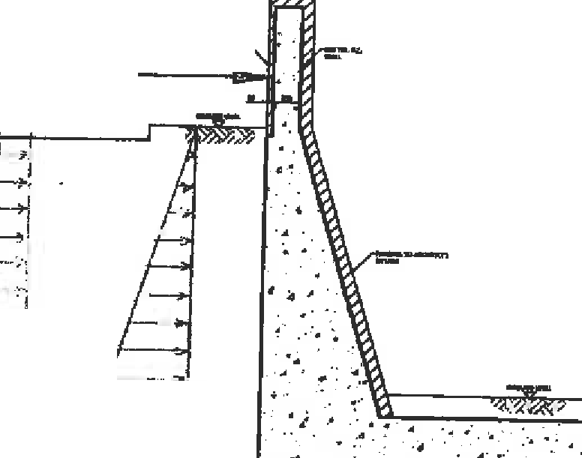\f",:J,-(t -1
I.°ST \/foelt:(..\:.CI,90 ­
e. 'U:J•

.,.,'

.i...

1----- -. ,

SOO M'-'\ C\'""'11"1 lJ.
retZ- FUNILE .

''l - -- ..
4· •·.

. I - --
_J ._''
4;,I:.;;, Fl(a,\ u::e,c, f.?J:M
;s7: " ''-
Ho

.•.

[•".'
.
.
µ\
'.
..
....
·.,,•
;j ::::::::==:s=::
I , .I
· ""--,
J --·-. · ,
"\

'9t,J..., fh;.:.:.:...,._ r.;,- r.e

  - Assumptions intended for calculation of structural element stiffness.

The stiffness of elements has been calculated using classical analysis. Stiffness of concrete is based on the values in 8S5400 part 4
  - Proposed range of soil parameters to be used in the design/assessment of the structure.

SOIL LAYER | Nspt | γ (kN/m³) | φ′ (°) | C’  (kPa) | Cu (kPa) | Eu | E’ (kPa)
Made Ground | - | 18 | 25 | 0 | - | - | 25000
Firm Clay | 10 to 50 at 17m | 20 (10 sub) | 27 | 0 | 50 at 2m  to 250 at 17m |  | 30000

- GEOTECHNICAL CONDITIONS

  - Acceptance or recommendations of the Geotechnical Design Report to be used in the design/assessment and reasons for any proposed changes.
  - Summary of design for highway structure in Geotechnical Design Report.
The geotechnical design involved three stages, which are summarised below;

(i) Ultimate Limit State (ULS) Analysis – This involves the use of factored soil parameters to estimate the required embedment of the wall, for overall stability to be maintained. This analysis has been carried out with the ‘CADS PWS2‘ geostructural modelling programme. Analysis also provides information on ultimate bending moments, shear forces and if applicable, ultimate loads on the struts.

(ii) Serviceability Limit State (SLS) Analysis – This involves the use of unfactored soil parameters to estimate the lateral displacement of the wall, as well as service bending moments, shear forces and if applicable, service loads on the struts. The analysis has been carried out with the ‘CADS PWS2‘ geostructural modelling programme.

(iii) Wall Capacity under Vertical Axial Loading – This is based on the traditional bearing capacity approach for axially loaded piles. However, the wall is assumed to act as a continuous deep strip footing below basement formation level, surrounded by a block of soil, with the assumption of a block type failure mechanism in the ultimate state. In addition, the bearing capacity factor N_{c} in the London clay is reduced with a reduction factor “f”, to account for the existence gaps between piles in the wall.

The reduction factor “f” is expressed as;
ƒ = πD
4𝑆

Where D = pile diameter and S = pile centre to centre spacing. This approach produces an estimate of the axial capacity of the wall per metre run. Multiplying this value by the centre to centre spacing of the piles yields the vertical capacity of an individual pile. See Adekunte (2014) for more detailed information on this methodology.

  - Differential Settlement to be allowed for in the design/assessment of structure.

Settlements should be less than 10mm. All foundation design allows for this, where possible deviations should be mitigated or designed out
  - Geotechnical Investigation.

The Geotechnical Investigation report is appended to this report.

- CHECK

  - Proposed Category

  - Proposed Independent Checker
Category 2

Fernhurst Design Limited

  - Erection Proposals or temporary works for which Types Sand P Proposals will be required, list structural parts of the permanent structure affected with reasons.
Erection method and sequencing of works given in Appendix 3.12.1

- DRAWINGS AND DOCUMENTS

  - List of Drawings (including numbers) and documents accompanying the submission

- Pile Design for 59 Elm Avenue
- STM – Geotechnical Ground Investigation – 59 Elm Avenue – FINAL
- ALL EXISTING AND PROPOSED PLANS 26TH JAN 2022
- THE ABOVE IS SUBMITTED FOR ACCEPTANCE

We confirm that the details of the temporary works design will be passed onto the permanent works Designers for review

Signed
Name
Design/Assessment Team Leader

Engineering Qualifications Name of Organisation Date
10 THE ABOVE IS AGREED SUBJECT TO THE AMENDMENTS AND CONDITIONS SHOWN BELOW

Signed Name
Position Held

Engineering Qualifications

TAA

Date

