Supporting Information – 4 Sherborne Place, Northwood HA6 2BH
Photographs:
The oak tree is blocking light to windows on the first and top floors
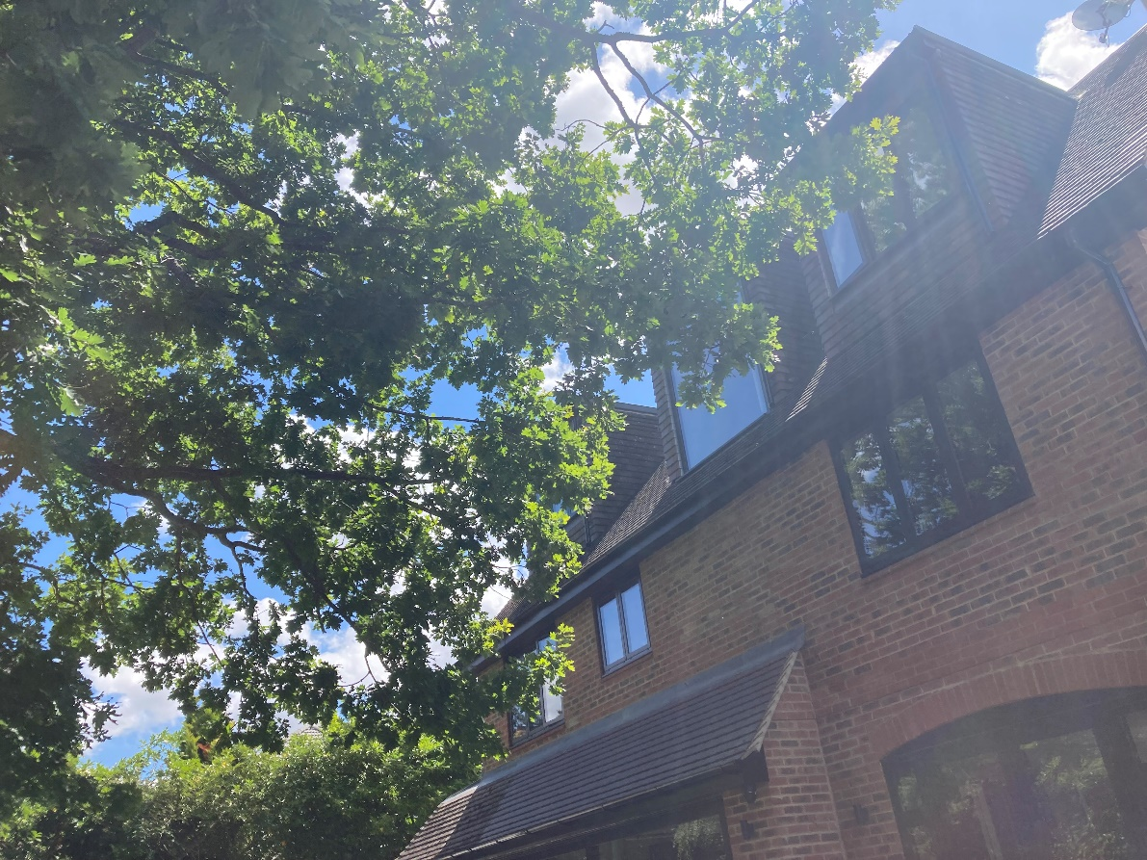
Picture 1

Picture 2 (view from top floor)
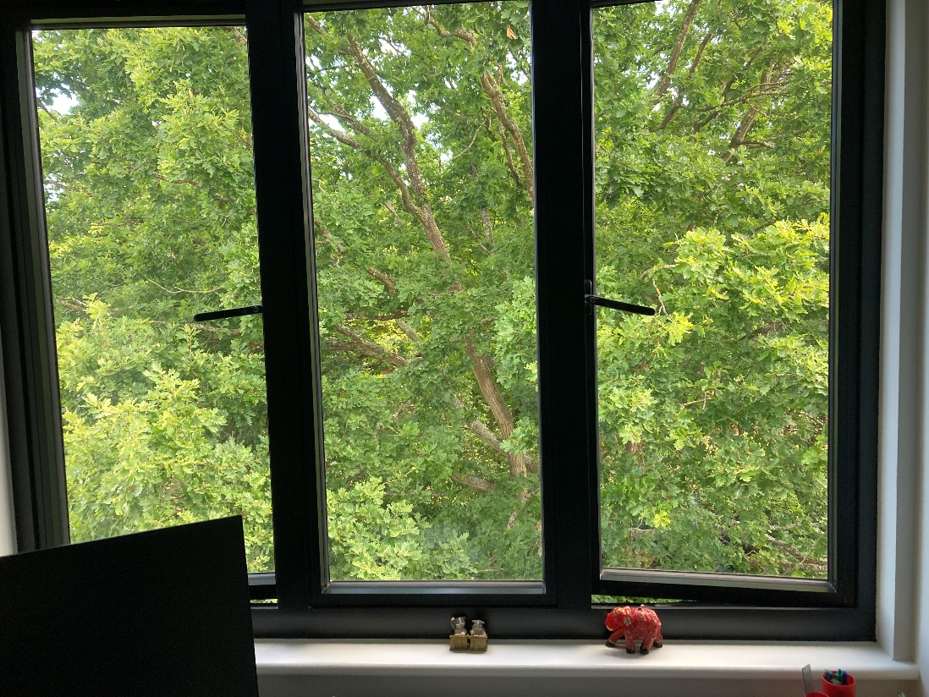
Branches of the oak tree are extending over the garage and garden room causing damage and blocking drains
Picture 3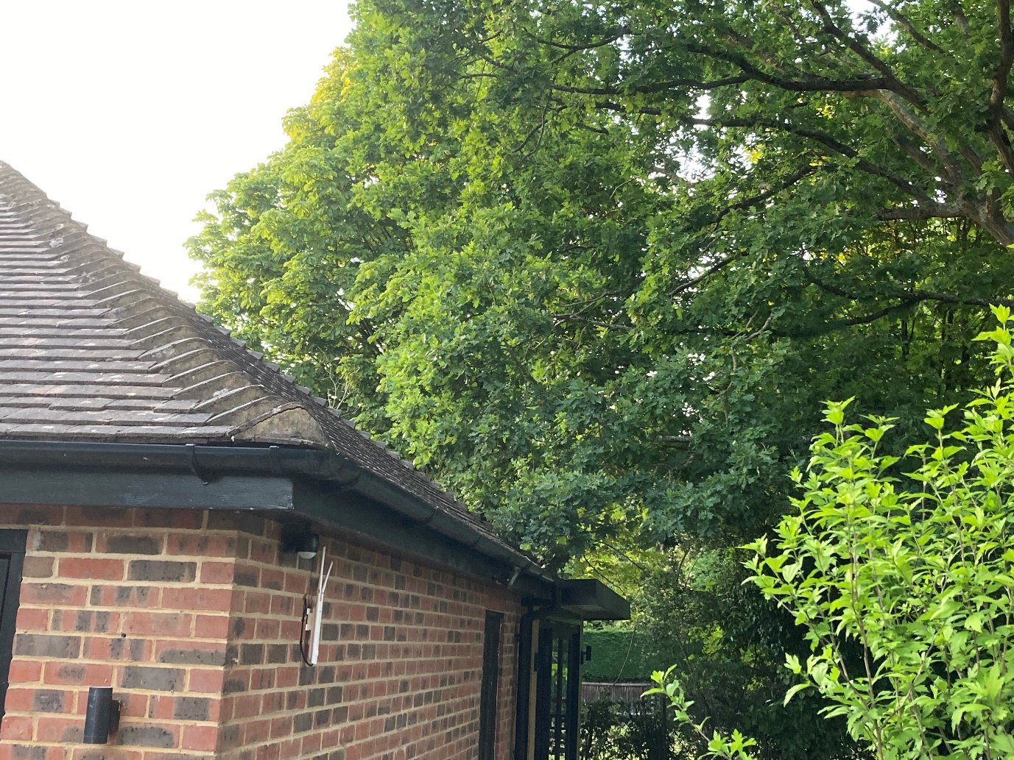
Picture 4
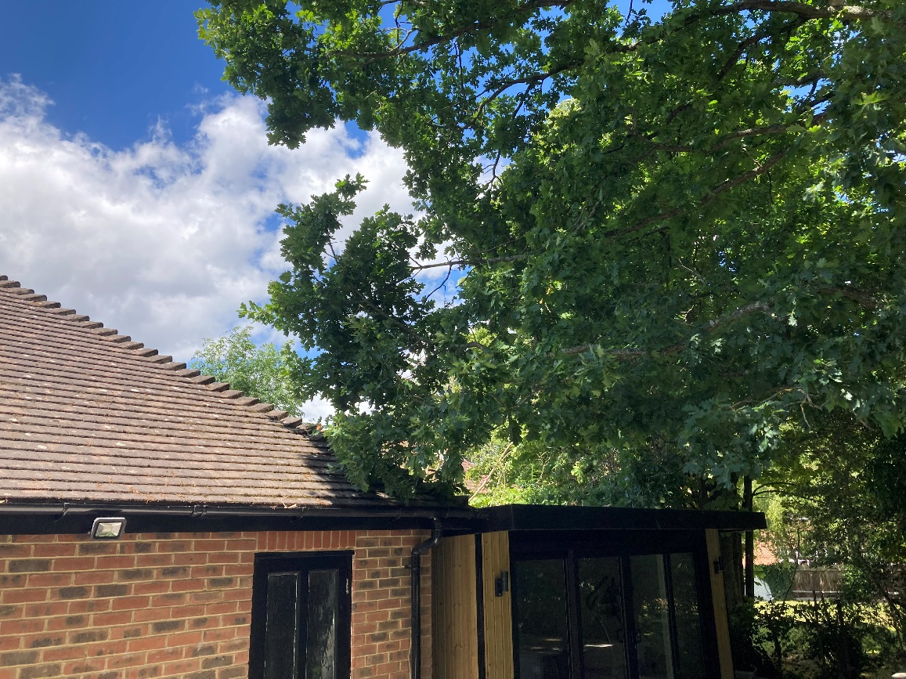

Picture 5
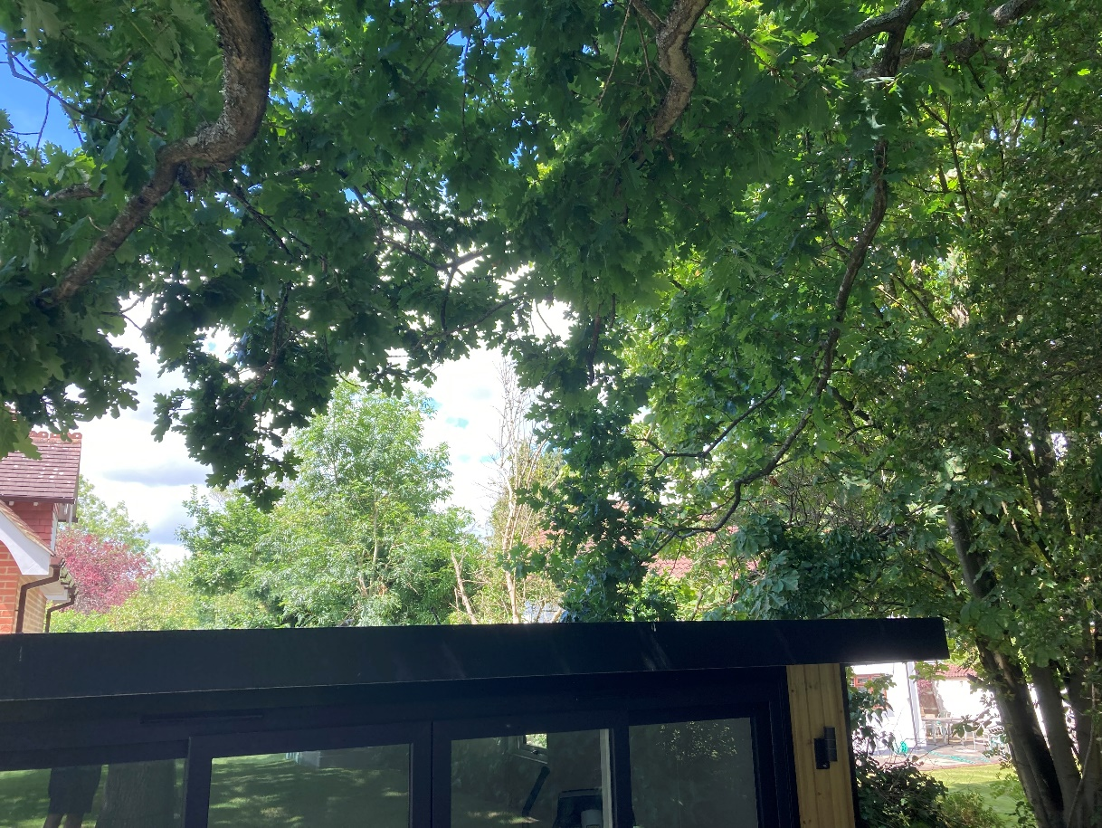
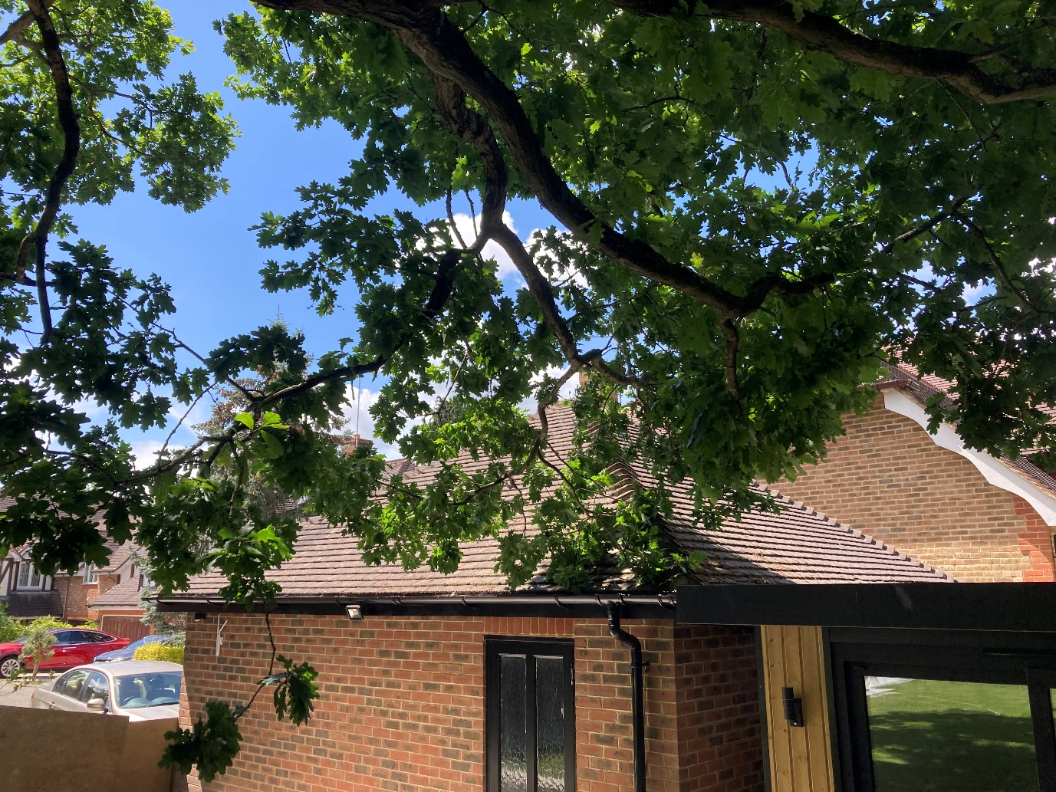

Picture 6
The branches of the oak tree are extending into the garden and over the garage but less so to the rear, resulting in an unbalanced crown
