97 Cromwell Road Hayes UB3 2PG – Planning application 5804/APP/2018/2337
Information for Condition 4 (Landscaping)
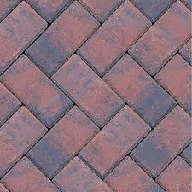
Porous Brick Paviors to be used for hardstanding and patios
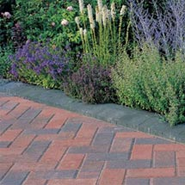
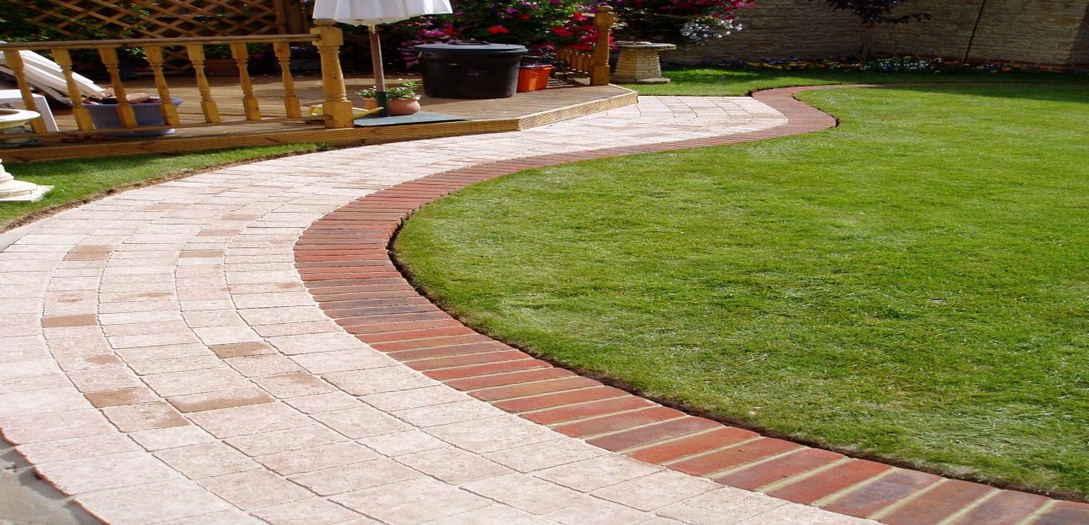
Porous Brick Paviors edging detail for perimeter flowerbeds and grassed areas
Proposed close board fence panels to be used to all boundaries
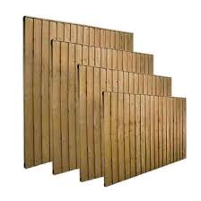

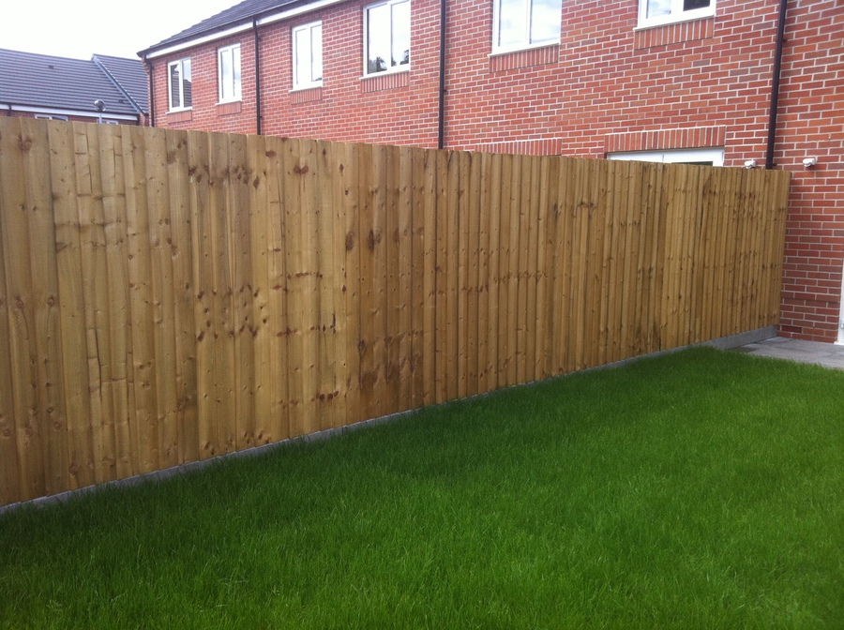

Condition 5 (Cycle / Refuse Storage)
Proposed type of cycle and bin storage
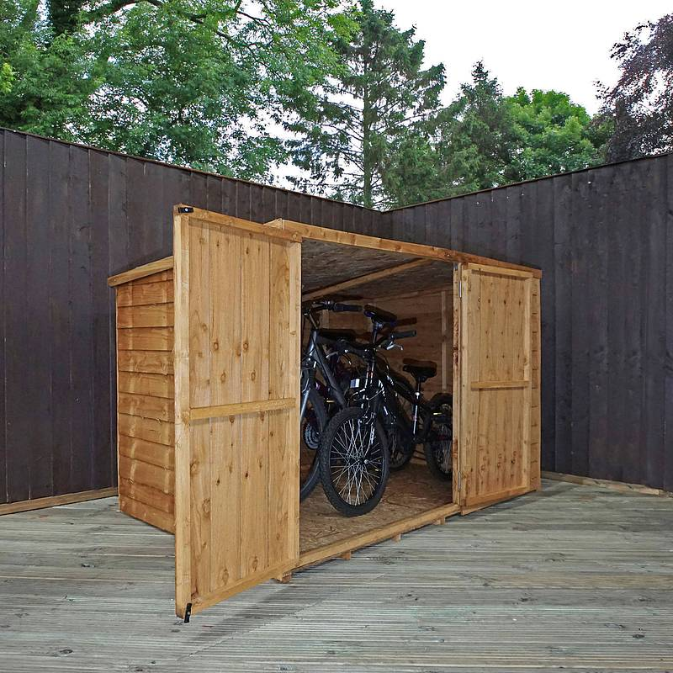
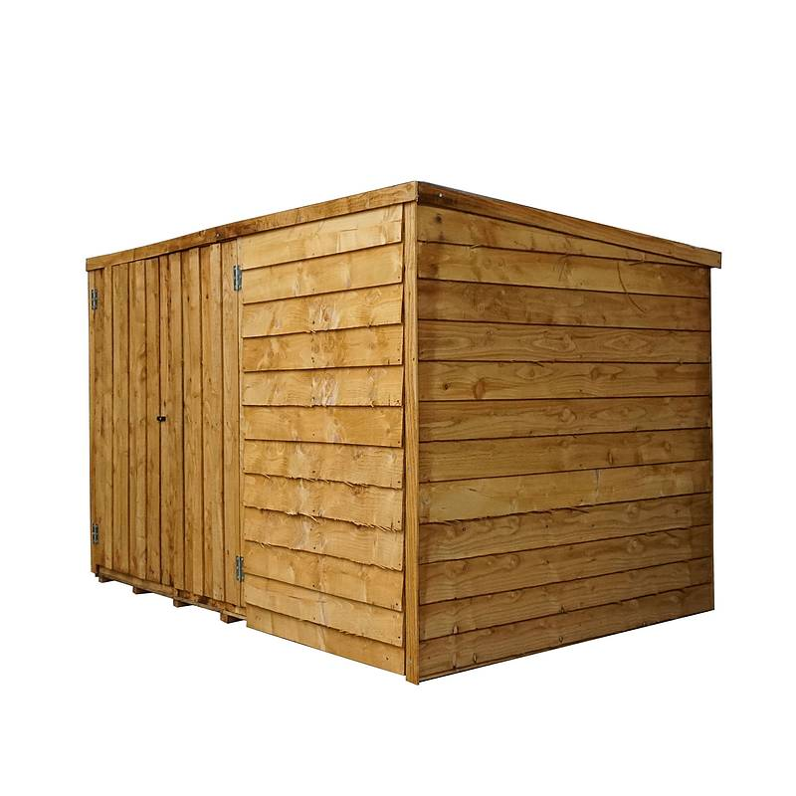
Proposed Bin Storage
