tTTs  contact us  14 Pemberley Chase  West Ewell, KT19 9LL  Company Number  13580987  info@toptrimtreesurgery.com02083972157 - 07926609474  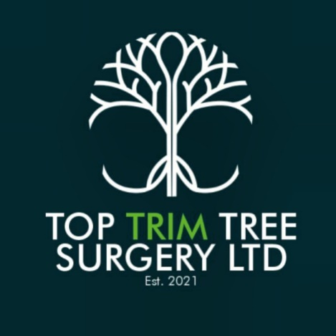 | English oak Assesment  11/04/2024  Following our site visit to 29 Ickenham Road, Ruislip, HA4 7BZ  to assess the mature Oak tree, we believe the tree would benefit from a crown reduction and thin. Also advisable to selectively reduce the weight on some major limbs that have grown mainly laterally to reduce the risk of failure. Thinning and removing any crossovers will aid tree’s health and help with light getting through benefitting rest of the garden also.  Deadwood throughout the crown and inspect major joints and forks for any cavities or defects. A crown reduction has been carried out on it before but a very long time ago, so we believe it’s time or another to maintain safety and aid the tree’s health.  We’d recommend a 3 to 4 metres crown reduction (roughly old pruning points) and a 20% thinning of the crown.  Sincerely  Leonel Medrado
  Top Trim Tree Surgery
  Your trusted tree surgeon | toptrimtreesurgery.com

