Tree roots damaging drive ways trip hazard and neighbours drive ways
Starting to lift in public footpath as well
Pigeon droppings have to be cleaned up every day (health hazard)
Can’t use the drive properly because of droppings

Would like to remove and re plant
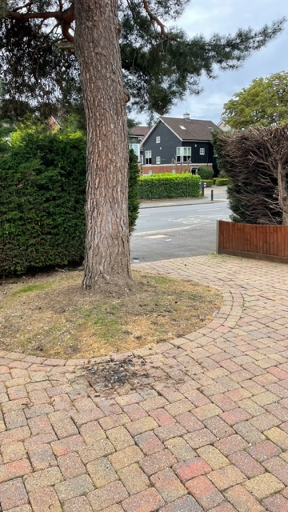
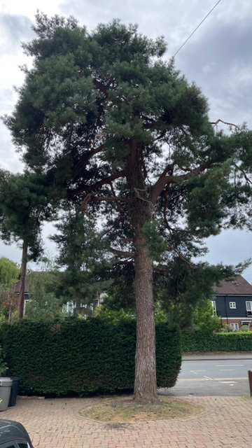
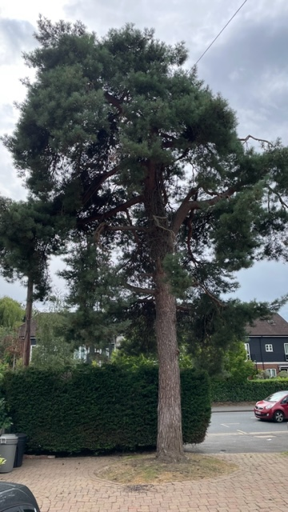

Kevin Woodham Arborist representative
Local Manager

BARTLETT TREE EXPERTS
Bartlett Tree Experts Ltd Coursers farm, coursers road ,colney heath, St Albans, Hertfordshire AL4 0PD
p Office:01727 825090 option 1 Mobile: 07808915881
e kwoodham@Bartlett.com

