PROPOSED EXTENSION TO GARAGE BUILDING AND
ASSOCIATED EXTERNALWORKS
AT
CHURCH GARDENS, CHURCH HILL,
HAREFIELD, MIDDX. UB9 6DU

SCHEDULE OF EXTERNAL MATERIALS
(to be read in conjunction with drawings 1600/ 60A & 61A

General
Any new planting required is to be carried out between September and March when weather conditions should be optimum. Avoid periods of draught, water logging and frost.
All planting areas should be made up of good quality topsoil, free of perennial weeds and weed seeds. There should be a minimum plating depth of 450mm.
At the time of planting spread a 20mm of well rotted manure or proprietary soil conditioner over the surface along with bone meal fertiliser at the rate of 50g per sq.m.
All shrubs to be container grown in 2 litre pots and planted with existing soil level/root ball at ground level.
Shrub beds can be mulched to help reduce further maintenance (i.e. weeding) and all hedges to be watered in.

Existing Trees
Existing trees on adjoining property to be protected in accordance with the recommendations of the Arboricultural Method Statement dated 11 April 2024 prepared by SJ Stephens Associates, with protective fencing erected along the top of the existing boundary wall for the duration of the works. Tree T8 to be removed as noted and tree branches overhanging the building area to be cut back as required. All tree works to be carried out to the standards as set out in BS 3998:2010 Tree Work – Recommendations.

Tree Protective Fencing
Tree Protective Fencing should be from weld mesh panels, at least 2m high, securely fixed, with wire or scaffold clamps, to a rigid framework. This framework should be constructed from scaffold tubes with vertical tubes, at a maximum interval of 3m and driven into the ground at least 0.6m. The structure should be well braced to resist impacts, constructed as per Figure 2 of BS5837. Protective fencing should be erected before any clearance or construction work commences on site. Notices should be fixed to the Tree Protection Fencing stating – “Tree Protection Fencing – No construction activity to take place within this area”.

EXCAVATIONS

All excavations within the building area to be carried out strictly in accordance with the recommendations as set out in the Written Scheme of Investigation (WSI), dated May 2024 as provided by KDK Archaeology Ltd. The building area is to be cleared and a 1.0m wide x 5.5m long strip of turfing to the top of the grassed bank is to be removed by hand and a trial trench is to be excavated to a minimum of 1.0m deep to this area. All excavations are to overseen by KDK Archaeology and Survey Records and Reports provided.

FORECOURT AREA

The extended forecourt area to be finished with a layer of Cotswold gravel laid over a 200mm permeable hardcore substrate with a geotextile membrane to the oversite. All areas to be edged with a double row border of 100mm stone sets laid on concrete base with sand cement pointing. Access pathways to be formed with 25mm Limestone paving slabs of four sizes (900x 600, 600 x 600, 600 x 300 & 300 x 300) laid in random pattern on sand cement bed and edged each side with a single row of 100mm stone sets as above to provide a 1.1m wide access pathway. Pathways laid with falls to each side.

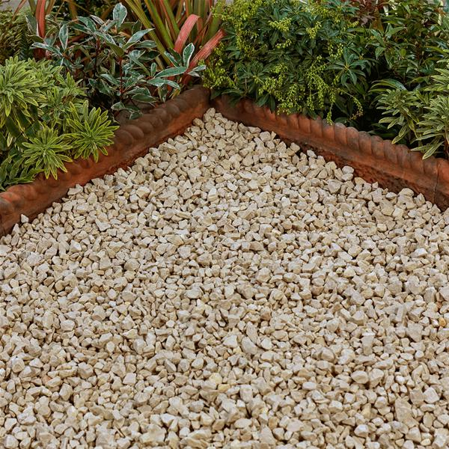
Cotswold Gravel

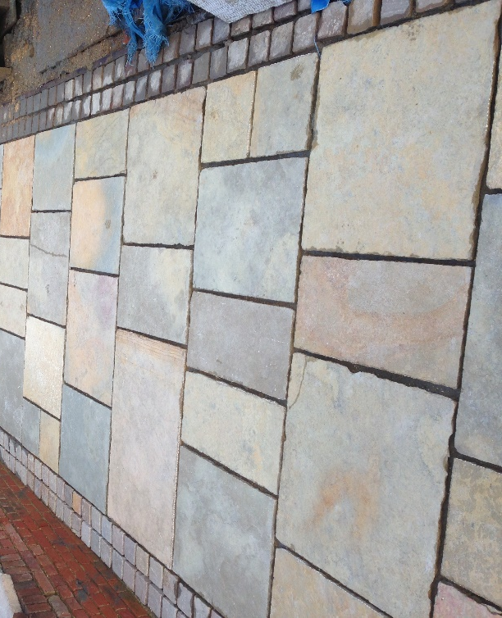
Limestone paving with stone set edgings

Grassed Bank
Following the completion of the building works, the existing grassed bank is to be reinstated up to the new building to the original levels. Grassed areas to be provided with a minimum of 100mm of good quality topsoil, graded and firmed to suitable levels. Turfs to be laid butted together with staggered joints and lightly firmed or rolled after laying.

Retaining walls
New retaining walls to the grassed terrace to be formed with 500mm wide steel gabion cages filled with random flint stones to match the existing. Cages to be single or double layer to suit the retained ground levels. Existing cage retaining walls to be dismantled prior to the excavation of the building area and to be reassembled in new areas as per layout plans.

BOUNDARY TREATMENTS

Section of existing boundary fencing adjoining building area to be removed and remains of existing boundary wall to be out. Wall to be demolished by hand where possible with bricks cleaned and stored safely on site for reuse in rebuilding the wall.

Lighting

900mm high Zone E27 Commercial Bollard LED light fittings (IP65) to be installed in front forecourt and rear garden areas as located on plan. Fittings to be in Anthracite grey, secured to in-situ concrete base and connected to electrical supply. Fittings to be controlled with daylight sensor.

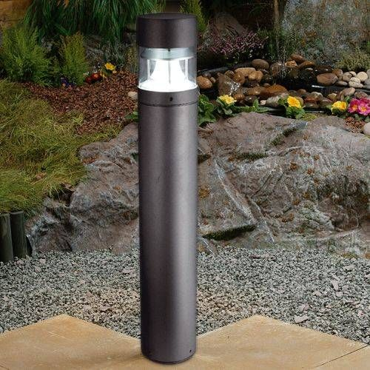
Zone E27 Bollard Light (BL)

MAINTAINANCE

Planting
Upon completion of planting it will be necessary to ensure good watering during any periods of prolonged draught.
Weeds should be removed regularly throughout the growing season (March to October) either manually or by using suitable herbicides.
All flowering shrubs should be cut back and shaped immediately after flowering.
Hedges should be trimmed in April and August, with facing shoots allowing plants to fill out and thicken to a final depth of 0.9m. All hedges to be kept at a height of 1.0m except NH1 & NH2, which should be kept at 1.8m in height.
Any planting that dies during the first 3 years should be replaced.

Lawns
Lawn areas should be mown weekly between mid March and October with occasional trims should unseasonal weather cause growth during the dormant months.

Surfacing
All gravel, slabbed and paved areas to be weeded regularly throughout the growing season (March to October) either manually or by using suitable herbicides.

PROPOSED EXTENSION

Facing brick

The external walls to the proposed extension are to be constructed with a 50mm Red Multi stock brick from H G Mathews to match the existing garage building. Brickwork to be laid in a Flemish bond in a 1:4 sand lime mortar mix with a stone cill and stained timber lintel to the new window opening to match the existing.

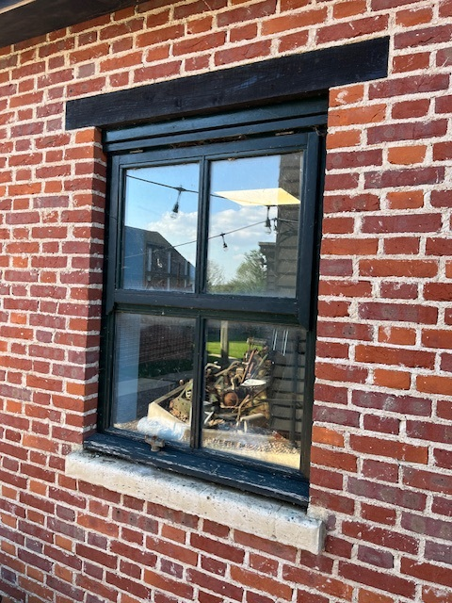

HG Mathews Red Multi Stock Brick
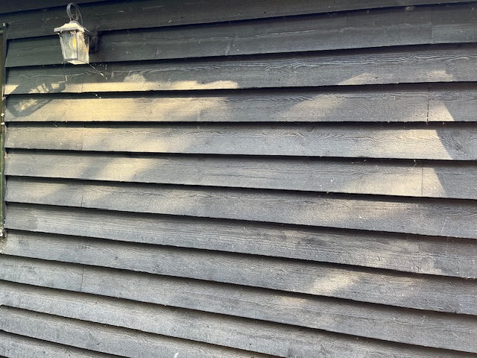
Black Barn timber cladding
Cladding
The front wall of the new extension facing the Tea Room building is to be clad in 175mm Black Barn timber boarding to match the existing outbuilding. Boarding to be fixed horizontally to timber framing with breathable felting behind. Provide 50 x 25 treated timber surrounds to door and window opening with 50mm sq. uprights to external corners.

Roof Tiles
The pitched roofs to the proposed extension are to covered with a Redland Rosemary Medium Mixed Bridle Clay tile to match the existing garage building. Tiling to be bonded into the existing with pointed verges to all barges and a terracotta angular ridge tile. Fascias, soffites and barge boards to be in treated timber and stained Ebony.

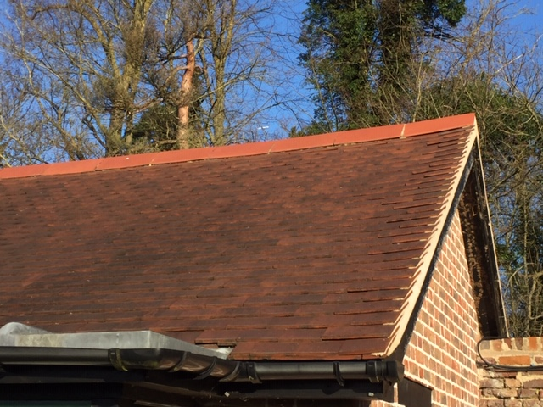

Redland Rosemary roof tiles with terracotta ridge
Rainwater Goods
Guttering to be 100mm half round with 65mm round downpipes all in black to match the existing.

Windows & Glazed Doors

The casement windows and glazed doors to the proposed outbuilding will be in hardwood to match existing. Frames will be made with flush fitting casements and fitted with 24mm sealed double glazing with black seals and beaded in. All frames to be stained in green to match existing buildings.

RETAINING WALLS

Existing gabion cage retaining walls to be removed to building area to be emptied and dismantled prior to the commencement of the excavation works. Cages to be reassembled and filled to form retaining walls in new locations as noted on plans.

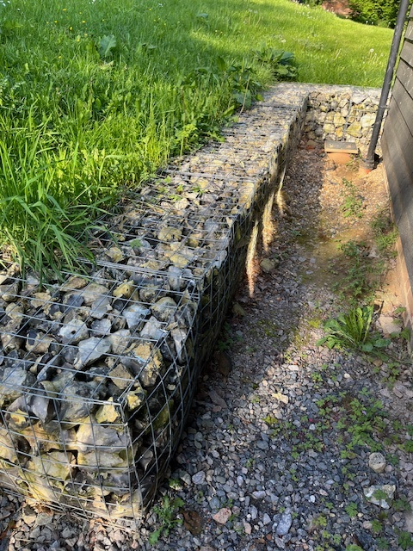
Flint filled Gabion cage retaining walls

HOME PLANS

MAY 2024

