DEMOLITION OF EXISTING WALLS AND SALVAGING AND STORAGE OF EXISTING BRICKS FOR REUSE

AT

CHURCH GARDENS, CHURCH HILL, HAREFIELD, MIDDX. UB9 6DU

METHOD STATEMENT

Walls to be dismantled to be cleared of as much vegetation as possible, prior to the commencement of the demolition works. All debris from same to be cleared for site or added to compost heap where suitable.

All demolition works to existing walls to be carried out by hand using hand tools and hand powered tools only.

All existing weed and plant growth to wall tops and wall faces to be cleared by hand. Plant stems to be cut down as low as possible and roots dislodged as surrounding bricks are removed.

Loose bricks to top of each section of wall to be taken off by hand. Bedded bricks to be removed singly and in single courses only using chisels, bolsters and where necessary a powered hand drill to break up mortar bedding.

All full and half bricks to be salvaged for reuse when rebuilding replacement walls. Bricks to be cleaned with mortar removed using hand scrapers and trowels and stored in timber crates immediately adjacent to the areas of new work. Full and half bricks to be stored in separate crates for ease of selection when incorporating into new build work.

All unwanted brick and mortar debris to be cleared from site

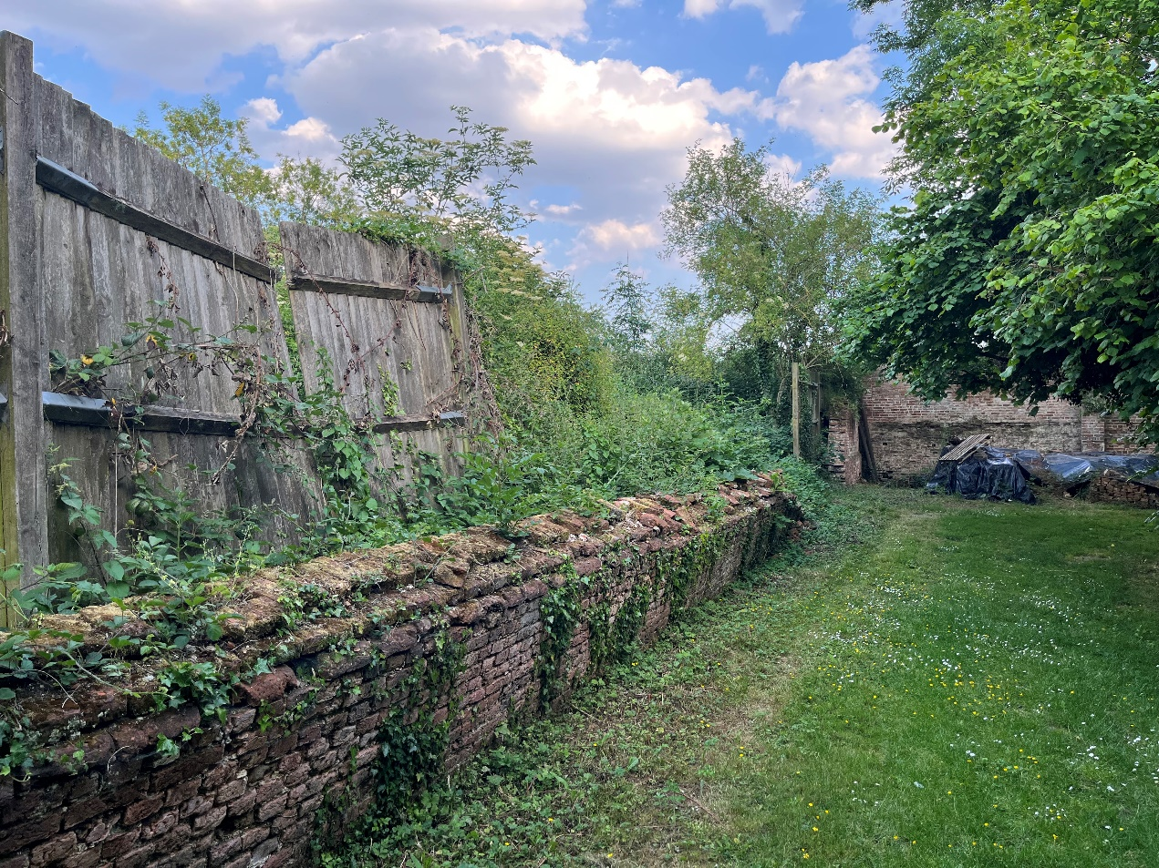
View South of the section of collapsed Wall 1 to be dismantled

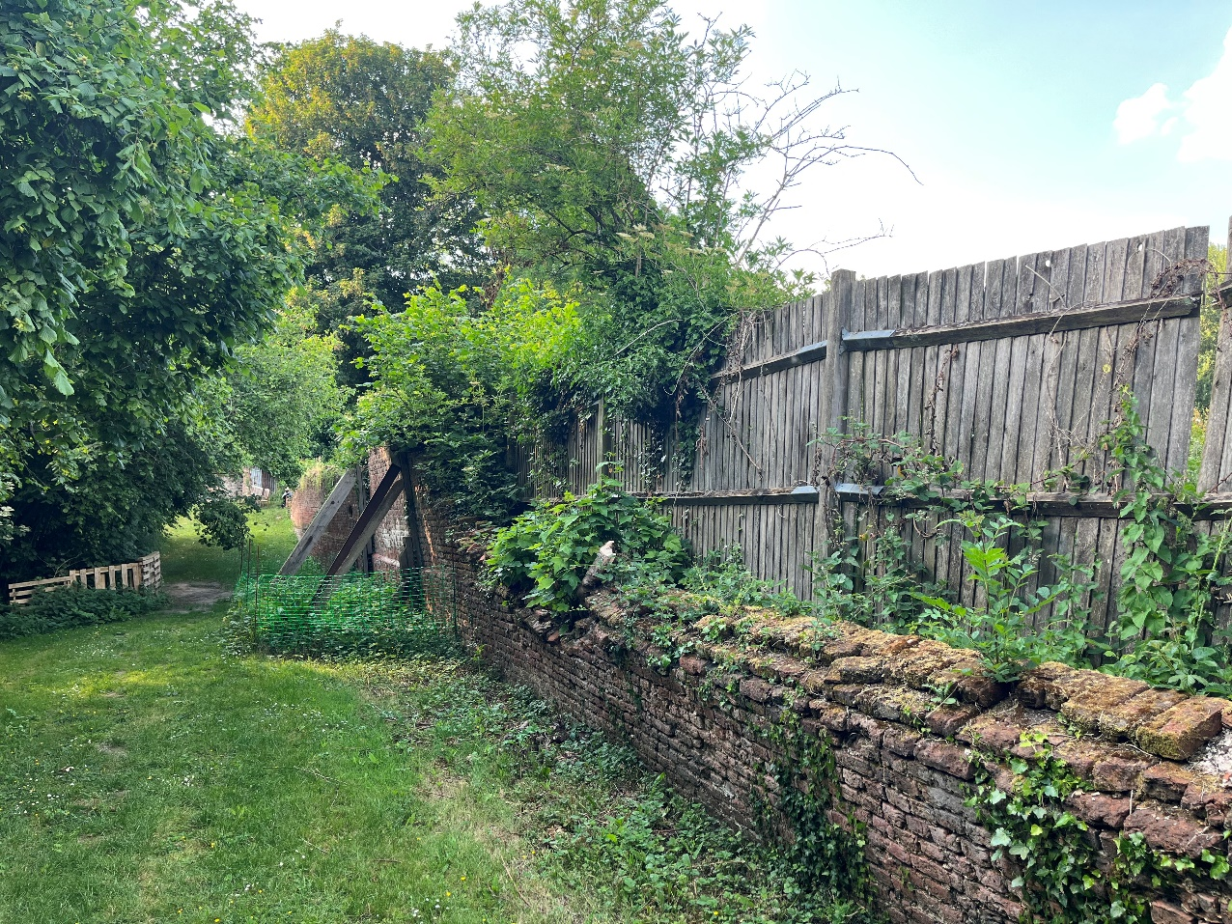
View North uth of the section of collapsed Wall 1 to be dismantled

