WALL REPAIR SAMPLE PANEL
For
CHURCH GARDENS, CHURCH HILL, HAREFIELD, MIDDX. UB9 6DU

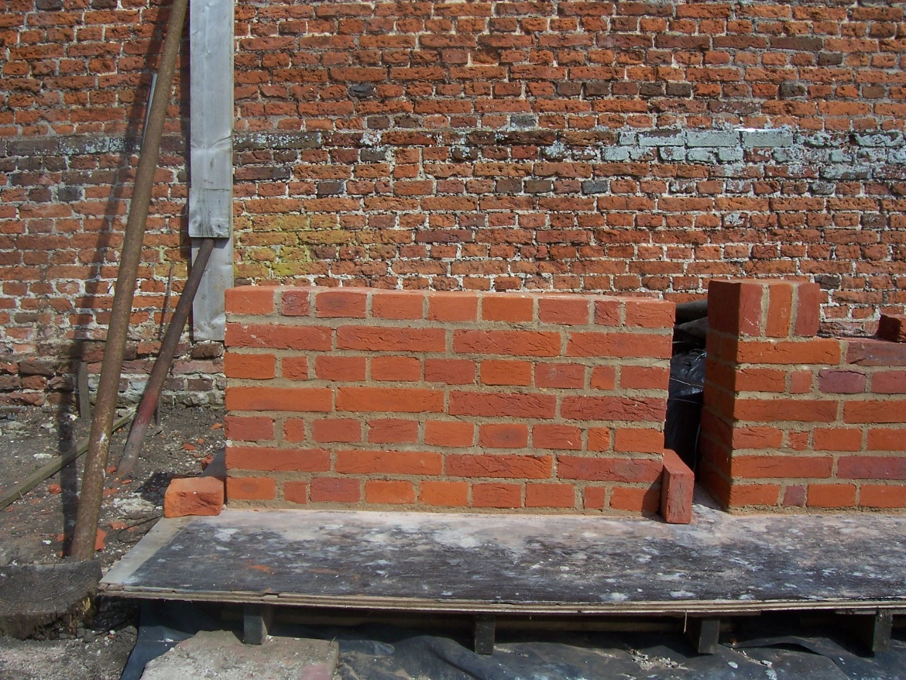
Approved brick repair / rebuild sample panel

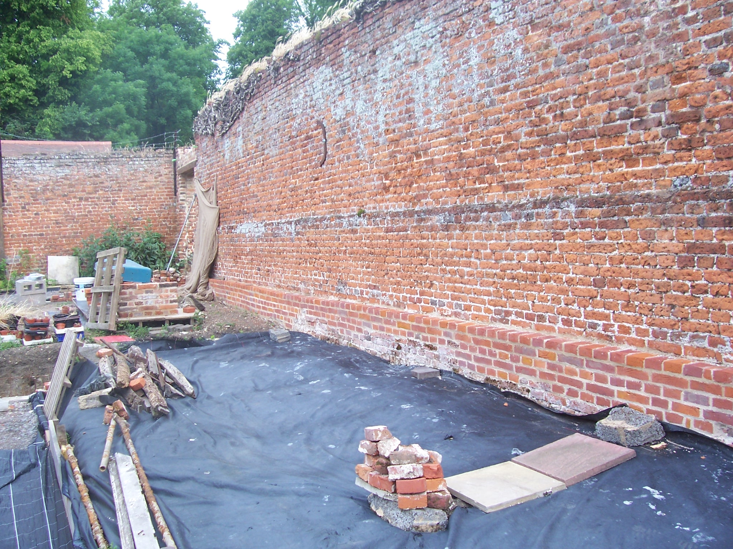
View to section of completed repairs to base of wall

