PROPOSED EXTENSION TO GARAGE
AT
CHURCH GARDENS
CHURCH HILL
HAREFIELD
MIDDLESEX
UB9 6DU

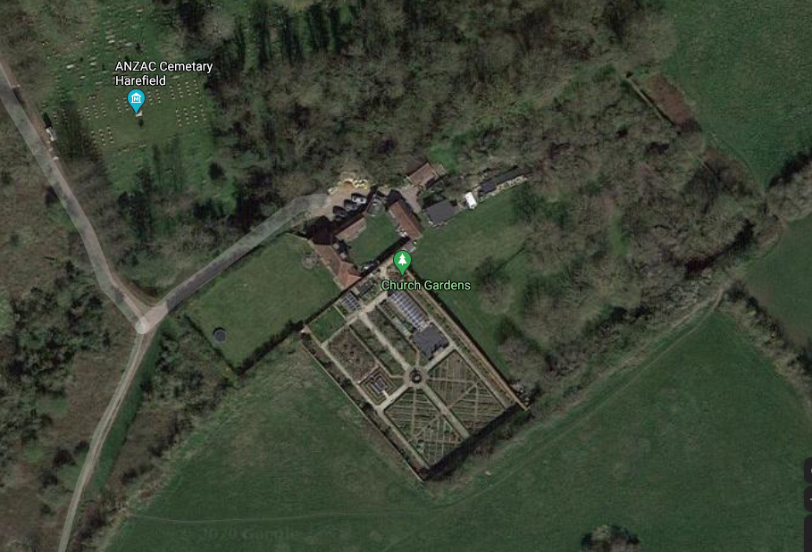

DESIGN & ACCESS STATEMENT
AND
HERITAGE IMPACT ASSESSMENT

PROPOSED EXTENSION TO EXISTING GARAGE
AT
CHURCH GARDENS, CHURCH HILL, HAREFIELD, MIDDLESEX. UB9 6DU

DESIGN & ACCESS STATEMENT & HERITAGE IMPACT ASSESSMENT

1.0 INTRODUCTION

  - This Statement has been prepared in support of an Application for Planning Permission and Listed Building Consent for proposed works at the above property. The proposed works relate to the construction of a single storey extension to the rear of the existing garage building to provide a display room / store for old garden tools and machinery, together with associated external works.

  - Church Gardens is a Grade II listed property which largely dates from the early 17th Century. The property comprises of a detached dwelling house, with detached annexe and garage, set in approximately three acres of grounds including a front lawn, Walled Kitchen Garden and Orchard and was originally part of The Harefield Place Estate. Harefield Place itself was demolished in the early 1800’s and it is understood that the existing dwelling house was the original Coach House, though it has been altered and extended since then.

  - The Kitchen Garden and Orchard are enclosed with C17th brick walls ranging from 2.0m – 3.5m high. The enclosing walls to the Kitchen Garden area have already been repaired and restored but the walls to the Orchard Area are in a serious state of disrepair and have been included on the At-Risk Register of Listed structures for many years and are now in urgent need of attention.

  - Within the last five years, Church Gardens has been open for public visits. This originally started on the August 2018 Bank Holiday Monday, when the gardens were opened up for a few hours as part of the National Garden Scheme. Since then, there have been three subsequent Open Days in 2019 and many private visits. Unfortunately, due to the COVID-19 situation, the gardens were closed in 2020 and 2021 but did reopen again on the August Bank Holiday in 2022. Since then, the gardens are open every Sunday afternoon for the public to visit together with accommodating visits by horticultural and other groups throughout the gardening season.

  - In 2021 and 2022, the new Tea Room building, which was granted Planning & Listed Building Consent in April 2021 was constructed and was officially opened for the August Bank Holiday in 2022. The Tea Room offers an excellent facility for our visitors, providing them with both indoor and outdoor seating to sample the refreshments on offer. The opening of the gardens for public access has been well received and many of our visitors have expressed a great deal of interest in our collection of old garden tools and machinery which we have amassed over many years. Presently, this collection is either displayed externally or is in storage and it would be ideal to have a protected enclosure to set it all out for the visitors to see at their leisure. The extension is in close proximity to the Tea Room building and would be easily accessible to all.

  - It is therefore proposed to construct a single storey extension to the existing garage building to provide this display / store room. The extension would be set into the existing grass bank to the rear of the garage, occupying a “dead end” area of the existing raised grass bank, replacing the existing steps and would be covered with a tiled pitched roof to match in with the existing garage. The grass bank is approximately 1.8m high in relation to the finished floor level of the garage and the existing Tea Room and as such, the bulk of the building volume would be “below ground”. By replicating the profile of the existing garage roof, the visual impact of the proposed extension would be very limited as the view from along the raised bank would be largely as is and the extension would be concealed from all other parts of the garden by the profile of Tea Room building.

  - Being at ground level and opening onto the main internal forecourt area, the extension building will be provided with a level threshold and level floor internally so as to be fully accessible to all.

  - This statement has been prepared in conjunction with a Heritage Impact Assessment in respect of the proposed works. A detailed Heritage Impact Assessment in respect of the all of the proposed works as approved in April 2021 was prepared by Dr Sarah Rutherford, Dip. Hort. Kew, M.A., Ph.D., which is included with this Application submission. Dr Rutherford prepared our original Conservation Plan for Church Gardens in 2004 and a great deal of the works proposed are in line with the recommendations within this Plan. As such, the Application submission is accompanied by detailed drawings, photographic record and full Schedule of Works in respect of the garden walls, together with a Personal Statement setting out the background and specific aims and objectives in relation to this project.

2.0 RELEVANT PLANNING HISTORY

2.1 This property has a reasonably active planning history since being refurbished for use as a family home by Mr and Mrs McHugh in 1996-1998. Applications submitted relate to the continuing restoration and improvement works to the property which have had to be implemented in a piecemeal and sequential manner as and when time and funds would permit and to ensure all works could be completed to the highest standard in order to retain, restore and enhance the historic fabric and character of Church Gardens. Planning and Listed Building Consents have been granted for modest single storey extensions to the main dwelling house, detached annexe and garage buildings to replace original outbuildings and repair and restoration works to the Kitchen Garden area, all of which have largely been implemented.

2.2 In April 2021 Planning Permission and Listed Building Consent was granted for a range of works to Orchard Garden including the construction of a large pond, a new outbuilding for use as a Tea Room , involving the removal of all original sheds and stores and repair and restoration works to the enclosing brick walls to this part of the gardens. The pond was completed in 2021and the Tea Room building with associated external works was completed in 2022. Some wall repair works have been undertaken and these are expected to carry on next year.

2.3 The above Planning and Listed Building submission was lodged following Pre Application consultation with the London Borough of Hillingdon Planning and Conservation Officers, Historic England and advice provided by Sarah Rutherford, our Historic Design Consultant and Karin Kaye of KDK Archaeology, both of whom have been involved with this property for many years - Sarah Rutherford prepared the Conservation Plan for Church Gardens in 2004 and Karin has provided several Desk Top Reports and undertaken various Watching Briefs in respect of previous works. All archaeological requirements have bene complied with in relation to the elements of the approved works that have been carried out.

2.4 The Historic Environment Impact Assessment prepared by Dr. Rutherford in respect of the new Tea Room building concluded that as the proposed building was now sited in an area of the garden already containing various adhoc structures that the visual and other effects on the historic environment setting of the rest of the walled garden, and particularly the terrace and arcade along the Northern boundary were considered to be minimal and acceptable. In terms of archaeological impact, Karin Kaye was of the opinion that this structure would cause minimal damage to the historic fabric and land form and on the basis of previous watching briefs in this area of ground, it was considered that the existing ground has been previously much disturbed and therefore unlikely to have any archaeological potential.

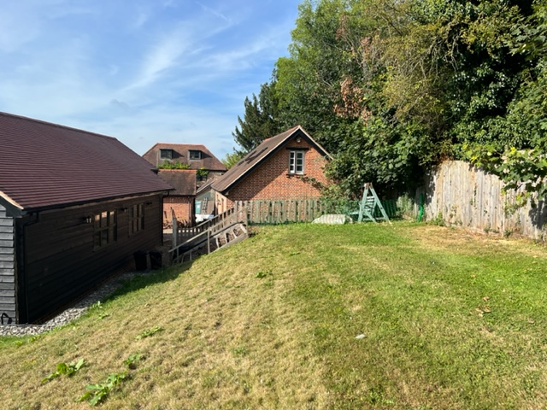

View of the location for the proposed extension

3.0 CONTEXT

3.1 The application site is located on the Southern edge of Harefield and to the rear of St Mary’s Church and lies within the Harefield Village Conservation Are and the Metropolitan Green Belt.

3.2 The Application site, comprising of the existing dwelling house and walled gardens is Grade II Listed and is included on the Register of Historic Parks and Gardens and is listed on the London Borough of Hillingdon At Risk Register of protected Buildings.

3.3 The current proposals relate to the ongoing restoration of Church Gardens as a unique Historic Garden but also now taking on board the development of the Gardens for public access. Our desire being, to share the ongoing restoration of this important heritage asset with the wider community and for the gardens to be financially sustainable going forward. While ensuring the long-term future for the whole historic environment within our ownership.

4.0 USE

4.1 The existing buildings at Church Gardens are in use as a detached private dwelling house with associated outbuildings including an annexe, detached garage and stores.

4.2 The Tea Room building approved in 2021 and completed in 2022 was designed to be a low key and small-scale addition to the garden, very sensitive to the historic character while providing basic facilities for relatively small, supervised groups of visitors to the garden, and now accommodating opening on Sunday afternoons throughout the gardening year. The building is functioning very well as both a tea room and a location for group meetings and events relating to the gardens and offering essential shelter during inclement weather.

4.3 Since it’s opening, this facility has proved very valuable in supporting the ongoing restoration, maintenance and upkeep of the gardens by developing a small, but valuable income stream that could be spread over most of the year. It has also enabled us to provide disabled access for our visitors and to accommodate visitor and disabled toilet facilities outside of our family home.

4.4 In this short period of opening up our gardens for public access, we have realised many visitors come several times a year, some to see the gardens as they vary with the different seasons and others to see the ongoing restoration works and new gardening project. Many visitors express a great interest in our collection of old garden tools and machinery that we have already amassed and display and it will be of much interest if we were able to display this properly and add to it over the coming years. The proposed extension will facilitate this going forward.

5.0 DESIGN PROPOSAL

5.1 The proposed extension is set immediately to the rear of the existing garage and is designed to be of similar form and appearance to that of the garage, with matching facing brick to the external walls and matching clay tiles to the roof.

5.2 The extension occupies the “dead end” area of the existing grassed bank, absorbing the present gap, the sleeper retaining wall and set of dilapidated timber steps. The extension building will be set into the grass bank and it masonry walls will be almost fully submerged on two sides with a black boarded frontage facing the Tea Room building.

5.3 Internally, the extension will provide a total of 25 sq.m. of floor area. New windows and doors to the extension building would be in painted hardwood framing, double glazed, all to match the existing frames in the Tea Room and garage.
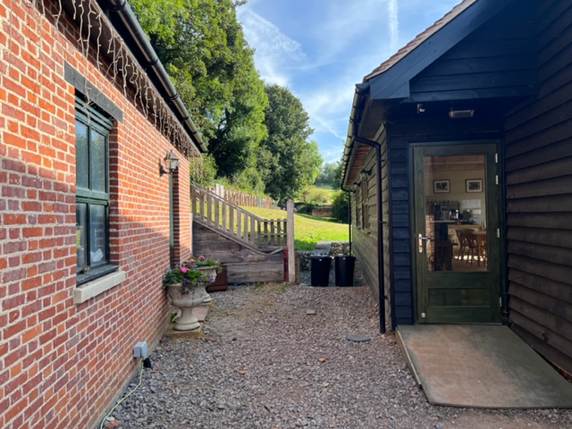

Proposed extension will maintain view between buildings through to gardens beyond

6.0 PLANNING CONSIDERATIONS & HERITAGE IMPACT

6.1 This property lies within the Harefield Village Conservation Area and the Metropolitan Green Belt and as such, the proposed works take account of relevant Planning Policies with the London Borough of Hillingdon Unitary Development Plan Saved Policies (September 2012) relating to design criteria for residential new build projects have been observed in the design for this proposal. The principal Policies applicable to this development proposal scheme and how they have been considered in the proposed design can be summarised as follows:

6.2 Outbuilding Footprint area – drawings 1600/20 & 61A
Drawing 1600/20 details part of the site layout plan for the property to 1:200 scale but covers the area of ground containing various outbuildings. The plan indicates the range of outbuildings that were present on the site when this property was purchased in 1996. The buildings within the Orchard area were primarily single storey stores and animal shelters which were constructed in either in-situ concrete or timber and covered with asbestos sheeting. There was one higher structure within the Stores area. Over the course of time we have had all the asbestos sheeting removed and some of the structures themselves have been removed to facilitate other buildings or have collapsed; their bases and some walls are still remaining on site. The original brick annexe building has also been rebuilt.

6.3 As you will note I have calculated the floor area of each group of buildings within the Orchard area which comes to a total of 228.5 sq.m. There was also a large poly tunnel enclosure within the Orchard area as shown on the plan, which I have not included within these figures. You will also note that there were substantial Greenhouse buildings within the Kitchen Garden area as indicated on the plan. These were brick, timber and glass structures, the majority of which have now been removed as part of the refurbishment of this area. However, these did have a total area of 229.3 sq.m..

6.4 Drawing 1600/61A detailing the current site arrangement with floor area calculations for existing outbuildings indicated for your information. From this you will note that with original stores, annexe, the garage and Tea Room, the total building area is 210.2 sq.m. The proposed extension and link is also indicated with an additional floor area of 42.0 sq.m., bringing the total to 252.20 sq.m.; which is slightly more than that of the original area of outbuildings for this part of the gardens. However, please also note that the area of outbuilding within the Kitchen Garden area now is substantially reduced to just 10 sq.m. compared to the original total above. As with the existing I have not included for the poly tunnel structure within these calculations.

6.5 With regard to Planning Policy DMHD3 (basement development) the proposed extension could be described as a semi basement. However, the extension is not designed to provide any habitable accommodation and due to its elevated position within the site, will not impact on any existing drainage systems or cause damage to the existing water environment. Furthermore, the sunken nature of the building will not impact on the Conservation Area setting in that a large part of it will be concealed below ground and the building itself will be largely concealed by the existing Tea Room. Excavations in connection with this proposed extension will be accompanied by an Archaeological Watching Brief, as has been the case with all previous projects within Church Gardens. However, to date none have revealed any archaeological content.

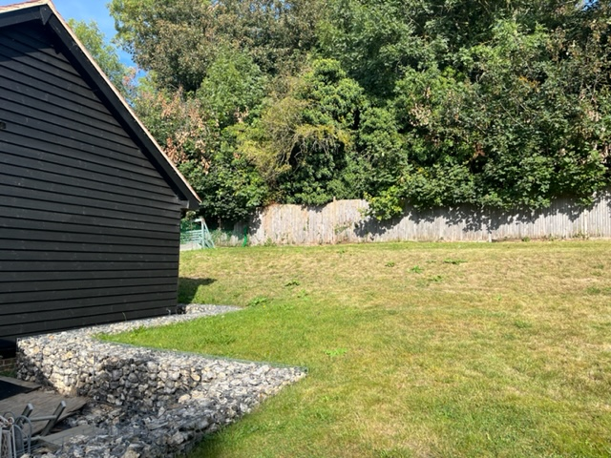

Proposed extension will be largely concealed by the profile of the Tea Room Building

6.6 Given the Listed Building, Conservation Area, Green Belt and Historic Garden setting of this property, the impact of these proposals on the historic environment is considered to be the primary planning issue and every effort has been made to address this in a sensitive and intelligent manner.

7.0 LAYOUT

7.1 The proposed extension to the garage is set to the rear of the existing building so as to be “contained” within the existing group of buildings on this part of the site. This is fully in accordance with the detailed Heritage Impact Assessment prepared in connection with the new Tea Room building and was accepted as part of that Planning and Listed Building Approval.
7.2 As previously stated, the location for the proposed extension has been carefully considered in relation to its impact on the gardens and it’s setting among the existing outbuildings is seen as the most unobtrusive that can be achieved. The building is also sufficiently well located to be easily accessible, both in terms of construction, with no disruption to the existing garden areas and for day to day use of the kitchen for deliveries, servicing, etc. and will not impact on any visitor outlook of the gardens.

8.0 APPEARANCE

8.1 The proposed extension to the garage will be largely constructed in 50mm hand made stock facing bricks to match the existing garage building. The internal façade facing the Tea Room Building will be timber framed and covered in black barn timber cladding to match the Tea Room itself with all window and door frames in painted hardwood to match. The new roof will be covered with Redland Rosemary plain Clay tiles with terracotta ridge tiles and painted timber fascia, soffite and barge boards, all to match the existing.

8.2 The materials used in the proposed extension are selected to compliment and reinforce it’s setting within the existing buildings.

9.0 SUSTAINABILLITY

9.1 The aim of this application submission is to assist in securing the sustainability of Church Gardens as a historic garden to the benefit of the property itself, the local community and the wider historic environment, by adding an additional visitor facility.

9.2 Over the past twenty-five years, the Applicants have invested heavily in Church Gardens, both in terms of time and money and whilst this may have been a labour of love in the most part, it has served to rescue a great deal of this property from dereliction. However, there is still a vast amount of work to do to complete this restoration project and the additional time and monies required to do this would be well beyond the means of most normal people. No financial assistance has been sought or provided for any of the works under taken and completed to date and it is highly unlikely in the present circumstances that any such financial assistance would be available in the foreseeable future.

9.3 In addition to the specific restoration works that are yet to be done, there is also additional costs involved in the ongoing development of the gardens themselves, both in terms of infrastructure, planting and ongoing repair and maintenance, all of which increases with every area of ground that is reclaimed as a manged garden space.

9.4 Since Church Gardens opened up to public visits in August 2018, and particularly so since the completion of the Tea Room, it has become evident that there is a huge interest in this historic garden and associated restoration project both within the local community and beyond and that there is a great potential for the gardens to be self – sustaining, at least in terms of ongoing operations and maintenance. Public Open days and private visits in 2018 and 2019 and the present weekend openings have generated some level of funding which could be much improved on with better facilitates and further restoration.

9.5 The proposed extension in providing a dedicated machinery store / display room will further improve the facilities available to the visitors to the gardens, creating a much more attractive centre for group meetings, talks and events and will enable the gardens to be presented in a much more professional and desirable way.

9.6 Currently, the gardens welcome groups of between 20-30 people and there is sufficient existing parking to accommodate this number of visitors. Group visits are arranged by appointment only, lasting 2-3 hours and based on previous activity, these are limited to one or two visits per week. The intention of the proposed extension is to offer an additional facility that will much enhance their visit

9.7 The general construction of the proposed extension will incorporate high levels of insulation to floors, walls and roofs within an air tight structural envelope.

9.8 The design for the new extension will incorporate rainwater harvesting by connecting into the existing harvesting system, to make use of the areas of sloping roof on the proposed building.

9.9 The use of permeable surfacing to the internal forecourt area will ensure that rainwater does not flow off the land.

9.10 All new windows and doors for the proposed extension and link will be factory manufactured with an integral thermal break and fitted with sealed double glazing and argon gas fill to minimise heat loss.

10.0 SCALE

10.1 The scale of the proposed extension takes reference from that of the existing garage building, and follows the same profile in terms of footprint and roof form. As such, it is designed as a single storey structure with a double pitched roof. The building will therefore be quite inobtrusive in it’s general setting and will complement the range of outbuildings as a whole.

11.0 LANDSCAPING

11.1 The internal forecourt area is to be retained and resurfaced with a mixture of limestone paving and gravel to provide a safe and level access to and from the property. Perimeter plant beds are to be provided at new and existing buildings.

12.0 ACCESSIBILITY

12.1 Pedestrian and vehicular access to the property will be direct from the existing track from Church Hill and past St Marys Church.

12.2 The existing property can accommodate up to 12 -15 car spaces which is considered sufficient to accommodate anticipated visitor numbers.

12.2 It is proposed to install a new set of access gates at the end of the private driveway, as already approved, to maintain a level of security for the property.

12.4 Disabled access is available from the private driveway into the property by the use of level pathways set into the gravel surfacing, leading into the internal courtyard and into the Tea Room building. Disabled access is presently available from the internal courtyard into the Orchard and Kitchen Gardens and will also be available into the proposed extension.

12.5 Fully accessible disabled toilet facilitates are provided within the Tea Room building.

Home Plans
February 2024

