PROPOSED GARDEN WALL RESTORATION, BUILDING AND LANDSCPAING WORKS AT
CHURCH GARDENS, CHURCH HILL,
HAREFILED, MIDDX. UB9 6DU

SCHEDULE OF LANDSCAPING & EXTERNAL MATERIALS - Revised 14-04-2021
(to be read in conjunction with drawings 1600/ 17D, 32B, 33A, 35, 36A, 38 & 39A)

HEDGES

General
Any new planting required is to be carried out between September and March when weather conditions should be optimum. Avoid periods of draught, water logging and frost.
All planting areas should be made up of good quality topsoil, free of perennial weeds and weed seeds. There should be a minimum plating depth of 450mm.
At the time of planting spread a 20mm of well rotted manure or proprietary soil conditioner over the surface along with bone meal fertiliser at the rate of 50g per sq.m.
All shrubs to be container grown in 2 litre pots and planted with existing soil level/root ball at ground level.
Shrub beds can be mulched to help reduce further maintenance (i.e. weeding) and all hedges to be watered in.

Existing Trees & Hedges
Existing trees and hedging to access driveway and Orchard garden areas to be retained and where necessary, areas of building works to be sectioned off with protective fencing erected prior to the commencement of any new building works as shown on plans. No works to be carried out to existing trees or hedging other than the removal of Tree T 80 to facilitate the construction of the new pond.

TREES

Existing Trees
Existing trees indicated to front and rear garden are to be retained sectioned off with protective fencing erected prior to the commencement of any new building works as shown on plans. Tree T80, is to be removed.

Tree Protective Fencing
Tree Protective Fencing should be from weld mesh panels, at least 2m high, securely fixed, with wire or scaffold clamps, to a rigid framework. This framework should be constructed from scaffold tubes with vertical tubes, at a maximum interval of 3m and driven into the ground at least 0.6m. The structure should be well braced to resist impacts, constructed as per Figure 2 of BS5837.
Protective fencing should be erected before any clearance or construction work commences on site.
Notices should be fixed to the Tree Protection Fencing stating – “Tree Protection Fencing – No construction activity to take place within this area”.

PLANTING BEDS

General
All planting to be carried out between September and March when weather conditions should be optimum. Avoid periods of draught, water logging and frost.
All plating areas should be made up of good quality topsoil, free of perennial weeds and weed seeds. There should be a minimum plating depth of 450mm.
At the time of planting spread a 20mm of well rotted manure or proprietary soil conditioner over the surface along with bone meal fertiliser at the rate of 50g per sq.m.
All shrubs to be planted with existing soil level/root ball at ground level.
Shrub beds can be mulched to help reduce further maintenance (i.e. weeding).
All plants to be watered in.
Plant beds to be arranged with the tallest plants to the back of the bed and lavender to the edge of the bed wherever possible.
In double row and deep beds, plant species to be placed in mixed groups to an irregular pattern.
In linear beds, plant species to be mixed in a regular pattern.

B1 10 No. Rosa Peace.
10 No. Rosa ( Peer Gynt).
10 No. Rosa Chicago Peace.
Plants to be installed to random layout at 800mm spacing.

B2 4 No. Lavandula Angustifolia.
1 No. Forsythia.
1 No. Jasminum nudiflorum.
1 No. Lonicera.
2 No. Skimmia japonica.

B3 2 No. Sorcoccoca hookerina.
3 No. Choisya Ternate Sundance
2 No. Hebe Midsummer Glory.
2 No. Euonymus Japonica.

B4 5 No. Lavandula Angustifolia.
2 No. Forsythia.
2 No. Jasminum nudiflorum.
2 No. Lonicera.

Beds B2, B3 & B4 to be formed with bedding plants as listed in pots and containers on gravel substrate.

FRONT FORECOURT & DRIVEWAY

Car parking/turning area
The existing sub base surfacing to the whole of the front forecourt parking and access driveway to be finished with a layer of Cotswold gravel. All areas to be edged with a double row border of 100mm stone sets laid on concrete base with sand cement pointing. Central pathways to be formed with 25mm Limestone paving slabs of our sizes (900x 600, 600 x 600, 600 x 300 & 300 x 300) laid in random pattern on sand cement bed and edged each side with a single row of 100mm stone sets as above to provide a 1.1m wide access pathway. Pathways laid with falls to each side.

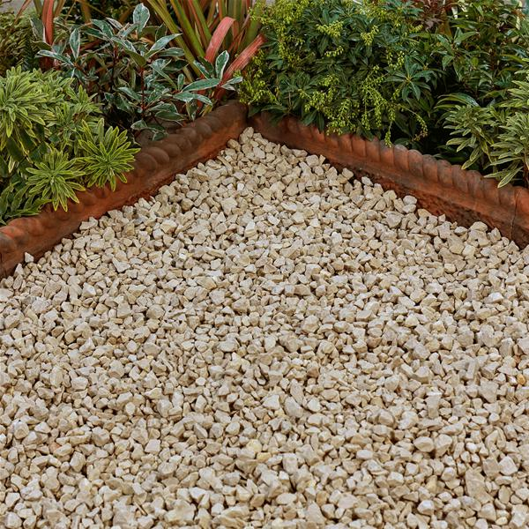
Cotswold Gravel

Pathways & Patios
The general circulation space within the entrance area to be finished in limestone “crazy” paving on sand cement bed with brick on flat edging. Defined pathways to be formed with regular paving slabs as above to 1.1m wide. Remaining “display” areas to be finished with Cotswold gravel chippings as above.

The patio to the proposed outbuilding to be finished with 600mm York Stone paving slabs laid in regular pattern on sand cement bed to existing hardcore sub-base with existing paving taken up.

Steps & Ramp
Steps to the outbuilding to be formed with paving slabs on brick risers.

Access ramp to the outbuilding to be of timber construction with 150mm wide decking boards on treated softwood timber framing with 200 x 50 strings. Balustrading to be formed with 40mm spindles at max. 100mm spacing with 75 x 50 moulded handrail. All timberwork to be stained.

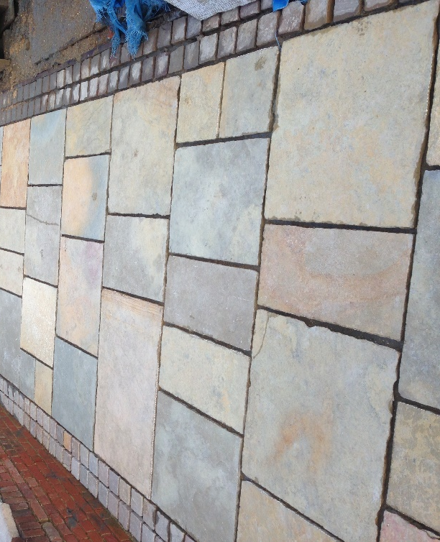
Limestone paving with stone set edgings

Lawn
Where existing outbuildings are to be removed, the whole area is to be cleared of all building rubble and hand dug out to 200mm deep and levelled over in readiness for reinstatement as grassed lawn to match into existing. Grassed areas to be provided with a minimum of 100mm of good quality topsoil, graded and firmed to suitable levels. Turfs to be laid butted together with staggered joints and lightly firmed or rolled after laying.

BOUNDARY TREATMENTS

Existing brick walls to all boundaries to be restored to their original height with repairs and rebuilding works as necessary, all as outlined on drawing 1500/12A & 1600/31 and detailed in the submitted Schedule of Works.

BIN STORE Appendix A

Bin Store
A timber boarded bin store will be provided to the existing bin store area as shown on plan drawing 1600/40. This will be constructed of sawn timber posts with stained timber board infill. The store will be covered with a pitched roof finished with wood shingles. The store will be provided with an outward opening doors fitted with a security lock.

Lighting

900mm high Zone E27 Commercial Bollard LED light fittings (IP65) to be installed in front forecourt and rear garden areas as located on plan. Fittings to be in Anthracite grey, secured to in-situ concrete base and connected to electrical supply. Fittings to be controlled with daylight sensor.

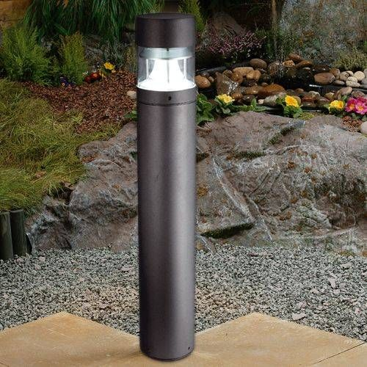
Zone E27 Bollard Light (BL)

Car Charging Points (CP).
1 No electrical car charging point to be provided to the front forecourt area. Unit to be Type DSI-EV 325 from Farnell Electrics or similar and mounted on 100mm sq. timber post as located on plans. Post secured to in-situ concrete bases and painted in anthracite grey. Unit to be wired back to electrical meters to main dwelling house.

Gates & Piers
A new 2.0m high x 4.0 wide electrically operated double gate is to be provided to the main entrance to the property as detailed on drawing 1600/39. The gates are to be fixed to new 2.2m high brick piers as detailed. Piers are to be constructed in Ibstock Hamsey Stock facing bricks in Flemish bond in sand lime mortar to match existing dwelling house. Piers constructed on 700mm sq. in situ concrete pad bases to 900mm deep with 152 x 152 UC 30 central steel column for gate fixing. Gates are to be connected to the existing electrical supply and automatically operated with key pad and remote controls.

MAINTAINANCE

Planting
Upon completion of planting it will be necessary to ensure good watering during any periods of prolonged draught.
Weeds should be removed regularly throughout the growing season (March to October) either manually or by using suitable herbicides.
All flowering shrubs should be cut back and shaped immediately after flowering.
Hedges should be trimmed in April and August, with facing shoots allowing plants to fill out and thicken to a final depth of 0.9m. All hedges to be kept at a height of 1.0m except NH1 & NH2, which should be kept at 1.8m in height.
Any planting that dies during the first 3 years should be replaced.

Lawns
Lawn areas should be mown weekly between mid March and October with occasional trims should unseasonal weather cause growth during the dormant months.

Surfacing
All gravel, slabbed and paved areas to be weeded regularly throughout the growing season (March to October) either manually or by using suitable herbicides.

PROPOSED EXTENSION & OUTBUILDING

Facing brick

The external walls to the proposed extension and the external walls of the proposed outbuilding to dpc level are to be constructed with an Ibstock Hamsey Stock facing brick to match the existing buildings. Brickwork to be laid in a Flemish bond in a 1:4 sand lime mortar mix.

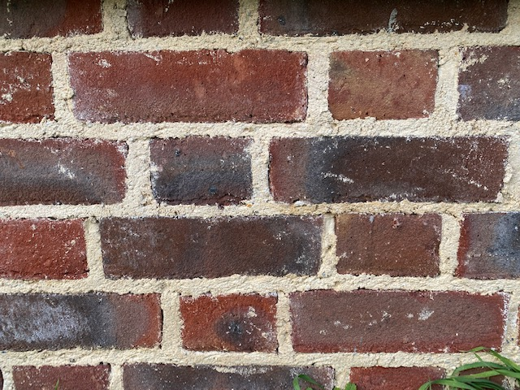
Ibstock Hamsey facing brick to house extension
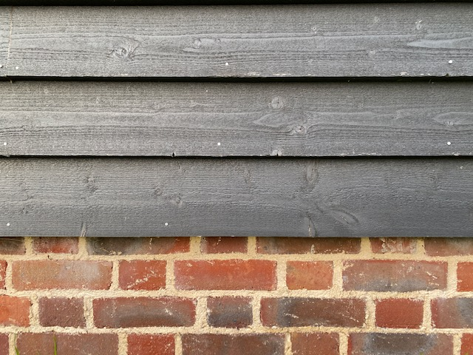
Ibstock Hamsey facing brick and timber cladding to outbuilding

Cladding
The whole of the superstructure of the new outbuilding is to be clad in 175mm Black Barn timber boarding to match the existing outbuilding. Boarding to be fixed horizontally to timber framing with breathable felting behind. Provide 50 x 25 treated timber surrounds to door and window opening with 50mm sq. uprights to external corners.
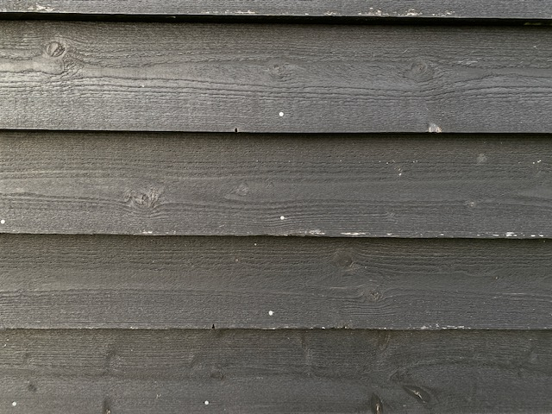

Black Barn timber cladding

Roof Tiles
The pitched roofs to the proposed extension and outbuilding are to covered with a Redland Rosemary Medium Mixed Bridle Clay tile to match existing buildings on site with pointed verges to all barges and a terracotta angular ridge tile. Fascias, soffites and barge boards to be in treated timber and stained Ebony.

Rainwater Goods
Guttering to be 100mm half round with 65mm round downpipes all in cast iron and painted black.

Gates
New entrance gates to access driveway to be in accordance with details as shown on drawing 1600-39A. Gates to be of galvanised steel construction with 40 x 20 solid section steel framing and 12mm square section uprights. Gates supported on hook and eye hinges secured into masonry piers. Feature letters “C” & “G” to be cut out in 50 x 12mm flat steel plate and surface fixed to gate framing. All metalwork to be painted balck.
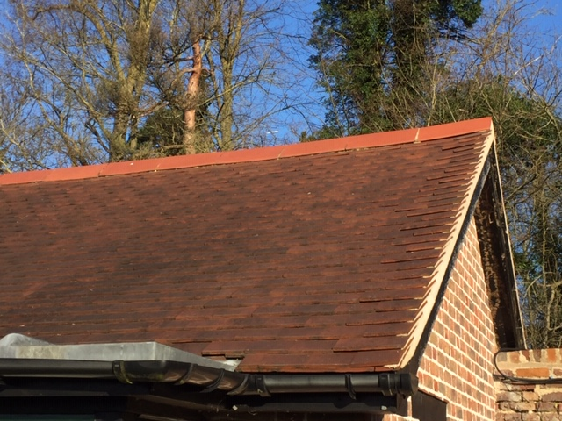

Redland Rosemary roof tiles with terracotta ridge.

Windows & Glazed Doors

The existing casement window frame to the Music Room building is to be taken out and refitted in the proposed extension as shown on plans.

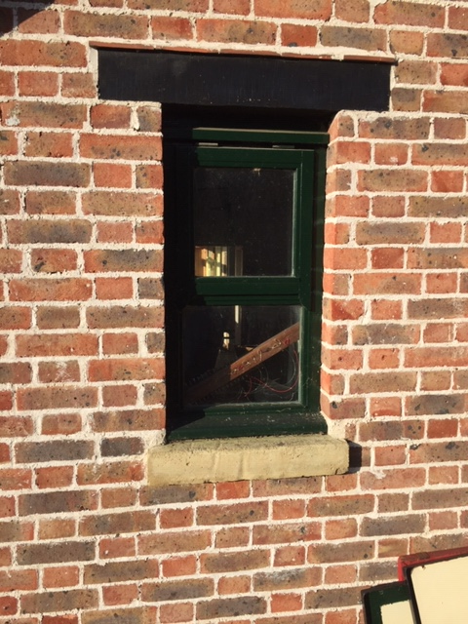
Existing window to Music room to be refitted to extension

The casement windows and glazed doors to the proposed outbuilding will be in hardwood to details provided. Frames will be made with flush fitting casements and fitted with 24mm sealed double glazing with black seals and beaded in. All frames to be stained in green to match existing buildings.

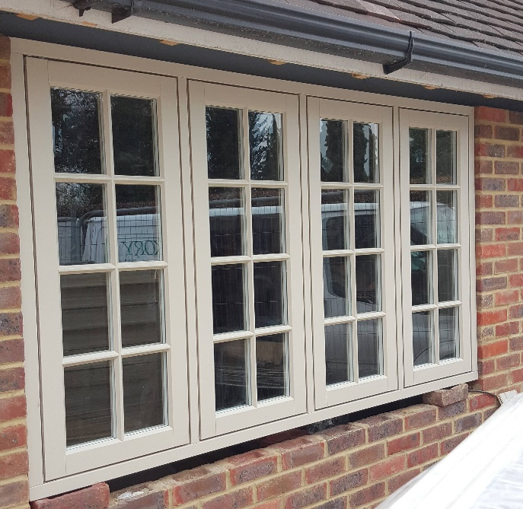

Stained hardwood window frames.

GARDEN WALLS
All repairs and rebuilding to existing garden walls to be completed using reclaimed bricks form existing structures taken down and new Tudor bricks to match. Bricks to be laid in English Garden bond to match existing in a 4;1 sand lime mortar mix with brushed pointing. Provide a 230mm Brick on edge coping to match existing.
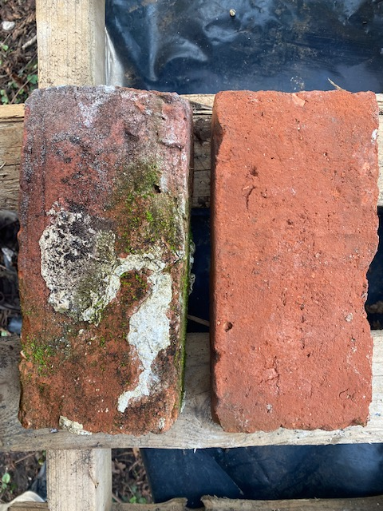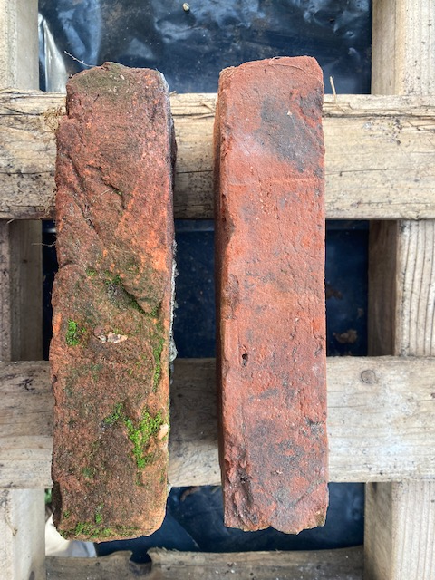
Existing and new reclaimed Facing bricks.
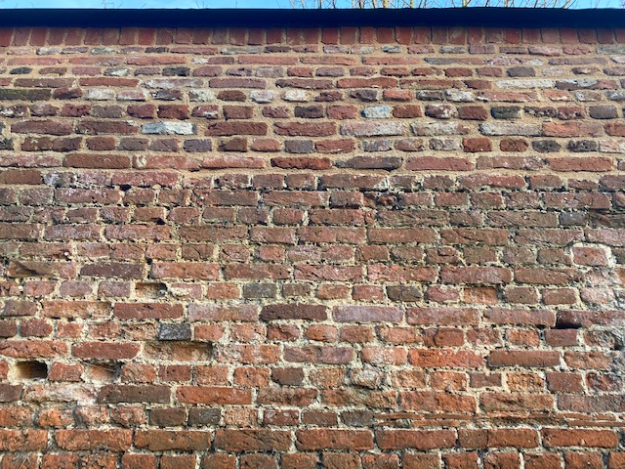
Sample of repairs to existing Southern Wall
