Date: 24/10/24
Client: Julia Hartley
Site: 20A Frithwood Avenue, Northwood, HA6 3LX
Description of Works: Maintenance

Items / Description / Phase | Value £
Method
It is mandatory for Health and Safety of the proposed site, to create a site safe enclosed working environment. This being around the whole perimeter of the demolishing and rebuilding processes. To do this, we will require an agreement and the access to the neighbouring property on one side only. This is to create a safe buffer zone and enable us to demolish & rebuild the dwelling safely.

Please use these notes in conjunction with the 1/100 scale drawing of our site set up proposals.

- Break back the current wall from the house to 1500 mm.
This later, will enable personal to walk around the build and potentially underneath the scaffolding for cleaning & maintenance.
The brick work will be toothed out to enable us to stitch back the brick wall as soon as reasonably practical.
- We have opted to use Heras fencing.
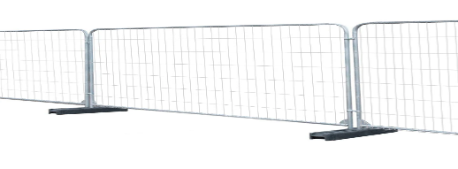
Our first consideration of purpose-built timber ply & posts dug into the ground and then concreted. Might impact the property too much and felt all the established trees and the ground I would imagine being quite difficult to dig by hand.
The Newly purchased heras fencing (Clean of any sharp protrusions& rust) the sections measuring 3.5 X 2 meters each. The required amount numbers four. The panels will all have weighted feet. But to further ensure that the fence will not topple over. The use of ground spikes is to be implemented.
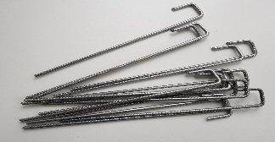
Together with the fencing braces and joiners to maximise the effectiveness and the security of the intended fence. All to be secured internally.
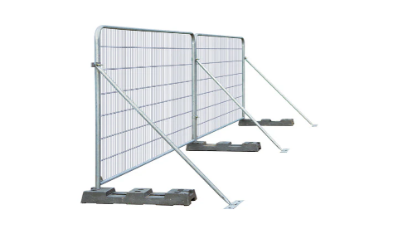
The Heras fencing will off course receive a privacy screen to complete.
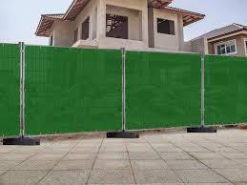
Access to the side of the property will have locking gates to enter. Which will be always secured outside of usual working hours of the week.
The required side access width would be a proposed 1500mm on to the property. This will accommodate the scaffolding to be erected when brickwork commences.
The scaffolding will have Monoflex & edge protection to the side of the scaffolding.
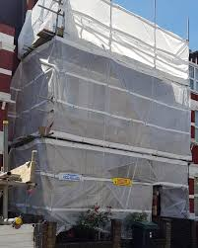

Any discarded foliage currently on the neighbouring property will be cleared.
Any fences or boundary walls deliberately damage or otherwise at fault to DRC will be repaired at our cost.
Grounds to the rear garden to left clear, clean from builder’s waste. Made good to side elevation wall of the project

- The pedestrian access via the Frithwood Avenue side is to receive a pair of locking gates. Made from ply & timber onsite.
It is not our intention to receive heavy goods deliveries from this side.
- Current Gas meter is sited here. The terminated gas pipe running along the wall currently is to be cut back to the meter box. This is to have a timber box built around, to protect it.
- Subject to the survey from UKPN. They will require a purpose-built Kiosk for the temporary supply. This is currently proposed here on the plan.
- The front area behind the entrance gates will serve as a small storage area.
Brickwork to the ground floor side extension is to receive ply protection to prevent soiling or corner damage if the circumstance threatens.
- Windows overlooking at ground level could receive some type of self-adhesive film obscuring to the windows.
(TBC with homeowners and completed if requested & happy to assist)
- The use of further Heras fencing to run against the properties current wooden fencing boundary. (To remain intact currently.) Complete with privacy screen as before.
- Proposed rear access gates for all deliveries and waste removals made from ply & construction timber. Posts concreted into the ground. Hinged and locked from the inside.
Appropriate signage is completed to both entrances
- All the site is to be graded down 100mm, and scalping’s spread and compacted to reduce mud transferring
- Water stop cock still to be confirmed. (After ground clearance and/or survey
- Welfare unit & Flushing toilet location
- Materials storage
- Proposed store area on grass verge
- Application for a hoarding license for the use of the grass verge

