London Borough of Hillingdon

Home Farm House
High Road
Ickenham

Design and Access Statement

1. Features on the existing site

Home Farm House is a Grade II listed building in the conservation area in the heart of Ickenham. The house is situated off High Road behind the pond and pump.

Home Farm House is a small late mediaeval house of high quality with jettied gabled end to road side. East extension of 1705, 2 storeys 1 window. High pitched tiled roofs with old chimneys. The original part is tile hung above with Victorian fishscale tiles. Stout square framing with brick filling visible below. Early C18 part of light red brick, with 1st floor band. C19 casement windows. Much exposed timber work inside. Side purlin roof with stout wind braces. Flat joists and hollow-chamfered beams, the chamfer continuing through braces to posts.
Modern north-east small extension.

Home Farm House is the original farm house of the Saich family farm which was sold in the late ‘90’s. The farmland was developed in to what is today a community of retirement apartments called Church Place.

Neighbouring properties include Home Bar & Kitchen at 16 High Road and no 12 High Road to the south west.

The property and gardens are surrounded by fencing and hedging.
Home Farm House today
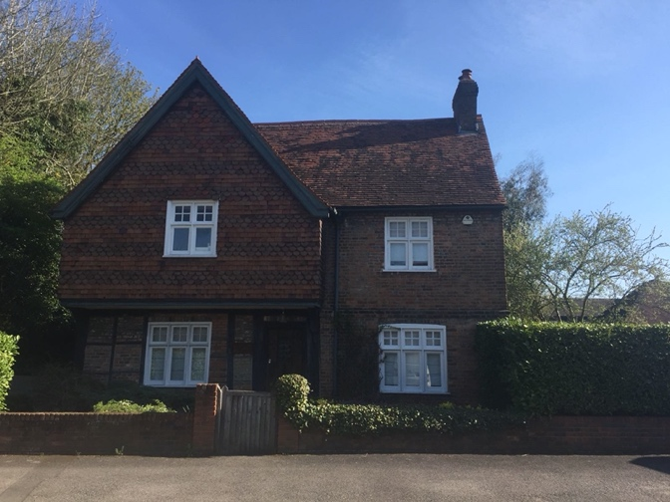

2. Design

The existing tiled roof comprises a mix of reclaimed handmade clay tiles, many of which are reaching the end of their useable life, and machine-made tiles which are inappropriate for this age of property. The work proposed is to retile the roof with handmade clay tiles.

3. Access

Ickenham is well served by both Underground and bus services.

The entrance to the property From High Road is through two carriage gates into a courtyard where there is plenty of off-street parking.

There will be two off-street car parking spaces made available for the contractors so there will be no impact on the spaces available for neighbours in the service road.

Residents at Church Place have pedestrian access rights through the driveway which will be maintained. Warning signs will be erected at both the High Road and Church Place entrances to Home Farm to alert pedestrians of the ongoing works.

There will be a requirement for a skip at certain stages of the works to take away the old tiles and timber battens. The skip will be sited in the driveway and properly fenced off. Pedestrian access will not be impeded and there will be space for mobility scooters or Zimmer frames.

If necessary, on occasion, the Church Place residents may be asked to use their entrance in Austin’s Lane rather than through Home Farm.

Scaffolding will be erected to the height of the eves to allow safe access to the roof.

WC facilities will be available on site for the contractors.

Home Farm Entrance from Service Road

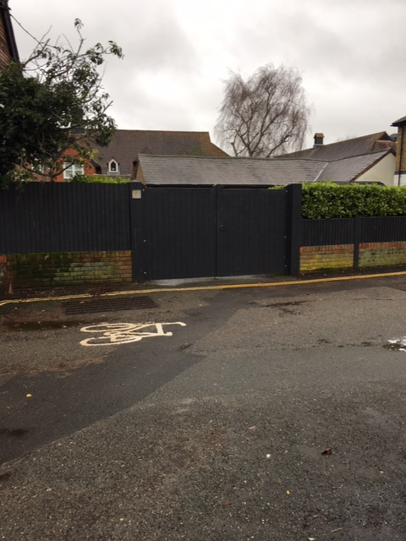

Home Farm Entrance – Gates Open
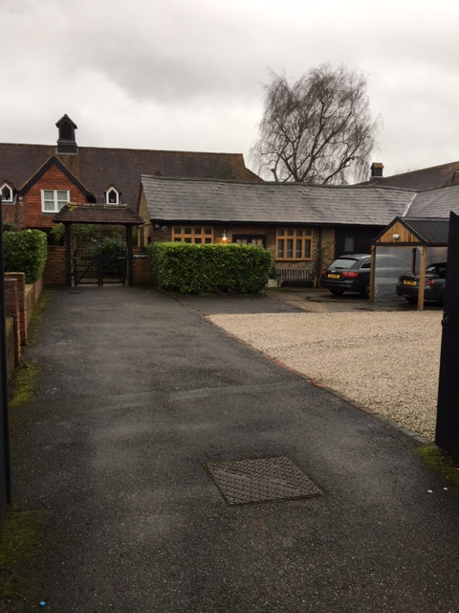

Home Farm Parking
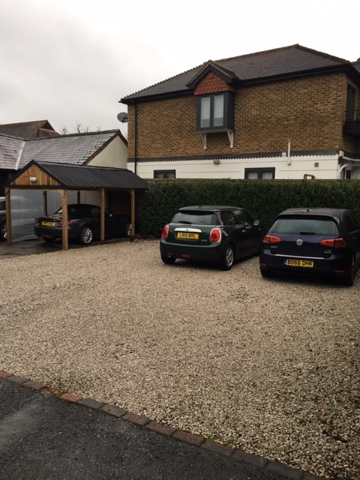

Home Farm Entrance from Church Place

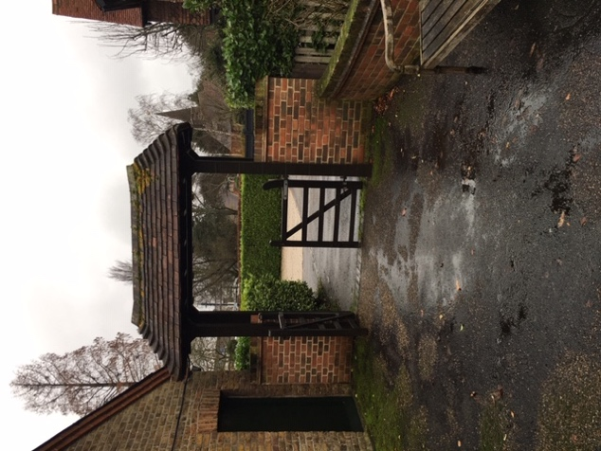

4. Heritage Considerations

Home Farm House is a grade II listed building in the conservation area in the centre of Ickenham Village.

The house is one of a few archeologically important buildings in the village including St Giles Church, Ickenham Manor and Swakeleys House.

The proposed works will include correct materials and techniques and will improve the appearance and function of the roof and be in keeping with the age of the building.

