Design and Access Statement

For

Double story rear and side extension

At
2 Vyners Way
Ickenham
Middlesex, UB10 8QQ

April 2021

Contents

1.0 Introduction
1.1 The Statement
1.2 Drawings List

2.0 Physical Assessment
2.1 Site Location
2.2 Surrounding Land Uses
2.3 Movement (Transport and access)

3.0 Design
3.1 History
3.2 Environmental
3.3 Use
3.4 Amount
3.5 Layout
3.6 Scale
3.7 Appearance

4.0 Conclusion

5.0 Appendix
5.1 Photos of existing site

- Introduction

1.1 The Statement

This Design and Access Statement has been prepared in support of a full Planning Application for the extension of a semi-detached house at no 2 Vyners Way including the demolition of the existing garage.

1.2 Drawings List

This Design and Access Statement should be read in conjunction with the following drawings.
- Site Location
- Block Plan
- Existing and Proposed Site Plan
- Exiting and Proposed Elevations
- Exiting and proposed Floor Plans

2.0 Physical Assessment

2.1 Site Location

The site is located at 2 Vyners Way, Ickenham. 2 Vyners Way was built in the 1930’s

2.2 Surrounding Land Uses

The surrounding properties in Vyners Way are all of varying styles, each house is different and most have been extended over the years.

2.3 Movement (Transport and access)

The driveway of 2 Vyners Way currently allows for parking for between 2 and 3 cars and this provision will be kept.

3.0 Design

3.1 History

The property has been through a number of refused planning applications most recently with an application in 2017 (48790/APP/2017/3645) and another in 2018 (73448/APP/2018/77). Both applications went to appeals and the decisions were upheld.

This application most closely relates to the application in 2017 where the reason for refusal was given due to the inclusion in the application of an unsightly porch that would have taken away from the properties unique features.

This application has removed the porch allowing for the property to keep all existing features and not be detrimental to the street scene.

3.2 Environmental

The property was built in the 1930’s and a lot of the building has not been changed in this time. The property consists of single brick walls with no cavity and therefor no insulation. The proposed building would allow for the majority of the properties walls to have cavities and be insulated.

3.3 Use

Existing
The existing building currently has the following accommodation:
Ground floor: Lounge, Kitchen/Dining and Garage with utility area
First Floor: 3 Bedrooms and 1 Bathroom

New
The new building would consist of the following accommodation:
Ground floor: Lounge, Kitchen/Dining, Utility Room and WC
First floor: 4 Bedrooms and 1 Bathroom

3.4 Amount

Existing
The existing house has a gross internal area of approximately 96 meters squared

New
The new gross internal area for the proposed extension will be approximately 40 meters squared for the ground floor and approximately 32 meters squared for the first floor.

3.5 Layout

The proposed floor layouts are shown on drawing Existing and Proposed floor Plans. The side and rear extensions are double story except the area directly adjoining No 4 Vyners Way where the extension will be single story to allow for 45 degree angle from the nearest window.

3.6 Scale

The existing roof and height of the ridge will be retained and the new roof for the double story rear and side extension will be subordinate to the existing roof. The single story roof at the rear of the property will be a flat roof.

The garage to the side of the property will be demolished and the new side extension will extend 2.5 from the sidewall of the house and will be set in 1 meter from the boundary of the property. This will result in the existing wall of the garage that is to be demolished no longer being used as the boundary between the two properties.

The rear extension will extend 4 meters from the back of the houses rear wall.

3.7 Appearance

The new extensions walls will be rendered from 0.5 meters above the ground to match the existing property. The roof will be tiled to match the existing roof tiles.

4.0 Conclusion

Every effort has been made during the design process to ensure the new building will be subordinate to the original. As well as ensuring that the desirable appearance features that the property has are not affected and where possible are enhanced.

5.0 Appendix

5.1 Photos of existing site

Front of property
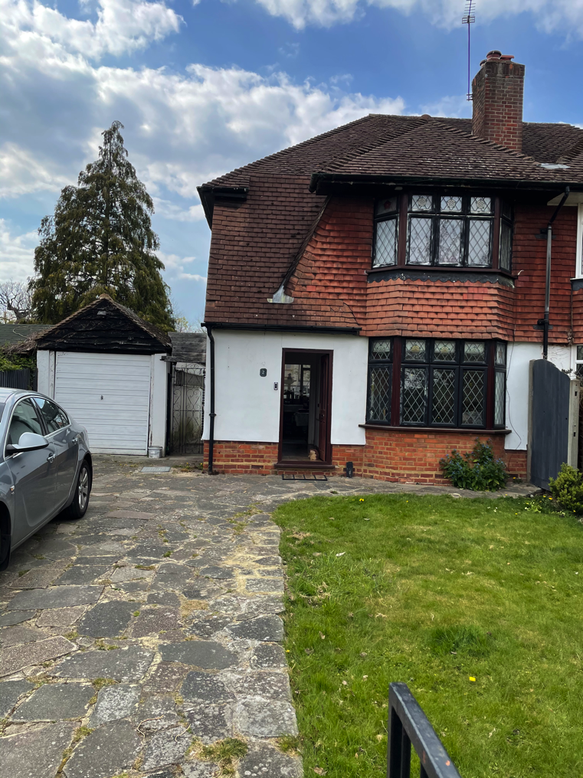
Rear of property

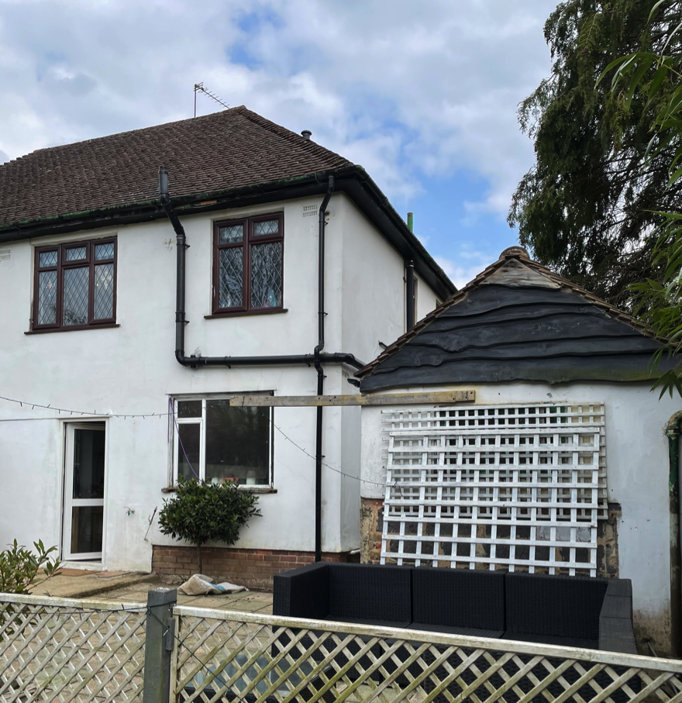

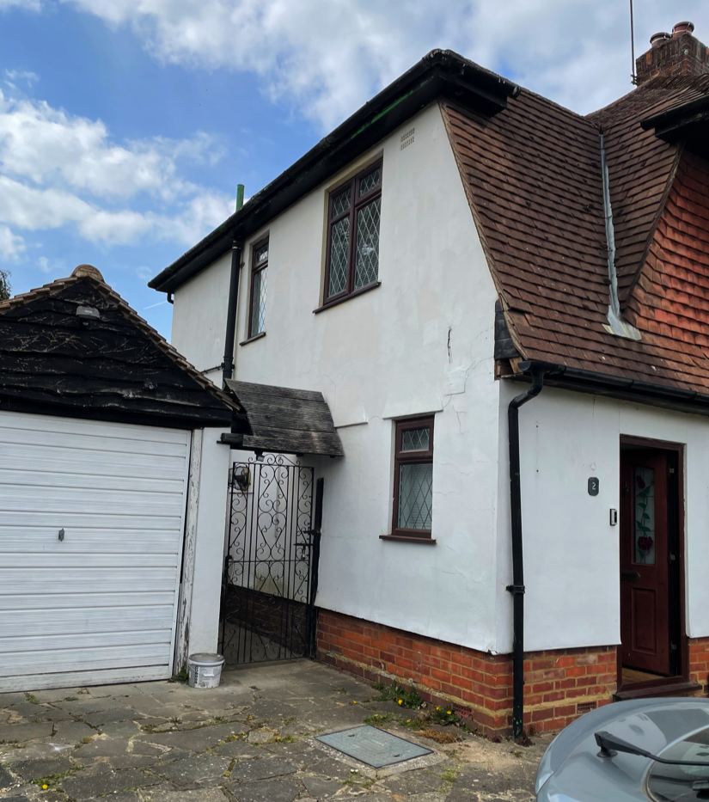
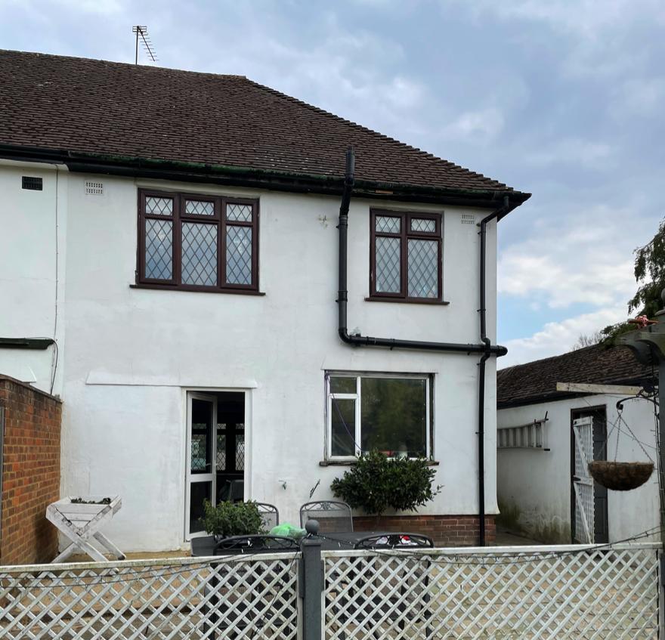
Side of property

