Front Door; Main roof; Bricks on front elevation; Fascia Boards and Soffits; Rainwater Pipes and Gutters; and Driveway
As existing.

Bricks for Extension
Red brick (per approved plans)

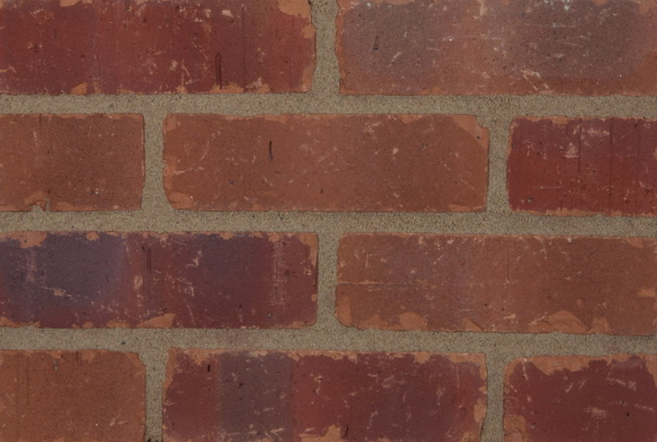

Dormer Cheeks/Roof/Capping Details

Brown Zinc (per approved plans)

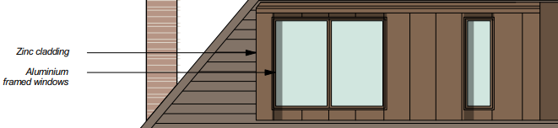

Windows to front and side elevation
White Sash Windows (per approved plans)

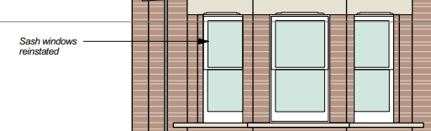

Windows and doors to rear elevation
Aluminum to match zinc cladding per approved plans
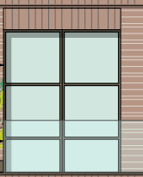

Balustrade to balcony on front elevation
Black to match neighboring houses

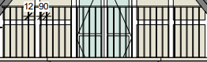

Balustrade to balcony on rear elevation
Clear Glass (per approved plans)

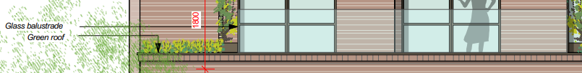

First Floor Roof
Wildflower Green Roof (per approved plans)

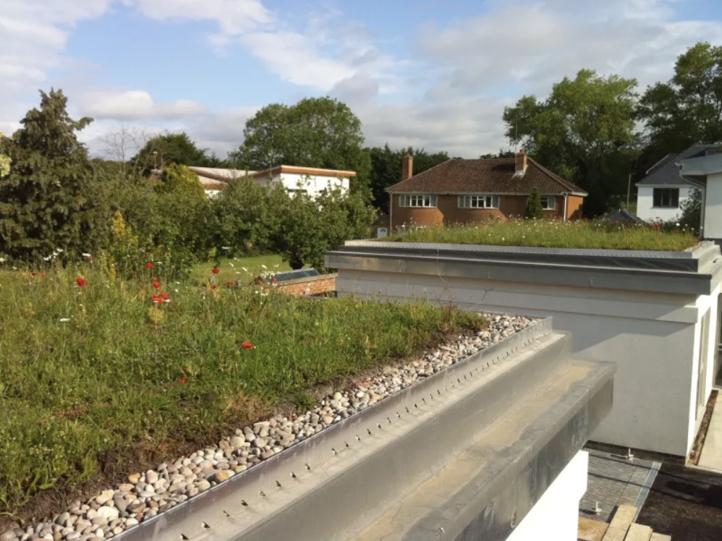
Second Floor Roof
Single ply membrane (per approved plans)

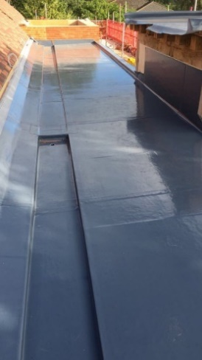

Rooflights
Conversation type set flush along the roof line (per approved plans and officers’ report)

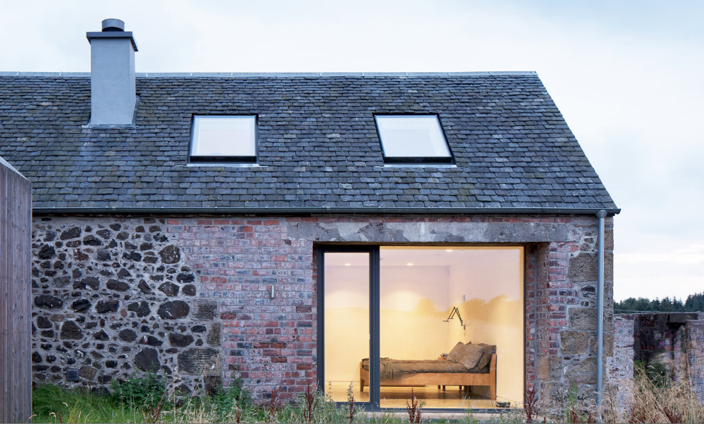

Balcony
Brown/Grey Decking (per approved plans)

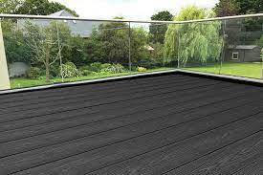

Privacy Screen/Planting
Brown timber privacy screen with green laurel planting – Minimum height of 1.8m from the finished floor level (per approved plans)

