Hi Chris,

Further to our emails below, please see the mortar spec information I have received from CPMG/B&K below which we believe is the best match to the mortar colour shown in the images on the submitted documents:

Manufacturer: Cemex
Product: Coloured mortar
Type: Yellow Medium
Website: https://www.cemex.co.uk/coloured-mortar

Please find below an image comparing the 2 bricks utilised within submission documents with the above mortar. We trust this is a good match and hope that this now provides sufficient information to discharge condition 7 accordingly.

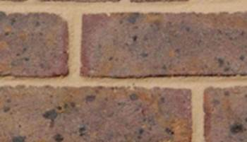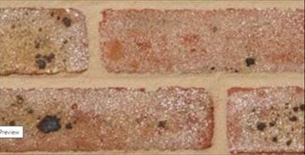

B&K’s programme requires above-ground works to begin from 1st March, so it is really important for us to get this condition discharged (as well as conditions 4/10 and 8/13) asap and preferably over the course of the next week.

