48 Warren Road, Ickenham, UB10 8AD
PROPOSED RESIDENTIAL DEVELOPMENT
MATERIAL SCHEDULE
Planning Reference 4185/APP/2022/429
Condition 3

The materials proposed are Wienerberger Mulberry Red Wirecut facing brick with a slate effect tiled roof (Mini Stonewold by Redland). There will be reconstituted Portland stone lintels to the windows and doors, as well as feature stone string courses and cappings. The windows will be dark grey powder coated aluminium.

EXTERNAL MATERIALS:

Parking Areas – Formpave Aquaflow Permeable Block. Colour - Red Brindle
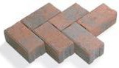

Patio & Paths – Formpave Aqua Slab Permeable Block Colour - Natural
Border Brick Edging Colour - Staffordshire Blue

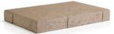
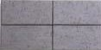
BUILDING MATERIALS:
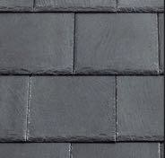
Slate Effect Roof Tiles
Mini Stonewold Tiles by Redland

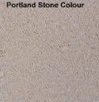

Reconstituted Portland Stone

Windows & Doors – Dark Grey Powder Coated Aluminium
RAL colour – 7021.

Hoppers / RWP – Dark Grey uPVC
RAL colour – 7021

Fascia board and soffit to be white uPVC.

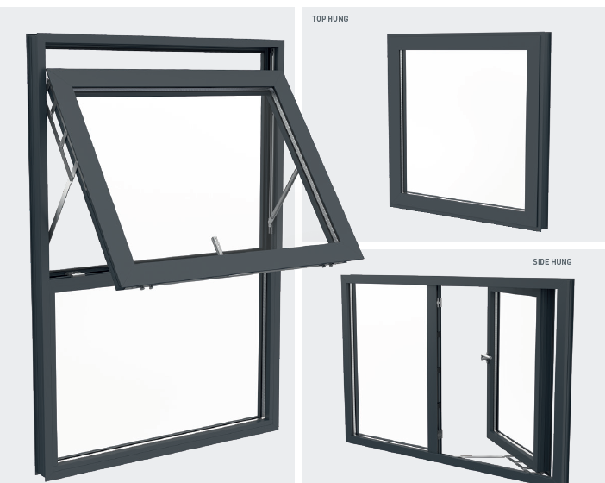 Alitherm 400 Window Type. RAL Colour – 7021.

Brick
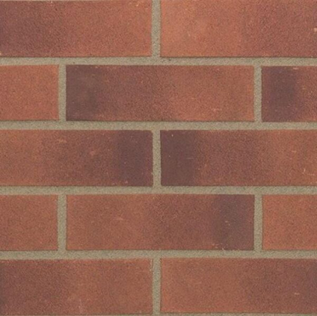
Wienerberger Mulberry Red Wirecut facing brick

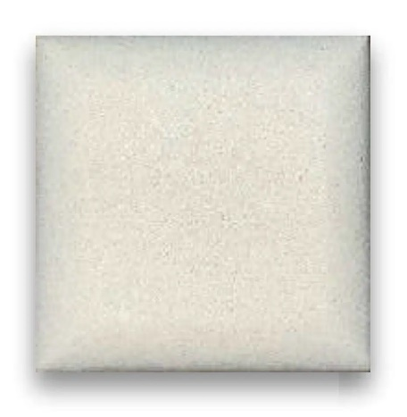
Procter Cast stone, colour – bathstone II, semi dry cast stone

GRP Flat roof – Grey colour

