- June 2022

PLANNING, DESIGN and ACCESS STATEMENT
- Land at rear of 20 Dorset Avenue UB4 8NS

Full planning permission for the erection of detached two-storey dwelling house on the land at rear of 20 Dorset Close with associated bins and cycle bay.

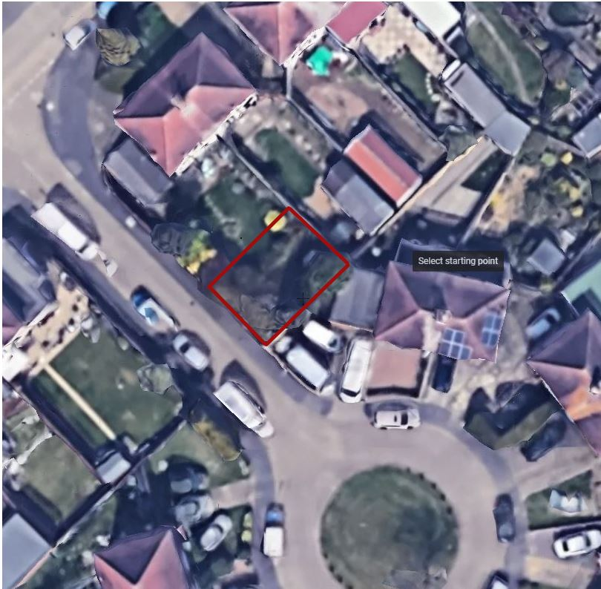

Introduction  Site and Surroundings | This application is to change a derelict piece of land into an integrated one bedroom dwelling with the private garden, with corresponding increase of visual and recreational amenity.  The Site is adjacent to 16 Dorset Close, and at rear of 20 Dorset Avenue in Hayes. The area is occupied by semi-detached and terraced houses, some with extension and loft conversion. The houses are constructed with brick and partially rendered with pebbledash. Garden timber fences and brick boundary walls are main separating features. Houses have pitched, tiled roofs.  Below are examples of dwellings in the neighbourhood.  The site is not located within conservation area. It is accessible from Dorset Close via timber gate. The site is not being used for any practical purpose at the moment.  The plot is no longer within curtilage of 20 Dorset Road, it is a separate freehold in different ownership and it is not possible for the two sites to be re-united. The site no longer functions as a garden and because no one can live there to look after it. The site started to attract fly-tipping and accumulating rubbish; although the gates are kept locked, the padlock is regularly broken off.  Integrating a dwelling into the site would allow it to be cultivated; creating an attractive place that would enhance the local area.  The applicant believes that preserving the site in its current state does not enhance the character of the local area.
  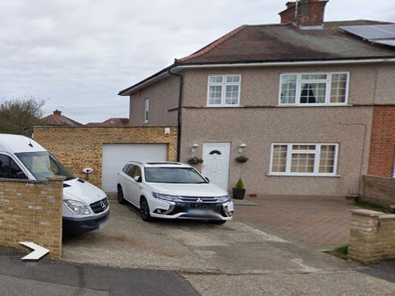  Figure 1 House next door | 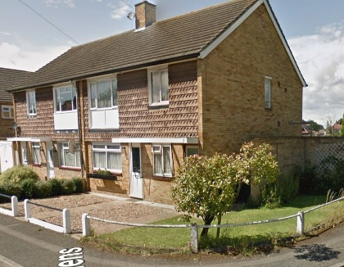  Figure 2 Houses on Percy Close
  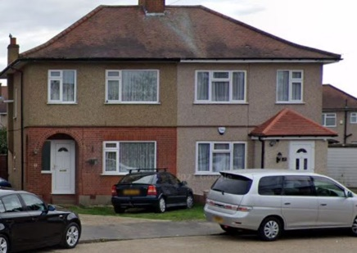  Figure 3 Other sample houses | 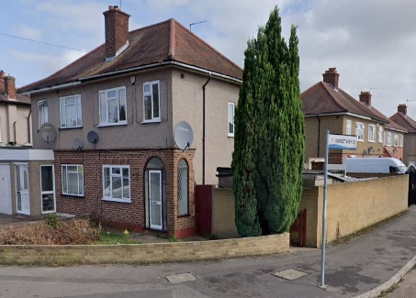  Figure 4 Sample House

Proposal  Scale  Character & Design  Inclusive Access  Policies  Proposed Materials  Parking  Cycle parking space  The impact of the proposal on neighboring properties  External Amenity Space  Residential Amenity  Waste and recycling  Sustainable Energy  Flood Risk  Conclusion | The applicant proposes to build a discrete, one bedroom house with private garden. The proposed house was designed to give generous accommodation.  The scheme is intended to improve the character of the area. It will be of appropriate size to the site, harmonising with its setting and will use the land efficiently.  Materials have been proposed whose appearance would preserve desirable aspects of the existing site, while replacing undesirable aspects with materials that would enhance it, both when new and as they age. To ensure that the building does not undermine local character, materials have been chosen which would blend into their surroundings.  The site is a separate freehold to 20 Dorset Avenue and cannot be re-united with it. Its current use as rubbish dumping space detracts from the character of the area. The proposed use would allow the site to be properly looked after and contribute positively to the local area and community.  The proposed dwelling is integrated into the new landscaping of the site. The low height, brick fence with planting behind would provide more attractive outlook for neighbouring properties than the current high timber fence with broken parts. The scheme provides good private garden space for the dwelling while increasing the visual and recreational amenity of the site.  There is a direct access to the site from Dorset Close. It is within easy walking distance of local bus routes and shops.  The site is also within walking distance to the local parks and playing fields.  The one bedroom house would be built over ground and first floor.  According to the DMH6 Local Policy it is more intimate in scale and lower than the main properties and the character articulated by the pitched roof , brick walls, orientation, set back from the street, setting – the building is set back from the site boundaries by 1m; is in line with the surrounding outbuildings.  The existing plot is enclosed from all sides by a 1.7m high fencing and as such the land does not contribute to the general openness as an open verge may.  Long views across the site are additionally blocked by the garages located directly behind the land.  The proposed building will be set back from the pavement and in line with the current buildings line to avoid overbearing effect.  The development is proposed to be 2 storeys and the top storey will be partially within the roof space to make the building subordinate to the neighbour’s houses, therefore it is not considered to be visually obtrusive.  The access to the site is on the ground floor and the door threshold will be flashed with the access pavement. There is a good access to the bedroom including bathroom on the ground floor. The corridor width and bathroom size are wheelchair user friendly.  National Planning Policy Framework 2021confirms small sized sites can make an important contribution to meeting the housing requirement of an area. It is considered that the proposal for one bedroom dwelling set back from the main road and with front landscaped gardens will make a positive contribution to the character of the area and is in accordance with the NPPF as it would help boost the supply of family housing in this sustainable residential area.  London Plan 2021 Policy H2 Small sites confirms that boroughs should pro-actively support well-designed new homes on small sites.  The external walls and the front boundary wall are to be built from bricks, so that the development relates to the neighbours buildings and their front boundary walls. Slate roof will be of similar colour to the other surrounding roofs. Side walls will be made of bricks to provide good acoustic separation between existing and proposed houses.  The site is located in PTAL 1b zone. No on-site parking is proposed.  Paving over a front garden to create a car parking space could harm the character of the street, reduce biodiversity and increase surface water run-off. Additionally, car access to the new space would remove one street parking for others.The applicant will provide parking survey as an evidence that on-street parking spaces within 200 m of the site are sufficient.  Cycle covered parking space for 2 bicycles is provided on site.  The layout of the proposed design provides a bedroom and bathroom on a ground floor, with kitchen/living on the first floor. All habitable rooms’ windows face away from the neighbours to ensure there is no overlooking. The rear window on the first floor is fixed and located 1.8m above the floor level.  Additionally, the pergola will provide the necessary privacy for the existing and proposed dwellings and prevent overshadowing at the same time.  The rear and right side elevations have no habitable room’s windows and the height of the proposed house is lower than the height of existing outbuildings to avoid any impact on the neighbours. The enclose daylight and overshadowing assessment report provides evidence that neighbours will not be affected by the proposed dwelling.  There will be no parking space provided on site and there will be no disturbance to the neighbours by cars entering the site.  Additionally, the side garden walls will be made of bricks to provide good acoustic separation between the properties.  Policy DMHB 18: Private Outdoor Amenity Space requires that a one bedroom dwelling has a minimum of 40 square meters. The proposed garden measures 42.5 m2 and as such would be of a sufficient size to serve for this one bedroom house. The amenity is appropriately screened from the neighbours and the street to provide privacy, south facing to maximize the light and acoustically separated to avoid impact on the neighbours.  Policy DMHB17: Minimum required gross internal area for a one bedroom house is 50 m2. The proposed house has an area of 63m2 and provides generous accommodation.  Appropriate waste and recycling facilities have been proposed on the plans suitable for the dwelling at the front of the site.  The proposed development embraces principles of sustainable design and construction.  High levels of insulation, along with air source heat pump, and Heat Recovery System will heavily reduce the building’s carbon footprint. The building will meet all requirements of the new Part L of the Building Regulations that already apply to all new developments from June 2022.  The site is located in ub4 8nt postcode which is classified a flood zone 1.  Land and property in flood zone 1 have a low probability of flooding, flood risk assessments on sites less than 1ha are not required.  https://flood-map-for-planning.service.gov.uk/confirm-location?easting=509510&northing=182755&placeOrPostcode=UB48NT  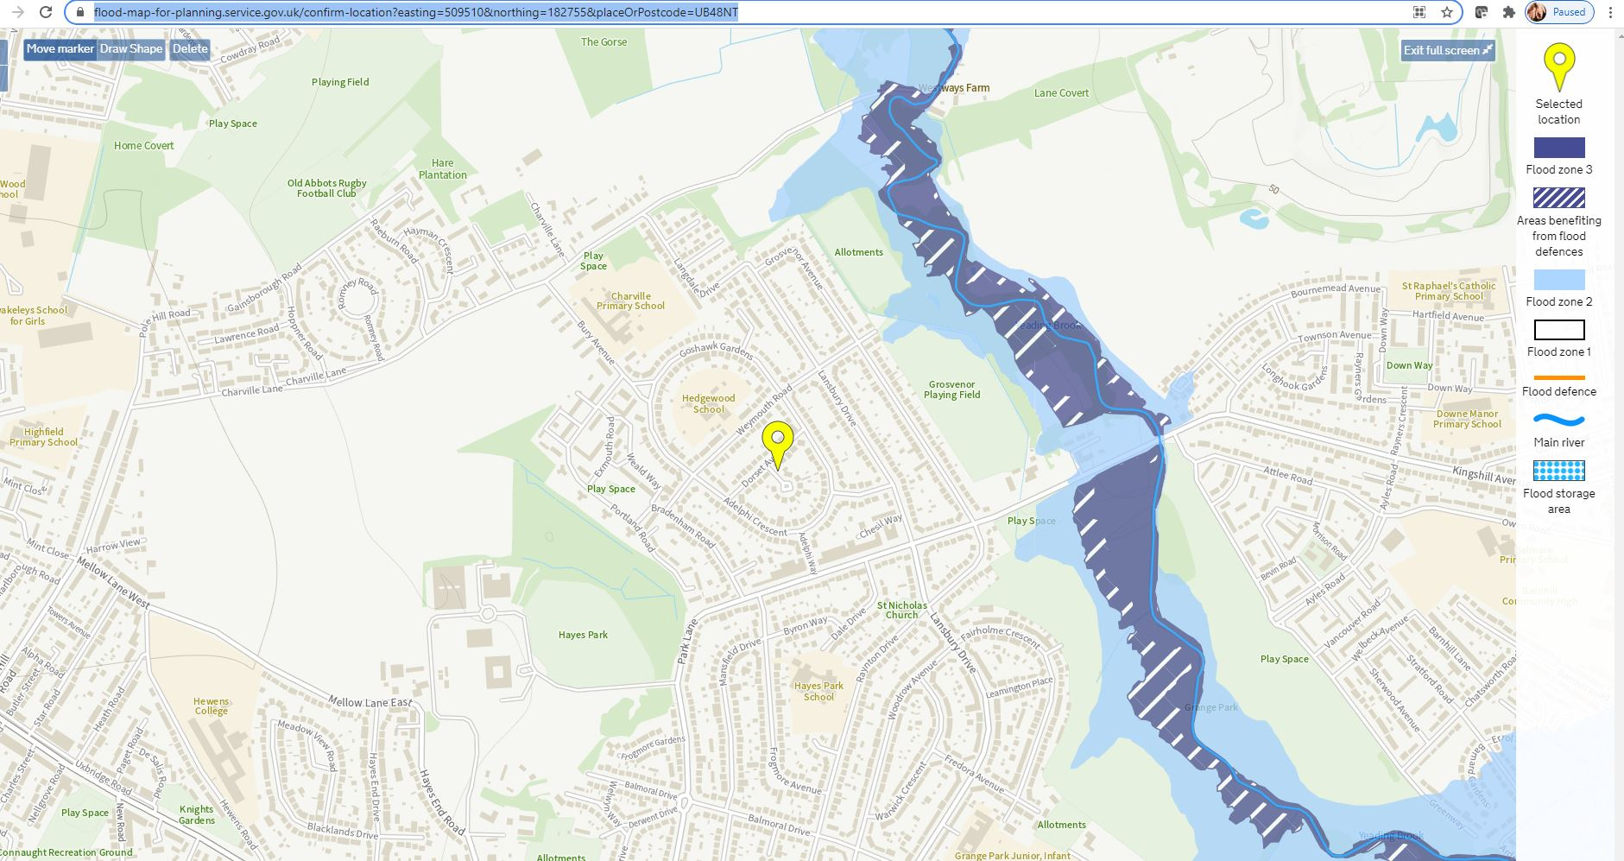  Figure 5 Site location in Flood Zone 1  The proposed design, scale and layout of the scheme are considered to be sympathetic to the aesthetic amenities of the surrounding area and neighbouring residents.  The proposal seeks to respect the local area through its position, pattern, scale, mass and bulk. As well as through appropriate detailing in the local area. The site is in a sustainable location and is in easy walking distance of amenities and outdoor spaces.  The proposed development will provide a clear beneficial connection of an entry-level young family or family downgrading to a smaller house after their grown up kids moved out.  The site is close to local services, shops, parks, public transport, medical services and other amenities. It is within sustainable location and its development for a family friendly new dwelling will be in accordance with National Planning Policy Framework.  Additionally, the development should be seen in the context of delivering new housing provision on a windfall site, contributing to new housing not previously identified in the allocated housing delivery plan.

