Proposed trellis (0.6m)
)_)
2.9
2.9
Proposed 0.6m trellis above existing fence
Existing close boarded timber fence
NW (rear) elevation
SE (front) elevation
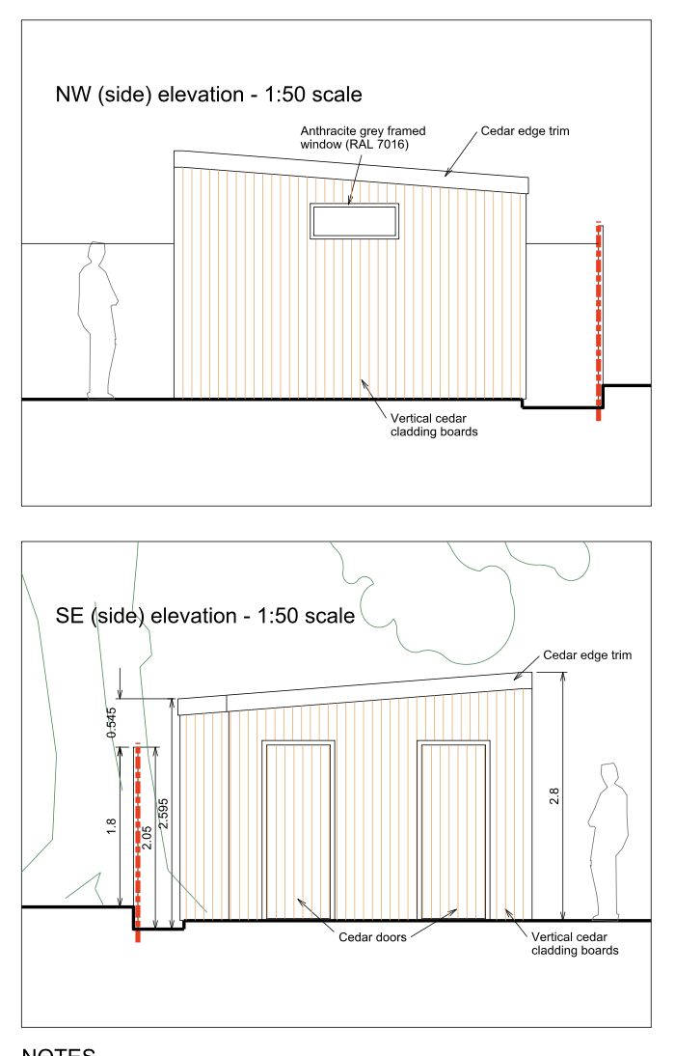
2.9
Matt black powder coated 4 x bi-fold doors (3.2)
0.5
Opening rooflights (1.2 x 1.2)
3.4
1.2
5.0
10.7

