Planning Statement
Site Address: 23 Kewferry Road, Northwood, Middlesex HA6 2NS
A: Description of proposal
- This document supports the Planning Application (ref. PP-14967386) submitted for the erection of a timber-framed garden room to the rear of the back garden of 23 Kewferry Road, Northwood, Middlesex HA6 2NS.
B: Description of site
- The application site comprises a large detached property with a sizeable rear garden and parking, landscaping and hardstanding to the front. The property dates from the late 1920s and was extended and refurbished during 2017 under Planning Application 40215/APP/2016/3090.

- Neighbouring properties numbers 25 and 19 Kewferry Road (note that there is no 21 Kewferry Road) are detached dwelling houses to, respectively, the north east and south west of the application site. The application site is not designated within a Conservation Area, nor an Area of Special Local Character.

- The site does not contain any Listed Buildings. The property is located on a street where all the properties have an array of characteristics. The variation in appearance, scale and materials on the front elevations in the neighbouring area also creates a mixed character. The site along with others along this road is subject to TPOs.

Figure 1 – Location Plan
C: Policy considerations
- National Planning Policy Framework (December 2024)
- Local Plan Designation
- London Plan 2021

Key Policies include:
- Local Plan
  - Part 1 Policies:
- PT1.BE1 (2012) Built Environment
  - Part 2 Polices:
- DMHB 11 Design of New Development
- DMHB 12 Streets and Public Realm
- DMHB 18 Private Outdoor Amenity Space
- DMHD 1 Alterations and Extensions to Residential Dwellings
- DMT 6 Vehicle Parking
- LPP D6 (2021) Housing Quality and Standards
- NPPF – 24 NPPF 2024 – Decision making
- London Plan 2021
- D12 Fire Safety
- D4 Delivering good design
- G7 Trees and woodlands

- The following are also relevant material considerations:
- National Planning Policy Framework (December 2024)
- National Planning Practice Guidance

D. Issues arising

  - Design
Policy BE1 of the Hillingdon Local Plan: Part One Strategic Policies (2012) seeks a quality of design in all new development that:
- enhances and contributes to the area in terms of form, scale and materials,
- is appropriate to the identity and context of the townscape, and
- would improve the quality of the public realm and respect local character.

Policy DMHB 11 of the Hillingdon Local Plan: Part Two - Development Management Policies (2020) states that new development will be required to be designed to the highest standards and incorporate principles of good design.

Policy DMHB 12 of the Hillingdon Local Plan: Part Two - Development Management Policies (2020) states that development should be well integrated with the surrounding area.

Policy DMHD 2 of the Hillingdon Local Plan: Part Two - Development Management Policies (2020) states that the Council will require residential outbuildings to meet the following criteria:
- the building must be constructed to a high standard of design without compromising the amenity of neighbouring occupiers;
- the developed footprint of the proposed building must be proportionate to the footprint of the dwelling house and to the residential curtilage in which it stands and have regard to existing trees;
- the use shall be for a purpose incidental to the enjoyment of the dwelling house and not capable for use as independent residential accommodation; and
- primary living accommodation such as a bedroom, bathroom, or kitchen will not be permitted;
- Paragraph A1.34 of the Hillingdon Local Plan: Part Two - Development Management Policies (2020) states that as a general guide, an outbuilding should be no greater than 30 square metres and should not significantly reduce private amenity space or the landscape and ecological value of the garden.

- Proposed height and proximity to the boundary
The overall footprint of the proposed building is 10.7 m by 5 m (totalling 51.58 m, given that the width of the building is reduced on one side).
It is proposed to be located 0.5 m from the rear boundary at its nearest point to the rear fence, a minimum of 1.1 m to the side boundary to the south west (shared with 19 Kewferry Road), and 5.1 m from the side boundary to the north east (shared with 25 Kewferry Road).
The proposed use of the outbuilding is as a gym and games room, which would be used incidentally in connection with the use of the host dwellinghouse and would therefore not give rise to any unacceptable level of noise or disturbance to warrant refusal.
Planning permission for the proposed building is required because its overall height would exceed the limits set under permitted development given its proximity to the boundary edges to the rear and south west of the property. Permitted development legislation states if the building is within 2m of a property boundary, the entire building’s height cannot exceed 2.5m.
Due to the layout of the garden it is not desirable to construct the building to the requisite dimensions greater than 2m from the boundary without manifestly compromising the functionality of the area adjacent to the proposed building.
The applicant wishes the highest part of the building to be 2.9m in order to achieve appropriate internal headroom throughout and also to optimise the overall external appearance of the building, especially considering its width (at 10.7m). It is considered that the proposal would meet the criteria for permitted development, if the roof plane height was to be kept below 2.5m. Unfortunately this does not provide sufficient clearance for some of the fitness equipment and so it was considered appropriate to make an application.
For the avoidance of doubt, regardless of the proximity of the proposed building to the boundary, building regulations will apply to its construction given that the internal floor area exceeds 30 square metres.
The decision makers should note that:
  - The size, scale, design and use of the outbuilding would be permitted development were it not within 2m of any boundaries,
  - The building could be located within 2 metres of the boundary if it was constructed to an overall maximum height of 2.5 m. It is important to note that the proposed building would only be 2.595m in height – i.e. 95mm higher than the permitted development threshold – at its nearest point to the boundary and the roof, which slopes upwards and away from the boundary, would only be marginally above that level at a point 2.0 metres away from the boundary;
  - There is plenty of precedent locally of planning permissions being awarded for garden buildings constructed less than 2m to the boundary and to an overall height greater than sought under this application.
As for ii), there is a valid “ fallback” position here: a fallback position is a development or use which could occur if the planning permission is refused, for example a development which is already permitted or can be built under permitted development rights. In the context of this application, a building of larger proportions and of greater height than for which permission is sought could be built under permitted development if it was located greater than 2m from the boundary.
In a Court of Appeal Judgement Mansell v Tonbridge and Malling Borough Council [2017] EWCA Civ 1314, Lindblom LJ confirmed that the legal considerations in determining the materiality of the ‘fallback’ position as a planning judgement were as follows:
- The basic principle is that for a prospect to be a real prospect it does not have to be probable or likely, a possibility will suffice.
- whether a decision-maker has properly identified a real prospect of a fallback development being carried out if planning permission were refused, there is no rule of law that, in every case, the real prospect depended on the site having been allocated for the alternative development in the development plan or planning permission having been granted for that development, or on there being a firm design for the alternative scheme, or on the landowner or developer having said precisely how he would make use of any permitted development rights available to him under the Town and Country Planning (General Permitted Development) (England) Order 2015 (as amended).

Where there is a realistic fallback position, it’s essential that the decision maker compares the effect of a proposal against the effect of what other development could lawfully take place. The question that a decision maker will ask is if planning permission were to be refused, and the ‘fallback’ would take place would it be less desirable than that for which permission is sought. Or would there be a noticeable difference between the two proposals, if not then what would actually be the harm in the planning permission being approved?

In this instance the use, footprint and height is akin to what could be achieved under permitted development, albeit if located a further 1.5 m away from the rear boundary. Moreover, a building of substantially more size, scale and height – up to 4 m high – could be achieved under permitted development without the need for planning permission. There is a real prospect that the fall-back position would be built and that the impact compared with this current scheme is (at least) no different.

  - The visual impact of the proposed building as located is, it is submitted, less impactful when compared to two alternative buildings which could be constructed within permitted development and without the need for planning permission.

- Figure 2 shows the relative profiles of the proposed building (black outline) and a building that could be constructed against the boundary within permitted development (red outline),

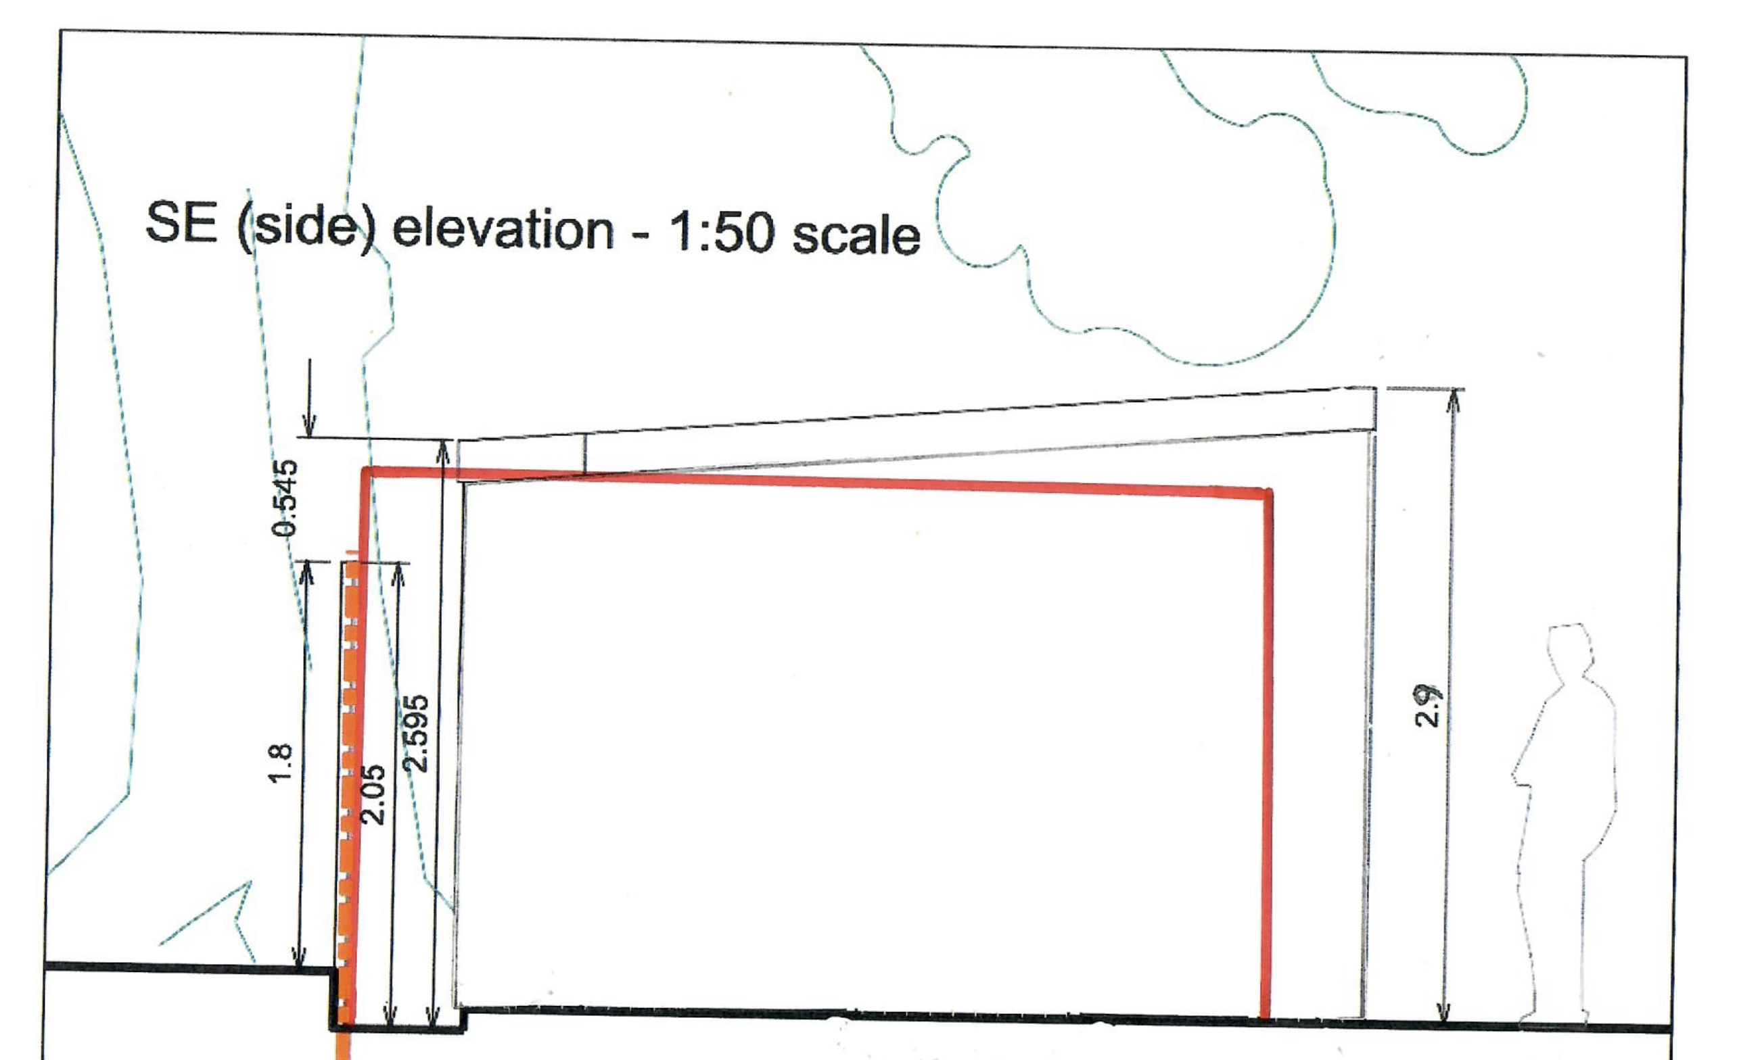

Figure 2

- Figure 3 shows the relative profiles of the proposed building (black outline) and two alternative buildings with, respectively, a mono pitched roof at 3 m (red outline) and a dual pitched roof at 4 m (green outline) constructed greater than 2 m away from the boundary under permitted development,
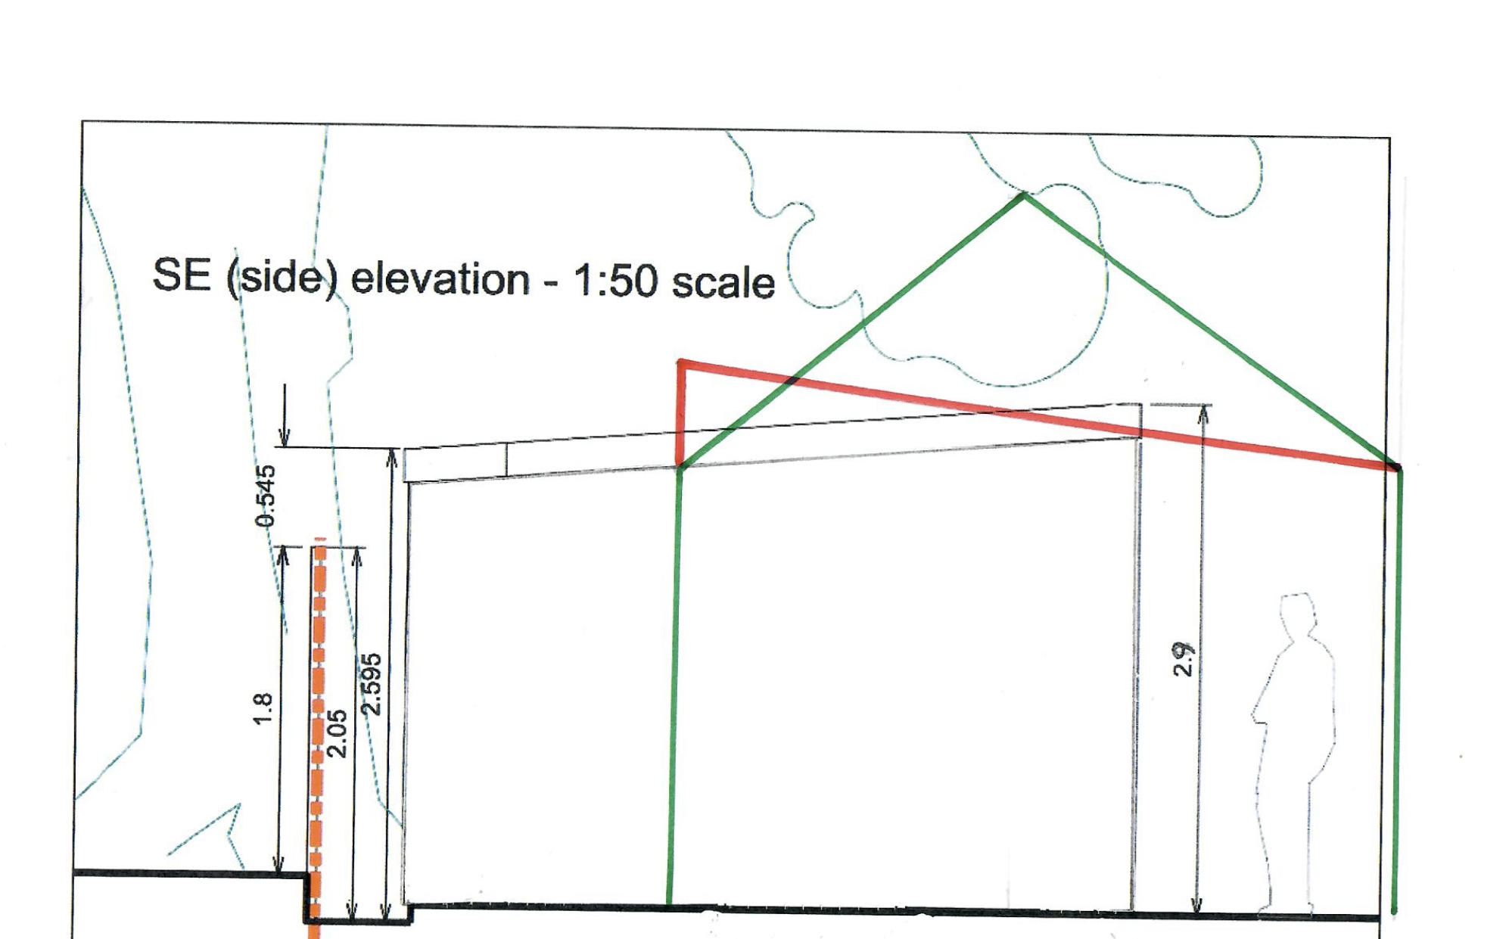

Figure 3

- Figure 4 shows the relative profiles of the proposed building (black outline) as against a building for which planning permission has recently been granted at nearby 33 Kewferry Road (red outline) (under Planning Application ref. PP-14171188). The buildings has been constructed 1m away from the fence and to a maximum of height of just under 4 m.
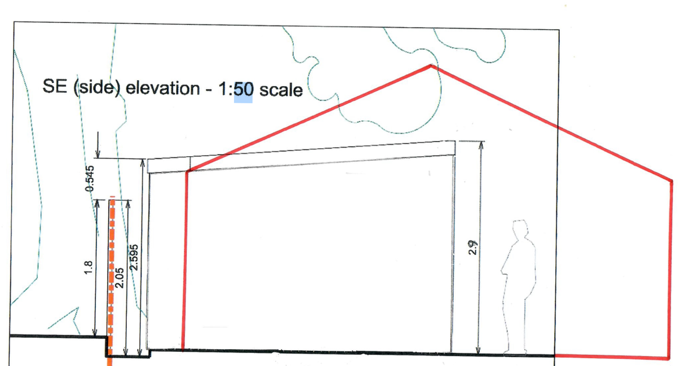

Figure 4

  - The building is capable of being constructed as proximate to the boundary as proposed and comply with the requirements of building regulations (including fire safety considerations). This has been confirmed by Hillingdon’s Building Control (email to applicant dated 05 May 2020 14:04). For the avoidance of doubt, regardless of the proximity of the proposed building to the boundary, building regulations will apply to its construction given that the internal floor area exceeds 30 square metres.
Therefore, given the scheme is not materially different to what could be achieved under permitted development and having due regard to the fallback position, it is considered the building should be granted planning permission subject to any relevant conditions if necessary to secure the use and protect the local environment.

- Character and appearance
The building would have a single sloping roof, which slopes away from the front at its greatest height of 2.9 m. It would be clad in matt black planking (which assists with its visual impact in the garden and when viewed from neighbouring properties) and with well-positioned and proportionate glazing. The type of finish is illustrated in Figure 5.

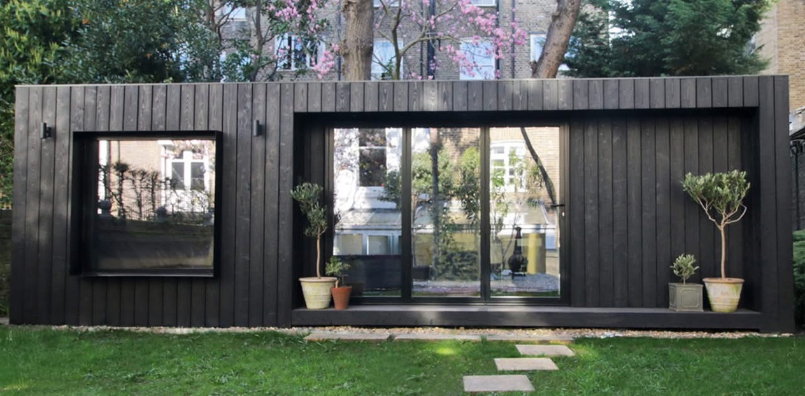

Figure 5

Its single-storey nature, footprint and positioning within the bottom of the rear garden area of the host dwellinghouse ensures it ‘reads-well’ as an obvious and subordinate building to the host dwelling. The siting, size and scale of the building ensure it does not undermine the character, appearance or significance of the host dwelling or nearby dwellings.

Whilst the outbuilding is relatively large, the size of the front garden is approx. 215.97 sqm, the size of the rear garden is 933.71 sqm, the footprint of the house is 261.2sqm. Given this, the outbuilding which is c. 50 sqm in internal footprint would not be over-dominant in relation to the host dwellinghouse or within the curtilage of the site itself. It would be subordinate to the host dwelling as mentioned earlier due to its size, scale, design and siting, sit comfortably within the larger residential curtilage, and is of a size akin to what could be achieved under permitted development. The use of the building as shown on the floor plans is incidental to the enjoyment of the host dwellinghouse. A condition stating it can only be used for incidental or ancillary purposes in relation to the host dwellinghouse and not as self-contained residential accommodation can be imposed. The condition can only state the building cannot have a separate postal address and a draft unilateral undertaking can be submitted to even secure the use of the building as a legal agreement rather than condition in order to provide comfort to the Local Planning Authority.

This planning application is also for permission to construct trellis fencing along the entire length of the existing rear fence (that is, to the rear of the proposed building). The fence was installed and is maintained by the applicants.

The current fence is constructed to a height of 1.8 metres above the level of the bottom of the garden of the property to the rear of the applicant's property (31 Gateway Close). The trellis fencing proposed would be 0.6 m in height, thus bringing the overall height of the fence to 2.4 mabove the level of the rear property's garden.

The proposed trellis is shown on the elevations sets out at in the enclosed plans.

The trellis will, in part, assist in softening the impact of the proposed building from the perspective of 31 Gateway Close. Per the photograph set out in Figure 6, part of the rear garden of 31 Gateway Close is currently bordered to the rear with a hedge of over 5 metres tall.

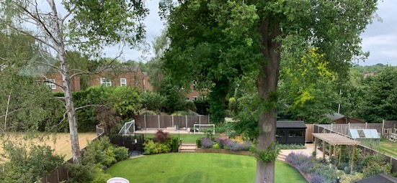
Location of proposed building

Figure 6
Moreover, Figure 7 features a photograph of 31 Gateway Close which shows that property to be situated at a significantly higher level than the applicant's property and thus it is considered that neither the proposed trellis nor building would be impactful to 31 Gateway Close, being at a level well below the adjacent hedging and at the bottom of a garden which slopes upwards away from the fence to the house itself at 31 Gateway Close. There is an opportunity for the proprietor of 31 Gateway Close to allow the existing shrubbery to grow to a greater height on that side of the boundary if this was felt desirable.

Given the siting, low eaves height of the proposal, height of boundary treatment, it is not considered the proposed outbuilding would lead to any loss of light, outlook or privacy when viewed from the habitable room windows and garden areas of properties along Gateway Close.

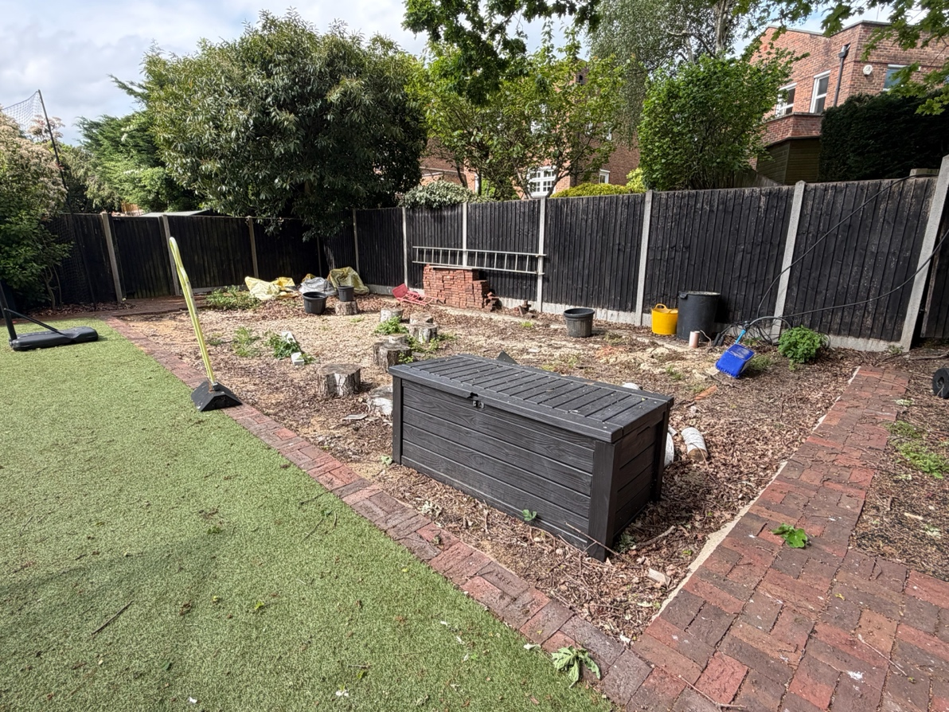
Figure 7
- Arboricultural considerations
The proposed building would be set to the rear of a large rear garden with mature planting and trees. Notably, there is a fine mature oak tree at the rear north-eastern corner.
Accompanying this application is an Arboricultural Impact Assessment prepared by SJ Stephens Associates dated 29 October 2025. The report concludes as follows:
“Provided the recommendations in this report are followed, the arboricultural impact of this development on existing trees is considered acceptable.”
- Similar sized schemes approved under planning permission

  - At 33 Kewferry Road, Northwood, an outbuilding was recently approved under planning permission reference 4429/APP/2025/1899. The outbuilding has a footprint of 50 sqm, is constructed to a height of 4m and at a distance of 1m from the boundary with its neighbouring rear property.
  - At 15 Kewferry Road, Northwood, retrospective permission under planning reference: 26090/APP/2019/2858 was granted for a garden building constructed closer than 2m to two boundaries with a neighbouring property and at circa 4m in overall height.
  - At 53 Elgood Avenue, Northwood, an outbuilding with an external footprint of 59.36 sqm located 0.3m away from the shared boundary with its neighbouring property and on a plot size significantly smaller than the application site was recently approved under planning reference 3440/APP/2025/3190.
  - At 41 Copse Wood Way, Northwood, an outbuilding was approved under planning permission reference 1896/APP/2025/1719. On one boundary, the overall height of the structure is significant at 4.37m and 1.85m away from the shared boundary.
  - At 21 Sunray Avenue, West Drayton, an outbuilding in the rear garden was approved recently under planning permission reference 7722/APP/2025/846. The outbuilding approved has a footprint of approx. 63 sqm which is larger than the proposal at the application site. Moreover, permission was granted for the building to be built on the boundary to one side of the property (i.e., with no gap between the neighbouring property’s garden), less than 0.5m away from the other, less than 1m to the rear boundary, and at a height of 3.25 m.
  - At 58 Blackthorn Avenue, West Drayton, an outbuilding in the rear garden area was approved recently under planning permission reference 41657/APP/2025/1061. The outbuilding has a footprint of approx. 67.5 sqm which is larger than the proposal at the application site. On all three sides with neighbouring properties, the distance to the boundary is less than 1m: on two sides, c.0.3m and on the third side, c.0.5m.
  - At 12 Morello Avenue, Hillingdon an outbuilding in the rear garden was approved recently under planning permission reference 77998/APP/2025/630. The outbuilding has a footprint of approx. 52.5 sqm which is not dissimilar to the proposal at the application site. Pemission was granted for it to be constructed with no gap between the neighbouring sides and rear properties and at a height of 3m i.e., higher than the proposed building under this application.
  - At 68 Coronation Road, Hayes, an outbuilding in the rear garden area was approved recently under planning permission reference 11896/APP/2025/840. The outbuilding approved at this site has a footprint of approx. 69.18sqm which is materially larger than the footprint of the outbuilding at the application site. The building was approved to be constructed on (i.e. with no gap) between the boundaries of its two neighbouring properties.
The works approved above have similar characteristics to the application proposal, many have a higher overall height, and some are constructed closer to – and even on – multiple adjacent boundaries. Together, they evidence that generous sized outbuilding similar or much larger in size for incidental purposes have been recently approved. The proposed use of the outbuilding is for incidental purposes and it only needs planning permission as it is within 2m of any boundaries. The fall-back position would be to move it further than 2m from any boundaries but could also result in a larger footprint ay a greater height being applied for. Given the fall-back position could lead to a much larger outbuilding, the proposal should give significant weight to this and approve the proposal subject to any relevant conditions.

Enclosures:
  - a Site Plan,
  - a Site Section,
  - Building floor plan, sections and elevation drawings;
  - an Arboricultural Impact Assessment, which supports the proposed construction of the building subject to a prescribed method of working;

David Carson, Applicant
28 May 2026

