

Drainage Review – Post Construction

Envar COmposting –Version one , July 2025
James Cooper – Head of COmpliance
in persual of discharge of condition 22 of 39755/APP/2023/652

Contents
1 Contents 2
2 Introduction 3

Planning Reference: 39755/APP/2023/652
Site Address: West London Composting, New Years Green Lane, Uxbridge
Prepared by: James Cooper Envar Composting
Final Version Date: 29/07/2025

Introduction

The West London Composting site (WLC) is governed by planning Condition 23, which stipulates that the facility must not be occupied until evidence (photographs and installation contracts) is submitted to demonstrate that the approved sustainable drainage scheme has been completed. The condition also requires that the drainage scheme be managed and maintained thereafter in accordance with the agreed management and maintenance plan. The reason for the condition is to comply with the Non-Statutory Technical Standards for Sustainable Drainage Systems, the National Planning Policy Framework, the London Plan (Policies 5.12 and 5.13) and Hillingdon Council’s Local Plan Policy EM6.

Summary of the Sustainable Drainage Scheme

No off-site discharge:
The WLC site captures all surface water and foul water within sealed tanks. There is no discharge of water off-site, either to public sewers or watercourses.
Surface water and leachate:
Rainfall, snow or any other precipitate, precipitating onto impermeable surfaces and any liquid leachate from the composting process are directed to a surface-water/leachate collection system. This system includes bunded areas, channel drains and gullies that feed into CIRIA 736 compliant overground storage tanks. The collected water is reused in the composting process for moisture control and dust suppression.
Foul water:
Separate foul-water tanks serve staff welfare facilities. Foul water is stored in sealed tanks and taken off-site for appropriate treatment by a licensed contractor.
Design standard:
The drainage design was undertaken to accommodate a 1-in-100-year storm event plus a 40 % allowance for climate change, with additional freeboard to provide resilience. This ensures that even extreme rainfall is captured on-site without flooding or overflow.
A requirement of the sites environmental permit which is issued and monitored by the EA the site is not allowed to discharge any water unless it is treated to comply with UKBAT (United Kingdom Best Available Techniques). The site has no water treatment plant and therefore there is no discharge.
Should the site be required to remove water for whatever reason (although this scenario is very unlikely) then the site will arrange for a collection and appropriate treatment to a licenced contractor such at a WWTP (wastewater treatment plant) such as Maple Cross WWTP.
Flood-risk reduction:
By capturing and reusing all water on-site, the scheme reduces the risk of flooding both on-site and off-site. The site’s finished levels and bunding prevent overland flow to adjacent land. The installation actually decreases peak floodwater volume as per the below calculations:
Below is an updated version of the report that incorporates a new section on peak floodwater reduction, along with references at the end. You can copy this text into your template or use the file link if attachments work for you.

Peak floodwater reduction
In addition to meeting the planning requirements, the site’s drainage system provides a measurable reduction in peak floodwater. A useful rule of thumb is that 1 mm of rainfall over one hectare produces 10 m³ of runoff. For the 4.1 ha WLC site, every millimetre of rainfall therefore equates to roughly 41 m³ of runoff. Capturing this water in tanks rather than discharging it prevents a significant volume of floodwater from entering the downstream network. Typical design rainfall intensities used in stormwater calculations are 35 mm per hour, with 50 mm per hour used as a conservative check. The table below illustrates the volumes captured for these design intensities and for a 70 mm event (which approximates a 1-in-100-year storm with a 40 % climate-change uplift):
Rainfall depth | Approx. runoff captured | Explanation
35 mm (≈ 1 h design storm) | ≈ 1 435 m³ | 35 mm × 41 m³/mm = 1 435 m³ of runoff captured
50 mm (conservative 1 h storm) | ≈ 2 050 m³ | 50 mm × 41 m³/mm = 2 050 m³ of runoff captured
70 mm (100-year storm + 40 % uplift) | ≈ 2 870 m³ | 70 mm × 41 m³/mm = 2 870 m³ of runoff captured

By retaining all runoff on site, the drainage system effectively reduces peak floodwater discharge to zero. This quantifiable benefit demonstrates that the site not only complies with planning requirements but also contributes to downstream flood-risk reduction.
- Environment Agency (2013) – Rainfall Runoff Management for Developments (Report SC030219). Section 5.5 notes that the sizing of stormwater networks is often carried out using a constant rainfall intensity of 35 mm/hr, with 50 mm/hr used as a more conservative design value

System Design and Construction

Design

In the original pre-construction details West London Composting Limited gave details of the construction details of the new tanks and existing infrastructure as follows:
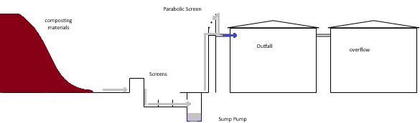
Figure 1 - tank design layout

The design is very simple with the leachate/runoff being collected in a site which is designed to be impermeable and shaped like a bowl so as all sides run to the centre tank storage areas.
The system then collects water in a sump which has a pump within it. this is float triggered and when it is full the high-volume pump delivers water to a suitably sized parabolic screen. The screen filters out any small detritus or contaminants to reduce tank maintenance requirements.
The collection channel in front is created out of blocks and in situ cast concrete design which creates a capture pit and weir system to further remove detritus and prevent blockage.

Construction

Construction was as per the designs which included the addition of an impermeable surface for the main pad as per the CQA report which can be found as appendix 4. The tanks are set into the top of a specially constructed pad with top level connections. This is so as if the tanks have a leak it is isolated from all others without requiring any interventions.
The main concrete pad is fully sealed surrounded by “Treif Kerbs” which are sealed using Sikaflex Pro 3 SL “ construction joint sealant for this type of operation.

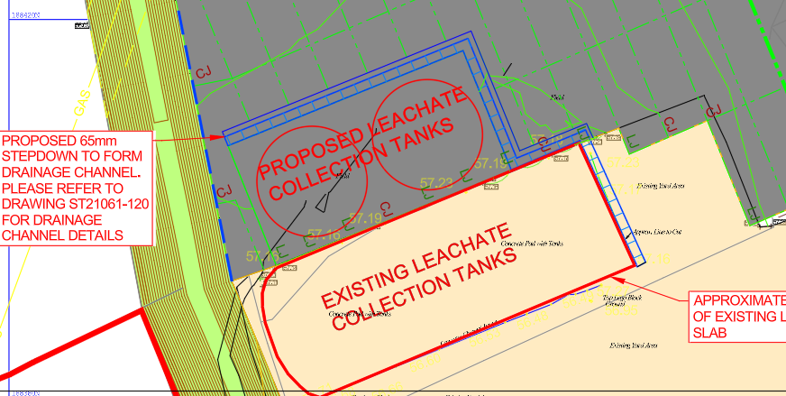
Figure 2 - top down layout of drainage channel and tank layout
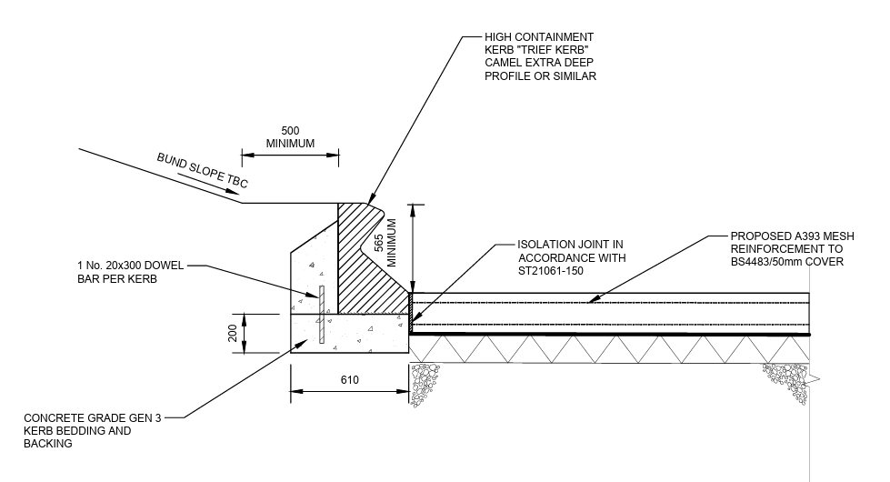
Figure 3 - Treif Kerb cross section and construction detail
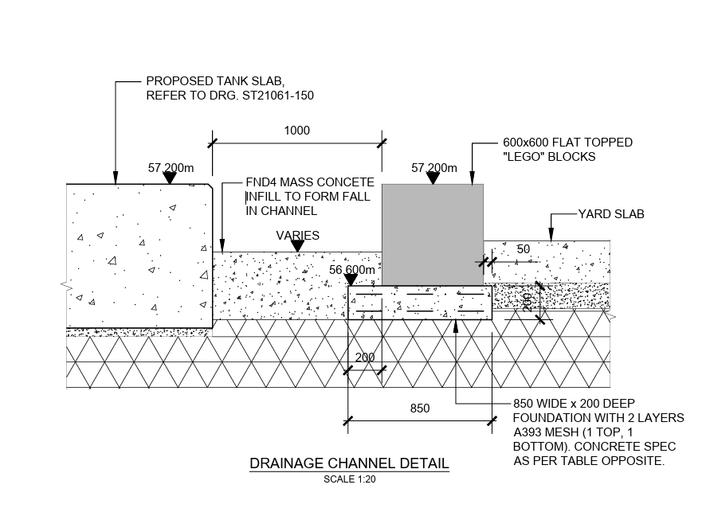
Figure 4 - Tank Channel Detail
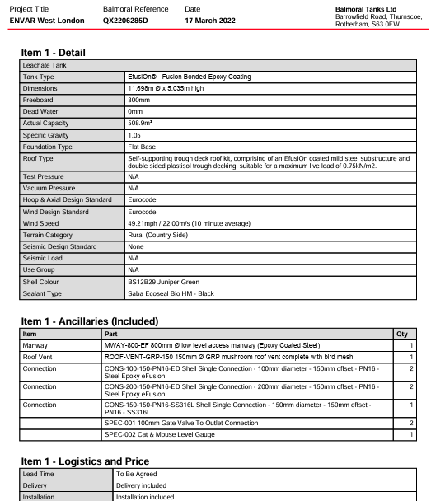
Figure 5 - tank construction specification within the contract of the tanks ordered

Appendix 1 and Appendix 2 gives full tank construction details in drawing form regards the order made at West London Composting Limited and which has subsequently been constructed.
Appendix 3 shows the slab formation on which the tanks were built

Evidence of construction in line with requirements

The main evidence showing the construction was built in line with designs is the consulting engineers report showing the construction complies with CQA (Construction quality assessment) requirements. this is attached as Appendix number 4.
Photos included below show the tanks in progress and constructed as well as the already existing other infrastructure which has been modified and retrofitted for the new site and to comply with the requirements of CIRIA 736.

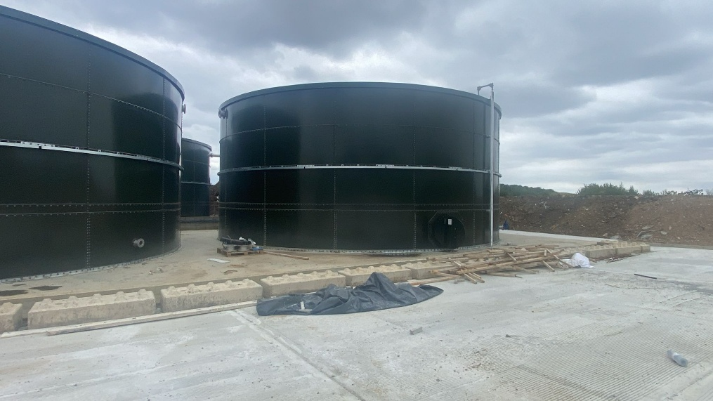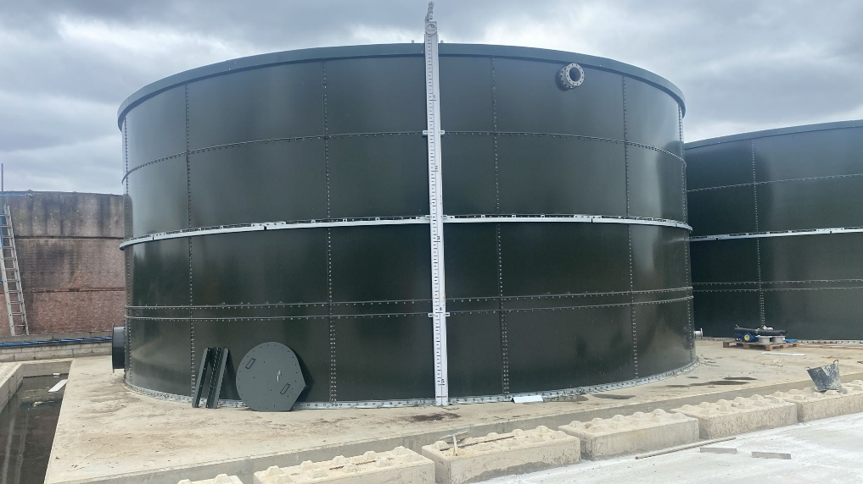
Figure 6 - new tanks
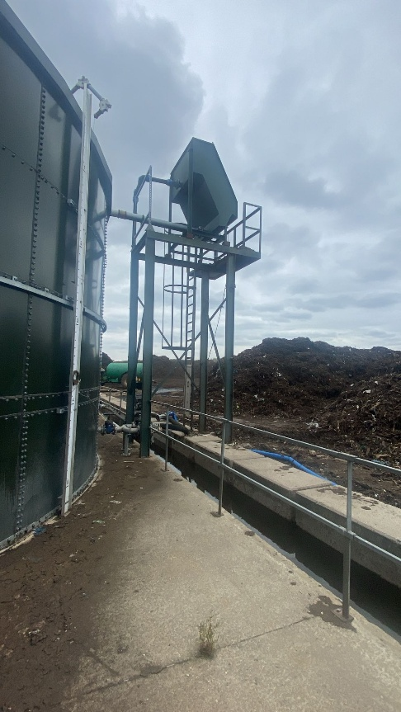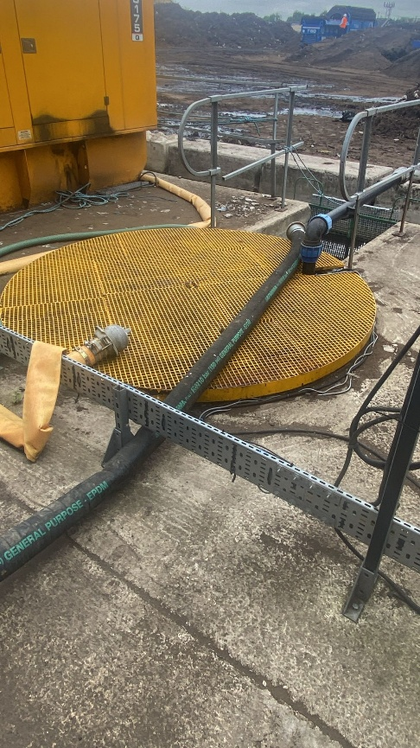
Figure 7 - existing parabolic screen with solids discharge back to composting pad (impermeable) and tank storage behind including off take point for reuse. collection sump can also be seen with float control and outlet to parabolic screen delivery pipe.

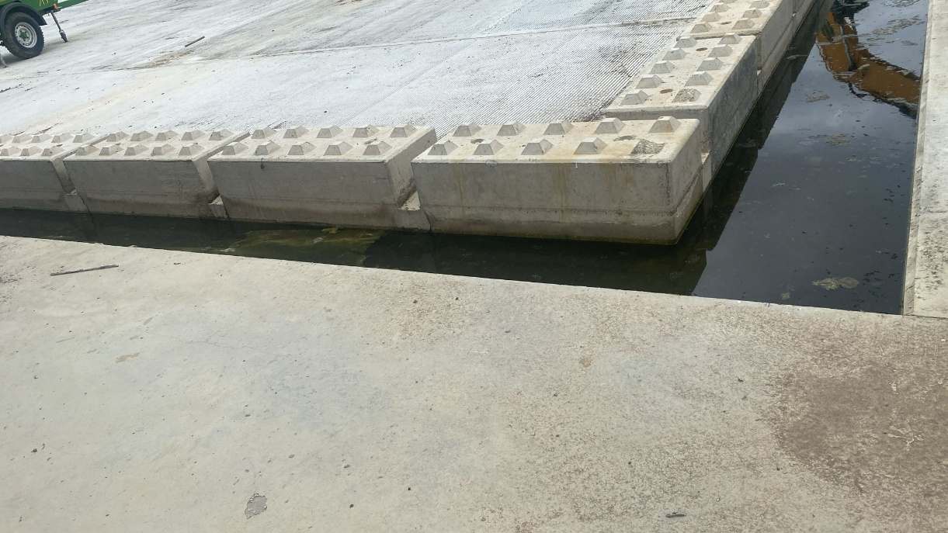
Figure 8 - newly constructed drainage channel to sump
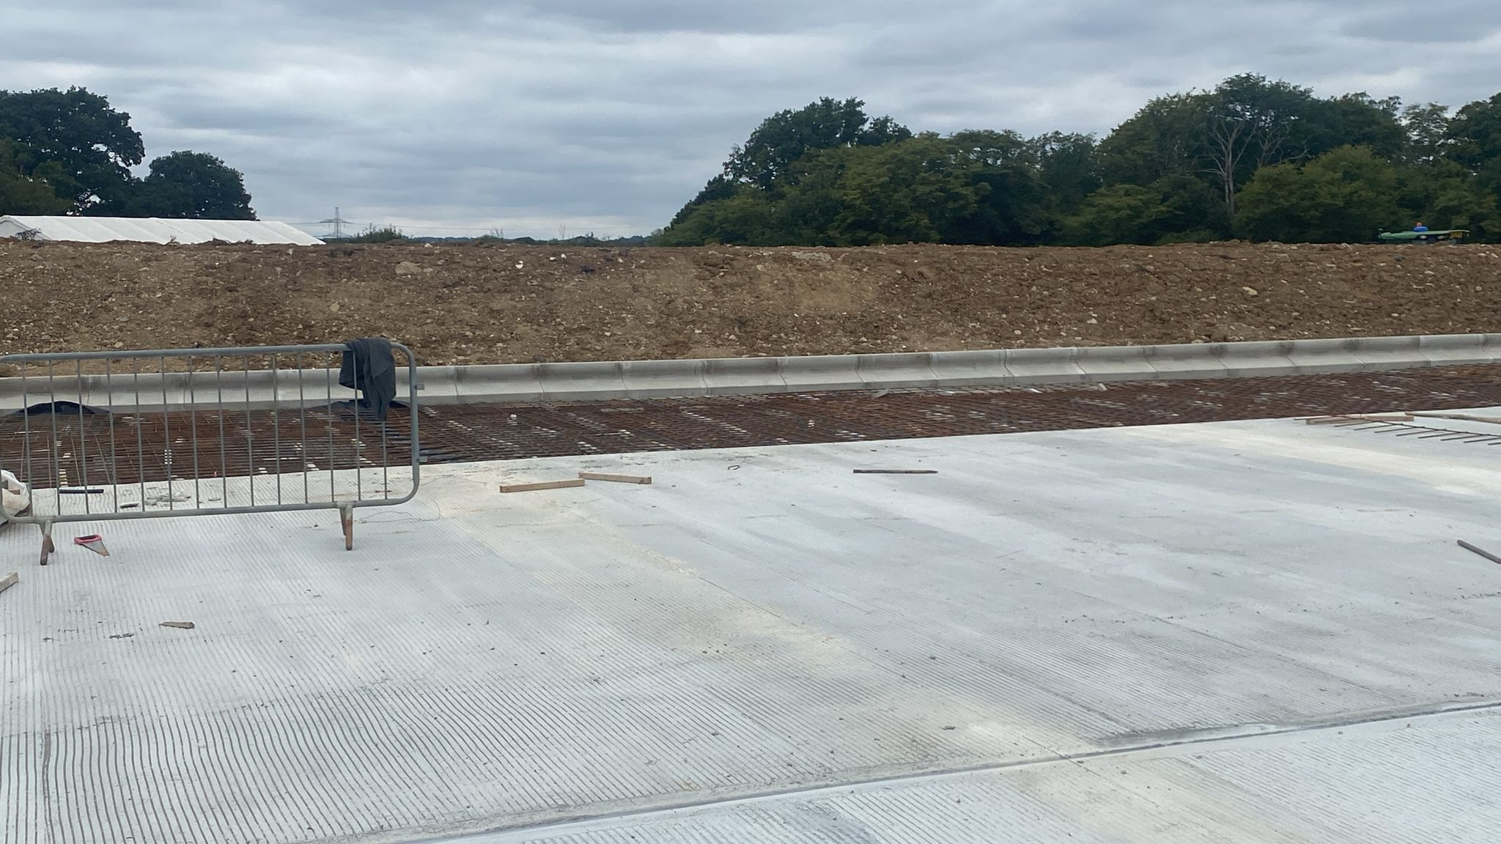
Figure 9 - treif side wall containment awaiting final pour
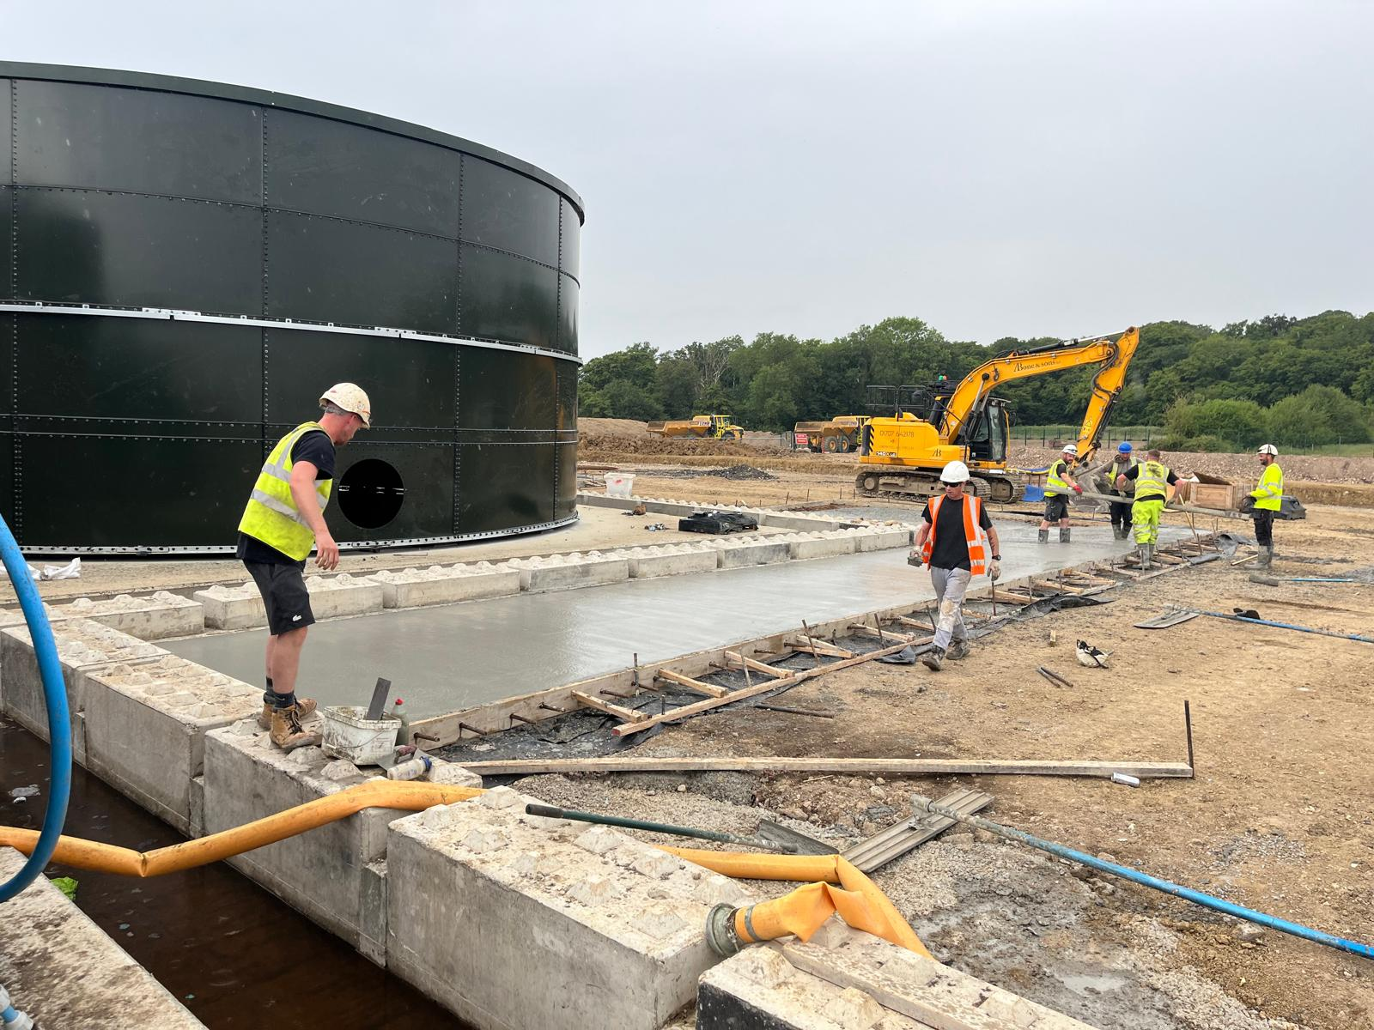
Figure 10 - drainage channel section to pad being sealed

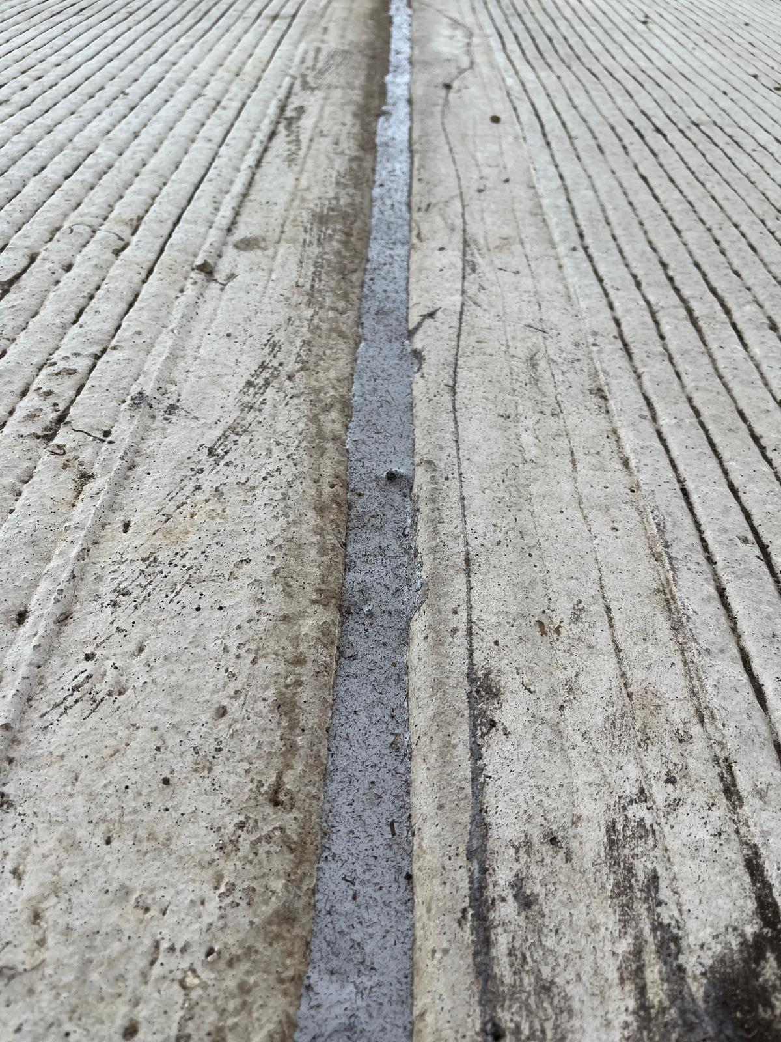
Figure 11 - Sika Pro Seal Pro 3 SL joint fully sealed along run

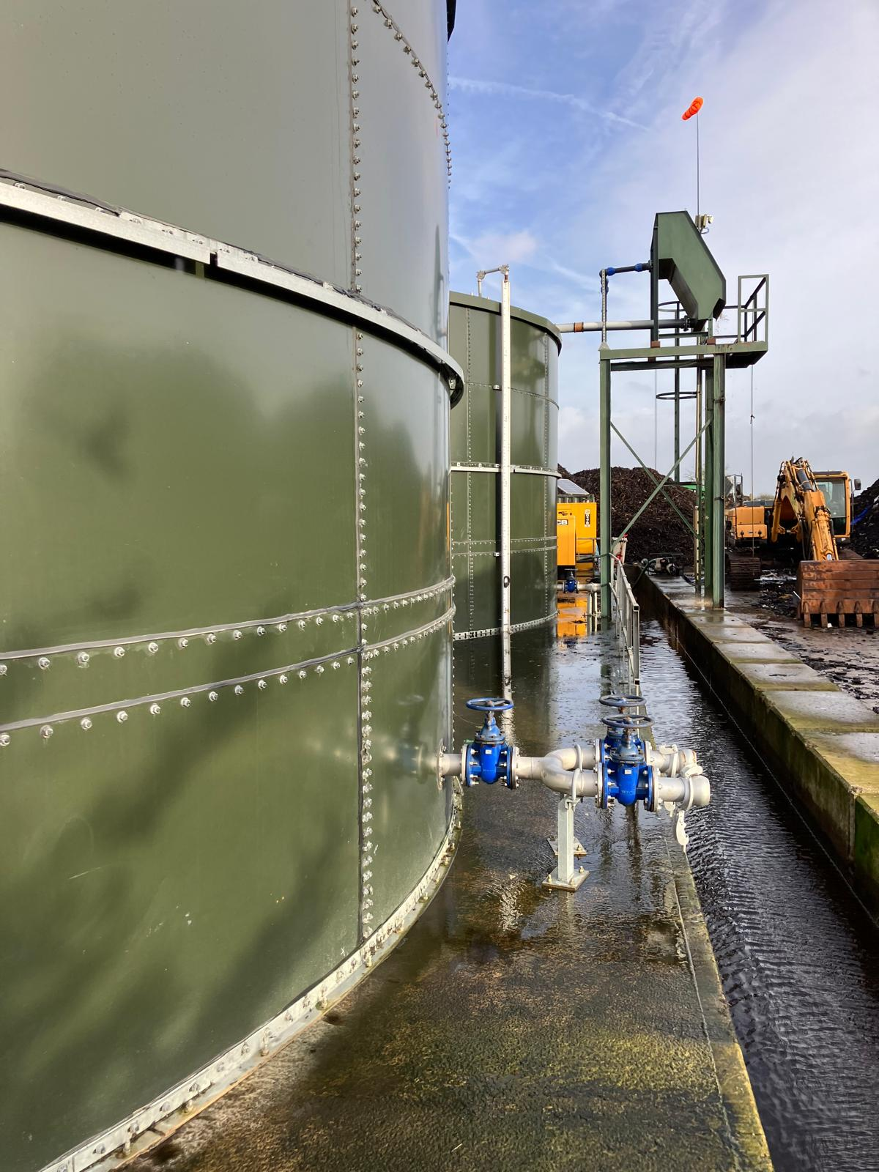
Figure 12 - existing connection points and parabolic screen for containment of all water

Management and Maintenance
A management plan is in place to ensure the long-term performance of the drainage system. Key tasks include:
- Routine inspection of bunds, gullies and drainage channels to remove debris and ensure free flow.
- Regular checking of storage tanks for integrity and capacity; pumps and sensors are tested and calibrated monthly.
- Scheduled emptying of foul-water tanks by licensed contractors.
- Ongoing training for site staff on spill response and the importance of preventing contamination of clean surface-water areas.
- Record-keeping of inspections, maintenance and any incidents as evidence of compliance.
- Following the new additional tank construction it is advised re-inspection should be carried out in the next 3-5 years based upon operator integrity checks which should visually carried out monthly and with annual level checks (fill and wait to see if level goes down). Should the operator see any corrosion developing a competent company should be brought into re-inspect the tanks.

Evidence of Completion

Photographic evidence of the completed drainage infrastructure, including bunds, gullies, storage tanks this is included in section 4.3. Appended information is included to demonstrate that the works have been completed in accordance with the approved design.

Conclusion

The sustainable drainage system at West London Composting has been installed in full accordance with the approved plans. As there is no off-site discharge, the system captures, stores and reuses all surface water and foul water generated on the site. The design provides capacity for a 1-in-100-year storm event plus a 40 % climate-change allowance, reducing flood risk both on-site and off-site. The completed works and management arrangements therefore satisfy the requirements of Condition 23.

