Oak
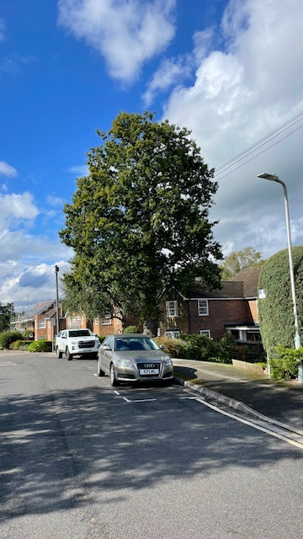
Silver birch
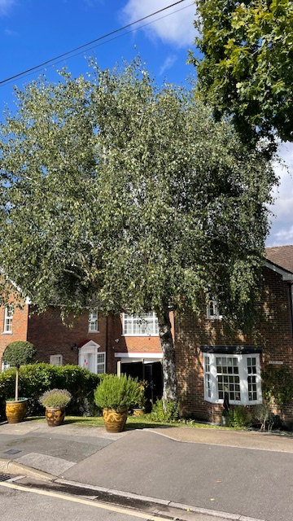
Magnolia left side
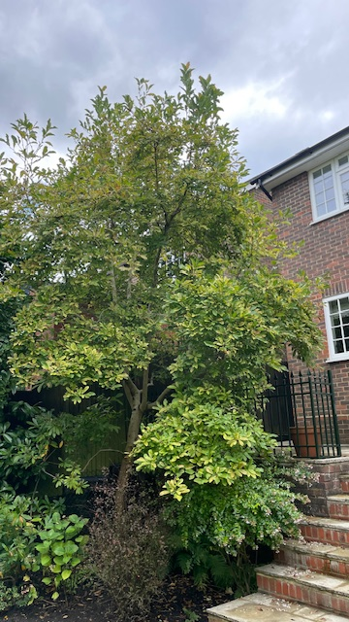
Right magnolia
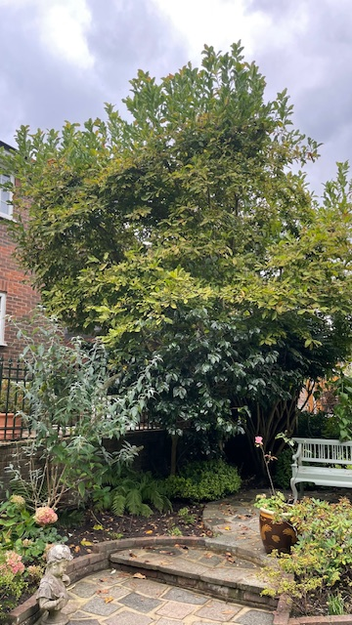
Laurel
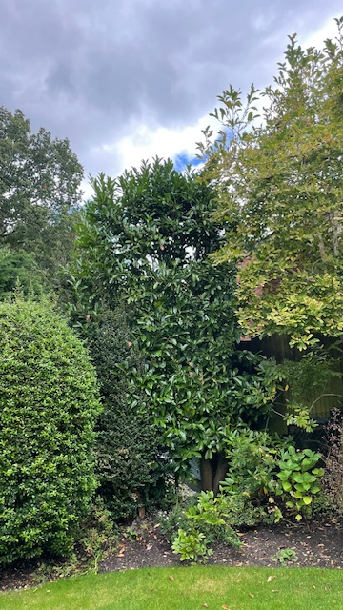

Kevin Woodham Arborist representative
Local Manager

BARTLETT TREE EXPERTS
Coursers Farm, Coursers Road, St Albans, Hertfordshire AL4 0PD
p Office:01727 825090 option 1 Mobile: 07808915881
e kwoodham@Bartlett.com
facebook.com/bartletttreeexperts
bartlett.com

