Colt Data Centre Services as owner of the site at Beaconsfield Road Hayes are requesting on behalf of ISG, the contractor executing the construction of the Data Centre on Colt’s behalf as per planning permission number 384214/APP/20214045, that the said contractor can continue to work on site from 6am until 12am during weekdays to facilitate the power floating of the concrete. The reason for this request is that the concrete can only be poured in small quantities without this approval, as the concrete has to semi set before it can be floated and at this time of the year that takes considerably longer. To not do this would have significant program implications for Colt and mean that target handover to their hyperscale client will not be met. The work consists of two operatives from the concrete laying company [Galldris], who are employed on a sub contract basis by ISG as main contractor on this project, traversing two polishing machines across the surface of the concrete to produce a smooth finish. These machines are similar to a sit on lawn mower but instead of having a cutting head, they have polishing heads. All equipment will be in place on the required floor before 6 pm and will not be removed until 8am the following morning to minimise plant movements during the late hours working. No additional materials or plant are required to carry out the work. It is an absolute maximum of two operatives with 2 assistants [H and S requirement] and one supervisor, running over the concrete on a sit on polishing machine. The additional noise is only the machines because nothing additional is required.

Details of the request

Extend working hours 6am to 12am Monday to Friday. 12 weeks. [Commencing on approval]
Works will also not be carried out on all 5 nights due to the rest periods required for the operatives. It is likely that work will only take place on three nights a week, but due to the nature of the work we are unable at this time to guarantee which nights or how many nights in each week.

Lighting: Normal lighting includes perimeter fencing and staircase lighting for security, additional task lighting in place for works include 3no with generators, all to be directionally faced inwards to avoid potential external lighting pollution.
Details of these machines are included at the end of this note. We are unable to provide zoning as this will be moved dependant on the concrete pours but we can confirm it will all be internally facing as to reduce any light over spill at the site boundary.

Deliveries: All deliveries relating to the construction site will be within normal working hours.

Parking: All parking will be on site.

Workforce: maximum 4no workers + 1no Supervisor.

Security: No additional security to that already in place at night.

Plant: See extract from works methodology, at no point will there be more than 2 machines working.
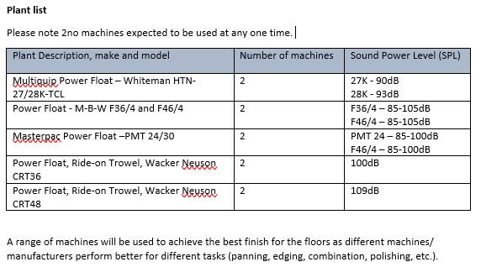

Noise: Sound power level calculated on the assumption of max noise 2no power floaters at 109dB power at one time equal to 101dB sound pressure level, with a distance of 190m to nearest Cherry Avenue receptor (Not accounting for building or vegetation impact, works on the floors is partially shielded by trees and adjacent industrial buildings which have not been modelled) this equates to at 55.4 dB level at nearest receptor and would be expected to be less given the existing shielding. Also please note this noise level was calculated at 190m which is the closest distance to residents much of the work will take place at great distances as we move from east to west and therefore the noise level will reduce further for some pours.





