

Mount Vernon Hospital: Woodland Walk Project
DESIGN AND ACCESS STATEMENT REVISED 11.01.21

Introduction
Over the last 2 years the Hospital has been working with the Centre for Sustainable Healthcare on a number of projects looking at potential improvements to green spaces across the whole site and also examining attitudes to the spaces on the part of staff and patients. The first project to be delivered was the Fern Garden, attached to the Day-patients Chemotherapy Unit; this scheme is now nearing completion, so work is underway to develop a second scheme, the Woodland Walk. Funding has been secured for the scheme from a new programme (East and North Hertfordshire Hospitals’ Charity) and this will augment the funding already in place from the Heathrow Community Fund.
The background to the project
The Grade II* Listed main building sits at the heart of the hospital site and occupies an elevated position, commanding long-ranging expansive views over the trees below, towards London. The lawn area to the front of the building would have played a critical role in patient care when the building was first opened round the turn of the century, as at this time it would have still been commonplace for patients to be wheeled out in their beds onto the terrace, or if on the upper floor, the balcony. From these positions they would have been able to enjoy the fresh air and the views across what was then open countryside. It was still strongly believed then that access to fresh clean air and sunshine played a key part in patients making a good and speedy recovery from illness.
Modern medicine has moved away from this emphasis on access to the natural environment and instead this approach has been replaced largely by an emphasis on clinical procedures, and accommodating patients in sanitised wards, ‘germ-free’ indoor spaces, often without any views onto the outdoor areas. However there is a growing body of evidence which suggests that access to green space during recovery from illness is actually extremely beneficial and has been proven to increase the speed of recovery significantly, it can also help reduce stress experienced during illness, with consequential improvements in the mental health of patients.
The Woodland Walk represents an attempt to re-dress the balance between these old and new approaches to patient care in the hospital by providing a facility which will encourage people to spend more time outdoors and to see this as a valuable therapeutic tool alongside the traditional ward environment and associated clinical procedures. Patients will benefit in terms of this access aiding their recovery; staff will benefit by being able to escape the ward environment for short breaks during the day, thus relieving their stress, and families can enjoy the peace and quiet of the outdoor space to recover from can be a stressful visit to the wards to see their loved one.

The existing site
The ‘Woodland Walk’ will comprise a circular pedestrian route located to the south of the main building. The route encompasses three distinct areas: the upper terrace, closest to the Listed building; the lawn area, and the wooded space which forms the southern edge of the site. Creation of the route will make an area which is currently inaccessible to the main target user group (patients and families), accessible again.
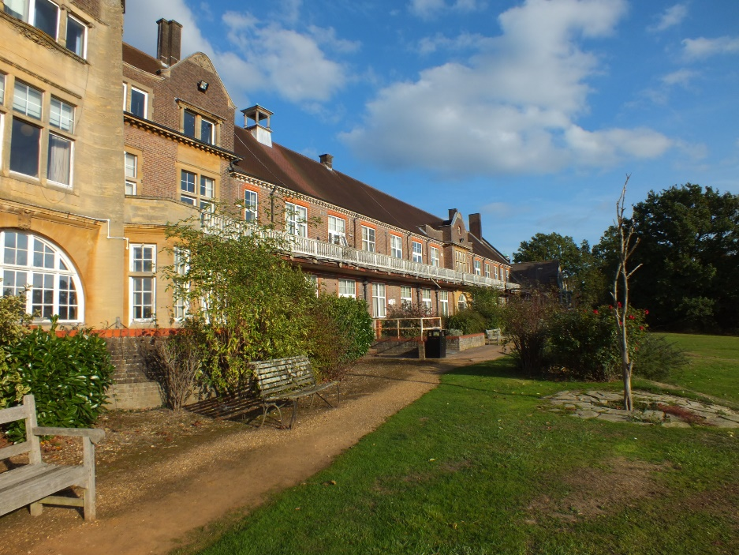
The Upper terrace

The upper terrace or path is well used by staff who use the seating during their lunch or other breaks. There is a large number of seats here and also a few picnic tables too. We have not found much evidence of use of this area by patients or their families.

The lawn area is the largest and most attractive green space across the whole hospital site. As there is a significant drop in levels between the path along the front of the building and the wooded space below, the lawn has been terraced into an upper and lower lawn area, separated by a low bank (including steps). This has enabled each lawn to adopt a more level profile which makes it more useable than if it sloped to follow the lie of the land. Another low bank separates the upper lawn from the path along the building frontage.
The lawn area is used mostly by staff who perch on the steps to eat a lunchtime sandwich or who sit on the benches along the top terrace / path. There is an informal kickabout area marked out on the upper lawn and this has been used occasionally over the years by staff football teams from within the Trust. Anecdotal evidence suggests that very few staff stray beyond the upper lawn and there is little evidence to suggest that patients and their families do either. There is little incentive for them to do so as there is no marked out route or seating, and the trees and shrubs look neglected and poorly maintained.
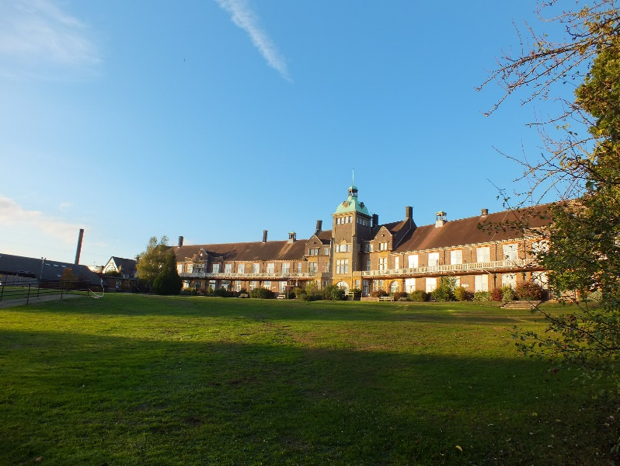
The Lawn area

The lawn area

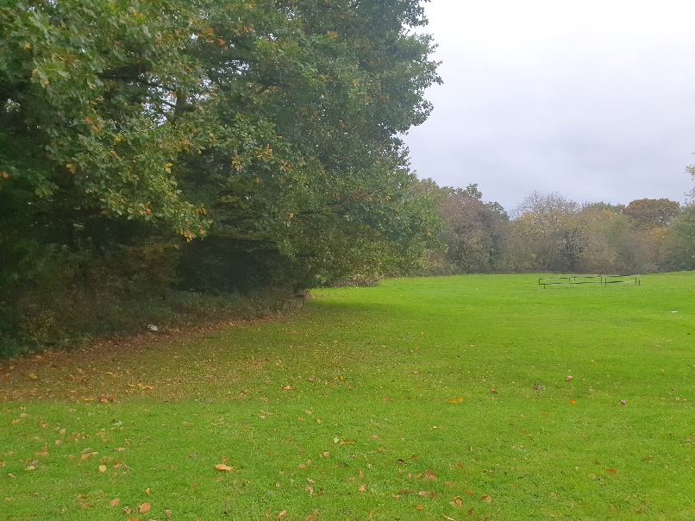
View south across the east side of the lawn, looking onto the woodland belt along the southern side

The wooded area marks the southern boundary of the hospital site and it features a row of fine mature specimen oak trees along the external site boundary as well as a row of over-mature (’veteran’) Hawthorn trees along the lawn edge. It is likely that both the Oaks and the Hawthorns date back to the original planting scheme c. 1900. Between these rows of trees, what would have been an open glade has been colonised by a large stand of bramble, making the whole area currently inaccessible, therefore there has been no usage of this area in living memory. There are also still remnants of parkland fencing in place along the boundary with the lawn, including a gate, suggesting that this area was intended to be used (and maintained).

Evidence for the scheme obtained through consultation
This project has come about following significant consultation with staff and patients carried out over the last five years. An early staff health and wellbeing working group identified staff preferences for activities that: took approximately 20 minutes, could be completed during staff breaks, were low cost, easily accessible and did not cause sweating. Walking was identified as the activity that best met these criteria. Patient engagement highlighted that whilst patients valued outdoor spaces to take a break away or to ’escape’ from their treatment, they felt disconnected with the outdoor space and unsure of what outdoor spaces they were “allowed” to access. Initiatives that support physical activities for patients has also become increasingly important within the NHS. Whilst the hospital is surrounded by greenery there is no accessible, green walking route across the site. Walks in car parks did not benefit staff or patients. Subsequent staff Health and Wellbeing days, questionnaires, Clinical Governance meetings, Patient Advisory Group meetings, Outdoor Space Stakeholder Group meetings, volunteer engagement, patient and carer engagement, staff 1:1 interviews and focus groups, Staff Health and Wellbeing Steering group meetings and Patient Experience group meetings have all informed how this project has developed and confirmed the high level of interest in the project. Making the lawn and wooded area below accessible has therefore become a top priority.

Proposed use
The route will be open to the public and there will be no restriction on who can use it however a key project objective is for it to provide a therapeutic tool for those who most need it, those recovering from illness, many of whom have restricted mobility. We would anticipate that staff will use the route as a means of escaping from work-related stress and the intensive atmosphere of the ward environment, but the primary user group the scheme is aiming at will be both in-patients and out-patients, and their families and friends who will be able to assist them in using the outdoor spaces.

Description of proposed layout
The route will be accessed from the upper paved terrace. Seating will be provided at key intervals so that those who are using it for rehabilitation purposes can rest when they need to. In addition, there will be low timber marker posts at 20m intervals so users can assess their walking capability and their level of improvement over repeated visits. It is also planned to include bird and bat boxes where possible.
The proposed path will be of shallow construction in self-binding gravel (100mm depth) so it is not anticipated that its construction will impact on tree roots however the route will be checked for the presence of any significant roots prior to construction starting. Any roots larger than a ‘finger width’ will be accommodated within the path surface and the limited excavation proposed around them will be undertaken by hand.

Section 1: The new path will lead from the terrace down the short bank via a ramped section, onto the lawn area below. The section of path skirting the east side of the lawn occupies the shadiest part of the route and will be especially valuable on hot sunny days. Patients undergoing chemotherapy are also usually very light-sensitive and are generally advised to avoid periods sitting out in the sun so these users will find this section helpful. The path will wind between small areas of longer grass and woodland-edge native flowers. These ‘meadow’ areas will improve the wildlife value of the site and will also provide seasonal interest where currently there is very little present. The meadow areas will attract butterflies and bees, possibly grasshoppers too, as well as some extra birdlife and as a result will make the lawn area feel more ‘alive’.

Section 2: as the path reaches the bottom of the lawn area it will enter the wooded area which forms the southern boundary of the Hospital site. This area will also provide useful shade for those who need (or like) to keep out of the sun. The wooded area is actually comprised of two parallel rows of mature trees, likely to be part of the original planting scheme c. 1900: oak trees to the rear, along the fenced boundary, and hawthorn trees along the front edge, facing onto the lawn. Between these rows of trees there will be an open glade through which the path will pass. Clumps of retained Bramble will provide habitat value, especially for roosting / nesting birds and alongside these will be planted some new native trees, mostly Hazel and Hawthorn. This will be a quiet, peaceful space, which feels remote from the Hospital site, though actually still close to it. There will be views over surrounding countryside towards London from the southern boundary.

Section 3: at the west end of the woodland area the path will exit back onto the lawn and as it heads north it will pass between some more meadow areas. As this section of path occupies the west side of the lawn it is in a sunnier position so here the meadow area can include a different range of plant species than on the eastern side. From this section of path it will be possible to look along the bank which divides the upper and lower level lawns which will also include some sun-loving meadow planting between the three flights of steps, which will add welcome colour during the summer months as well as improving the wildlife value of this area, further.

Section 4: is the existing upper terrace which has a bound gravel surface and already contains a generous amount of seating. This section is easily accessible from the building for those who are not yet ready to tackle the longer route round the lawn. No works are planned to this section as part of this scheme though it is anticipated that shrub pruning will take place over coming months to rejuvenate what is now quite a mature group of shrubs along the terrace edge.

Access policy
Other than Section 4 of the path (the upper terrace) where no work is planned as part of this scheme, the rest of the route is currently completely inaccessible to those with reduced mobility. These would fall into the following categories: stick and frame users; wheelchair use (either motorised or not) and ambulant, but in poor health, or weak, and needing frequent rest stops.
- The bank provides a barrier to access onto the lawn at both the eastern and western ends of the Terrace. Though only a short relatively shallow bank, anyone using a stick, frame, or wheelchair, or even those with unsteady footing, would be unable to traverse this slope
Solution – to construct a surface ramp at either end of the Terrace, with associated simple timber handrail on each side

- The grass area would not be accessible to anyone using a stick, frame, or wheelchair, or even those with unsteady footing, as it is on a slightly slope all the way round and damp / soft in localised areas
Solution – to construct a surfaced path in self-binding gravel which will give firm footing below and which will have a small enough aggregate to be easily trafficked by wheelchairs

- The woodland area would not be accessible to anyone using a stick, frame, or wheelchair, or even those with unsteady footing, as the ground underfoot is rough and rutted. In addition, the entire wooded area is extremely overgrown.
- Solution – to clear the scrub, open up the route, and construct a surfaced path through this area.

Conclusion
The work planned will enable a large group of patients (both out-patients and in-patients), as well as family members who will be assisting them, to access an area which is currently completely ‘out of bounds’, and thereby being able to take advantage of the numerous therapeutic benefits of being out in the ‘natural’ environment. This will help accelerate their recovery from illness and will provide an extra tool for clinicians to use in their management of this group.

Please refer overleaf to Addendum

ADDENDUM 11th January 2020
We have used this addendum to respond to the queries in red received from the Council’s Accessibility Officer.
1. To be accessible, the minimum surface width of an access route (i.e. between walls, kerbs or path edgings) should be at least 1800 mm for general routes, although a width of 2000 mm is preferable to accommodate larger electric mobility scooters. Will this be achieved?

The path shown on the plan is intended to be 1500mm wide, this has been deemed the appropriate path width for this natural environment. A wider path, particularly one 2m wide, would look very out of place here and will be out of proportion / scale with the landscape setting. The landscape is part of an historic layout and as such we have a responsibility to balance user requirements with aesthetics which are appropriate for such a sensitive historic site (Grade II listed building). However we are aware of the need to allow sufficient width for motorised wheelchairs to pass. We intend to achieve this by creating what are effectively passing places, so that at each seating bay the path will be widened locally to a width of 2000mm.

The path is relatively short in length and there are good sightlines along its length and seats are spaced at regular and relatively close intervals, so wheelchair users will be able to pause in a seating bay when they see someone coming the other way. We are of the view that this design solution offers the best compromise between desirable and achievable path width particularly in the context of what are expected to be relatively low levels of use (as evidenced by other similar settings). Please advise us if you feel we need to consider this further.

We note that current guidelines in respect of the Corona virus require 'social distancing', meaning a distance of 2m between passers-by. As we would not be able to guarantee this will be maintained here it is probable that the site managers will close the path until the requirement for social distancing ends.

2. For disabled people who need a generous amount of space when moving about, the provision of narrow approaches creates difficulties. The new pathway should be firm, as level as possible and free from obstructions, such as litter bins and signposts. Resin bonded gravel should be used for all surfaces. Please provide details.
We have designed many paths suitable for disabled use in public spaces and have used our experience to develop this scheme. There will be no site furniture placed within the path surface other than the seats which will be located so as to maintain a clear width of 2000mm as described above, so the path will be free of any clutter which could provide obstacles to movement. The pathway will be firm and level without any undulations (these may result in surface water ponding which would detract from the useability of the surface). In line with Sensory Trust guidance we will construct the path to a minimal crossfall rather than a camber, where it is necessary to prevent water ponding on the surface.

The surface material proposed is self-binding gravel. This is the material of choice for many historic settings as it is similar in character to what would have been used originally on such a site. Self binding gravel is a naturally-occurring material composed of different sized pieces of aggregate, from 20mm diameter, down to dust. This mix of sizes enables the individual pieces of aggregate in the path surfacing material to lock together to form a firm surface with plenty support, suitable for wheelchair-users, unlike a loose gravel such as pea shingle (for instance) which wheelchairs would sink into. This material is designed to shed and to a lesser degree absorb surface water. Please also note that the proposed path is reached via the existing terrace path which in contrast to the proposal, has a shallow loose gravel surface, therefore the self binding gravel is seen as being very much an improvement on this. (Please note that the terrace surface is already used successfully by those in wheelchairs).

Resin bonded gravel is a very useful surfacing material but it involves a top dressing of aggregate laid over an asphalt or concrete base to which it adheres via a tack coat of resin. This would require a deeper path construction which would be far more costly and potentially more intrusive in terms of tree roots. In addition it is a non permeable surface compared with the self binding gravel surface which does allow some permeability, preferable in this situation, given that we are installing it below the tree canopy. We would not recommend using a resin product in this setting as a naturally occurring material such as SB gravel will be much more in character.

The Sensory Trust has this to say about Self binding gravel:
"Low cost, depending on local source. Informal appearance. Provides good grip and level firm surface as long as it is well prepared and constructed. Has a tendency to rut easily, particularly under wet conditions and can be muddy. Not recommended for wet areas".

We have noted the comment re rutting however this tends to occur when the path is used by bicycles, especially on bends, or in areas where there are very high levels of use. We would not anticipate rutting to be an issue here. Workmanship is key to a successful SB gravel surface and as Project Landscape Architect we will be on site during construction to check that the path is being laid in accordance with good practice.

3. Ramps should accord with the specifications set out in BS8300-1:2018. In gardens, where it might not be practicable to adhere strictly to the recommendations in this standard, the aim would nonetheless be to maintain as close compliance as possible. Please provide details.
Like the path, the ramp should appear to sit well in the landscape setting and appear appropriate within this sensitive historic environment. In an ideal world it would look as though it had always been present. Access at the top of each ramp will be spacious as the ramp will be approached via the existing terrace path, which is a wide firm surface. There are currently a number of site furniture items in the vicinity of both ramps and these will be relocated prior to opening the proposed path, to ensure that there is sufficient circulation space at the top of each ramp.

The ramps will be constructed to a maximum gradient of 1:12. We have not been supplied with a topographical / levels survey for this scheme so will ensure that levels at top and bottom of both ramps are checked by the contractor. We are aware this is steeper than is normally recommended however as the ramps are very short, we have followed the recommendations of the Sensory Trust in saying " Any routes that include a gradient are potentially hazardous and exhausting to people with limited mobility. It is essential to consider slope together with distance as sometimes a slightly steeper gradient over a shorter length may be preferred to a very long ramp".

The ramps will follow a straight run without any bends and will be around 8 - 9m long with one central landing 1.5m long to create a resting point. The landing is slightly longer than normally specified to ensure that larger motorised wheelchairs can be easily accommodated there. They will be constructed in the same material as the path surface. The ramp surface will be firm and even, stable, and non-slip, with well compacted crushed stone sub-base with a high proportion of fines (as the path below). A timber handrail of between 900mm – 1000mm high will be provided on both sides of the ramp to improve access for users who may have a stronger or weaker right or left side.

4. The intended pathway should have a detectable demarcation which can be followed by people who are blind or partially sighted, for example a wall, building line, kerb edge, grass verge, barrier, or clearly detectable change in texture of the surface underfoot. Visual contrast should also be provided sympathetically within natural and/or historical environments. Please provide details.
The proposed path is to be located within two very different types of surfaces which will in our opinion provide sufficient contrast for users.
Within the LAWN area the grass either side will provide a natural demarcation in terms of surface texture and 'feel' underfoot.
Within the woodland area the NATURAL WOODLAND FLOOR either side will provide an equivalent level of natural demarcation in terms of surface texture and 'feel' underfoot.
The path itself will be of a much lighter appearance than the grass and woodland floor either side and this will provide an additional visual contrast, one which is highly appropriate for this historic landscape setting.

Aileen Shackell (Project Landscape Architect) 16.12.20
REVISED 11.01.20 TO INCLUDE SPECIFICATION INTO ON RAMPS ETC

