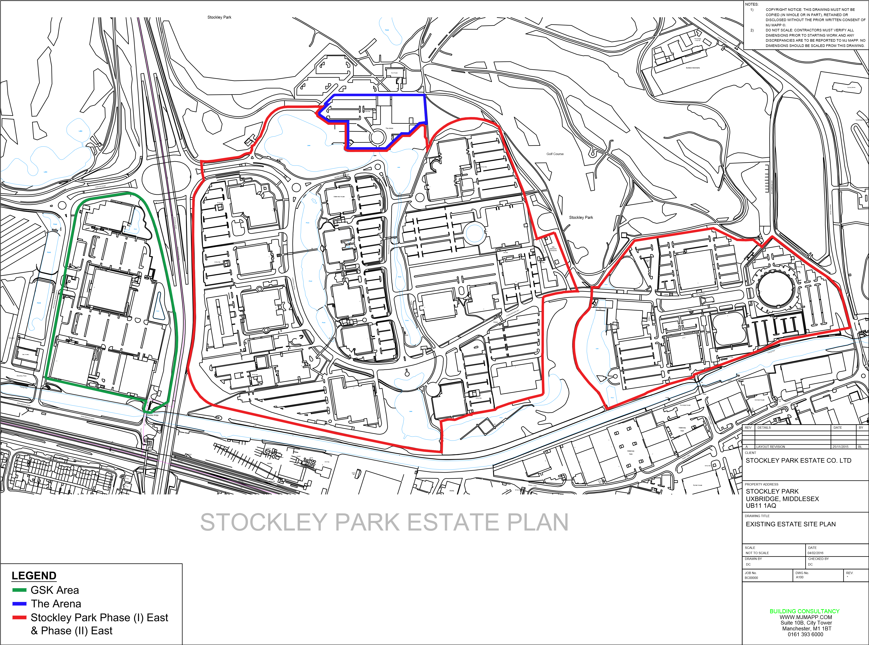
Zone 5
Zone 4
Zone 3
Zone 2
Zone 1

