PROPOSED CONVERSION OF EXISTING DWELLING HOUSE
TO PROVIDE ONE TWO BEDROOM AND ONE THREE BEDROOM SELF-CONTAINDED FLATS
WITH ASSOCIATED EXTERNAL WORKS

AT

1 FORRIS AVENUE
HAYES
MIDFDX.
UB3 2AS

DESIGN & ACCESS STATEMENT

PROPOSED CONVERSION OF EXISTING DWELLING HOUSE TO PROVIDE ONE NO. TWO BEDROOM FLAT AND ONE NO. THREE BEDROOM FLAT WITH ASSOCIATED EXTERNAL WORKS
AT
1 FORRIS AVENUE, HAYES, MIDDX. UB3 2AS

DESIGN & ACCESS STATEMENT

1.0 INTRODUCTION

  - This Statement has been prepared in support of an Application for Planning Permission for proposed conversion works at the above property. The proposed works relate to the conversion of the existing dwelling house to provide one no. two-bedroom flat and one no. three bedroom flat with associated external works and parking.

  - No. 1 Forris Avenue is a semi-detached two storey dwelling house which we believe was originally constructed in the 1950’s. The original house has been enlarged with a single storey side and rear extension providing additional living accommodation and the roof space has been enlarged and converted to provide additional bedroom accommodation.

  - The property is located on a corner plot where Forris Avenue runs into Lannock Road. The front garden to the property has been largely paved to provide parking for up to three cars. A detached single garage building has been constructed in the rear garden with vehicular access onto Lannock Road and providing an additional car parking space in front.

  - Forris Avenue comprises of a mix of detached and semi detached dwelling houses, flats and maisonettes. Original dwelling houses at No.3, 4 & 5 have already been granted Planning Permission to be converted to two separate self-contained flats with allocated parking and private amenity areas.

  - The existing accommodation at No. 1 comprises of an open plan Family and Kitchen area to the rear with separate living room and guest bedroom to the front on the ground floor, two bedrooms and a study on the First floor and a main bedroom suite at attic level. The existing property has a gross internal floor area of 178.0 sq.m.

  - The current Application proposes to convert the existing building to provide two self contained flats. The building is to be divided horizontally with Flat A, a three bed unit, occupying the ground floor with a gross internal floor area of 97.80sq.m.and Flat B, a two bed unit, occupying the First and Second floors, with a combined gross internal floor area of 80.2sq.m..

  - As such the proposal requires minimal alterations internally other than installation of kitchens and bathrooms and the creation of separate entrances, which involves enclosing the existing front porch and providing separate access doors into the main hallway. Other than very minor alterations to existing windows and doors to the side elevation, the external appearance of the property is retained as existing.

  - Externally, the front of the property is to remain largely as is, with low level bin storage units to be provided inside the existing front boundary and hedge to serve both dwellings and to be easily accessible from both the building and the street frontage for collection purposes. The existing remaining hardstanding to the front can accommodate car parking to serve the Ground floor flat.

  - Externally to the rear, the existing garden area is to be subdivided to provide separate external amenity area for both proposed flat units. The existing 2.0m high brick wall to the side boundary along Lannock Road is to be retained and the new private garden spaces are to be enclosed with new 1.8m high close boarded timber fencing to prevent overlooking. The new garden space for Flat A has a usable area of 27.2sq.m. and the garden to Flat B has a usable area of 30.4 sq.m.

  - The existing garage building to the rear of the garden is to be retained for use as general storage and cycle storage for Flat B with the existing vehicular access and car parking space also retained. The existing side access is to be subdivided lengthways with a 1.8m high close boarded fence to create separate access to each rear garden area. Two cycle stands are to be provided in the side access for Flat A.

  - In summary, the proposed development meets the general criteria of the London Plan in relation to conversion s of existing dwellings. The development has minimal external impact on the general street scene and the existing character of the area. The proposed flat units provide two bedroom/ three person and three bedroom / four person accommodation with floor areas in excess of the required minimum of 60 sq.m. Both proposed flat units have separate entrances and separate private amenity spaces of adequate size and both have both cycle and car parking spaces that comply with the minimum requirements.

2.0 Waste Strategy

2.1 This proposal involves the conversion of an existing dwelling house to two self-contained flats requiring no external extensions or alterations. The works involve minimal alterations works to the structural fabric of the existing building. As such, there will be limited waste created which will be taken to an on-site skip located in front of the existing garage and thereby not impacting on the existing off street parking on Lannock Road.

2.2 The main element of work required is the upgrading of the existing intermediate floor to a separating floor between Flats A & B and wherever possible, existing materials, such as flooring, internal doors, architraves and skirtings together with any structural timberwork will be salvaged and reused. The existing floor will be insulated to achieve the require sound proofing and floor Existing ceilings will be relined to achieve the required fire rating.

2.3 For the conversion scheme, as detailed on drawing 2232/2A, a total of four bin enclosures are provided to the front forecourt of the property, easily accessible from both flat units. These enclosures are to accommodate 2 No. 240L bin units to accommodate separate domestic waste and recycling, a 110L bin to accommodate food waste and a separate enclosure to accommodate green waste container bags.

2.4 Both flat units are to be provided with the facility to store two cycles. A purpose made secure cycle store is to be located on the front forecourt for use by Flat A and flat B can store cycles within the existing garage building.
3.0 Parking strategy

3.1 This property currently has vehicular access from both Forris Avenue and Lannock Road. The access from Lannock Road serves a single car parking space and a single garage building. The car space will be used to accommodate skips at various times but when not in such use, will provide an additional contractors parking bay. The front forecourt area will be used to accommodate up to three contractors vehicles during the building works see FIG. 1 below. With such on-site provision, there should no impact on existing off street parking as a result of these works.

3.2 To support the conversion of the property, both existing vehicular accesses will be retained. The access from Lannock Road will serve a parking space and garage which will be allocated to Flat B. The access from Forris Avenue and the existing front forecourt will accommodate one car space for Flat A - See FIG. 2A below. An active Electrical Vehicle charging point is to be provided to the front elevation and within the existing garage building to the rear.

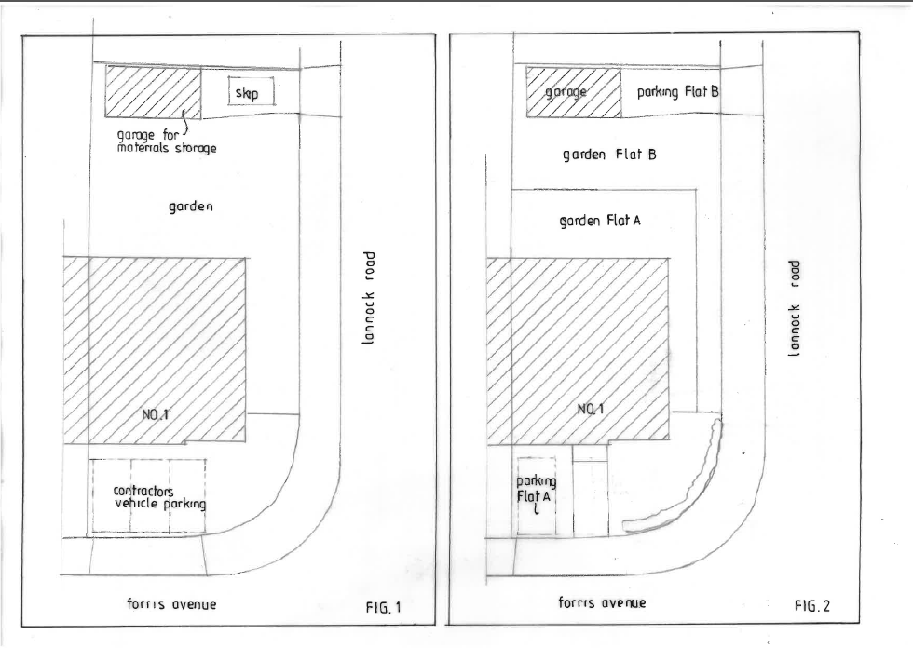

Home Plans
January 2026
(revised July 2026)
(revised August 2026)
(revised September 2026)

