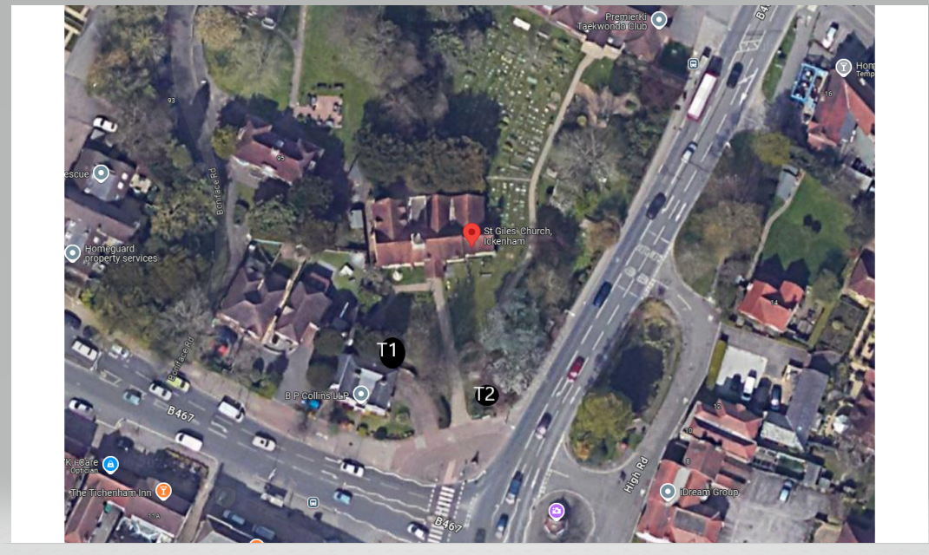

Property Address:
St Giles Church,
Ickenham,
Middlesex
UB10 8BE

T1 Yew - Reduce spread of entire canopy by approx 2m and shape accordingly, trying to maintain the dome shape that has already been established, reasons for work is to maintain size for location and clearance to neighbouring building.

T2 Cherry - Reduce spread of cherry tree by approx 2m which is growing over the church notice board (only) back to previous points.

