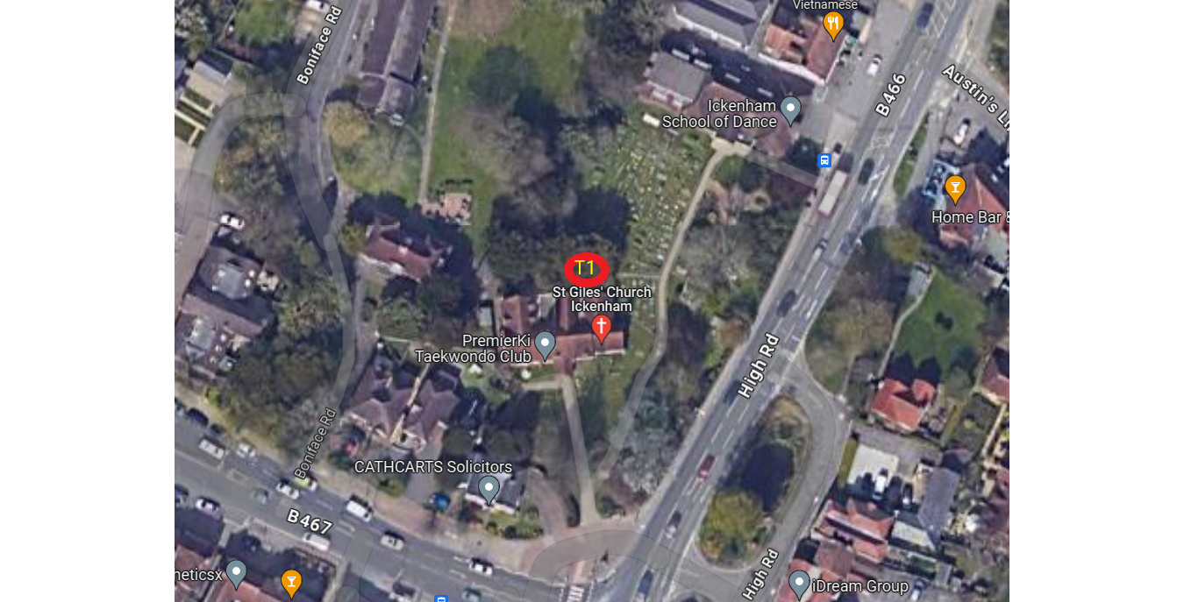

Work Location –

St Giles Church
Ickenham
Middlesex
UB10 8BE

Works to be done –

T1 – Yew – Reduce spread of tree to provide up to 2m clearance to the church building leaving the spread of the tree at approx. 15m

