November 2024
DESIGN & ACCESS STATEMENT
23 Pine Gardens, Ruislip, London, HA4 9TN

Contents
Introduction 2
The Site 3
Planning History 4
The Proposals 5
Planning Policy Context 6
Planning Policy Assessment 7
Conclusion 10

Introduction

This Design & Access Statement has been prepared by Dimensions Planning on behalf the applicant to support a full planning application submitted to Hillingdon Council. The application seeks permission for the erection of a part single, part two-storey extension to the side and rear of the existing property to facilitate its subdivision into two dwellings comprising 1 x 3-bedroom flat and 1 x 1-bedroom flat. The development includes provision for car and cycle parking, external amenity spaces, and other associated works.

The purpose of this statement is to introduce the site and the development proposals, outline the relevant planning policies and material considerations, and demonstrate how the proposals align with these to justify the granting of planning permission.

The proposals have been designed with regard to national, regional, and local planning policies, incorporating recognised best practices to ensure high-quality and sustainable development. The scheme is in general conformity with the Local Plan and the latest national and regional planning guidance, particularly regarding delivering sustainable, well-designed housing.

The development proposal:

‘Erection of a part single, part two-storey extension to the side and rear to accommodate the subdivision of the existing dwelling into two dwellings of 1 x 3 bed and 1 x 1-bed flats, car/cycle parking, external amenity space and other associated works‘.

The design approach reflects a detailed analysis of the site and its surroundings, ensuring that the scheme integrates harmoniously with the character and context of the local area.

The Site

The application site consists of a two-story semi-detached dwelling situated on a triangular-shaped corner plot on the eastern side of Pine Gardens. The property features an area of hard standing at the front, providing off-street parking, along with a private rear garden.

The surrounding area is residential in character, comprising a mix of two-story semi-detached houses in a variety of designs. The adjoining property, No. 21 Pine Gardens, is located to the northeast of the application site, forming the other half of the semi-detached pair. To the south lies No. 25 Pine Gardens.

The site is not within a Conservation Area or an Area of Special Local Character, and it does not contain any Listed Buildings or trees subject to a Tree Preservation Order. However, the property is situated within a Critical Drainage Area, which may influence considerations for surface water management as part of the development proposal.

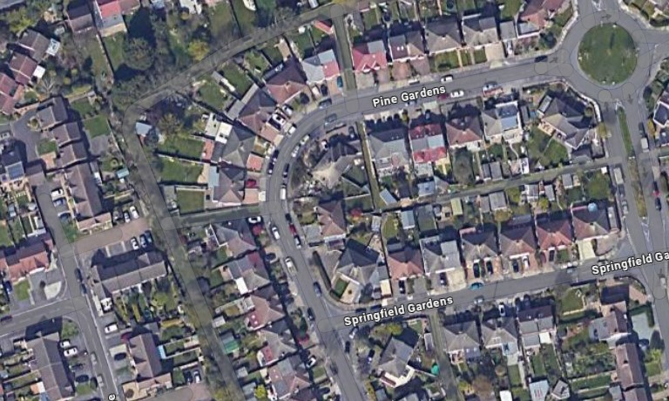

Planning History

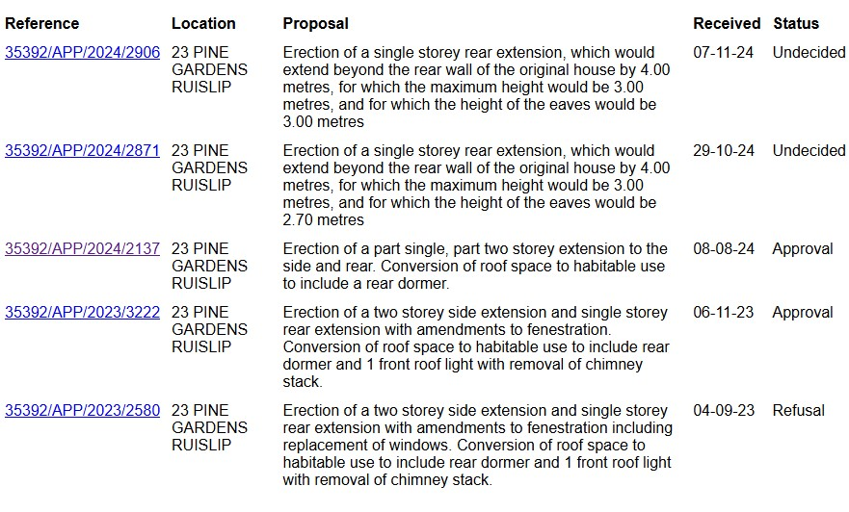

The Proposals

The proposed development is for the erection of a part single, part two-storey side/rear extension to facilitate the subdivision of the existing dwelling into two dwellings comprising of 1 x 3 bed and 1 x 1-bed flats along with car/cycle parking, refuse storage and external amenity space.

The proposed part single, part two storey side/rear extension replicates the extant scheme reference 35392/APP/2024/2137 in size, scale and design. Unlike the extant scheme this proposal does not include a rear dormer window and therefore reduced the overall built form of the development.

Each of the two flats would provide high quality living accommodation exceeding all the minimum space standards. The existing front entrance would provide access for both flats.

Flat A on the ground floor would provide family accommodation with dedicated and direct access to private outdoor amenity space, whilst Flat B would provide a smaller unit with a sizeable garden that can be accessed directly from within the site along the side access path.

Two off-street parking spaces would be provided within the existing front courtyard and would utilise the existing crossovers. A generous soft landscaped area would be formed to the front courtyard enhancing the visual appearance of the site.

Dedicated cycle and waste storage enclosures would be located appropriately within the front courtyard.

Planning Policy Context

The following National, Regional and Local Plan Policies are considered relevant to the application:

NPPF (2023):
Section 4 Decision making
Section 5 Delivering a sufficient supply of homes
Section 11 Making effective use of land
Section 12 Achieving well-designed and beautiful places

London Plan (2021):
D3 Optimising site capacity through the design-led approach
D4 Delivering Good Design
D6 Housing quality and standards
D7 Accessible Housing
H1 Increasing housing supply
H2 Small sites
H10 Housing size mix
SI 3 Sustainable drainage
T6.1 Residential Parking

Local Plan Part 1 Policies (2012):
H1: Housing Growth
BE1: Built Environment
EM6: Flood Risk Management

Local Plan Part 2 Policies (2020):
DMH 2 Housing Mix
DMH 4 Residential Conversions and Redevelopment
DMHB 14 Trees and Landscaping
DMHB 11 Design of New Development
DMHB 16 Housing Standards
DMHB 17 Residential Density
DMHB 18 Private Outdoor Amenity Space
DMEI 10 Water Management, Efficiency and Quality
DMHD 1 Alterations and Extensions to Residential Dwellings
DMT 1 Managing Transport Impacts
DMT 2 Highways Impacts
DMT 6 Vehicle Parking

Planning Policy Assessment

The main issues for consideration are:

- Principle of development
- Character and Appearance Impact
- Neighbouring Amenity Impact
- Quality of Accommodation
- Highway Impact

Principle of Development

Policy DMH 4 of the Local Plan states residential conversions of existing dwellings will only be permitted where less than 10% of properties have been redeveloped into flats and that the floor area of the original building is 120m2 or more.

From a check of council tax records and planning history, it appears that of the 146 properties, none are known to be converted and so the development represents 0% of the street, thus compliant in this regard.

The internal floor space of the original dwelling is 97.2m2 which is a departure from Policy DMH 4.

However, having regard to the undeveloped nature of the dwelling on a medium-sized plot, the additional floor space associated with the extant permissions adds a further 69.2m2 floorspace, such that there is a sufficient amount of internal floorspace and outdoor amenity space for two flats and would exceed the required 120m2. The extant permission is a material consideration in the assessment of this proposal and should this scheme fail there is a real prospect of its implementation. As such, the intent of the policy would be fully adhered to.

It is also highlighted that the assessment of the previous permission(s) (and by extension the subject application) concluded an absence of any adverse impact upon the street scene and with no further erosion of the front garden, there is already adequate parking and no additional traffic congestion. Whilst there is the loss of a 2 bedroom dwelling, which is below family sized, it would be replaced with a well appointed and fully compliant 3 bedroom family unit with a net gain of an additional 1 bedroom unit. As such, the loss of the existing dwelling is sufficiently outweighed by the benefits of the scheme.

Accordingly, whilst there is in part a policy departure from Policy DMH 4, there remains adequate justification for the departure and the principle of the residential conversion should be supported. This has been implemented in similar applications like application 76956/APP/2022/3602 & 14032/APP/2021/2749 where if the extended property can meet or exceed 120m2 then it is acceptable.

Policy DMHB 17 of the Local Plan requires a density of 35-70 units per hectare. The conversion of the existing building to two flats would have a density of 67.6 units per hectare (Dwellings per hectare = 2 / 0.029591​ ≈ 67.6 uph) as such the density of the development is acceptable.

Policy DMH 2 of the Local Plan requires a mix of housing units of different sizes in schemes of residential development. The proposal involves the loss of a 2-bed dwelling, however re-provides a 3-bedroom family unit and net additional 1-bedroom unit. On a small-scale development within a mix of dwelling types in the street, there should be no objection to the dwelling mix.

In conclusion, the proposed development would be in accordance with the aforementioned policies and therefore the principle of development should be supported.

Character and Appearance Impact

The acceptance of the proposed part single, part two storey side/rear extension has been firmly established by virtue of the extant scheme which this proposal replicates. It is highlighted that current proposal unlike the extant scheme does not include a rear dormer window and therefore reduces the overall built form of the proposal and represents a betterment over the extant scheme. There should therefore be no objections to the proposed enlargements.

Neighbouring Amenity Impact

Policy DMHB 11 together with Policy DMHD 1 sets out the requirement to ensure development proposals do not adversely impact neighbouring amenities.

As previously considered acceptable, the proposed part single, part two storey extension would not extend beyond the rear elevation of the property and maintains a minimum separation distance of at least 2.5m to the common boundary with no.25, this combined with its angled siting ensures the proposal would not adversely impact neighboring occupiers in terms of overshadowing, light or outlook.

Quality of Accommodation

Policy DMHB 11 and DMHB 16 of the Local Plan requires a high standard of design with minimum space standards for internal and external spaces. Similarly, Policy D6 of the London Plan sets out housing quality standards.

The provision of units against the requirement is set out in the table below:

 | Unit Type | Proposed GIA (sqm) | Required GIA (sqm)
Flat A (Ground Floor) | 3b4p | 85 | 74
Flat B (First Floor) | 1b2p | 55.8 | 50

As per above, all units exceed the minimum space standards.

All bedrooms comply with the requirements whereby double bedrooms are at least 11.5sqm in area and 2.75m wide and single bedrooms a minimum 7.5sqm in area with a width of at least 2.15m.

Policy D6 requires 75% of the floor area for each unit to have a minimum of 2.5m floor-to-ceiling height. Both units would benefit from 2.5m floor-to-ceiling height throughout.

Both units would be dual aspect with ample glazing ensuring a good standards of outlook and daylight levels.

The ground floor unit opens onto a subdivided rear garden providing direct access for this family unit. The rear garden for the upper floor unit is accessed via the side access path and is positioned at the rear of the garden.

Policy DMHB 18 sets out private outdoor amenity space standards. The below table sets out the requirement against the provision:

 | Requirement | Provision
Flat A (Ground Floor) | 30sqm | 30sqm
Flat B (First Floor) | 20sqm | 54.7sqm

As per above, each unit meets/exceeds the required outdoor amenity provision.

In conclusion, the proposal would provide a high quality living environment for future occupiers of the respective units.

Highway Impact

Policy DMT 2 and Appendix C address car parking impacts and the required off-street parking provision. It requires 2 spaces for 3-4 bedroom flats and 1.5 - 1 space for 1 bedroom flats. Nevertheless, Policy T6.1 of the London Plan, which is the most recent adopted plan of the Local Plan, provides maximum standards and requires for this proposal which lies in a PTAL 2 rating, up to 1 space for 3 bedroom units and .75 spaces for 1-2 bedroom units. Accordingly, the maximum provision (rounding up) is 2 spaces.

The proposal provides 2 off-street parking spaces utilising the existing crossovers for the property. This accords with the maximum parking standards of the London Plan and therefore should not be objectionable.

Cycle Parking:

In accordance with Policy T5 of the London Plan, each unit would require two cycle parking spaces. The proposal provides for a dedicated store within the front courtyard to accommodate a total of 4 cycle spaces and therefore in compliance with the standards.

Refuse Storage:

A dedicated bin store will be located alongside the south western side boundary with sufficient capacity to meet the requirements for all waste streams. The location of the bin store is in close proximity to the highway providing ease of access to both residents and collectors.

Flood Risk

The site lies within a Flood Zone 1 meaning it is at low risk from flooding. Furthermore, the flood map for planning government website notes it is at very low risk from surface water flooding and unlikely to result in groundwater flooding. It is noted that the Councils GIS indicates the site lies within a CDA, however, this appears to conflict with other available data including the Councils CDA maps and West London Strategic Flood Risk Policy Map which does not indicate the site lies within a CDA. In any event, the proposal is for the conversion of the existing property through extensions and measures such as soakaway areas or permeable surfacing would sufficiently mitigate any added risk.

Conclusion

The principle of the development should be supported and is principally in accordance with the aforementioned policies. The proposed enlargements feature as subordinate additions and largely replicate the extant scheme. The proposal would result in a net gain of family housing and provide a high quality living environment for future occupiers. The proposal does not raise any concerns in terms of impacts to neighbouring amenities or the highway network. Consequently, the proposal should be supported and approved. The applicant is willing to accept any reasonable conditions.

