23 Mansfield Drive, Hillingdon – Site Photos – 17/11/23
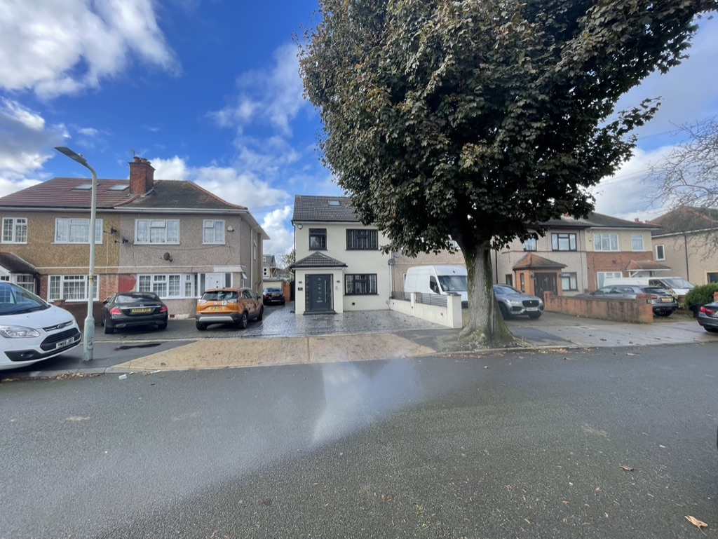 | 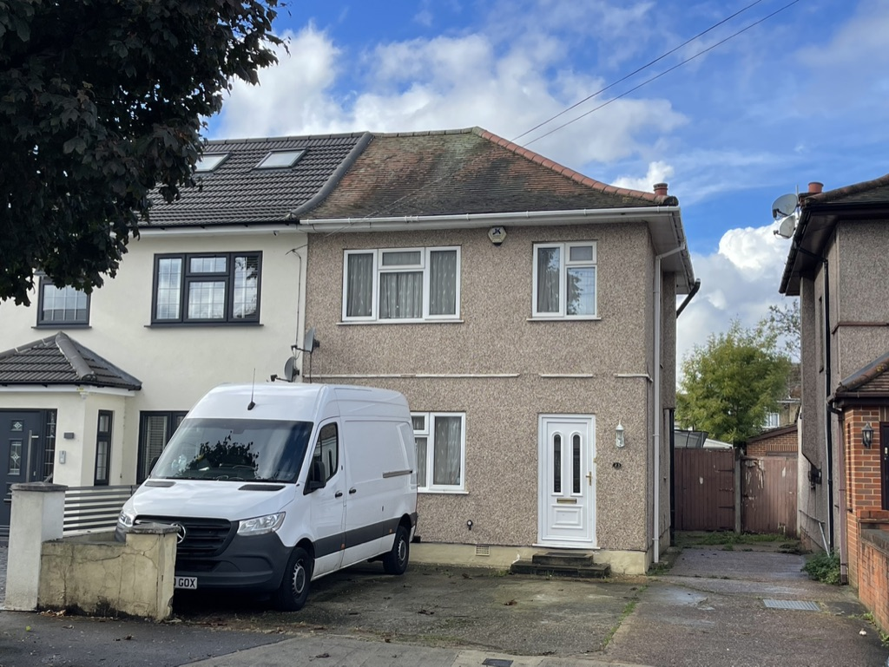
- Front Semi-detached property (21, 23 & 25) Mansfield Dr | - Close up of side access/boundary with nº 25 Mansfield Dr
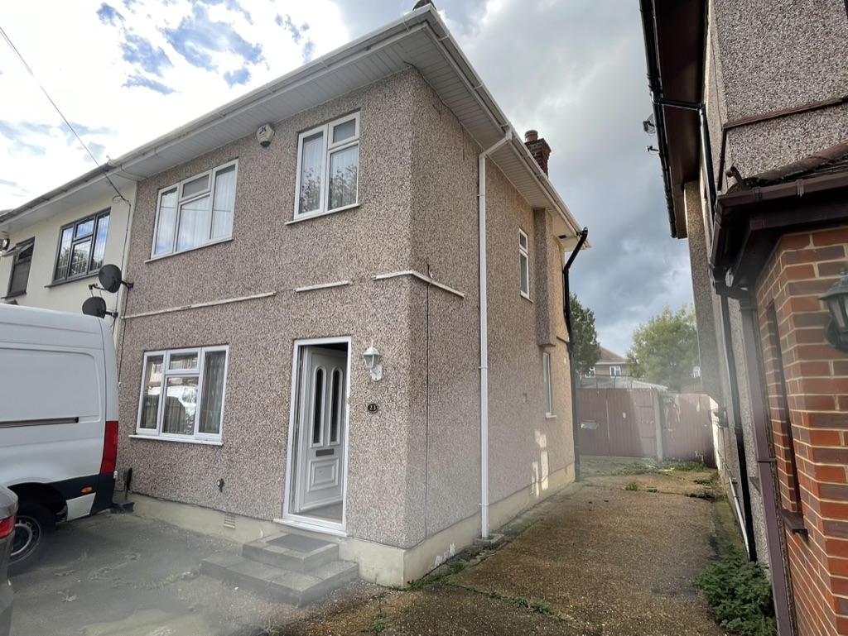 | 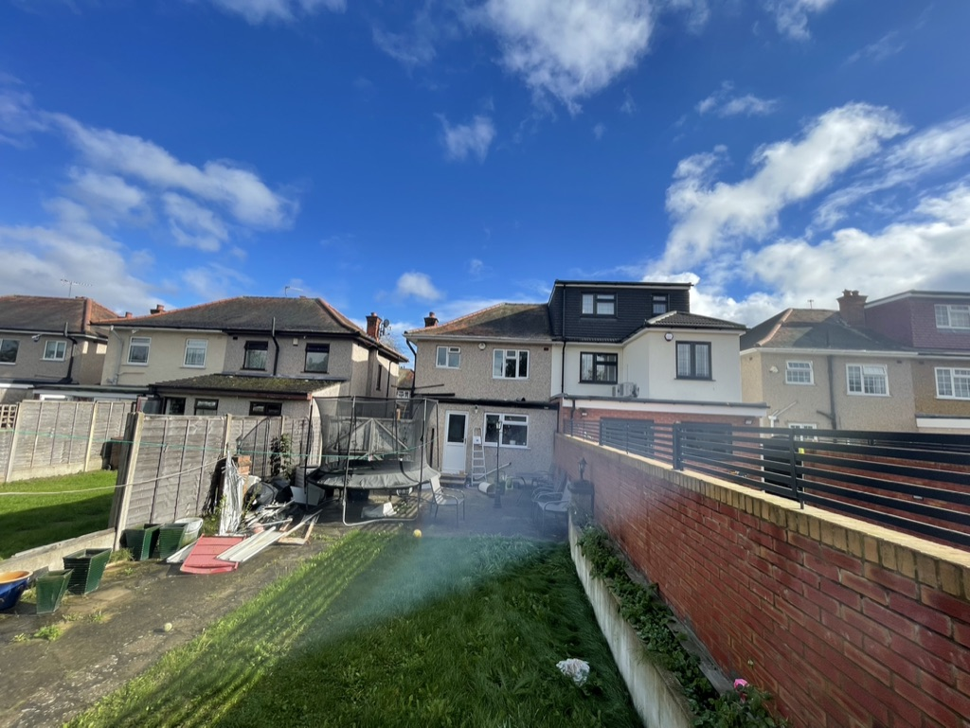
- Common Driveway between 23 and 25 Mansfield Dr | - Front: Semi-detached property (23) Mansfield Dr/Side Access abutting nº. 25
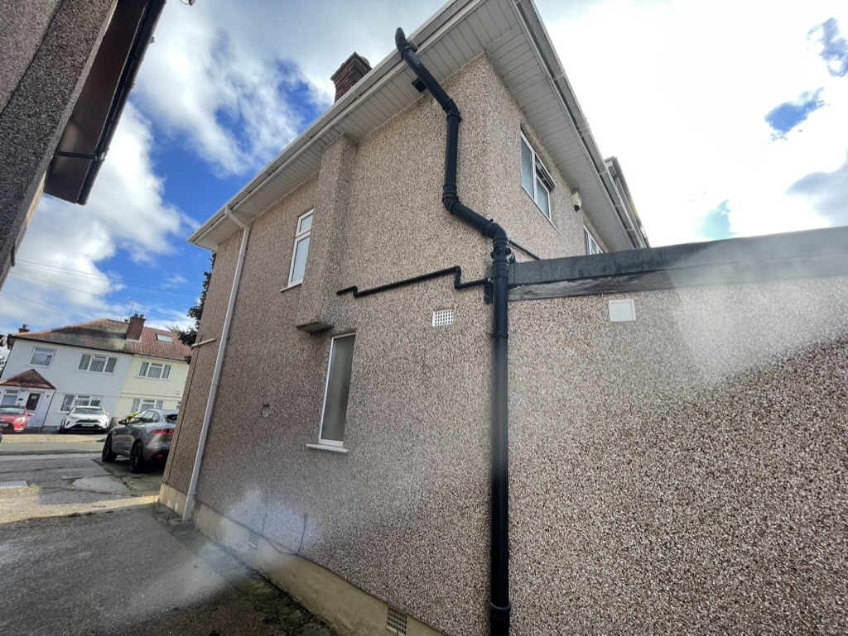 | 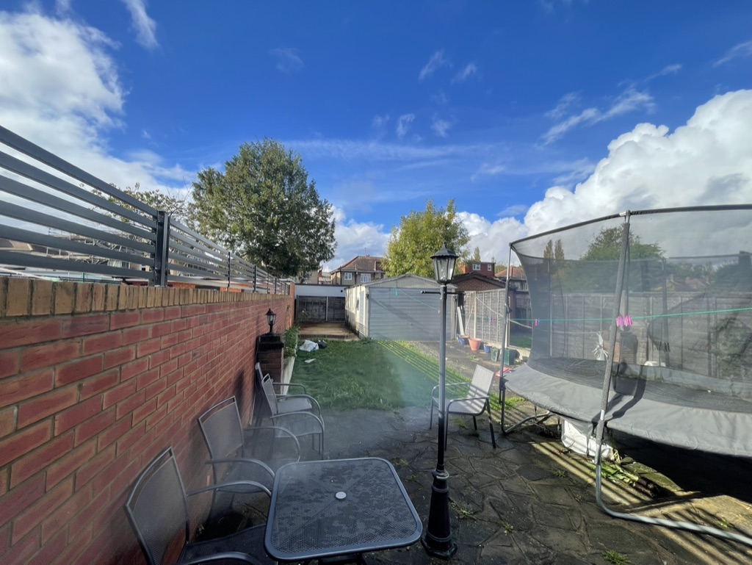
- View to rear side access | - Boundary/side access with Nº.23 Mansfield Dr
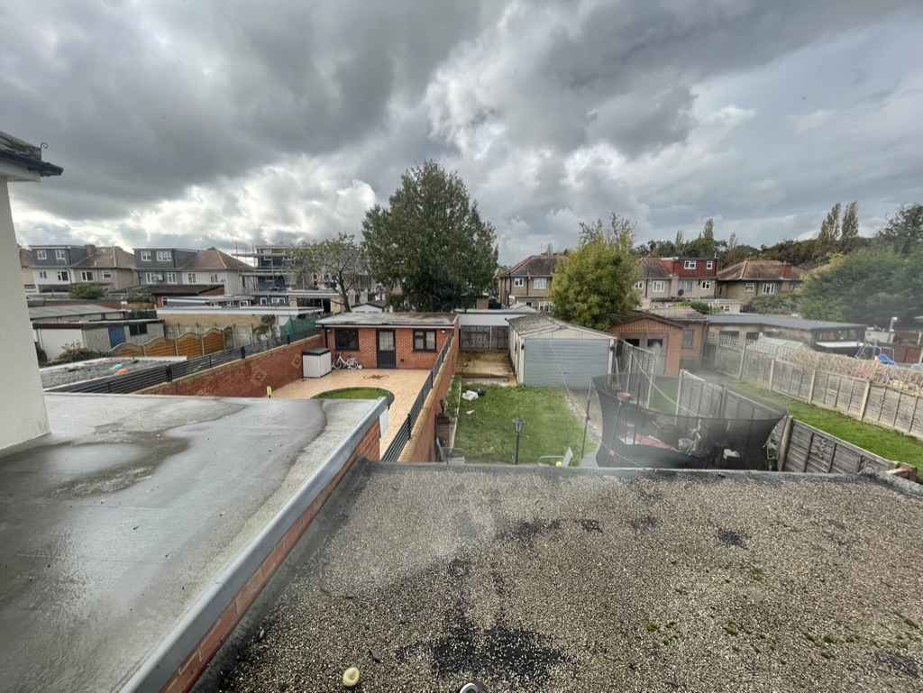 | 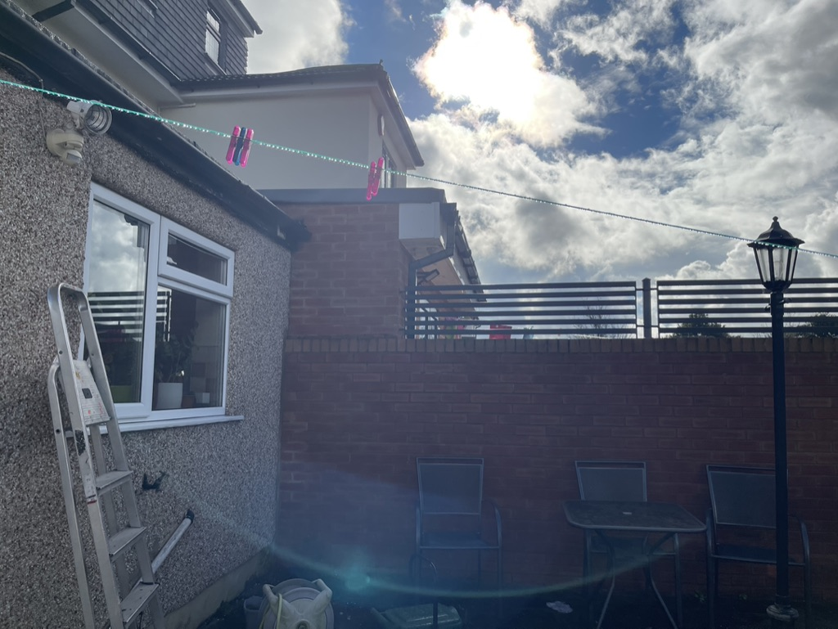
- Rear gardens of properties nº. 21, 23 and 25’s Mansfield Dr | - 21 Mansfield Dr Rear, Loft, Part Single Storey and Part two Storey Extension in background
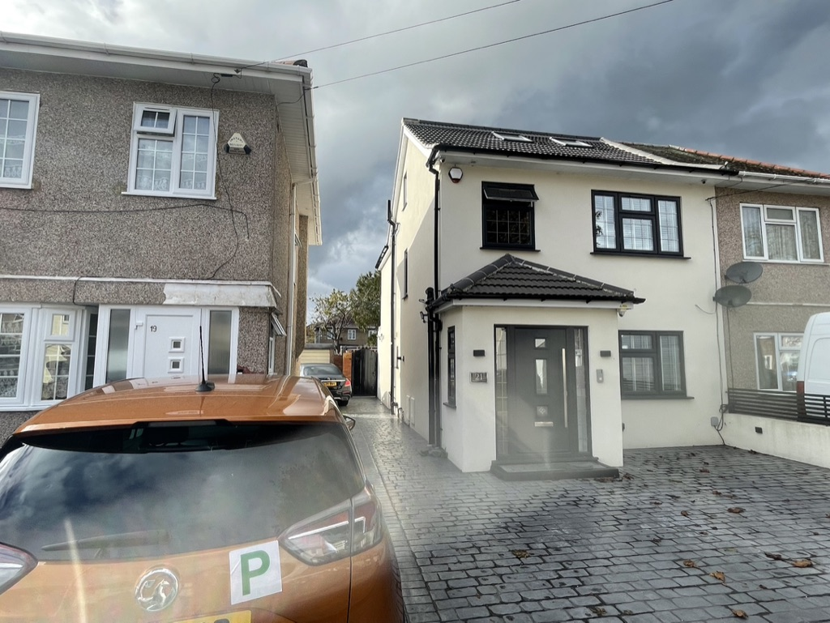 | 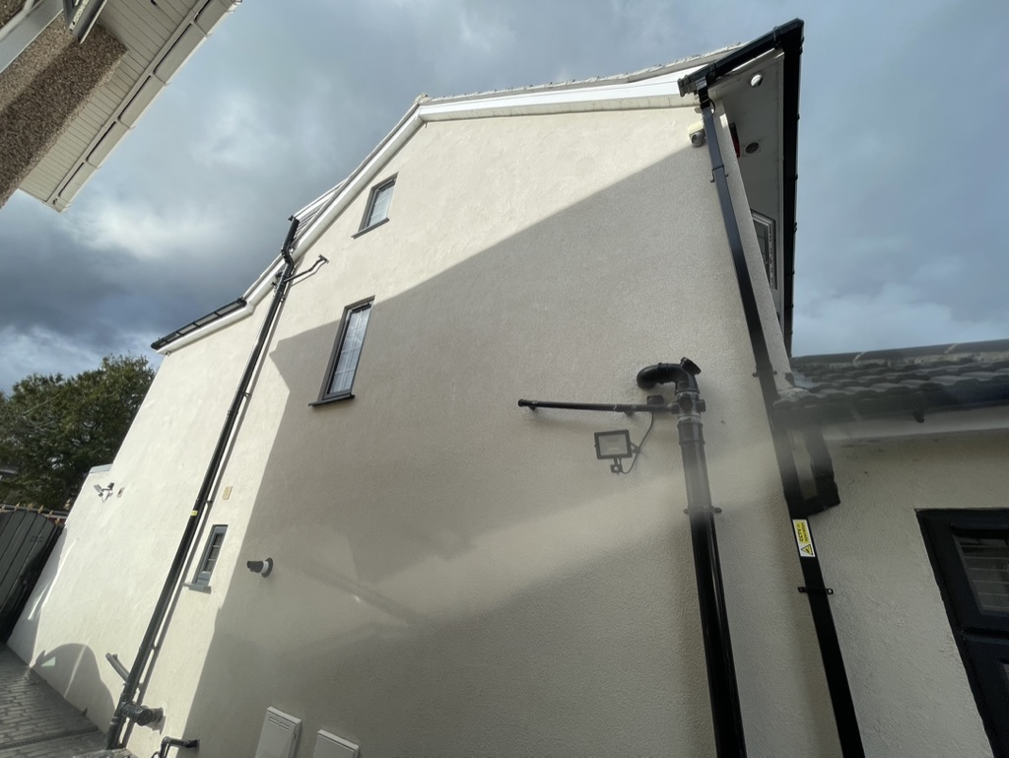
- 21 Mansfield Dr Front/Entry Porch and Skylights | - Flank of nº. 25, with rear extension and entry porch
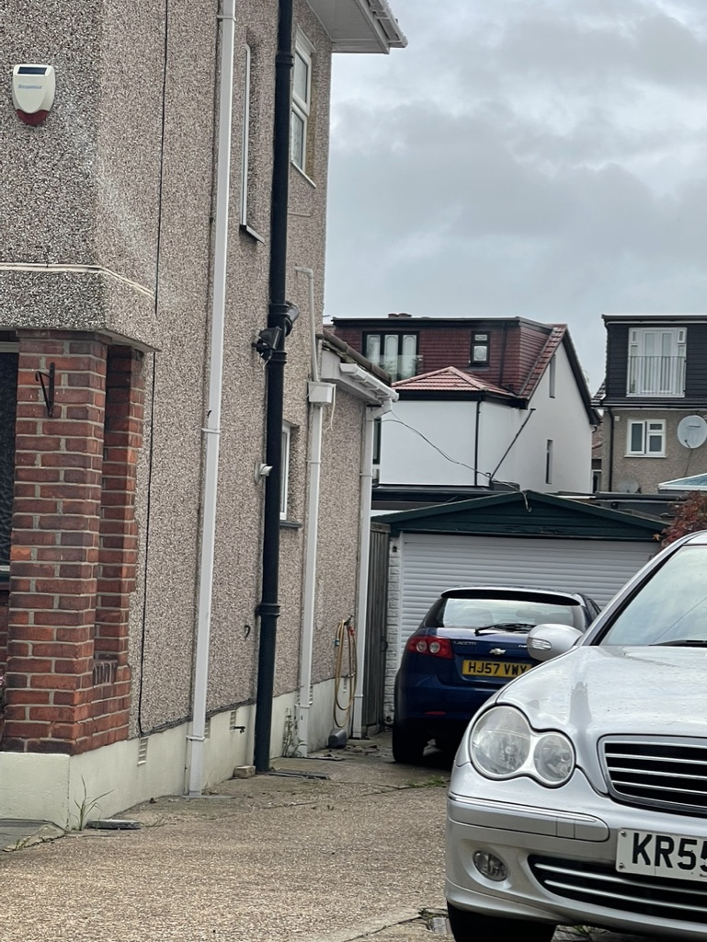 | 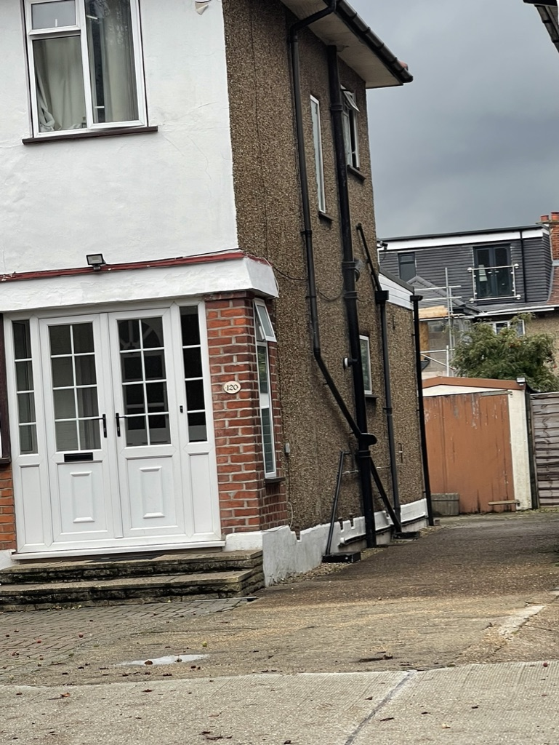
- Dormers with Juliet Balcony and 2 storey extension | - Rear Dormers with glazed Juliet Balcony

