Meadow High School
Construction Management Plan
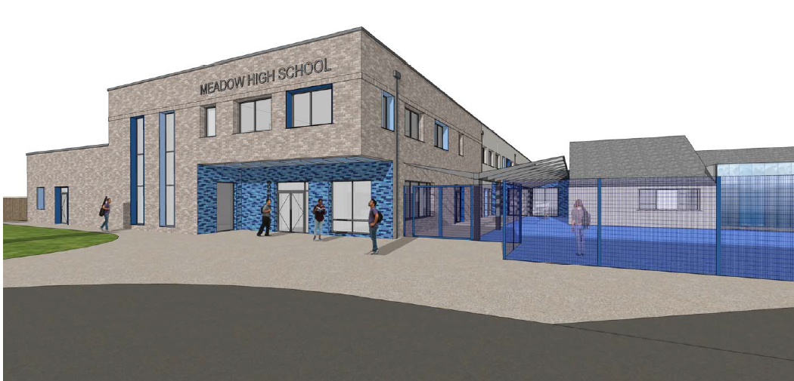
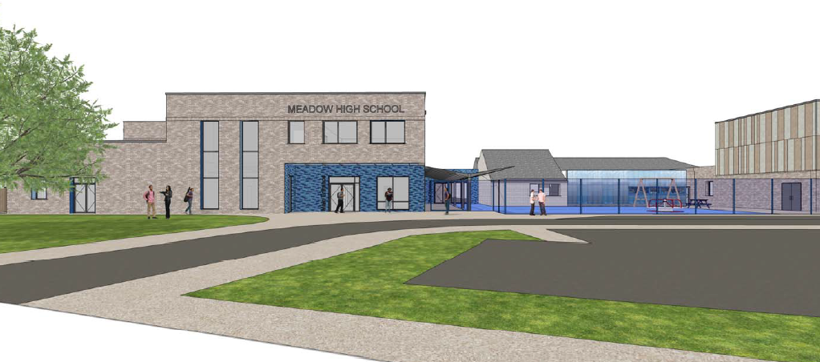



Issue – For Planning Application
Revision - A
18/05/2020
1.0 Contents
- Contents
- Introduction
- Project Description
- Site Operations
  - Site Management
  - Communication of the works
  - Noise and Vibration
  - Dust Suppression / Air Quality
  - Site Security
  - Working Hours
  - Scaffolding
  - Temporary Services
  - Phasing and Programme
- Environmental Management
  - Ecological Protection
  - Local Nuisance
  - Hazardous Substances
  - Tree Protection
- Public Safety
- Drainage and Dewatering
- Waste Management
- Traffic Management & Highways Work
  - General Measures
  - Deliveries
  - Parking
  - Public Transport
  - Plant Selection / Emissions
  - Highways Works
- Key Contacts
Appendices

2.0 Introduction
This document sets out the site control measures and strategies which will be employed to, as far as is reasonably practicable, minimise the impacts of construction operations on traffic and the local environment.
This plan has been developed to support the planning application for the construction of the new Meadow High School in Hillingdon. The Construction Management Plan will be a ‘live’ document that will be monitored and reviewed throughout the duration of the project to ensure that it reflects the current site activities and hazards. The plan will be distributed to all key stakeholders and sub-contractors involved with the project, to ensure that the measures set out are always followed.
Galliford Try has developed this plan as the principle contractor for the project.
3.0 Project Description
The Meadow High School project will provide a new a new teaching space on the existing school grounds, on Royal Lane in Hillingdon including the following key work activities;
- Removal of the existing temporary classrooms to the South of the school, and installation of 2 new ones in the NE corner of the school field.
- Construction of a Steel framed two storey building focused along the Southern boundary of the site. This to include teaching spaces, a new entrance / reception area, food technology space and a new hall / canteen facility
- Demolition of the central section (EFAA building) of the school to create space to construct a new sports hall and external hard play area
- General making good / new hard landscaping and car parking to the East elevation, adjacent to Royal Lane.
The School is located off Royal Lane in Hillingdon. Royal Lane is a 30mph road and within the immediate vicinity of the project has houses occupying the opposite side of the road, a Mosque to the Southern Boundary, and the open space of Philpots Farm to the West. The main access to the site both during construction and permanently will be via Royal Lane with the existing entrance being widened and a one-way system into and out of the car park being enabled. There is very limited public parking available in the immediate area around the School site.
There are reasonable public transport links with the nearest bus stop being an 8 min walk away on Pield Heath Road, served by buses U1, U2, U3, U4 and U7: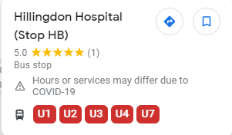

The U1 bus route also links to Uxbridge Tube Station – with the total journey only 20 mins via bus and foot.
Figure 1 - Location of Meadow High School site on Royal Lane, and proximity to M25 and Uxbridge Tube Station
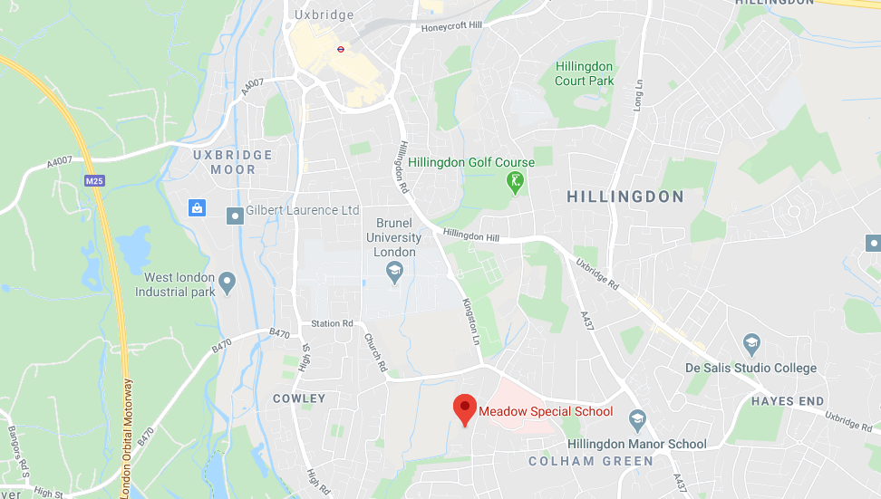

The main access for the project will be via the Royal Lane entrance, opposite Bryony Close. This will be enlarged and will have a permanent gateman to manage deliveries etc. Access for the new temporary classrooms will be via Benson Close to the North, but this will not be used for day to day construction activities.
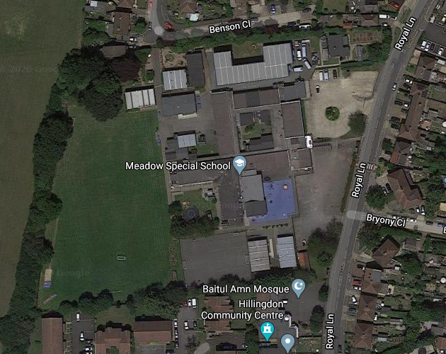
Figure 2 - Aerial Photo of the site location
4.0 Site Operations
This section details the control measures Galliford Try will employ on this project to ensure construction activities are always safely controlled and that the impact of these operations is minimised on all stakeholders to as great an extent as reasonably practicable. Appendix A illustrates the proposed location of the construction site fencing, compound and work areas and should be read in conjunction with the following sections.
4.1 Site Management
As principal contractor, Galliford Try will have responsibility for health, safety and environmental aspects of all construction operations on site. Control of operations will be coordinated by the site management team on site which includes a Project Manager who will be the main point of contact for all site related issues and other Site Management personnel for day to day running of the site.
The site team will be supported and assisted by our regional office based staff including environmental, planning, temporary works and health and safety managers. Services installation co-ordination and management will be achieved by the appointment of a services manager to the project.
Prior to any sub-contracted works commencing on site, strict controls are used to ensure that suitable method statements, risk assessments and environmental control plans are in place. These documents are all reviewed prior to works commencing and are monitored and updated as works progress. A general risk assessment of the works has been undertaken by Galliford Try management and is included in Appendix B. Safety of the Public, School staff & Pupils and Site operatives is of paramount importance to Galliford Try.
4.2 Communication
To ensure that all stakeholders of the project are all made fully aware of any disruption to the local area caused by construction activities it will be important to provide effective communication in advance of works. Galliford Try will work closely with London Borough of Hillingdon, Department of Education, Meadow High School and the local community to identify the stakeholders and ensure they are consulted and updated throughout the construction process.
Galliford Try is an associate member of the Considerate Constructors Scheme and takes its responsibilities to the local community and environment very seriously. Some of the measures that will be implemented on the project include;
• Contact details for the Project Manager posted on the site hoarding and construction area fencing, who will be available 24/7 to deal with any queries or issues.
• Information / Community notice board erected at the site entrance and in other suitable locations to inform local residents and stakeholders of upcoming works
• Galliford Try will feed into the existing temporary school’s communication system to make parents and staff aware of any potential disruption
• Periodic letter drops to residents throughout the project to update them
• Where appropriate Galliford Try will utilise social media to assist with the communication of the works to enable interested parties to stay updated with upcoming works.
• Communication will be reviewed and approved by relevant parties prior to its general release.
4.3 Noise and Vibration
Galliford Try will endeavour to minimise noise and vibration disturbance throughout the project by employing appropriate measures during the different stages of project delivery. Galliford Try will create Local Impact & Nuisance Management Plans for some of the sub-contract packages to tailor measures specific to each element of work and will use guidance from BS 5228 ‘Noise Control on Construction and Demolition Sites’ as the best practice guideline. Some of the control measures which we will utilise on this project include;
• Tool Box Talks In accordance with BS5228 will be provided to operatives on noise and vibration to ensure the whole workforce is aware of best practice for reducing noise and vibration.
• Within task specific method statements, noise advisory levels and noise action levels will be identified to ensure safe control over the works.
• Plant and equipment will be powered down when not in use to avoid unnecessary noise and vibration.
• All plant and equipment will be properly maintained in accordance with manufacturer’s instructions.
• Plant will be selected with the task in mind to ensure appropriate size plant and equipment is used in accordance with task requirements.

4.4 Air Quality
Construction operations can have a detrimental impact on air quality when not managed properly. Given the construction site is located next to the existing school where children will be playing outdoors and public housing nearby. It is of additional importance to ensure that air pollution is kept to a minimum. Specific control measures to reduce pollution will be detailed in the Local Impact & Nuisance Management Plans outlined in section 4.3. The following measures will be used to minimise the impacts of construction work;
• When possible materials will be ordered so as they do not require cutting on site to eliminate the need for cutting operations, this is particularly important due to limited space available on site
• Cutting activities will always be damped down with water
• No burning of materials or bonfires will be permitted on the site at any time
• All non-road mobile machinery (NRMM) to use ultra-low sulphur tax exempt diesel (ULSD) where available
• All loads entering and leaving site will be covered
• Any temporary site roads stoned up areas will be damped down during dry periods to prevent dust from spreading
• The requirements for dust suppression generally will be monitored daily and called in as and when required
• Demolition works will always be damped down to minimise dust

4.5 Site Security
Galliford Try will establish a secure compound around the construction area of the project for each phase as per Appendix A – Logistics Plan. The Galliford Try compound will be securely hoarded with initially a mix of Heras fence and timber hoarding for the enabling works, before a full timber hoarding being established. There will be a vehicles access gates off Royal Lane which will be closed when not in use and locked securely at night. The gates will be installed such that they will open into the site so as not to obstruct the pedestrian footpaths/roadways outside of the site.
During the Enabling Works, there will also be limited access from Benson Close for the install of the new temporary classrooms. At all times, permanent traffic marshals will be in place to manage the deliveries.
Any plant left on site will have immobilisers fitted and the keys will be secured away from the plant in a safe location. Construction work areas will be fenced off where any interaction with the general public is expected. No plant or materials will ever be stored on the public highways.
CCTV security to be installed around site hoarding to ensure site security.
Emergency contact details for the Project Manager will be clearly visible on the site perimeter at the site gates if any emergency requires it. Daily fence checks will be undertaken by the site team to ensure that the site perimeter is secure to prevent unauthorised access. Galliford Try will hold assemblies/briefings within the existing school to communicate the dangers of construction sites to the secondary school children to reduce the risk of pupils trying to access the site.
4.6 Working Hours
Core working hours for the site are proposed to be;
Mon – Fri: 07.30 – 18.00 and Sat: 0800 – 1300
Galliford Try personnel will always be present whenever any work is taking place on site.
If for any reason work is required to be undertaken outside of these hours, this will be communicated to all relevant parties for prior agreement.
Delivery times will be strictly enforced by Galliford Try. Deliveries will be co-ordinated to avoid school pick up and drop off times. As such we will ensure no deliveries between 08:00-9.00am and 3.00-400pm. Further information on the controlling of deliveries can be found in section 9.2.

4.7 Scaffolding
Conventional scaffolding, where required, will be independent with boarded lifts to suit the nature, location and type of the operations being carried out. All scaffolding will be securely tied to the structure and will include suitable access.
Scaffolding will be provided, erected and maintained in accordance with all current statutory regulations and brick guards will be to used to serves as guarding.
Suitable guard railing will be utilised to prevent falling from unprotected edges of the excavations, upper floors and staircases as applicable.
No person other than certified competent scaffolders will be permitted to erect, alter, adapt or dismantle any conventional scaffolding.
4.8 Temporary Services
• Power supply will be provided by a connection to the existing school
• 110v power will be utilised throughout the building.
• Water will be provided direct from the mains system for use in the welfare facilities.
• Temporary drainage will be connected into the existing onsite foul drainage

4.9 Phasing and Programme
We have planned the works to be undertaken by the five main phases;
- Phase 1 Demolition of the existing Temporary Classrooms and Install of 2 New – EFAS and EFAR – Aug 20 – Sept 20
- Phase 2 Construction of the new Meadow High School – Oct 20 – Sept 21
- Phase 3 Asbestos Survey / Removal to Existing Blocks – Jul 21 – Nov 21
- Phase 4 Refurbishment Works to Knuckle & Pulled-up Block & Demolition of EFAA - Oct 21 – Feb 22
- Phase 5 New Sports and Changing Facilities Building & Removal of Temporary Classrooms and Made Good Playing Field – Feb 22 – Aug 22
Planned Programme Duration
Our construction programme for the entire project has an overall period of 102 weeks with a contract completion in August 2022. The first phase, which is demolition and install of the temporary classrooms will commence from 7th Aug 2020, and works proper to the new build from the 5th Oct 2020.
Mobilisation
Immediately prior to starting on site we will undertake a letter drop to all local residents providing contact telephone numbers for our on-site management should any issues arise during the build relating to the community. A community open evening will be held prior to starting on site to explain the construction process and timeline for constructing the new school facilities. Liaison with school and community will continue throughout the project.
The site establishment works will commence with the erection of the perimeter hoardings to segregate the construction working area from the operational school buildings and external areas. All the suppliers and supply chain contractors will be issued a traffic management plan which will confirm the vehicle restrictions. There will be a daily logistic meeting on site with the contractors and schedule will be produced to coordinate the timed deliveries.
Construction Access
Construction deliveries will be directed onto Royal Lane to where the construction entrance Is located, from the M40 to the North and the M4 to the South
The construction traffic will be controlled by a dedicated gateman / banksman, thus preventing any unauthorised access to the construction works. The entry to the site will be controlled at the gatehouse, where all personnel will report to the gateman. An electronic turnstile will control and monitor access for construction operatives, site visitors and Galliford Try management
All deliveries will be controlled at the site entrance and directed to the unloading area. The deliveries will turn around within the site boundary to mitigate the need for vehicles reversing onto Royal Lane.
- Phase 1 Demolition of the existing Temporary Classrooms and Install of 2 New – EFAS and EFAR
The first phase of works is the enabling works to allow the new build to go ahead. This involves the demolition of the existing temporary classrooms to the South of the school, and the install of two new ones in the North-East corner of the playing field. There is also the establishment of tree protection zones and service diversions required for the new build.
- Phase 2 Construction of the new Meadow High School

The second phase is the build of the main new school building where the original temporary classrooms have been removed from. The build is a steel frame construction, with brickwork cladding connected back to an SFS system internally, and a 3 ply felt flat roof on a concrete deck. This phase also includes for the secure hard play area to the South, re-surfacing of the first section of the car park, and new permanent fencing and gates.

- Phase 3 Asbestos Survey / Removal to Existing Blocks

This phase relates to the asbestos survey and then removal from the existing school areas now decanted into the new building.

- Phase 4 Refurbishment Works to Knuckle & Pulled-up Block & Demolition of EFAA

This relates to the refurbishment of blocks EFAA, EFAB and EFAC, and the demolition of the remainder of EFAA to create space for the new sports hall and external sports areas.

- Phase 5 New Sports and Changing Facilities Building & Removal of Temporary Classrooms and Made Good Playing Field

The final phase is the construction of the new Sports Hall where the EFAA has been demolished. Again this is a steel frame structure, with a mix of render and brickwork to the external elevations, and a 3 ply felt flat roof on a concrete deck. Externally there is a MUGA adjacent to the sports hall, and then the removal of the temporary classrooms and the making good of the existing playing fields.

5.0 Environmental Management
5.1 Ecology
Ecological protection measures will be implemented as required in accordance with the ecological assessments and approved mitigation strategies.
5.2 Local Nuisance
The Construction Liaison Representative for the project shall be Tony Sedgwick (contact details can be found in the Key Contacts section 10.0)
The project shall be registered with the Considerate Constructors Scheme and measures will be implemented to reduce all elements of nuisance caused by the construction of the works.
Contact details for the public to use to make any complaints or query regarding the project shall be posted on the fencing for the work areas. Galliford Try will also supply a number of update notice boards and online systems to enable people to comment via the internet. The Construction Liaison Rep will feed any comments/complaints back to the relevant individuals within the school and council upon receipt. Letter drops will also be undertaken in advance of works starting, with periodic updates on progress with information on any aspect of the project which may impact the local residents.
To reduce the visual impact of construction activities from public areas, a solid timber hoarding shall be installed to screen off the construction activities for the build elements of the project. The hoarding will be kept in good condition and the verges will be kept tidy and where appropriate landscaped. Heras fencing will be used during the initial install of the temporary classrooms to the North West of the school field.
Wheel washing facilities will be provided on site as necessary during relevant periods of the project to ensure that no debris is carried onto the local highways. Road-sweepers will also be available on call in the event of any accidental debris spill on to the road.
Very limited parking will be available on site during the initial construction phases, but as the frame develops and space becomes less available on site, there will be no Parking available within the site area, or on the school grounds.
Sub-contractors will be encouraged to use public transport, and shared car & van usage, and avoid the nearby residential areas.
5.3 Hazardous Substances
Any materials which fall under the COSHH regulations shall be stored in a suitable container in accordance with the COSHH sheet and manufacturer’s instructions. These materials will be stored in a locked enclosure, with appropriate bunding to ensure that no discharge into the local environment is possible.
A spill kit will be available for all storage areas and an action plan will be in place to deal with any accidental discharges such as spillages, along with emergency plans for relevant activities.
5.4 Tree Protection
Tree Protection will be installed in accordance with approved arboriculture method statements and plans to ensure that relevant trees are suitably protected from damage during construction activities. Relevant signage will also be installed, and a strict permit to enter will be incorporated. This is mainly to the trees to the left of the entrance off Royal Lane
6.0 Public Safety
The safety of the public and the workforce is paramount to Galliford Try during all construction operations.
Consideration of the public, school staff and pupils will be the first consideration during all activity planning. Robust and secure fencing will border the site to ensure that access is not possible for pupils or other members of the general public. The construction site will have its own dedicated access to avoid interface and conflict with the existing school access points. Adequate warning signage will be placed on all fencing to ensure the hazards are clearly visible to all passing pedestrians.
When construction vehicles or deliveries are approaching the site, they will be met by the site banksman / traffic marshall, who will manage the safe access and egress of construction related vehicles.
There is suitable space within the site boundary to act as a holding area for deliveries as per the logistics plan in Appendix A to ensure that deliveries are not blocking the main road and/or footpath.
Galliford Try will ensure sufficient control of all sub-contracted works to ensure that no risks are placed on the general public.
During the construction phase of the project, fire assembly points will be clearly shown on site traffic management plans and agreed with the school. Joint fire drills will be held with the school if practicable to ensure that all parties understand the fire routes and assembly points. Additional fire drills will be held in the event of significant changes in the fire safety plans due to different phasing of the project.
7.0 Drainage and Dewatering
7.1 Existing Surface Water
Existing building and external areas drain into the private SW system serving the school which discharges into the Thames Water SW sewer located on Benson Close. Public sewer discharges into the River Pinn located 270m to the west of the school.
Site investigation indicates that the site is located on topsoil and made ground overlying clay strata (Langley Silt Member) underlaid by Boyn Hill Gravel Member and London Clay Formation. Groundwater has been monitored and recorded between 0.82m and 1.69m below ground level.
Considering the above, infiltration as means of disposal is not feasible on site due to the clay sub soils and high groundwater table above the gravel strata.
MicroDrainage calculations have been carried out taking into consideration the contributing areas within the development boundary. Any contributing areas upstream of the site have not been included. The existing flow rates have been calculated as follows:
Qbar: 1.2 l/s
1 year return period: 36.8 l/s
30 years return period: 48.1 l/s
100 years return period: 50.1 l/s

7.2 Proposed Surface Water
The proposed surface system will be designed to agree with the National Standards for
Sustainable Drainage.
The proposed development will be divided into 5 main build phases:
- Phase 1: Demolition of existing temporary and install of new temporary classrooms
- Phase 2: Erection of the southern building and associated external areas
- Phase 3-5: Erection of northern extension and construction of car park, MUGA and associated external areas.
In addition to the above, the available depth of the existing SW system is very limited therefore, the proposed development has been divided into two sub-catchment areas in line with the phasing plans.
The proposed surface water infrastructure will be restricted to two litres/sec for each catchment area prior to its connection onto the existing private SW sewer, which is a betterment of 90% of the current discharge for 1 in 1-year event and 92% of the current discharge for 1 in 100-year event.

7.3 The London Plan
Policy 5.13 Sustainable Drainage contained within The London Plan states that development should utilise sustainable urban drainage systems unless there are practical reasons for not doing so, and should aim to achieve greenfield runoff rates and ensure that surface water runoff is managed as close to its source as possible in line with the following drainage hierarchy:
1. Store rainwater for later use:
The green areas on site are very limited therefore storing rainwater for later use would not be efficient.
2. Use infiltration techniques:
Infiltration is not feasible due to the clay sub soil and high groundwater table.
3. Attenuate rainwater in ponds or open water features for gradual release:
There is no space available on site to utilise this method of attenuation without creating a safety hazard to the users.
4. Attenuate rainwater by storing in tanks or sealed water features for gradual release:
Attenuation tank and tanked permeable paving will be utilised to store rainwater prior to
discharge off the site via control chamber.
5. Discharge rainwater direct to a watercourse:
The existing private SW drainage discharges into the Thames Water system which discharges into the River Pitt located 270m to the west of the school land.
6. Discharge rainwater to a surface water sewer/drain:
This method will be utilised to discharge surface water from the site.
7. Discharge rainwater to combined sewer:
Not required.

7.4 Runoff Destination
A site investigation report has been carried out by Opus International Consultants Ltd. It indicates that the existing ground is underlaid by clay and gravel layers and groundwater table is relatively high therefore confirming infiltration as being an unsuitable method of disposal.
Surface water from phase 2 will be attenuated using a cellular tank and discharge into the existing private surface water drainage via pumping chamber.
Surface water from phase 3-5 will be attenuated using tanked permeable sub-base to the parking areas and MUGA and attenuation tank located under MUGA. The final discharge into the private drainage will be via hydro-brake.
Existing private surface water system connects into the public sewer located on Benson Close which discharges into the River Pinn located 270m to the west of the site.

7.5 Peak flow control
Flow rates off site will be restricted using a Hydrobrake and a pumping chamber to a maximum flow rate of two litres/sec for each catchment prior to connection to the public sewer. Discharged flow from the site will not exceed the current flow rate for the 1 in 1 years rainfall event and the 1 in 100 year rainfall event.
Flow rates from the development for each storm:
1 year return period: 3.7 l/s
30 years return period: 3.8 l/s
100 years return period: 3.8 l/s
100 years + 40% climate change return period: 3.9 l/s

7.6 Volume control
Two attenuation tanks, both with a capacity of 240m3 will attenuate runoff from the proposed development. In addition, 400mm thick tanked permeable sub-base under parking areas and 300mm thick tanked permeable sub-base under MUGA will store runoff from these areas prior to discharging into the system.
The runoff volume discharged for 6-hour rainfall event from the site without attenuation:
1 year return period: 161.918 m3
30 years return period: 356.797 m3
100 years return period: 462.643 m3
100 years + 40% climate change return period: 647.701 m3

7.7 Flood risk within the development
The system will be designed in accordance with CIRIA SuDS manual with no flooding in the 30 year event and no flood water leaving the site for the 100 year + 40% climate change critical storm event.

7.8 Exceedance Events
In storm events exceeding the designed storm events above the 100 year + climate change the flow of water would run towards the west of the development.

7.9 Structural integrity and construction
Surface system will be designed and constructed using approved materials in line with Building Regulation’s and current British Standards appropriate for the location and proposed use.

7.10 Maintenance and operation
The drainage system will be CCTV surveyed on completion to ensure that the system is fully operational and maintenance schedules provided in the O&M manual for the owner to maintain the attenuation tanks and tanked permeable paving.

7.11 Existing and Proposed Foul Water.
New foul drainage from Phase 2 is proposed to discharge via gravity into the Thames Water sewer located on Royal Lane. This connection will need to be agreed with Thames Water and a Predevelopment Enquiry submitted to confirm the capacity of their sewer. Alternatively, foul drainage will be pumped into the private foul drainage serving the school and the storage volume will be agreed with Building Control.
Phase 3-5 foul drainage will connect to the existing private drainage prior to discharging into the Thames Water sewer located on Benson Close.
Any new foul drainage will be connected to existing Thames Water foul sewer and a Section 106 application made to Thames Water.

7.12 Water Quality Management
The surface system will be designed in order to not affect the water quality of the receiving watercourse. CIRIA SuDS Manual 2015 Chapter 26 assigns pollution hazard indices for different land use types and SuDS mitigation index for every SuDS component depending on where the discharge is, surface or ground water.
CIRIA SuDS Manual states that ‘To deliver adequate treatment, the selected SuDS components should have a total pollution mitigation index that equals or exceeds the pollution hazard index’
Pollution hazard indices for land use are as follows:
Residential roof: TSS 0.2 Metals 0.2 Hydrocarbons 0.05
Residential car park: TSS 0.5 Metals 0.4 Hydrocarbons 0.4

SuDS mitigation indices are determined by the type of SuDS utilised on site. The proposal for this site is permeable paving therefore the following indices have been used:
Permeable Paving TSS 0.7 Metals 0.6 Hydrocarbons 0.7

Both catchpits manhole & chamber will be installed upstream and downstream of the attenuation tank providing additional treatment for the surface water drained from the impermeable areas which will improve the water quality further.
By improving the water quality of the final discharge, the proposed SuDS will enhance the biodiversity and amenity of the receiving final watercourse (River Pinn).

8.0 Waste Management
Skips for construction waste will be located within the Galliford Try secure compound and all construction waste will be placed within these skips. Under no circumstance will any construction waste be placed within school or public bins.
Waste segregation will take place on site with Asbestos, Timber, Inert, Plasterboard, Metal and General waste skips located in the compound at suitable points during construction.
All waste which leaves site is recorded and statistics are provided to Galliford Try on a monthly basis on waste recovery/recycling and waste to landfill. A Site Waste Management Plan will be created and used throughout the project.
Waste carriers licences and Tip licences will always be checked prior to any waste removal off site. A designated individual will be responsible for checking all tickets, licences.
Pollution mitigation measures will be active throughout the construction process in accordance with the Pollution Prevention Guidelines produced by the Environment Agency. Spill Kits will be available adjacent to any fuel storage areas and these will always be in securely locked containers with suitable bunding to prevent any uncontrolled releases.
9.0 Traffic Management
The mitigation measures detailed below will be provided to all sub-contractors and suppliers who visit the site. Galliford Try will include the measures within its on-site Local Impact & Nuisance Management Plans and Project Environmental Management Plans. Please also refer to logistics plans in Appendix A.
9.1 General Measures
Directional Signage will be placed near to the site to assist delivery drivers in finding the site to avoid them taking the incorrect route and causing further congestion. Warning signage will be placed near to the site entrance to warn motorists and pedestrians/cyclists of the location of the site entrance and the hazards from it i.e. large vehicles.
Letter drops to local residents will be sent out prior to the project starting and in advance of any change in the access strategy to ensure they are well informed and have the opportunity to offer comments to the construction team. Residents will also be encouraged to inform Galliford Try management of any contractor parking which takes place within the residential areas, to assist with the management of construction traffic.
A speed limit of 5mph will be enforced for site vehicles and deliveries and will be signed on all access and egress points. This will assist in reducing the noise impact of plant and deliveries.
9.2 Deliveries
Construction deliveries will be directed from the M40 / A40 to the North and the M4 to the South to Royal Lane. The construction entrance will be located off Royal Lane.
The construction traffic will be controlled by a dedicated gateman / banksman, thus preventing any unauthorised access to the construction works. The entry to the site will be controlled at the gatehouse, where all personnel will report to the gateman. An electronic turnstile will control and monitor access for construction operatives, site visitors and Galliford Try management.
All deliveries will be controlled at the site entrance and directed to the unloading area. The deliveries will turn around within the site boundary to mitigate the need for vehicles reversing onto Royal Lane
All deliveries will be subject to the Galliford Try delivery induction which covers a basic site induction and ensures the competence of the driver and all deliveries on site will be recorded. The key elements of this Construction Management Plan will be included within this induction.
Galliford Try site management will coordinate daily deliveries to stagger arrival times and avoid congestion. All loads entering and exiting the site will where practicable be covered.
All vehicles will be checked prior to leaving the site for muck on wheels to ensure no debris is taken off site onto local roads. If required wheels will be washed down to remove excess debris.
No deliveries will be undertaken on the public highway at any time.
9.3 Parking
Due to the constraints of the off-site parking, and very limited onsite parking, public transport will be highly promoted as the mains of travel to and from the site.
Under no circumstance will operatives be allowed to park along Royal Lane or in the local residential areas. This will be communicated to all sub-contractors in advance of beginning on site and at site inductions.
Sub-contractors will be encouraged to use public transport where practicable. Galliford Try will provide a safe area for the storage of bicycles to encourage site operatives to cycle to work.
Periodic reviews of parking arrangements will take place throughout the project to ensure that the construction project it not having an adverse effect on the local residents.
Local residents will be encouraged to assist in the enforcement of the no contractor parking on residential streets by alerting site management to ay occurrences so they can be dealt with immediately.
9.4 Public Transport
Galliford Try will encourage all sub-contractors and staff to use public transport wherever possible to commute to the site.
Galliford Try will include a section on public transport within the site induction to inform all operatives of the access via local buses, train and cycling. The school is located just a 5min walk to nearby bus connections, and 20 mins by public transport to Uxbridge Tube Station. Details of the methods of public transport will be posted up within site canteens and welfare areas with times and costs to encourage personnel to use these methods.
9.5 Plant Selection / Emissions
Galliford Try has a comprehensive environmental management recording system to capture all emissions which are produced due to construction activities. Each month the data collated from the signing in register, delivery induction and records and other construction information is collated into a report to calculate total emissions. These are monitored and then targets are set for reducing these emissions. This is an important management tool and helps Galliford Try understand trends and set improvement targets.
To help reduce emissions all vehicles and plant will be turned off when not in use and not left idling. All vehicles will be properly maintained and serviced. Where possible silenced plant will be used to reduce the noise impact of construction operations. Where these items are unavailable or economically unsuitable and works are taking place close to residential properties, noise monitoring will be employed to ensure noise limits are within acceptable levels.
9.6 Highways Works
This is limited to that of the upgrading the surface finishes of the existing bell mouth entrances from Royal Lane and installation of new curbs where these are affected by the works.
10.0 Key Contacts
This project will be managed from Galliford Try’s regional office in Guildford and a site office will be established at the school for site management to oversee the day to day running of the site. The personnel listed below will be involved throughout the duration of the project and can be contacted regarding any query or concern in relation to the project.
Sean Herbert – Operations Manager – sean.herbert@gallifordtry.co.uk – 07526 168776
Ron Vidler – Health, Safety & Environmental advisor – ron.vidler@gallifordtry.co.uk – 07701 355760
Tony Sedgwick – Senior Project Manager – Tony.Sedgwick@gallifordtry.co.uk – 07894 968655

Guildford Office – 01483 477 000
Contact details will be posted on the site hoarding along with specific details of the site management team

Appendices
Appendix A – Site Logistics and Phasing Plan
Appendix B – Construction Phase General Risk Assessment

