T1 – Oak Tree.
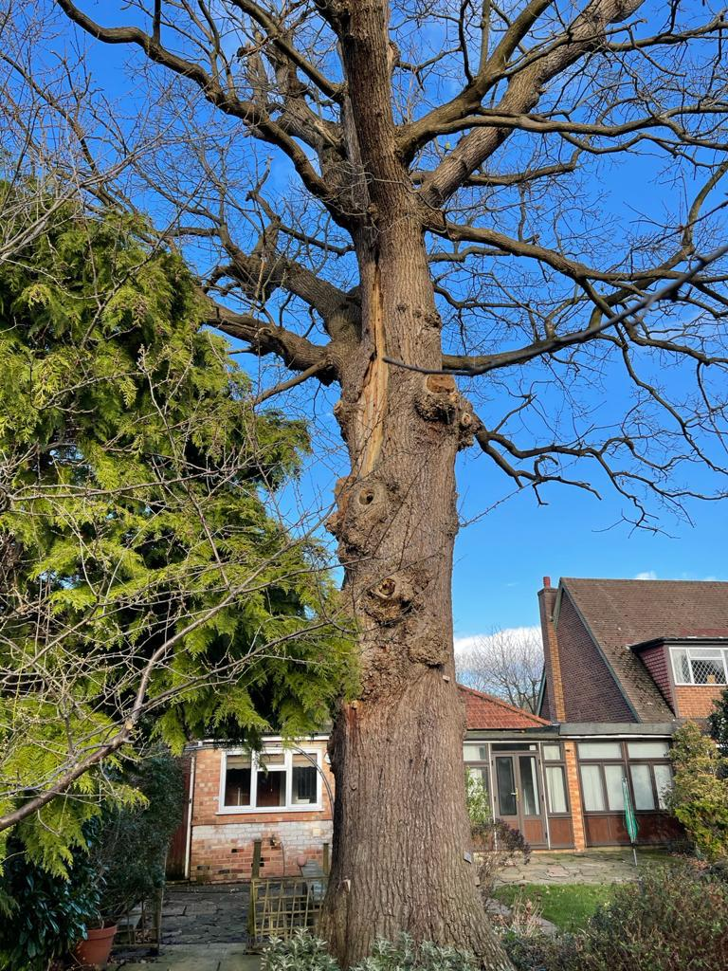
To be felled and the stump ground due to the heavy lean on the tree which is going toward the house only 8m away. The lean cmes from storm damage which has damaged and weakened the main stem and trunk of the tree. We suggest it is safer for the tree to be removed the client is worried that another bad weather spurt could lead to the tree falling on the house.

Storm damage has created a large crack in the Trunk

T1
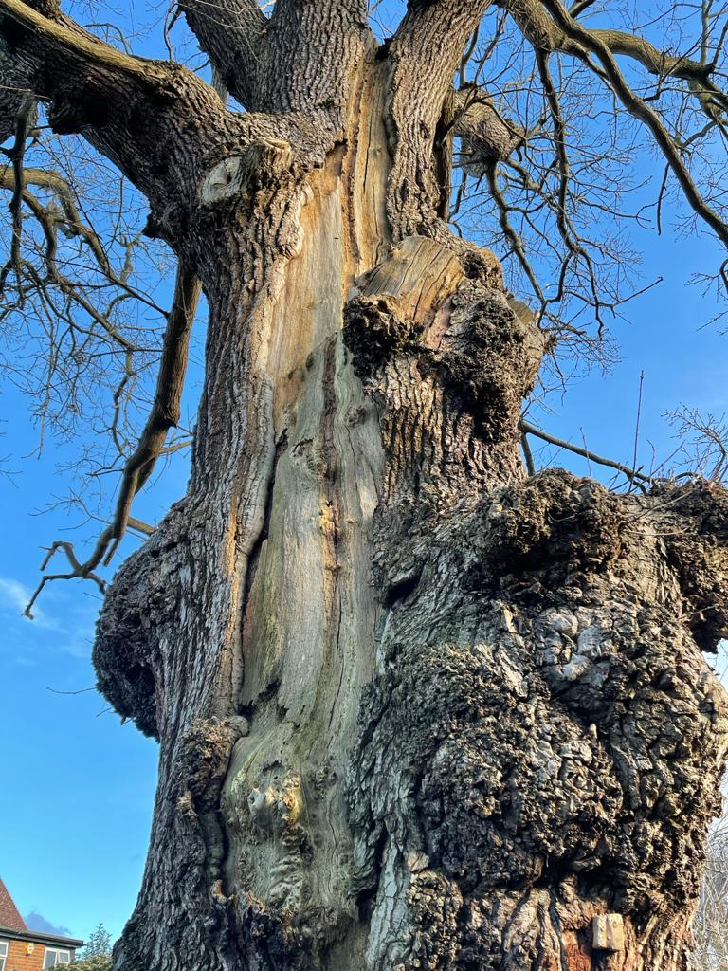
Storm damage has created a large crack in the Trunk which has increasingly grew larger
T1

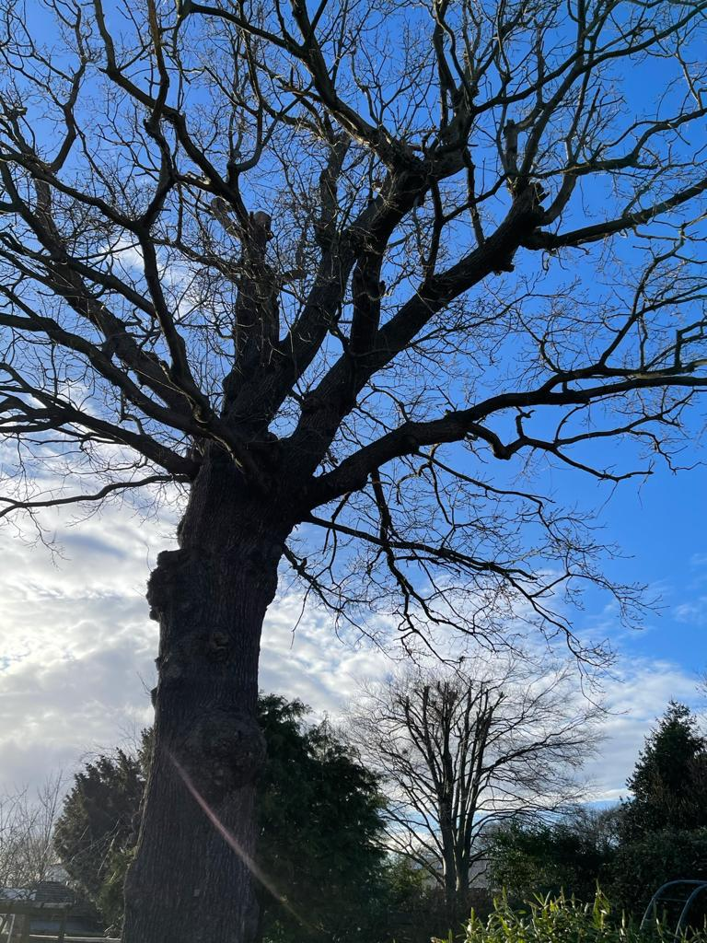
Heavy lean increasingly becoming worse due to bad weather, this is now leaning toward the house and client is worried that it may snap and fall
T1

