Site Location Plan with the site boundary outlined in red – 71 Clyfford Road
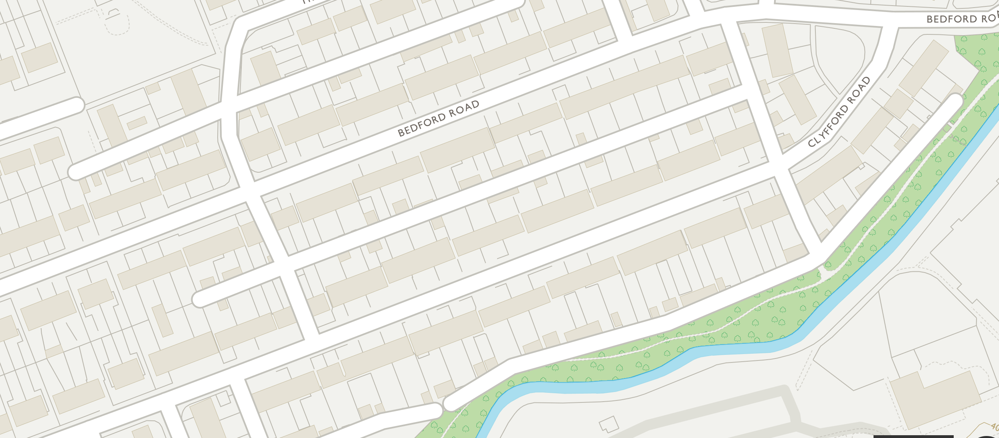
Proposed Site
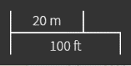
N

Picture of Old Building (Please note that this is now knocked down)
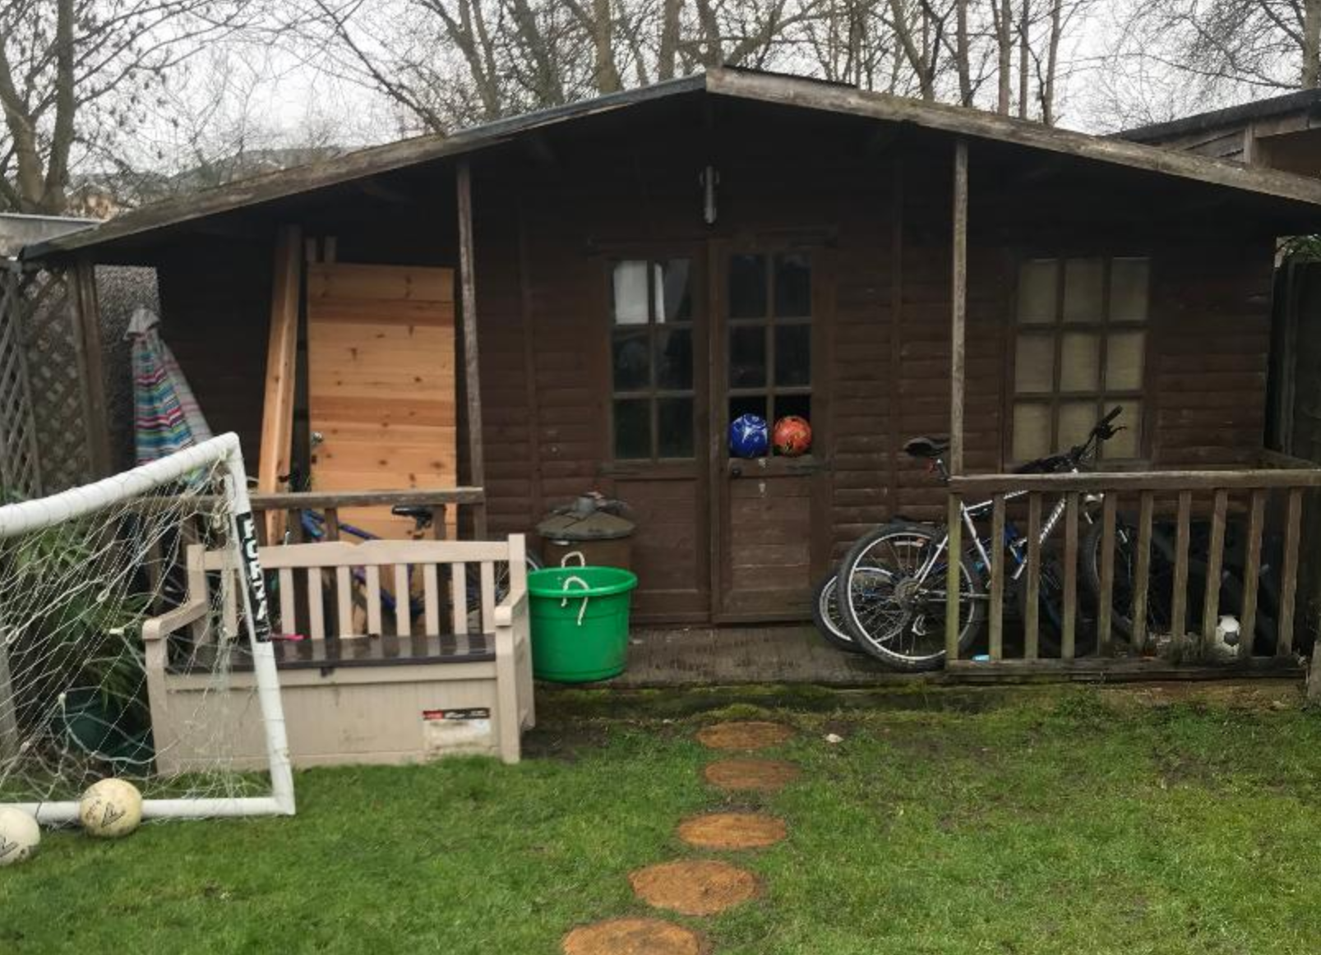
Existing and Proposed Floor Plans and Elevations ¿ including the host dwelling.
Please note that the existing Building has been knocked down prior to this application as I had to prove that the existing Concrete Foundation was ok to use which it is.
Proposed Floor Plan as below
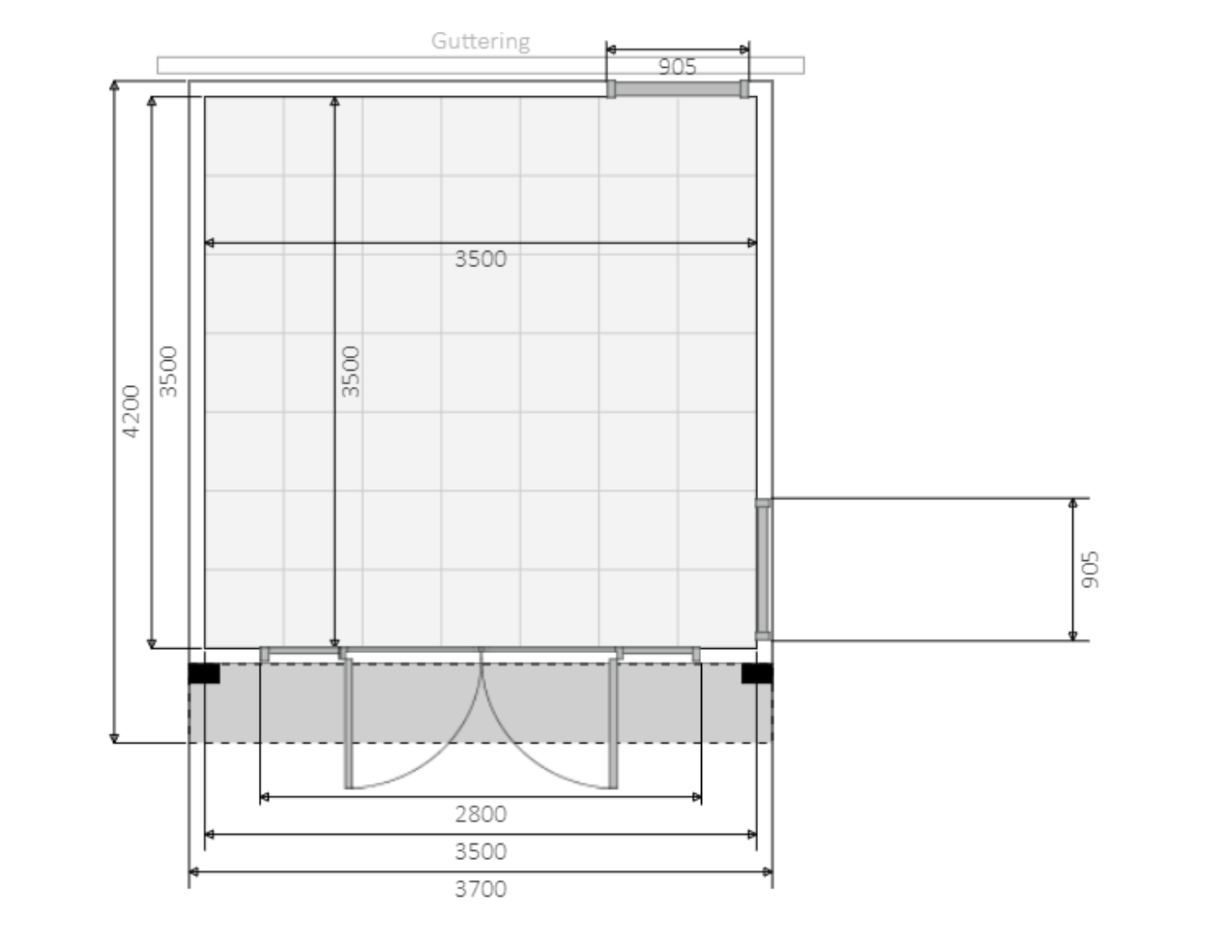
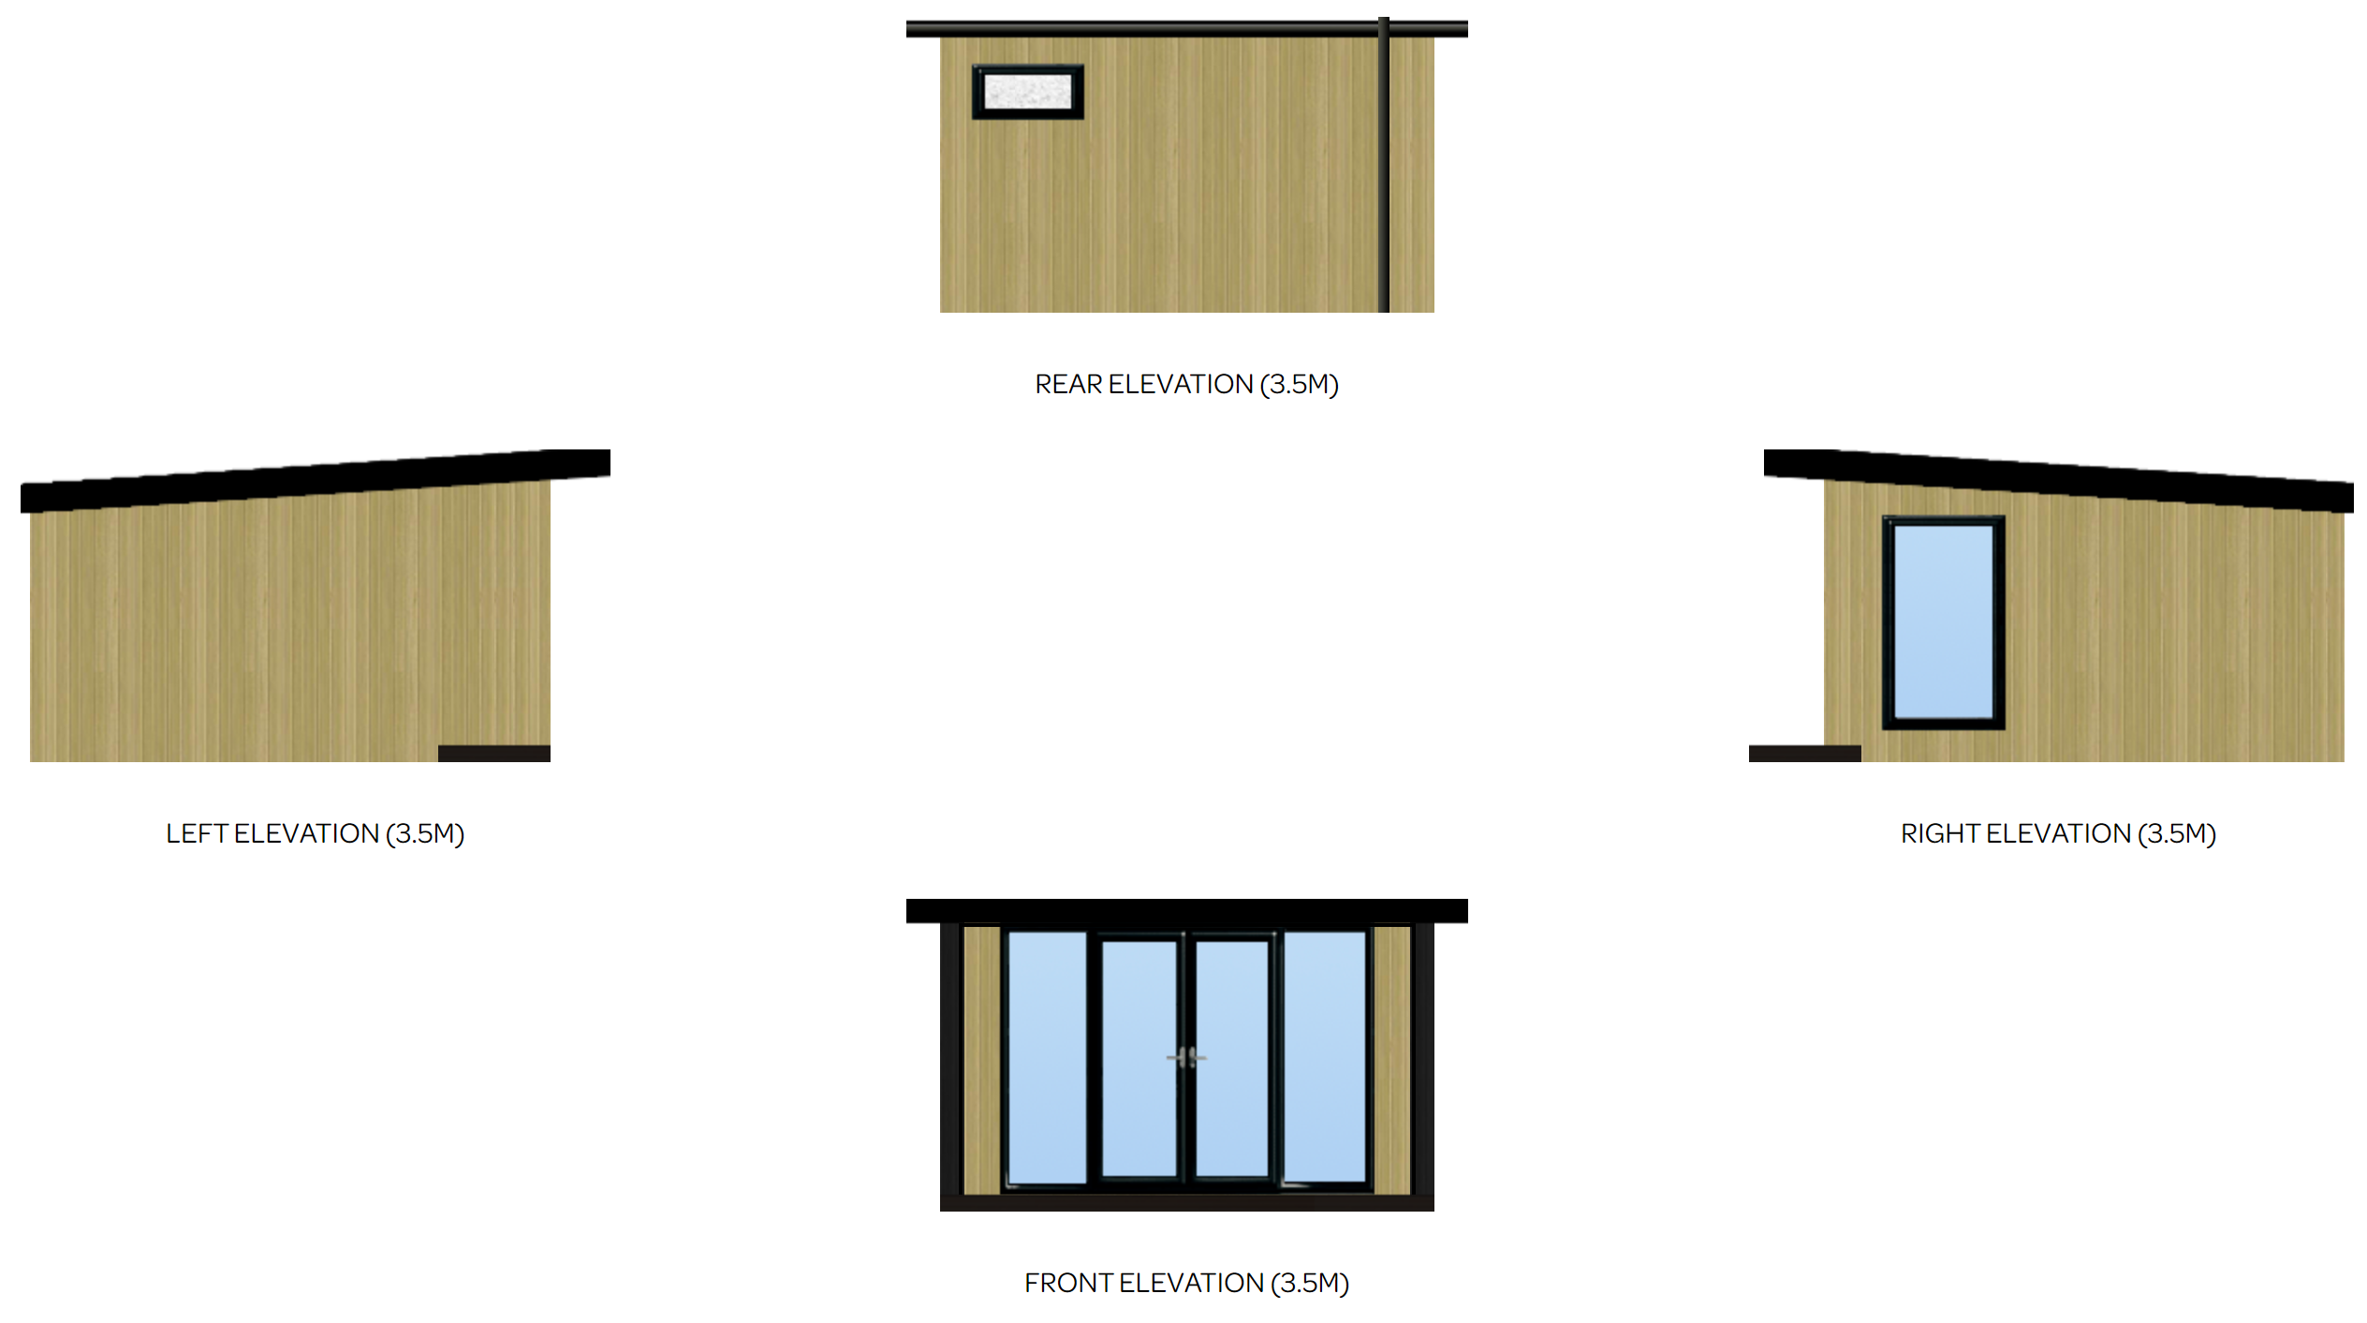
3700
2500
2500
3700
4200
2500
4200
2500
4200
External Plan as above
Please note that the (3.5M) denotes the Internal Dimension of 3.5m squared.
Picture of Concrete Base – Garden Plan

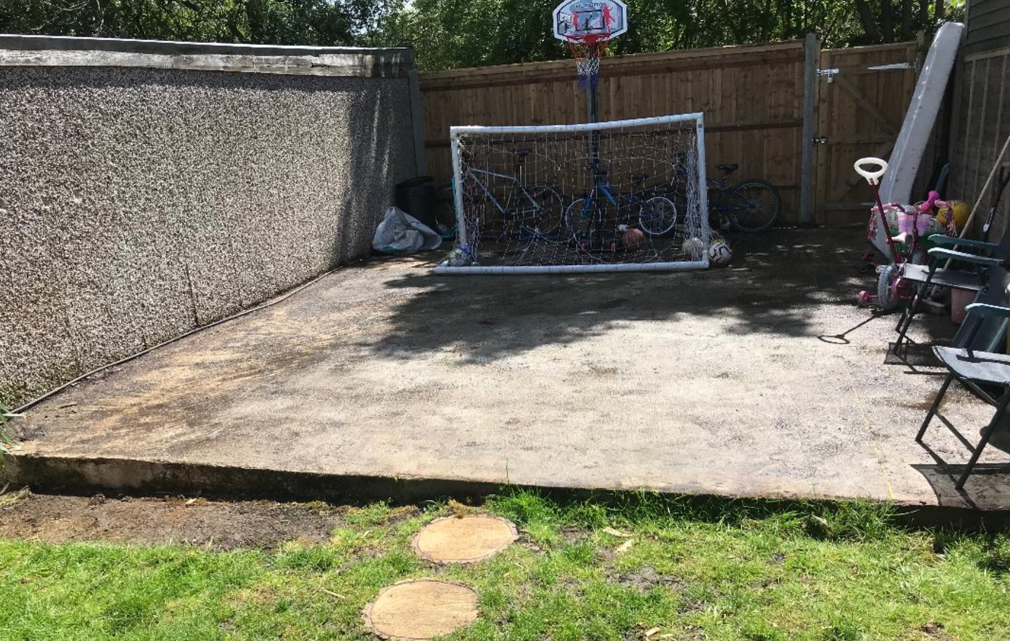

70000
Concrete Base

20
Concrete Base Incline
50000

Garden

Garden Plan as above
Block Diagram Plan with the site boundary outlined in red – 71 Clyfford Road
N
Proposed Development

Purpose of the Proposed building
The New Buildings will be used for additional space for my Children to play in; having 3 Children they find themselves with not much space to play in hence the additional room being sought after. The New Building will have Electrical Power and a Hard Wired Internet Connection to it but will have no Water Feed to it.

