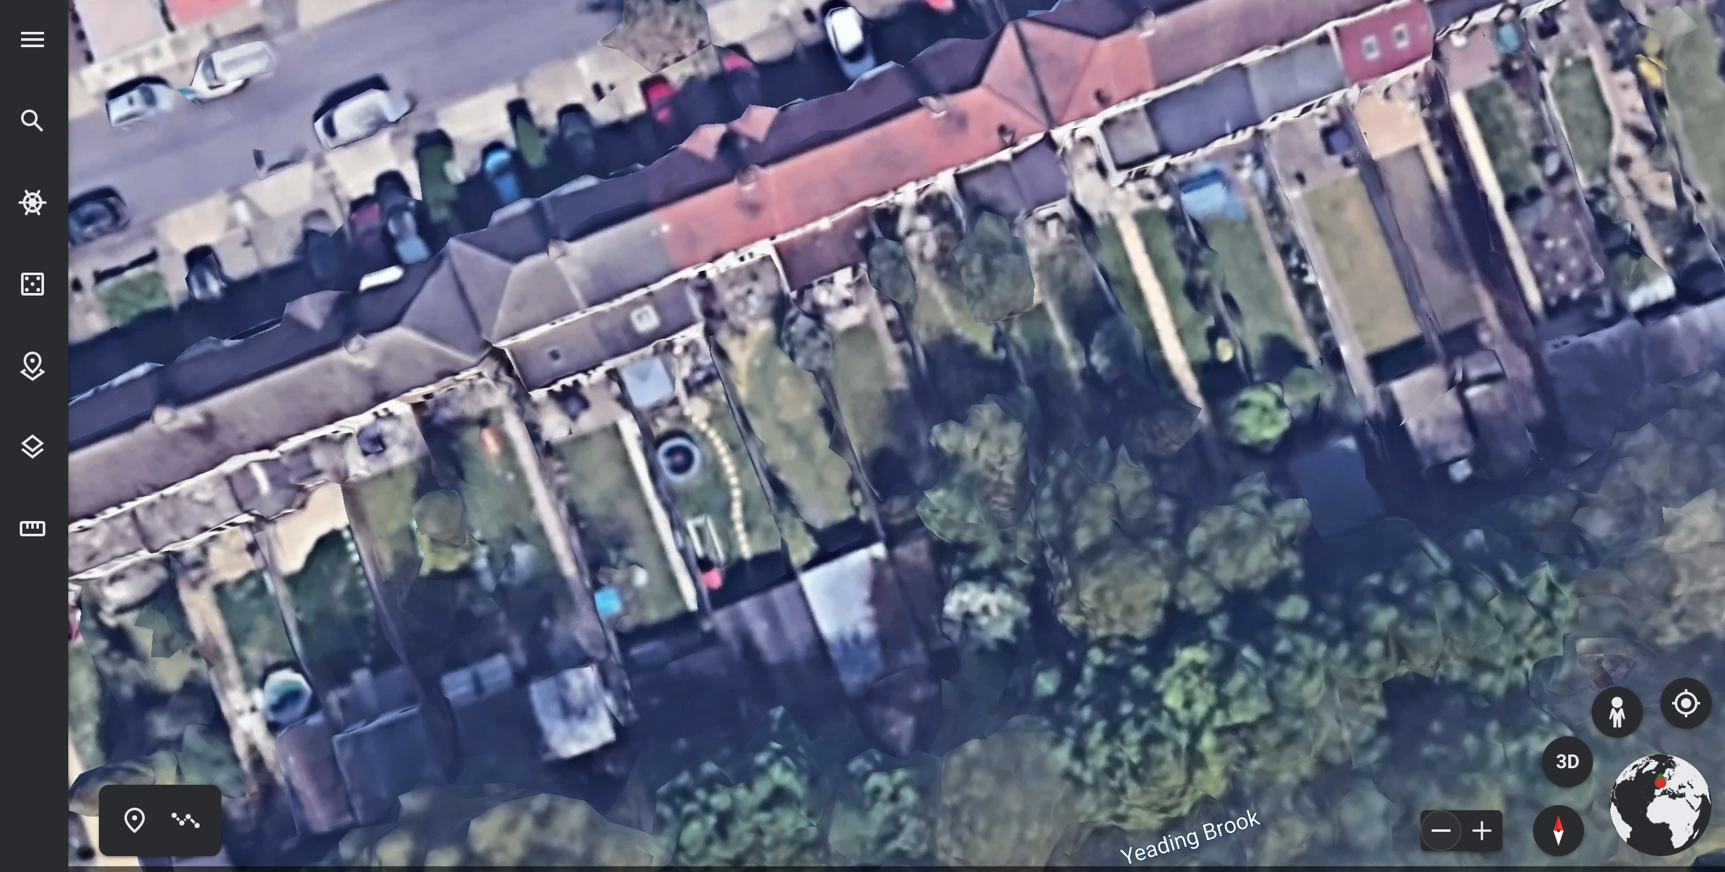

Address – 71 Clyfford Road, Ruislip Gardens, HA4 6PX
Existing Building can be seen within the Red Circle. Dimension of old Building was 5.5m (width) x 7m (length)
Image taken from Google Earth

