PLANNING, DESIGN & ACCESS STATEMENT

ADDRESS; 49 PINE GARDENS, RUISLIP, HA4 9TS.

- INTRODUCTION

  - This statement has been prepared in support of planning application at 49 Pine Gardens, Ruislip, HA4 9TS.

  - The application seeks planning permission for a two-story side extension with a pitched roof to match existing. The application will provide a ground floor kitchen/dining area and a first-floor bedroom with ensuite.

- SITE LOCATION AND DESCRIPTION

  - The application comprises of a two-story semi-detached residential property that benefits from a substantial corner plot. It is located towards the middle of Pine Gardens in an area that is characterised by a variation of residential semi-detached properties, many of which have been extensively extended to the side with single and double story extensions. The property benefits from a large front forecourt area which makes adequate provision for off street car parking. The property also benefits from a substantial side and rear garden with large concrete garage.

  - The application property benefits from being a corner plot that sits at the junction with Langley Avenue. The property benefits from a rear access to the garage via the alleyway off Langley Avenue. The property is adjoined by number 51 Pine Gardens. To the rear of the property is 3 Langley Avenue.

- DESIGN CONSIDERATIONS

The proposed two-story side extension has been revised based on planning recommendations and current planning regulations to sit well within the site boundary. More than adequate space is retained to the side and rear of the property avoiding a cramped appearance. Careful consideration has been given to the impact of the proposed development on neighbouring properties. There are no issues so far as neighbouring amenity is concerned having regard to privacy, overlooking or loss of outlook. The proposed design responds to the established pattern and scale of surrounding development and harmonises the appearance of the architectural composition. Setting the extension back from the existing property clearly identifies the new work to prevent the terracing affect and does not compromise the corresponding building line. This sympathetic approach is not detrimental to the appearance and symmetry of the pair of the semi-detached houses or the wider street scene.
  - The current and original width of the existing property at is widest point is 6.1 metres where the first floor WC extends (please see existing plans). The measurement is not to the later extended ground floor utility. Therefore, in accordance with planning regulations the proposed extension does not exceed half the existing width of existing property at 3.04 metres (please see proposed plans).

  - The extension has been set back 2metres (see proposed plans) to the existing front façade well beyond the recommended 1m stated in policy DMHD1 minimising any impact on surrounding properties on Langley Road. The adjacent property at 3 Langley Road has extended the building line by building a porch and garage which is not shown on location or site plans. The property at 18 Coombe Drive has an out building that extends the building line well beyond the proposed extension. (See photos below)

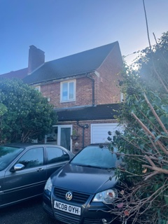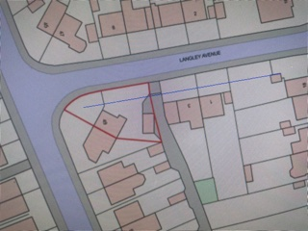

  - There are numerous historical examples on Pine Gardens where single and double story side extensions have been built far exceeding current planning regulations as per the adjoining property at 47 Pine Gardens where the extension exceeds 4metres. Please see below, a typical example of double story side extension at 75 Pine Gardens.

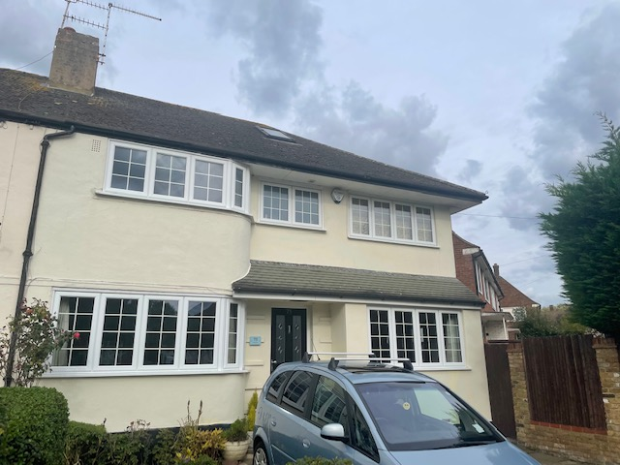
No. 75 Pine Gardens

