

Discharge of conditions

Version 1

Condition 4, 6, 8 & 9

Site Address: 545 Uxbridge Road, UB4 8HP

Proposal: Erection of new dwellinghouse, following demolition of existing dwelling with associated works.

.

1- Conditions Overview

Planning conditions associated to application 28174/APP/2023/3327

Following conditions have been responded to within this document and supplementary documents.

Condition 4 – No development shall take place until a landscape scheme has been submitted to and approved in
writing by the Local Planning Authority. The scheme shall include: -1.
Details of Soft Landscaping
1.a Planting plans (at not less than a scale of 1:100),
1.b Written specification of planting and cultivation works to be undertaken,
1.c Schedule of plants giving species, plant sizes, and proposed numbers/densities where appropriate
2. Details of Hard Landscaping
2.a Refuse Storage
2.b Means of enclosure/boundary treatments
2.c Car Parking Layouts (including 2 'active' and 2 'passive' electrical car charging points)
2.d Hard Surfacing Materials
3. Schedule for Implementation
4. Other
4.a Existing and proposed functional services above and below ground
4.b Proposed finishing levels or contours
Thereafter the development shall be carried out and maintained in full accordance with the approved details.
REASON To ensure that the proposed development will preserve and enhance the visual amenities of the locality and provide adequate facilities in compliance with Policies DMHB 11, DMHB 12, DMHB 14, DMEI 1, DMT 2 and DMT 6 of the Hillingdon Local Plan Part 2 (2020) and Policy G5 of the London Plan (2021).

Condition 6 - Prior to work commencing, details of step free access via the principal private entrance, and all the other points of entry and exit, shall be submitted to, and approved in writing, by the Local Planning Authority. Such a provision remains in place for the life of the building.
REASON To ensure that an appropriate standard of housing stock, in accordance with the 2021 London Plan Policy D7 is achieved and maintained.

Condition 8 - Notwithstanding the approved plans, prior to commencement of development, product details and samples of all external materials and finishes shall be submitted to and approved in writing by the Local Planning Authority. Samples shall be made available on site for inspection and details shall include manufacturer information. Works shall be carried out in accordance to approved details.

Condition 9 - Prior to installation, product details of all external windows and doors shall be submitted to and approved in writing by the Local Planning Authority. Works shall be carried out in accordance to
approved details.

2- Site Photographs

Photo to illustrate the site entrance

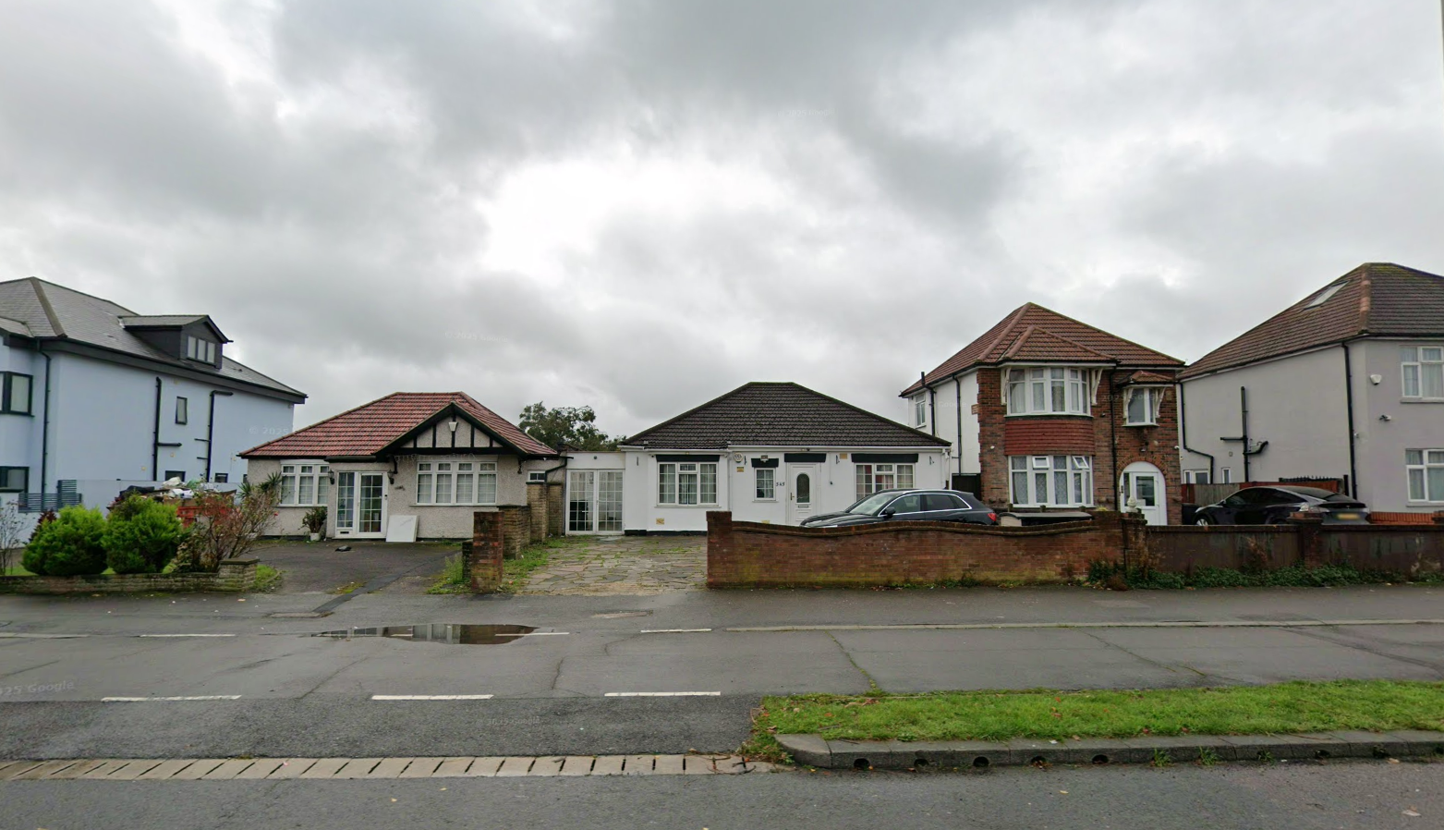
545 Uxbridge Road, Uxbridge – Detached property

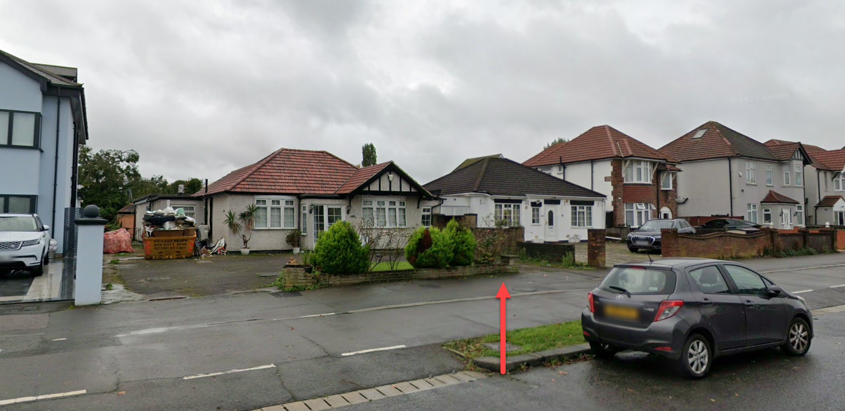

4 – Landscape Plan – Condition 4

Condition 4 – No development shall take place until a landscape scheme has been submitted to and approved in
writing by the Local Planning Authority. The scheme shall include: -1.
Details of Soft Landscaping
1.a Planting plans (at not less than a scale of 1:100),
1.b Written specification of planting and cultivation works to be undertaken,
1.c Schedule of plants giving species, plant sizes, and proposed numbers/densities where appropriate
2. Details of Hard Landscaping
2.a Refuse Storage
2.b Means of enclosure/boundary treatments
2.c Car Parking Layouts (including 2 'active' and 2 'passive' electrical car charging points)
2.d Hard Surfacing Materials
3. Schedule for Implementation
4. Other
4.a Existing and proposed functional services above and below ground
4.b Proposed finishing levels or contours

__________________________________________________________________________________

1. Details of Soft Landscaping

1.aPlantingPlans (Scale 1:100)
A planting plan at 1:100 scale is enclosed, illustrating the layout and positioning of all proposed soft landscaping elements. This includes front and rear gardens, boundary planting, and buffer zones.

1.b Specification of Planting and Cultivation Works
The planting works will be carried out using cultivated topsoil to a minimum depth of 300mm, with all planting beds mulched to 75mm using bark chippings. All planting will take place during the first suitable planting season (October to March) following site completion. Plants will be watered regularly until establishment and replaced if failed within the first 12 months.

1.c Schedule of Plants (Species, Sizes, Densities)
- Front garden and boundary:
  - Buxus sempervirens (Box hedge), 45–60cm high, 3 per linear metre
  - Lavandula angustifolia (Lavender), 2L pots, 5/m²
  - Acer palmatum ‘Orange Dream’, 1.5–1.8m high, one specimen tree
- Rear garden:
  - Photinia x fraseri 'Red Robin', 1.2–1.5m high, 2 per linear metre along the rear boundary
  - Festuca glauca and Heuchera mix, 3/m²

2. Details of Hard Landscaping

2.a Refuse Storage
A secure, timber-clad refuse storage area is provided to the front of the property with capacity for two 240L wheelie bins. This complies with LB Hillingdon’s waste storage design guidance.

2.b Means of Enclosure / Boundary Treatments
- Front boundary: 900mm high brick wall with black metal railings
- Side and rear boundaries: 1.8m close-boarded timber fencing with gravel board and concrete posts. Alternatively brick built wall to match house.
- Access gates: Lockable side gate in timber to match fencing

2.c Car Parking Layout (including EV provision)
- Two off-street parking spaces are proposed to the front, demarcated with permeable block paving
- One active EV charging point to be installed per LB Hillingdon standards
- One passive EV provision provided with ducting and infrastructure for future connection

2.d Hard Surfacing Materials
- Front drive: Permeable resin-bound gravel in grey/Alternative brick SUDS Pavers
- Pathways: Buff sandstone paving slabs
- Rear patio: Charcoal porcelain tiles
All hard surfaces will be SUDS-compliant to minimise surface runoff.

3. Schedule for Implementation
- Soft landscaping works: To be completed within the first planting season post-completion (Oct–Mar)
- Hard landscaping and boundary treatments: To be completed prior to first occupation
- EV charging installation: Completed prior to first occupation
- Maintenance: All landscaping will be maintained for five years post-installation, with any failed or dead planting replaced in the next available planting season

4. Other

4.a Existing and Proposed Functional Services (Above/Below Ground)
- All below-ground services (water, foul, surface, electricity) have been coordinated to avoid conflicts with planting zones
- EV infrastructure is integrated within the hardstanding design and protected by ducting

4.b Proposed Finishing Levels / Contours
- Site levels are largely retained with gentle grading to match the existing topography
- Rear garden will slope gently away from the dwelling to allow natural drainage
- Levels shown on the accompanying section and site layout plan

5 – Step Free Access – Condition 6

Prior to work commencing, details of step free access via the principal private entrance, and all the other points of entry and exit, shall be submitted to, and approved in writing, by the Local Planning
Authority. Such a provision remains in place for the life of the building.
REASON
To ensure that an appropriate standard of housing stock, in accordance with the 2021 London Plan
Policy D7 is achieved and maintained.

All thresholds to the property will be step free access to comply with Approved Documents M

Typical Detail as set out below:
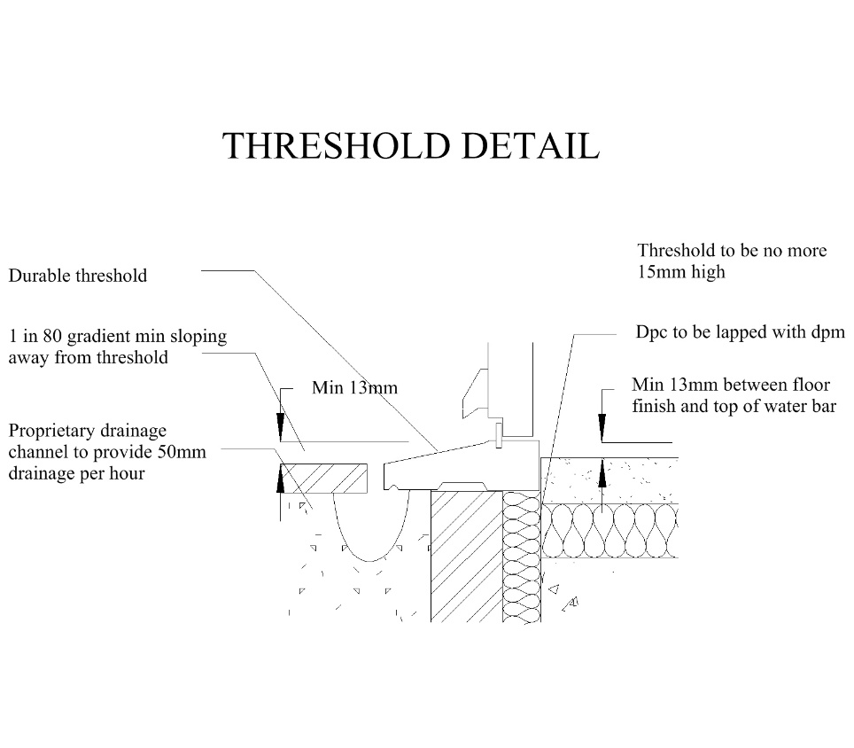

6 – Materials External – Condition 8

Notwithstanding the approved plans, prior to commencement of development, product details and samples of all external materials and finishes shall be submitted to and approved in writing by the Local Planning Authority. Samples shall be made available on site for inspection and details shall include manufacturer information. Works shall be carried out in accordance to approved details.

Roof Tile

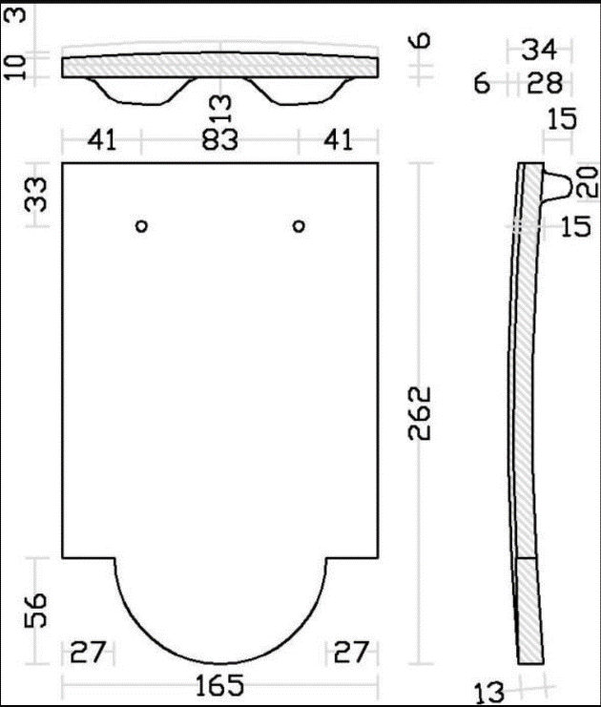
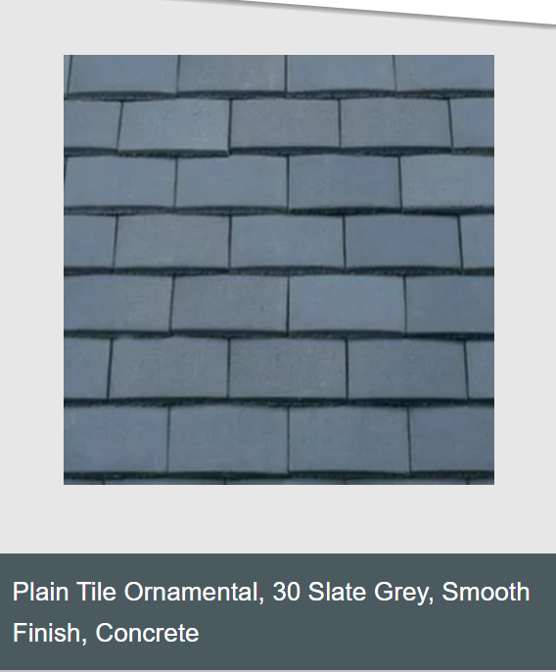

Concrete plain tile to compliment nearby tile format.
Decorative club pattern tile – Front elevation Second floor

Brick Wall

White/Cream Brick – Wienerberger – Linear brick
UK_MKT_DOC_BRI_12760066_Elignia_Nordica_White.pdf
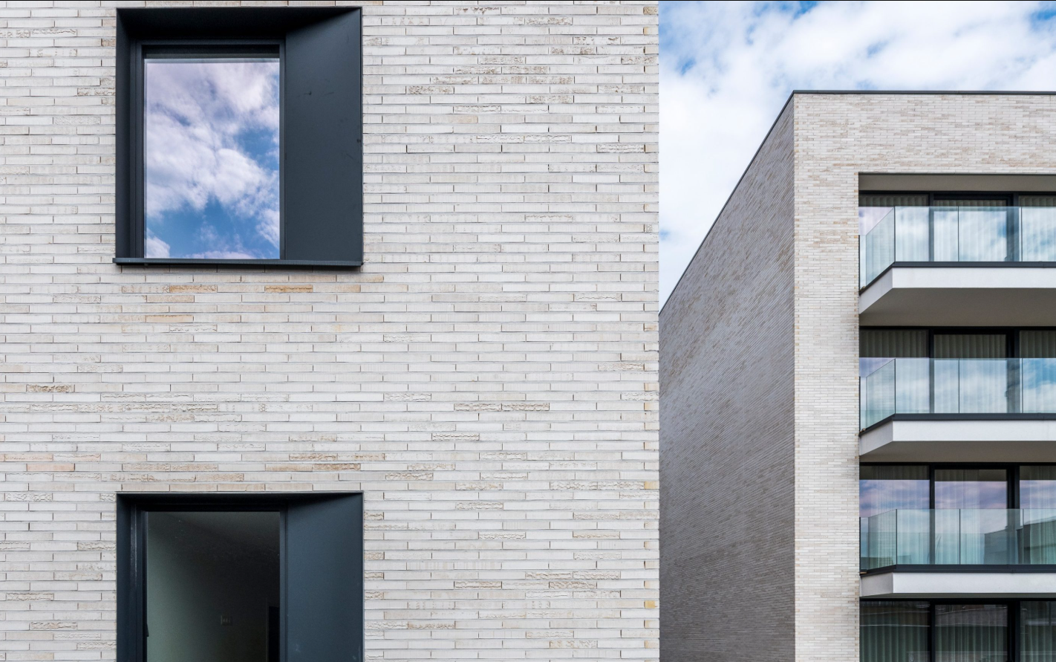

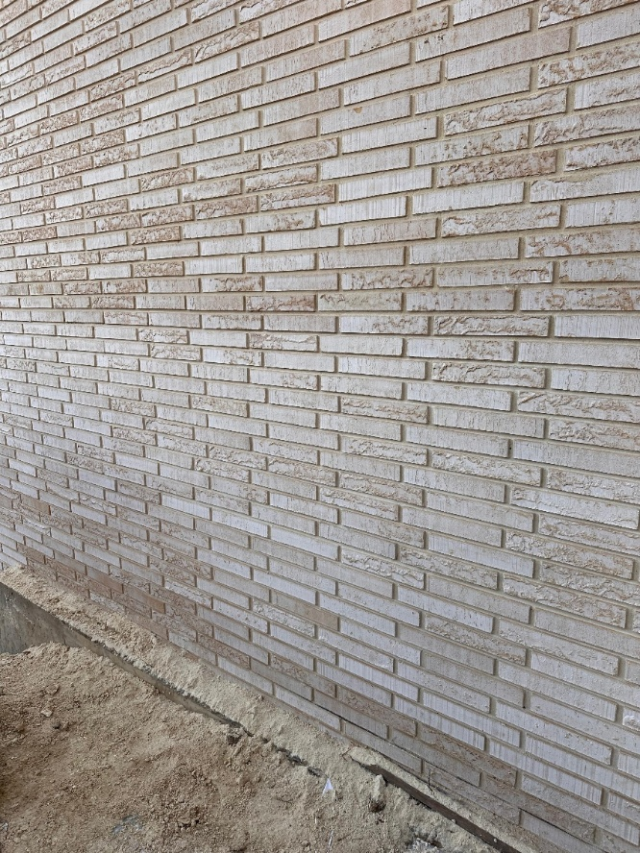
The left photo shows a sample from a completed brick wall from one of our ongoing developments withing Ealing Council.

The original property (545 Uxbridge Road) on this site featured a white rendered façade which lacked contextual sensitivity and detracted from the character of the surrounding area. In contrast, we propose the use of a high-quality white/cream facing brick with a subtle luster, paired with white mortar and white cement.

From a distance, materiality evokes the clean, monolithic appearance of a white rendered building. However, upon closer inspection, the brick reveals a refined palette of soft brown and cream undertones, offering depth and visual interest. This considered approach to texture and tone not only maintains a light and elegant appearance but also significantly elevates the architectural quality of the street scene.

Windows


Anodized bronze windows to complement the character of the brickwork. The soft luster of the brickwork has highlights of brown tint. Taking this element to create a visual interest with the windows would highly complement the overall character of the development.



Front Door
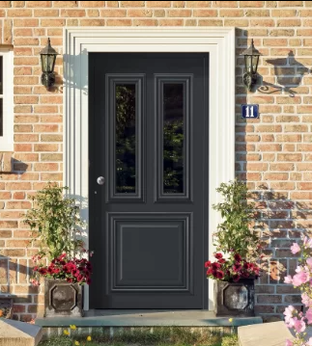
Black RAL 9011 aluminum front door

Rear Door
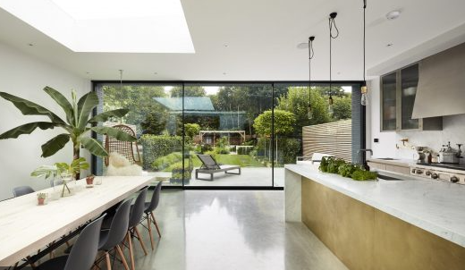
Contemporary sliding doors with 20mm sightline. Floor to ceiling.

Flue extract and vent openings.
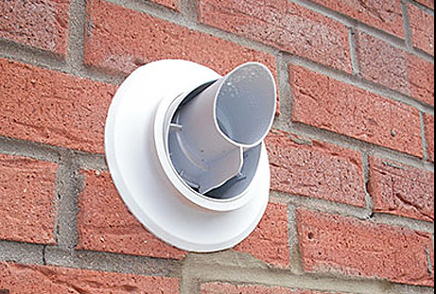
External flue for boiler – Vaillant

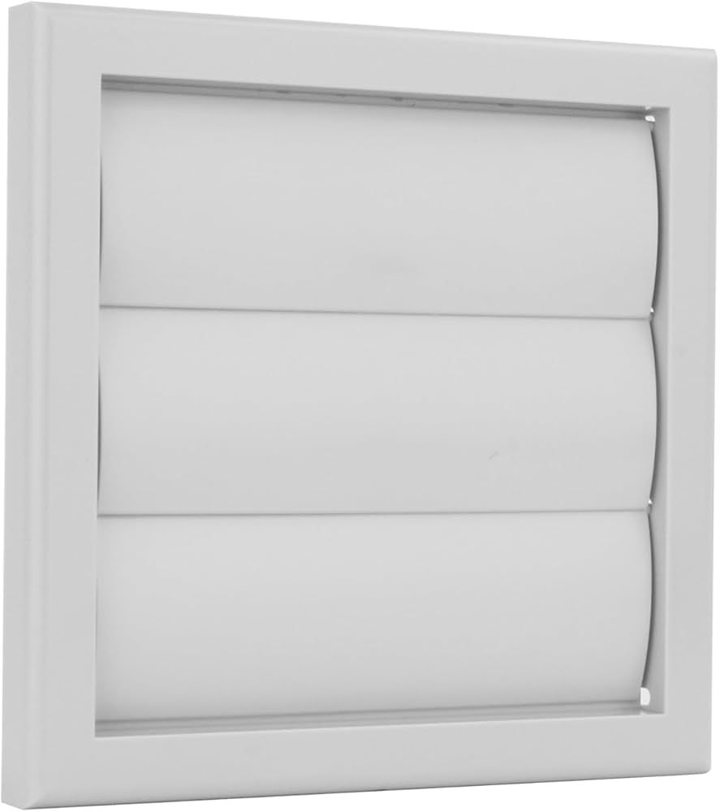
External Bathroom Vent

Fascia, soffit and gutter design.
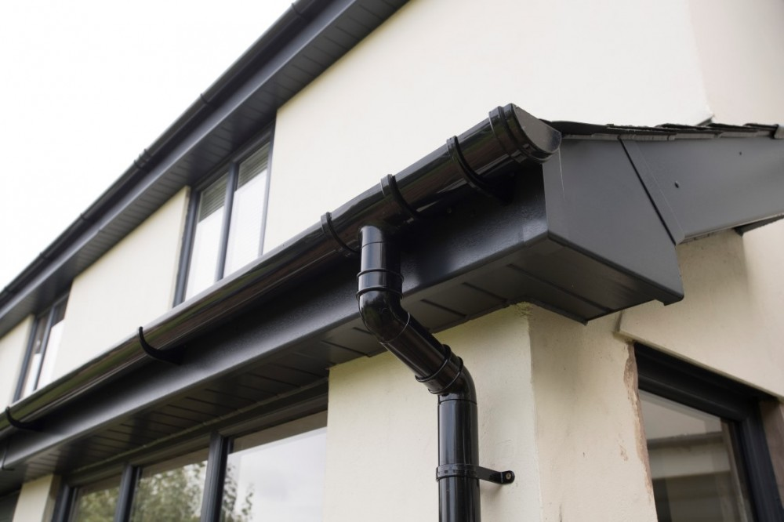

Side gates
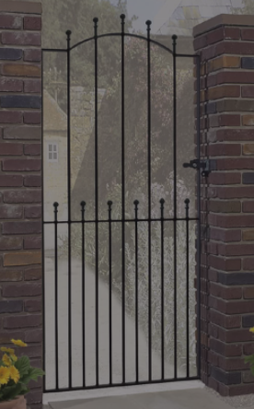

Ball top steel gate. Painted in black Hammarite Ultra Smooth rust proof paint.

Please contact the agent directly to provide shipping address for any physical material samples required.

