Design and Access Statement for Proposed Rear Extension and Extension, Alterations and conversion of existing Garage
June 2022
Introduction

This Design and access statement is for a proposed single storey extension to an existing rear extension to improve the current layout for modern living.

It is also proposed to extend, alter and attach the existing garage to the extension to provide a study/home office area. The existing garage is narrow and using it to garage a car is not practical as getting out of a car inside the garage is near impossible.

It is proposed to construct the rear extension first and follow on with the garage conversion in a couple of years subject to approval being granted.

Use

The property will be used as a family home. This project is to update the layout of the property to provide a usable space for modern living while maintaining the existing ambiance of the property. The existing layout as seen on drawing 5 MILL RD/BL/2022/01 does not work the dining room is a vertical corridor to the kitchen and the odd shaped rear extension gives little current scope to improve the layout.

The proposal does not require any alterations to the existing vehicular or pedestrian accesses.

Site Details
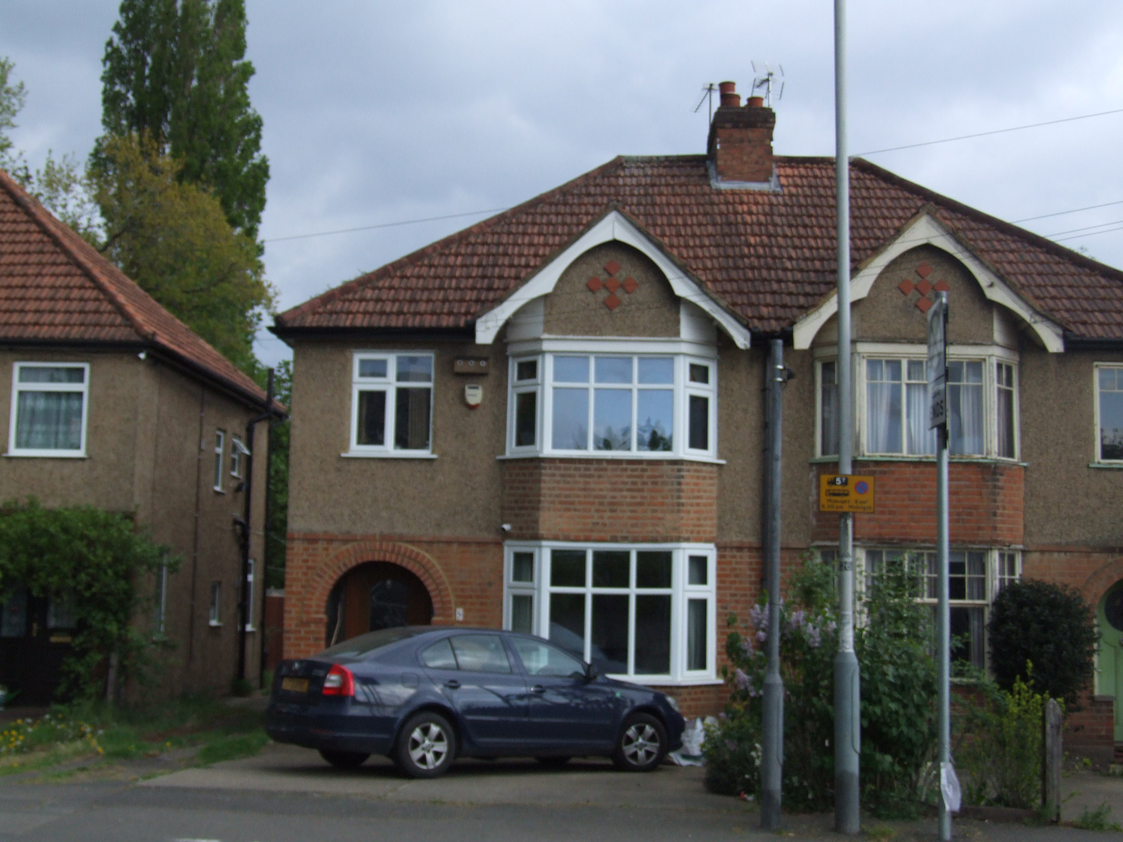

The site comprises a three bedroom 1930’s semi-detached property on Mill Road West Drayton just off the “The Green”

The property has a shared drive to a garage.

The Neighbouring properties are of the same style and size.

The site is set within the vibrant community of West Drayton with local shopping amenities
Located in West Drayton, Yiewsley and Cowley.

The Site is also well served with local schools

There are many opportunities locally for recreation including

- Bowling Clubs
- Iver, Thorney and Richings Park Golf Clubs
- Many local footpaths for walking
- Stockley Park

Parking within the area is a mixture of off street parking and roadside parking. Currently the
existing house has a garage that is not used for parking and two spaces on the drive.

Size

The proposed additional floor space to be constructed by this application is 13.6m2. The property is to remain three bedrooms.

Transport Facilities

Bus Routes
- U1 – West Drayton - Ruislip
- U3 – Uxbridge – Heathrow Terminals 2 & 3
- U5 – Uxbridge - Hayes
- 350 - Hayes – Heathrow Terminal 5
- 222 – Uxbridge - Hounslow
Trains
The nearest station is West Drayton station 0.7 miles away
Iver Station is 1.6 miles away.
Tube
The nearest station is Uxbridge station 3.4 miles away

Proposal and Appearance

- The garage and extension to it is to remain brickwork to match the surface finish and colour of the original.

- The Roof tiles are to be plain roof tiles again to match the size and profile of the existing garage tiles.

- The window style and size are to resemble those on the existing property and be white upvc to match the existing.

- The proposed extension to the existing rear extension is to render and dashed with pea shingle to match both the existing extension and house.

- The two parking spaces are to remain to the front of the property

Inclusive Access

The Proposed layout includes a larger cloak room to make the properties facilities easier for less ambient visitors all be it down two steps. Hand rails will be provided to aid access and egress.

Layout

The application is to improve the layout of the property to provide a future proof home both the current young couple’s family now and as it expands also any future occupants of the property while respecting the street view of the area.

Bats

The Home owners are keen conservationists and have sort advice on protecting the bats that roost in the existing void behind the fascia for part of the year. They contacted a licensed bat worker (CL18 licence 2015-14398-CLS-CLS) to inform the extension design optioneering

This is their advice that the owners are happy to be conditioned.

“Thanks for sending through those plans. As requested, I have put together my understanding and personal opinion as a licensed bat worker (CL18 licence 2015-14398-CLS-CLS) to inform the extension design. I've also set out advice to you on what mitigation may be required based on my knowledge of the plans, so you understand what will be needed later.

From our previous discussions, I know that you have had a volunteer bat roost visit confirm that the roost is a maternity roost of soprano pipistrelle bats and that you have been monitoring them since. As of last year they were still returning and using the roost (counts for this year are due to start in June). Surveys of the roost can be undertaken from May to September and for a roost of this size typically this would comprise 2 or 3 visits (depending on what is needed to characterise the roost) in line with BCT guidance.

As you know bats and their roosts are protected under the Wildlife and Countryside Act 1981 (as amended) and the Conservation of Habitats and Species Regulations 2017 (as amended), whilst the presence of bats also constitutes a material consideration in planning. As the works are affecting a known bat roost, they will need to be undertaken under a licence from Natural England, which can be applied for following grant of planning permission. Any mitigation or compensation design will not only need to be agreed through the planning process but also will be subject to approval from Natural England before they will grant a licence. The licence needs to be informed by survey data.

From what you have sent through and our discussions, I understand that the extension will remove the current access location for the bats (beneath a gap in the bargeboard on the south eastern elevation) and joists will block access to the current roost location (a gap between joists in under the flat felt roof of the extension) at the rear. Ideally, if there is any way to design the extension to leave access to the original roost location, even if it is further into the roof (away from the edge), this would be preferable as the bats are more likely to adapt to a change in an old roost rather than adapt to a new roost location. Where this is not possible, the design of the new roost and access follow the principle of 'like for like' and should be as close as possible in location, dimensions and conditions (materials, aspect, etc) to the original. Other considerations are to minimise illumination (security lights or windows) and the flyway should be unobstructed to and from the access. I know from our discussions that previously the bats did access from under bargeboard on the north east face of the extension so siting the new access in this aspect would be sensible. The location you have proposed is certainly a valid option but consideration needs to be given to how close it is to the window and how much space is above the window. The window could illuminate the entrance (pips emerge early so are fairly tolerant of light but if the current access is not lit it is preferable to minimise this) and also there may be a risk of juvenile bats hitting the window or coming in through an open window (they are not good flyers, initially). You could reduce this risk through design, perhaps changing the location or size of the window? Another option is to provide the access under the corner over the toilet although it is hard to understand from the plans how constrained this is by the door. For the purposes of the design it may be worth including both options on the drawings (there is no reason you cannot provide two access points or even two roost locations). Providing the replacement roost location within the flat roof extension immediately adjacent to any access is reasonable.

Conclusion

Ben wishes to work with the local planning authority and the neighbouring owners and should the case officer require any further information or alteration to the application in order to gain a positive recommendation please contact me. Any such changes or additional information can be actioned to comply with your timetable.

