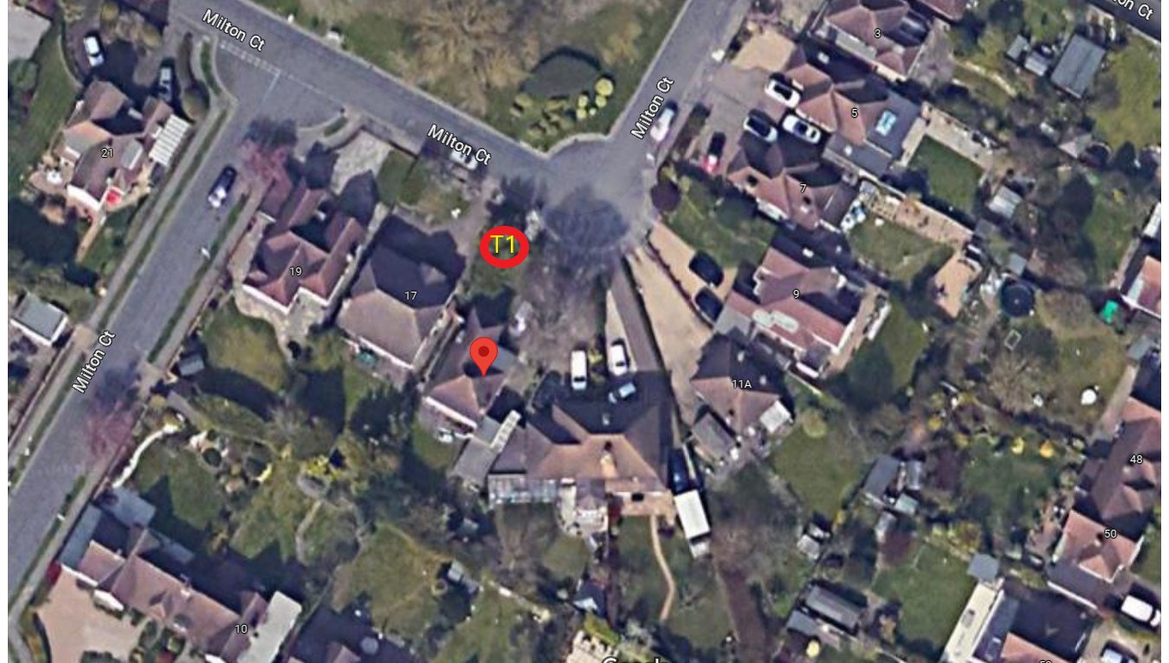
Work Location -

15 Milton Court
Ickenham
UXBRIDGE, Middlesex
UB10 8NB

T1 – Beech – Reduce crown height and spread of tree to previous pruning points approx. 1-2 metres leaving a spread of approx. 15meters

