ADDENDUM ARBORICULTURAL REPORT

Crawford Reference: SU2206150

Insured:
Mrs Barbara Thompson
143 The Greenway
Ickenham
Uxbridge
Middlesex
UB10 8LT

Insurer:
RSA - John Lewis
6th Floor
Bowling Mill
Dean Clough
Halifax
HX3 5WA
Claim Reference: 202210030891
05 September 2023

Crawford Claims Solutions – Subsidence
Cartwright House,
Tottle Road,
Riverside Business Park, Nottingham, NG2 1RT
Tel: 0115 943 8266

RECOMMENDATIONS

Oak T1 –Reduce height from 16.5m to circa 14m and Reduce lateral RADIUS to 8m which would leave a lateral SPREAD of 16m leaving balanced crown, leaving a well-balanced crown (in accordance with BRE IP7/06 “Pruning trees to reduce water use” to mitigate root induced clay shrinkage subsidence.

INTRODUCTION
We have been asked by insurers to comment on movement that has taken place to the above property. This report outlines the arboricultural issues and provides justifications for the recommended works. This report should be read in conjunction with the MWA Arboricultural Appraisal Rereport dated 12/04/2023

TECHNICAL CIRCUMSTANCES
The damage was first noticed in September 2022 and hence Insurers were notified.

HISTORY & TIMESCALE

Date of Construction Circa 1920
Damage First Noticed 15 September 2022

TOPOGRAPHY
The property occupies a level site with no unusual or adverse topographic features.

OBSERVATIONS
The damage of concern affects the rear kitchen and through lounge of the property with external cracks to the rear elevation.

CATEGORY
Damage Internally: Kitchen - Horizontal cracks across the ceiling - 1-2mm wide. Vertical cracks 1/2mm wide to right of door to lounge and to right of external side door.

Through Lounge - Vertical crack 3mm wide to left side of door to kitchen and vertical crack 1/2mm
wide to right side of door to kitchen. Horizontal cracks across the ceiling 1/2mm wide. Vertical
crack -1mm wide above door to hall. Vertical crack - 1mm wide above gap to front section of
lounge.

Damage Externally: Vertical cracks 2mm wide above and around side door to kitchen and side door to garage.

Maximum Crack: 3mm
Damage Category: BRE Category 2 (Slight damage with cracks up to 5.0mm wide)

GEOLOGY & SOIL
Reference to the British Geological Survey online viewer confirms that the geology comprises of London Clay.

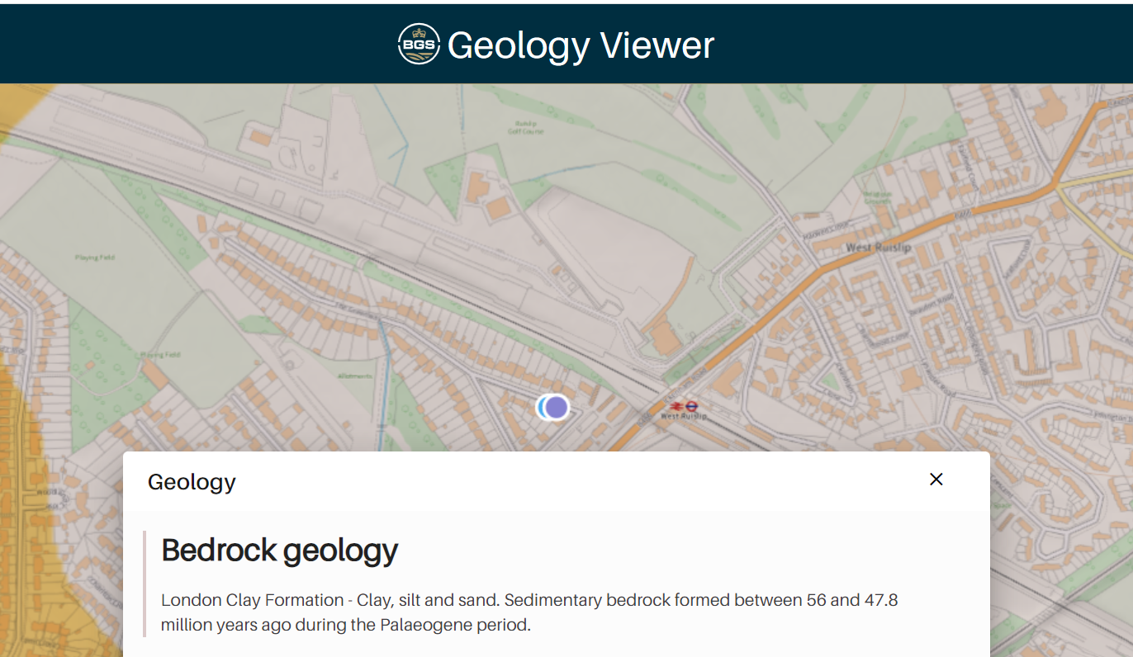

London Clay can significantly change in volume due to seasonal variations in moisture content, particularly if influenced by tree roots extracting moisture.

VEGETATION
There are trees and shrubs nearby, some with roots that may extend beneath the foundations. The following are of particular interest and recommendations have been made to provide a remedy to the damage:-

Tree roots can be troublesome in cohesive (clay) soils because they can induce volumetric change. They are rarely troublesome in non-cohesive soils (sands and gravels etc.) other than when they enter drains, in which case blockages can ensue.

PHOTOGRAPHS

VEGETATION INFLUENCE
According to the standard published work on the subject (Cutler, D.F. and I.B.K. Richardson, (1989) further confirmed by Mercer, Reeves & O’Callaghan (2011) in shrinkable clay soils, Oak species are capable of causing subsidence damage at distances up to 30m, with 75% of cases occurring where the tree was within 18m. The Oak T1, at only 14m, is therefore well within its species’ potential rooting and influencing distance of the building and would be capable of causing seasonal soil drying beneath foundations.

PATTERN OF MOVEMENT
Damage was observed to occur during September 2022 during a time of year when soil moisture deficits due to tree root activity would be reaching their peak.

The area of movement and damage is consistent with the locations of the subject Oak T1 and this is by far the most significant item of vegetation nearby that is likely to be causal.

The pattern of movement is entirely consistent with the seasonal, cyclical influence of tree roots on soil moisture, foundations moving down during summer months when roots are active and extracting soil moisture, then returning to recovery and uplift as soil moisture increases during winter when tree roots are inactive.

DISCUSSION
The pattern and nature of the cracks is indicative of an episode of subsidence. The cause of movement is clearly attributable clay shrinkage exacerbated by tree root activity.

The timing of the event, at a time of year when soil moisture deficits due to tree root activity would be reaching their peak.

The presence of shrinkable clay beneath the foundations and the proximity of vegetation where there is damage indicates the shrinkage to be root induced. This is a commonly encountered problem and probably accounts for around 70% of subsidence claims notified to insurers.

TREE AGE

The subject tree appears to pre-date the construction of the damaged structure therefore there is a theoretical risk of adverse soil heave occurring if the tree was to be removed entirely.

MITIGATION OPTIONS

Tree reduction option - Pruning is generally unreliable as a means of controlling water uptake. Whilst the tree remains, even if heavily pruned, damage is likely to continue or worsen, as the roots will continue to extract moisture from beneath foundations of the damaged building. In any event, the tree is sufficiently close to the structure that even heavy pruning is very unlikely to reduce root moisture uptake. There is no linear relationship between foliage volume and the amount of water lost. Being dynamic organisms, trees react to pruning by trying to restore the root to shoot ratio by producing as many leaves as they can. These new leaves are usually juvenile leaves with a larger surface area and generally more pores on the underside, these pores stay open for longer compared to an unpruned tree and increase the degree of water uptake by the roots. Research has shown that even a heavily pruned tree will quickly return to absorbing soil moisture and the seasonal movement and damage will continue. This is particularly the case with the subject Oak trees due to their size, age and species characteristics, and this species grows back successfully following pruning.

The publication “CONTROLLING WATER USE OF TREES TO ALLEVIATE SUBSIDENCE RISK” © 2004 BRE on behalf of the Link Consortium for Horticulture Link Project No. 212 concluded that:

• For practical soil moisture conservation, severe crown-reduction 70-90% of crown volume would have to be applied. Reduction of up to 50% crown volume is not consistently effective for decreasing soil drying.

• To ensure a continued decrease in canopy leaf area and maximise the period of soil moisture conservation, crown reductions should be repeated on a regular managed cycle with an interval based on monitoring re-growth.

We would also refer to the “Pilot study to determine the feasibility of using existing claims data to determine the impact of tree pruning on subsidence incidents on swelling clay soils” Hipps & Atkinson 2014
Conclusions of that publication are as follows:
“1. Nine cases were studied
2. In three cases pruning eliminated foundation movement
3. In four cases pruning reduced foundation movement
4. In two cases pruning had no effect
Pruning can be used as a reasonable way of minimising risk and preventing first instance of subsidence: (30% linear crown reduction every two years).
However, if pruning rather than felling is desirable then 40 – 50% linear crown reduction is required.”

Root barrier option - Root pruning as a form of mitigation is inherently unreliable as the level of excavation required could include many cubic meters of soil to be guaranteed to have removed all roots causing a nuisance, to effect such a remedy might materially make the tree unsafe or so biologically damaged as to destroy the amenity being the subject of the attempted remedy. Also, new roots will immediately seek to colonise the soil subject to the root cutting and the nuisance will recur. Due to the juxtaposition of T1 in relation to the damage, a root barrier would not be practical to instal.

Underpinning – if the tree was to continue causing seasonal soil drying following pruning then the only appropriate solution would be underpinning to stabilise foundations, the cost of which is currently estimated at £60,000. The current reserve for superstructure repairs only is £5,000.

Tree removal – The removal of any trees that are causal or contributory will allow the soil beneath foundations to rehydrate and to recover its original moisture content. However, due to a theoretical risk of adverse soil heave occurring if the tree is removed, crown reduction pruning has been recommended as a potential remedy. If crown reduction pruning fails to provide an effective remedy then soil testing and heave calculations would be required prior to considering entire removal of the tree.

Drains - There are apparent issues in relation to drains, but soil softening/washing by an escape of water is not considered to be a factor in the damage.

RECOMMENDATIONS

Oak T1 –Reduce height from 16.5m to circa 14m and Reduce lateral RADIUS to 8m which would leave a lateral SPREAD of 16m leaving balanced crown, leaving a well-balanced crown (in accordance with BRE IP7/06 “Pruning trees to reduce water use” to mitigate root induced clay shrinkage subsidence. (subject to TPO consent being granted).

Statutory Controls – The Oak T1 is covered by a Tree Preservation Order administered by the London Borough of Hillingdon, therefore an application is required and consent needs to be granted prior to any tree works occurring.

The tree is located within the rear garden of the risk address.

RESERVES

Superstructure repairs - £5,000
Estimated Engineering solutions - £60,000

Yours faithfully

Chris Davies Dip.Arb.(RFS), F.Arbor.A
Arboricultural Consultant - Subsidence Team
Crawford & Company

Standard References:
Anon, British Standard BS 5837 (2012), “Trees in Relation to Design, Demolition & Construction, Recommendations”, British Standards Institute. London.
Anon, British Standard BS 3998 (2010), “Tree Work - Recommendations”, British Standards Institute. London.
Biddle, P.G, (1998), “Tree Root damage to Buildings”, Willowmead Publishing Ltd. 2 Volumes, 376 & 299 pp.
Building Research Establishment, BRE Digests 63, 64, 67, Soils & Foundations, 240, 241 & 242, Low Rise Buildings on Shrinkable Clay Soils.
Cutler, D.F., (1995), “Interactions of Tree Roots & Buildings”, In Watson, G., and Neely, D., (Eds.), Proceedings of Trees & Buildings Conference, Lisle, Illinois, ISA Publications.
Cutler, D.F. and I.B.K. Richardson, (1989). Tree Roots and Buildings. Longman Scientific and technical. 2nd Ed. 71pp.
Gasson, P.E. and Cutler, D.F. (1990) Tree root plate morphology. Arboric. Journal 14, 193-264
Hipps, N.A., Atkinson, C.J. & Griffiths, H. 2006. “Pruning Trees to Reduce Water Use”. Information Paper 7/06 Building Research Establishment. Watford UK. 8pp.
Lonsdale L (1999) Principles of Tree Hazard Assessment and Management HMSO
Marshall, D., D. Patch and M. Dobson, (1997) Root barriers and building subsidence. Arbor Practice Note 4, AAIS. 8pp.
Mattheck, C. and Breloer, H. (1994) The body language of trees. HMSO 240 pp
Matheny N.P & J.R.Clarke, (1994), “A photographic guide to the Evaluation of hazard trees in urban areas”, 2nd Edition, International Society of Arboriculture.
Mercer G, A Reeves and D O’Callaghan “The Relationship between Trees, Distance to Buildings and Subsidence Events on Shrinkable Clay Soil” Arboricultural Journal 2011, Vol. 33, pp. 229–245, © AB Academic Publishers 2011
Shigo, A.L., (1986) A new tree biology. Shigo & trees, associates, Durham, New Hampshire, USA, 595 pp
Shigo, A.L. (1991) Modern Arboriculture. Shigo & trees, associates. Durham, New Hampshire, USA , 490pp
Strouts R.G & T.G. Winter (1994) “Diagnosis of ill health in trees”, HMSO 307pp
Town & Country Planning Act Part VIII (1990). Issued by the Secretary of State for the Environment, HMSO

