Charville Lane - Demolition and Construction Management Plan
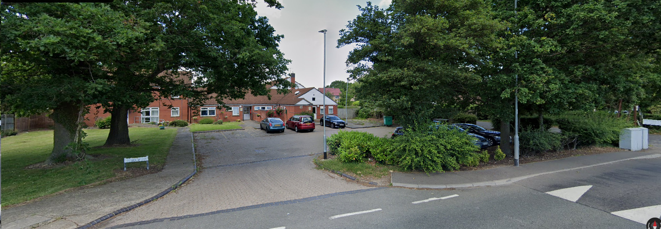



Bugler Developments Ltd
Bugler House
25 High Street

Rickmansworth
Herts
WD3 1ET

Tel: 01923 777988

Development Name | Charville Lane
Client | London Borough of Hillingdon
Site Address | Charville Lane Children's Home  113 Charville Lane  Hayes  UB4 8PD
CMP Author | Paul William Fuller  Bugler Developments  paul.fuller@bugler.co.uk
  +44 (0)7596 882567
CMP Produced by
Name |  | Signature | Date
Paul Fuller |  |  | 13/12/2023
CMP Accreditation Date
CMP Reviewed By
Name |  | Signature | Date
CMP Accreditation Date

Contents

- Executive Summary & Construction Management Plan Objectives

- Site Context

- Overview and Construction Phasing

- Considerate Constructors Scheme (CCS)

- Strategies to Reduce Impacts

- Pedestrian and Vehicular access to the works

- Site Parking

- Hours of Operation

- Plant and Equipment

- Plants and Materials: Loading and Unloading

- Plants and Materials: Storage

- Wheel washing

- Noise Pollution and Control

- Control of Emission, Dust and Dirt

- Air Pollution and Controls

- Scheme for Recycling / Disposal of Waste

- Temporary Highway Works or Closures

- Boundary Treatments and site security

- Newsletters and Communications with Neighbours

Appendices

Appendix A – HGV Construction Vehicle Site Routing
Appendix B – On Site Logistics Including Material Storage
Appendix C – Summary Construction Programme
Executive Summary

This Demolition and Construction Management Plan (CMP) has been developed to discharge pre-commencement condition 20 for the Charville Lane redevelopment in the London Borough of Hillingdon. This CMP document will look in detail at the following
  - Phasing of the development
  - Working Hours
  - Measures to prevent mud tracking onto footways and adjoining roads
  - Traffic management and access arrangements (vehicular and pedestrian)
  - Measure to reduce the impact of the development on local air quality
  - Storage of materials on site during both the demolition and Construction Work phases

It will demonstrate a clear strategy for the delivery of the works (both demolition and construction) along with the measures to mitigate the impacts on the wider surroundings and local residents.

CMP Objectives
The overall objective(s) of this CMP are to provide details to discharge the following:
“Prior to development commencing, the applicant shall submit a demolition and construction management plan to the Local Planning Authority for its approval. The plan shall detail: (i) The phasing of development works (ii) The hours during which development works will occur (please refer to informative I15 for maximum permitted working hours). (iii)Measures to prevent mud and dirt tracking onto footways and adjoining roads (including wheel washing facilities). (iv) Traffic management and access arrangements (vehicular and pedestrian) and parking provisions for contractors during the development process (including measures to reduce the numbers of construction vehicles accessing the site during peak hours). (v) Measures to reduce the impact of the development on local air quality and dust through minimising PDECCAP (ODB 2022) 26544/APP/2023/2303 6 of 10 emissions throughout the demolition and construction process. (vi) The storage of demolition/construction materials on site. The approved details shall be implemented and maintained throughout the duration of the demolition”
To support the realisation of this objective, several sub-objectives have been agreed and include:
- Encouraging construction workers to travel to the site by non-car modes
- Promote smarter operations that reduce the need for construction travel or that reduce or eliminate trips in peak periods
- Encouraging greater use of sustainable freight modes
- Encouraging the use of greener vehicles
- Managing the on-going delivery of the CMP with construction contractors
- Communication of site delivery and servicing facilities to workers and suppliers
- Encouraging the most efficient use of construction freight vehicles
- Lower emissions
- Enhance safety - Improved vehicle and road user safety
- Reduce congestion - reduced trips overall, especially in peak periods

Purpose of the CMP
This CMP has been prepared to outline the strategy for the redevelopment of the scheme as detailed above. The employer and landowner for these works is London Borough of Hillingdon. The main construction contract is programmed to start on site in Spring (April) 2024.
In the context of the development, it should be noted that main construction activities will comprise utilities disconnections and diversion works, demolition, site clearance and levelling, and the new build of the residential houses, the educational building and MUGA along with associated site infrastructure. The CMP seeks to deal with all the issues associated with the demolition and construction phase of the redevelopment.
The CMP identifies in general terms, the likely effects associated with the activities and outlines proposals for the mitigation of these effects.
Key project drivers for the development include:
- Security levels maintained to secure perimeter of site
- The Health and Safety of all staff, users and members of public
- Established emergency routes to be maintained throughout the duration of all works
- Noise and dust disruption kept to a minimum
- Housekeeping and appearance
- Build quality to meet local authority and LBH requirements
- Project to be delivered within requisite time limits

This CMP is intended, both in written and diagrammatic form, to describe the strategy of the project team in taking the works from inception to completion with minimum disruption to the local infrastructure and environment.

What is a Construction Method Plan (CMP)?
CMP’s help manage all types of site operations. They improve the safety and reliability of deliveries, access and public seclusion from the building site.
What are the benefits?
CMP’s help manage all types of site operations. They improve the safety and reliability of deliveries, access and public seclusion from the building site.
CMPs can benefit both Bugler Developments and the local community. As these are considered in detail in the plan, they will provide benefits and advantages including:
- Reduced disturbance to adjoining residents and businesses and improved security
- More reliable and less frequent deliveries
- Reduced
- noise and air pollution and intrusion

Site Context
The Charville Lane site is located wholly within the administrative boundary of Hillingdon. The site is bounded by Charville Lane to the South and Ridings Lane to the East. The site is within walking distance to both the Romney Road and Charville Academy bus stops which are served by the 195 and U7 bus routes.
Development Proposal
The Charville Lane development will comprise of:
  - Six units supporting up to twelve children – Each unit incorporates end user beds alongside staff accommodation (Bedroom with an en-suite bathroom)

    - 2xNo. 2-bed house (accommodation for 1 end user and 1 staff member)
    - 2xNo. 3-bed house (accommodation for 2 end users and 1 staff member)
    - 2xNo. 4-bed house (accommodation for 3 end users and 1 staff member)

  - The development also incorporates communal areas so recreational activities can be facilitated and there is an educational building where young people have access to PC’s for homework and also if they are supported by the virtual School
  - There is also a communal Multi-Use Games Area (MUGA) in addition to a private garden to each house
  - All site access roads and infrastructure

Overview and Construction Phasing
The proposed development comprises demolition of an Childrens Centre and the construction of six houses and an educational Centre across three blocks. Both blocks are of traditional construction (Brick and Block). There is a MUGA area and car park included in the contract.

The works are to include one new storm sewer connection under a Section 50 agreement into what will be the new car park for the development; all communal facilities, associated external works, landscaping, car parking and statutory authorities’ service connections.

The substructure will comprise of CFA piles to three blocks; the superstructures will comprise brick/block masonry external wall construction and party walls. Houses will have precast floors to ground, first, second, third floors and roofs together with precast stairs.

Start on Site is shown as 8th April 2024. It is anticipated that the construction works will be complete in 52 Calendar Weeks from start on site date. The Contract Completion date is 31st March 2025. The sequence and phasing of the works is set out below:

- Site establishment, including site hoarding to secure site and segregate construction from the public, service disconnections and tree protection
- Demolish to existing Childrens Centre (including removal of asbestos)
- Site strip and establishment of new access road and parking areas
- Install pile mat
- Piling foundations
- Substructure works including drainage
- Ground floor beam and block floors
- Superstructure works – traditional brick and blockwork
- Pre-cast concrete floors which will be installed with a mobile crane
- Internal fit out
- STATS connections
- Second phase external works and finishes
- Client snagging

No handover will take place until satisfactory safe access is available for both vehicles and pedestrians together with all associated external works and statutory approvals etc.

Prior to commencing the works on site, a letter will be sent by the contractor, on behalf of Bugler Developments (BDL) and London Borough of Hillingdon (LBH) to the residents and neighbours to publicise the works and the proposed programme.
The contact details for the site management team will be made available and regular neighbourly newsletters will be provided.
Notice will be given to nearby residents prior to the commencement of any major elements of the works.
The overall programme will span approximately twelve months (52 calendar weeks (with tasks overlapping) and can be divided into the following main elements:
Activity | Period
Site establishment and demolition | 6 weeks
Site access road and parking bays | 6 Weeks
MUGA part one | 5 weeks
Piling | 2 weeks
Substructures | 8 weeks
Superstructures / envelope / roofs | 18 Weeks
Internals and fit out | 22 Weeks
External works | 18 Weeks
MUGA part 2 | 8 Weeks
Inspections and handover | 6 weeks
Overall Period | 12 months

The construction programme is shown in its breakdown elements in Appendix C.

Considerate Constructors Scheme (CCS)
The Considerate Constructors Scheme (CCS) is a standard code of practice for all building contractors. It covers a variety of issues such as appearance, neighbourliness, respect, safety, responsibility, accountability and the environment. It is independently monitored and CCS Assessors visit each site at least twice throughout the works.

Bugler Developments register all sites with the CCS as a matter of policy irrespective of whether the client is a Social Housing Provider or a Private Developer. All personnel on site have to comply with the code, which is designed to minimise or reduce disruption for local residents and businesses.

During the construction phase should anyone have concerns they will be able to contact the Site Manager, whose contact details will be displayed on the site hoardings prominently should there be any complaints.

An “out of hours” number for direct contact with a Bugler member of staff will also be provided, which will be displayed prominently on the site hoarding.

A comments book will be available to any member of the public wishing to contact us about other activities. Any comments raised will be addressed as appropriate and will be responded to.
Strategies to Reduce Impacts
The following Strategies have been considered and committed to in order to advise this CMP.

Planned Measures Checklist | Committed | Proposed | Considered
Measures influencing construction vehicles and deliveries
Safety and environmental standards and programmes | x
Adherence to designated routes | x
Delivery scheduling | x
Use of holding areas and vehicle call off areas |  |  | x
Use of logistics and consolidation centres |  |  | x
 | x
  Re-use of material on site
Implement a staff travel plan | x

Safety and environmental standards and programmes

All HGV Construction vehicular movements to and from the site will be to the pre-approved route to minimise air quality issues and all vehicles will be required to comply with low emissions requirements and will be registered with FORS and CLOCS. This will be placed in all orders whether direct with material suppliers or through third party subcontractors.

Adherence to Designated Routes
The selected delivery routes as highlighted in the map in Appendix A will be placed in the site orders with both direct material suppliers and sub-contractors. In addition, suitable signage will be displayed in the immediate vicinity of the site to display where the deliveries need to access and egress. This applies to construction traffic and HGV movements.

Delivery Scheduling
An online material booking system will be implemented which material deliveries will need to be scheduled in at 48 hours in advance. Any delivery that has not been scheduled and booked in will not be accepted on site. Regular subcontractor meetings will be held to make sure that materials deliveries are planned out and that the system is being properly used.

Use of Holding Areas and Vehicle Call-off Areas
It is considered that the site will be able accommodate scheduled deliveries within the boundaries – delivery strategies have been considered to ensure that the use of call off areas and holding areas will not be warranted.

Use of Logistics and Consolidation Centres
The development is of a small size, and therefore, it is not considered that off-site consolidation centres will be required. Materials will be booked in as detailed below and be brought to site following the principles of Just In Time deliveries. Large materials such as Trusses and PCC Planks will be called off directly from the Suppliers as required by site progress.

Re-use of Material on Site
Materials such as crushed concrete will be reused as far as practical. All materials will be subject to an on-site waste management plan with the aim of reusing and recycling as much as possible.

Implement a Staff Travel Plan
The proximity of Hillingdon Underground and Hayes and Harlington (Elizabeth Line) mainline station with excellent public transport links will enforce operatives to use public transport. Showers on site and secure cycle racks will be provided to allow the use of pushbikes.
A shuttlebus system from Hayes and Harlington station will also be explored with the individual subcontractor.
On-site parking will be limited to 6 vehicles during weeks 1 – 8 whilst enabling works and demolition take place During weeks 9 – 48 we will be able to accommodate 10 vehicles in total whilst groundworks/super-structure and finally internal works take place, this will be enough as maximum number of operatives will be 15 and they will all be asked to use public transport. For those that are unable to use public transport, the can park on site .
Parking along Charville Lane and surrounding roads by contractors will be strictly prohibited.
Visitors parking bays will be accommodated on site, to ensure reduced impact on adjoining roads.
No contractor parking would be acceptable on the adopted highway.

Pedestrian and Vehicular Access to the works
The site is located off Charville Lane Road. All deliveries / visitors and the workforce will use this road to access the site. There will be limited parking on site. We will have separate vehicle and pedestrian access gates to keep pedestrians safe whilst entering site.

Appropriate signs will indicate where the compound is and warn all pedestrians of site traffic and warn drivers onsite of the crossing point together with speed restrictions to further reduce the risk.

The pedestrian route will be separate from the vehicular route via barriers in accordance with

- Good practice
- HSE guidance on separation of vehicles and pedestrians

Vehicles will enter the site and exit the site via Charville Lane – left hand turn in, left hand turn out - under the control of a Banksman to ensure that they do so safely. Drivers entering the site will do so under the control of the Banksman who will either direct the vehicle to the work area they are required for or direct them to park and report immediately to the site office for clear direction as to where to deliver materials etc.

The access route will be stated on all orders and there will be signage to support this. This will ensure that there is reduced traffic on the local roads and that deliveries of materials etc. will be distributed as quickly and efficiently as possible. This also helps reduces congestion and carbon emissions from the works.

All materials delivered to the site will be offloaded mechanically e.g. through use of a telehandler, Hiab etc. unless they are sufficiently light and sized to be moved by hand. All small vehicles that can will access and exit site in forward gear. Following a swept path analysis of the site during construction we have found that rigid vehicles and larger cannot turn around inside site so they will enter site in forward gear and exit site in reverse gear under the supervision of trained Banksman / Traffic Marshal.

All vehicle unloading will take place within the site and will not affect public highways or adjacent occupiers.
All management of construction traffic and access will be carried out in accordance with a Construction Traffic Management Plan as set out below:
- Planning and managing both vehicle and pedestrian routes
- The elimination of reversing, where possible
- Safe driving and working practices
- Protection to the public
- Adequate visibility splays and sight lines
- Provision of signs and barriers
- Adequate parking for off-loading storage areas

Refer to Appendix B – Site Set-up Plan during Demolition and Construction.
Site Parking
There will be limited onsite parking for the workers and visitors and this will communicated in all supply chain orders and will be covered at all pre-contract meetings and in all operatives’ site induction, to reinforce this strategy.

Operatives will be asked by senior management to use public transport to travel to and from work. This will help reduce any impact of the works on the surrounding streets by reducing congestion and it will also help reduce the carbon emissions from the project.

On-site parking will be limited to 6 vehicles during weeks 1 – 8 whilst enabling works and demolition take place During weeks 9 – 48 we will be able to accommodate 10 vehicles in total whilst groundworks/super-structure and finally internal works take place, this will be enough as maximum number of operatives will be 15 and they will all be asked to use public transport. For those that are unable to use public transport, they can park on site.
Parking along Charville Lane and surrounding roads by contractors will be strictly prohibited.
Visitors parking bays will be accommodated on site, to ensure reduced impact on adjoining roads.
No contractor parking would be acceptable on the adopted highway.

It should be noted that this policy of using public transport can only be encouraged and not be enforced as operatives with valid tax certificates are able to park on the Highway by law which we cannot overrule.

Hours of Operation and Working
In compliance with Application ref: 26544/APP/2023/2303, any works during the demolition / construction phase that generate audible noise at and beyond the site boundary shall be only carried out between the hours of 08.00 and 18.00 Monday to Friday and between 08.00 and 13.00 on Saturdays and at no time whatsoever on Bank Holidays and Sundays.

Contracts and subcontractors will be informed of the reduced availability for parking on site for operatives or management and will be informed to make use of local public transport. Deliveries are only to take place between these hours excluding 08.30 to 09.30 and 15.00 to 16.00 Monday to Friday in order to keep congestion in Charville Lane to a minimum arising from school drop offs and collections from Charville Academy Primary School which is nearby. This will be stated on the supply chains orders to reinforce this policy. Avoiding peak hour deliveries is to be encouraged as this will reduce traffic congestion in the area arising from the works. It will also help reduce the carbon emissions and air pollution from the project as the transport deliveries to the site will not be queueing in peak hour traffic making their journeys more efficient.

Plant and Equipment
Consideration has been given to the type of plant that is likely to be used during the construction works. The plant and equipment associated with each key element of the construction are shown in the table below:

Plant | Enabling & Demolition | Construction
Hydraulic breaker | *
Long reach breaker | * | *
Tracked / wheeled excavator | * | *
Air compressors | * | *
Power tools (incl percussion drills, cutting discs, pipe threaders) |  | *
Hand/power wash tools |  | *
Jet wash facilities |  | *
Piling rig |  | *
Scaffold |  | *
Delivery lorries | * | *
Skips & skip trucks | * | *
Mobile access platforms | * | *
Mobile Craneage |  | *
Forklift All Terrain |  | *
Wheel Washing Facility | * | *

All non-road mobile machinery (NRMM) will comply with the NRMM emission of gaseous and particulate pollutants regulations 2018. All contractors will be made aware of this requirement at the pre-order meetings and regular checks by Bugler management team will take place to ensure our contractors comply.

Plant and Materials: Loading and Unloading
We will aim to minimise disturbance and disruption arising from the loading and unloading materials and equipment for the construction of the units. Integral to this plan we shall ensure that all delivery vehicles arrive within the restricted hours (stated above) and ensure that they park their vehicles in a position that will not block, disrupt or irritate any of the residents. By restricting deliveries to these hours this will also prevent delivery lorries and the like arriving to site early in the morning and parking up with their engines running as is often the case especially during winter when the driver requires the heater to stay warm. This will help reduce air and noise pollution arising from the works.

All loading and unloading of plant and materials will take place within the site boundary. The principles of “just-in-time” delivery will be adopted. A holding bay will be incorporated within the Site Logistics Plan (see Appendix B) to ensure no waiting will be encountered on Charville Lane or local streets.

Deliveries will be controlled by a 48-hour advanced booking system with the logistics team. This will encourage planning of works to ensure that materials are bought in on time without impact to the surrounding vicinity. A full logistics study into material deliveries will be undertaken to assess the vehicle movements required to deliver the project. Within the site boundary materials will be unloaded via forklifts and taken immediately to the required workface.

Anticipated delivery frequencies are shown on the below chart on a month-by-month basis:

Demolition and construction vehicle movements will be managed to minimise the impact on the local road network. The below table provides an indicative level of construction traffic trip generation associated with the construction phase of the development.

Vehicle Type | Average Trips Per Day
Heavy Goods Vehicles (HGV) | 4
Cars and Light Goods | 12

Materials will be delivered on a “just in time” basis. This will be drawn up one week in advance, and in liaison with the supply chain and Bugler Developments management with deliveries, giving adequate notice on planned deliveries and then booked into the 48-hour advance system.

The HGV movements would be spread across the working day outside of the AM and PM peak periods. The arrival and departure of light vehicles would be concentrated during the morning and evening periods but would be less than the predicted levels of traffic during the operational phase of the Development. Peak Vehicle movements are expected between Month 5 and month 8. These are expected to peak at circa 10/day.

It is anticipated circa 500 of these deliveries will be required to construct the buildings including demolition arisings, muck away, concrete, bricks and blocks, precast floors, roof timbers, plasterboard and kitchens. This also includes plant deliveries and collections. Most of these will occur during the first ten months with only small deliveries after this as the works draw to a progressive close. This equates to between four and five lorries per day on average, noting that there will be some peaks and troughs.

Demolition and HGV construction traffic access will be via Charville Lane. Demolition and construction vehicles will access the Site using the main arterial roads, most notably the A40, as far as possible to minimise the impacts on the local road network. This is shown in the HGV Construction Vehicle routing map in Appendix A.

Whilst none are envisaged, If abnormal or oversized loads are required to deliver materials to the Site, notice will be given to the London Borough of Hillingdon, depending on the routing, and the Police, the Fire Brigade and other emergency services, sufficiently in advance of the required closure or diversion dates. Should any hazardous materials arise during the course of the works, these materials will be transported to a licensed disposal site using permitted routes.

The anticipated maximum workforce will peak at around 15 Operatives per day. When combined with the average lorry movements per day this reinforces that this is a small sized project which will have minimal impact on the local area in terms of emissions, noise, dust and traffic flow. These impacts will be further reduced by ensuring that the controls detailed in this document are followed.

Any machinery used to unload vehicles shall aim to keep noise to a minimum and only operate during the pre-determined times, as stated in ‘Hours of Operation’. When not in use for more than a minute their engines will be turned off to again reduce emissions and noise pollution.

Emergency Vehicles

Emergency vehicles must be able to access the sites and surrounding roads, at all times. By encouraging the use of public transport for Operatives, by only receiving deliveries outside the rush hour and by managing any parking of vehicles which may occur in surrounding roads, we will maintain access for emergency vehicles.

Plant and Materials: Storage

All equipment and materials shall be stored in the site, out of the way of residents and the general public, in the pre-defined areas indicated on the site plan in the Appendix.

The site shall be hoarded with a minimum of 1800mm high fencing to the perimeter of the development to ensure that the works remain inaccessible to the general public. During normal working hours the site vehicle gates will remain closed. These will only be opened by the Banksman when a delivery arrives.

There will not be a large quantity of materials stored at any one time as the site is constrained and the project is relatively small. Materials will be scheduled to arrive as they are required i.e. “just in time” (see note above) in relation to and in conjunction with the construction programme.

Wheel Washing

This is regarded as one of the main environmental nuisance problems arising from construction sites. We will therefore take strict measures to minimise this problem as follows noting that due to the size and scale of this site this is a low-risk development:

- The provision of easily cleaned hard standings for vehicles entering, parking and leaving the site as the first operation following site clearance of the existing structures
- The provision of wheel washing facilities via a powered jet washer
- The use of a mechanical road sweeper to clean the public highway adjacent to the site i.e. Charville Lane, as required. This will be utilised more during the early site operations particularly when installing the new road and parking areas, the foundations and substructure stage of the project

Once vehicles have entered the site they will be directed to the area of the site where they are to offload their materials or pick up the soil arisings etc. They will park on the hardstanding formed and switch off their engine to reduce emissions and noise pollution. Materials will then be off loaded or waste will be loaded via mechanical means such as a hiab, forklift etc. Once the lorry is unloaded or loaded then the vehicle will turn around and exit the site under the control of the Banksman at all times.

All vehicles will remain on the hardstanding’s to reduce any mud going on their wheels and in turn, onto the highway when they leave site.

When leaving the site as a further control all vehicles will have their wheels cleaned as required to ensure that no deposits are left on the road and in extreme cases when there is a large volume of vehicles exiting the site – which is highly unlikely due to the relatively small size of the development - and weather conditions prevail a road sweeper and/ or brush will be deployed.

All vehicles leaving site will have their loads suitably sheeted and secured.
Noise Pollution and Control
Works will be in accordance with British Standards BS 5228-1:2009+A1:2014 and best practicable means will be employed and these are noted below.

Noise control will primarily be dealt with at source. Mechanical plant and equipment will be selected and specified taking its noise profile into consideration. All plant and equipment will be of modern design and manufacture to benefit from up-to-date developments in technology for noise reduction. Any plant in excess of four years old will not be allowed on site to promote efficiency and to ensure that the site benefits from advances in technology. All plant must be regularly serviced to ensure that it is operating at maximum efficiently thus further reducing noise and air pollution.

Where possible, electrically driven plant will be used such as mortar silos as opposed to diesel driven mortar mixers. If petrol or diesel powered plant is required, as stated above this will be properly maintained and checked regularly.

We intend to crush all bricks, roof tiles, concrete and the like generated from the demolition of the existing building. This will be used as part of the new subbase for the on-site roads, patios, footpaths and the like. This strategy will further reduce the number of lorry movements to and from site which would be required to remove the waste and also to import new stone. The recycling of the arisings will also reduce the burden on landfill sites and also help preserve the Earth’s natural resources.

The use of the crusher will be notified to London Borough of Hillingdon Council via a demolition notice and will be subject to any permit system and restrictions placed upon us. All demolition and crushing activities will dampened down before and during the works to reduce dust arising from the works.

Appropriate acoustic baffles will be fitted to air intake and exhaust systems. Stationary equipment, such as compressors will be fitted with shields to mitigate noise outbreak. Excavators, dumpers etc will have exhaust suppressors. All site Operatives will be properly trained in loading, unloading, excavation and handling techniques to prevent improper use of equipment which can generate unnecessary noise. All Plant Operators will be advised to switch off the machines engines when plant is not in use to reduce noise and air pollution.

The construction of the building envelope will be carried out in as short a programme as possible to minimise any inconvenience to the local residents and businesses both in terms of noise and air pollution. This means that the enclosure of the building occurs early in the overall programme and any noise generating activities will be carried out internally, shielded from the external environment.

Plant or equipment will be sited as far away as is practicable from the existing dwellings in Heatherwood Drive, Ridings Lane and Charville Lane but in practical terms this is difficult as the site is very constrained and the existing properties are a short distance away from the site. The use of barriers, e.g. Soil mounds, site huts, and acoustic matts on fencing to deflect noise away from noise sensitive areas will be employed wherever practicable.

Where possible, building elements or components will be assembled off site in factory conditions e.g. precast concrete upper floors which will further reduce noisy activities on site.

All machinery to comply with the current legislation of 80 dB (A).

Noise assessments will only be carried out as per Control of Noise at Work Regulations 2005 if requested by the local authority as the site is in close proximity to existing buildings and residents.

Anyone who has a daily or weekly exposure to noise exceeding 80dB(A) or a peak pressure reading of 135dB (A) will be warned of the dangers of working in a noisy environment, advised of the systems being used by the company to reduce noise levels and issued with and trained in the use of ear protection. Health surveillance and enforced ear protection is compulsory if weekly noise levels of 85 dB or above or a peak sound pressure reading of 137 dB is reached.

Method statements from all subcontractors will be vetted to check that they adequately include the details on the need to manage excessive amounts of noise in accordance with this Construction Management Plan and reduce them as far as practically possible.

Control of Emission, Dust and Dirt
Best practicable means will be employed to control dust and these are noted below. Dust monitoring will only take place if requested by the Local authority as the site is near existing buildings and residents.

Dust is defined as particles up to 75 μm in diameter and is produced through the action of crushing and abrasive forces on materials. A wide range of activities, including traffic movement, construction/demolition, mineral workings and general industry, generate nuisance dust.

Large dust particles can cause eye, nose and throat irritation, whilst the smaller fraction of particles with an aerodynamic diameter of 10 μm or less (PM10) is more of a health concern as the particles can enter the lungs causing breathing and respiratory problems.

Dust Movement

In order to establish the effects of dust release on locations around the proposed development site, research referenced in the DETR publication ‘The Environmental Effects of Dust from Surface Mineral Workings’ (1995) was consulted. A study of coal particles referenced in this guidance concludes that small particles of 10 μm diameter can travel for up to 1,000 m or further, larger particles of around 20 μm in diameter can travel 500 m, and 30 μm particles can travel 300 m. Particles with a diameter of 50 μm were found to fall out of the air within 100 m of release. Although this research was carried out on coal particles, it is considered relevant to particle release from the construction and demolition process.

For a dust nuisance to arise, the following factors must be present:

- Finely divided, dry material is present on site as a dust source
- Wind blowing from the site to the receptor
- Wind speed sufficient to entrain the particles

The prevailing wind direction is therefore important in establishing the areas that are most likely to experience any dust nuisance during the construction process.

The UK Meteorological Office classification notes that a wind speed of greater than 6.7 m/s ‘raises dust and loose paper, small branches are moved’.

In recognition of the distances travelled by various sized particles, Part 1 of the research ‘The Environmental Effects of Dust from Surface Mineral Workings’ (1995) refers to zones around a mineral working area where a dust nuisance is likely to occur. It concludes that the most likely zone is an average 200 m from the perimeter of the source, although under unusual circumstances dust nuisance may occur outside this area.

Mitigation of Potential Dust Nuisance

Guidance on the mitigation of potential dust nuisance has been the subject of many publications during recent times especially by the HSE via Guidance documents on their website. The contents of these documents provide a comprehensive management and mitigation strategy targeted at the construction process and aimed at minimising dust generated from these processes. The ethos behind the guides and the methodologies proposed within them has been and will continue to be used to formulate a mitigation and control strategy employed to control any impacts that may arise from the Charville Lane development.

Our strategy to mitigate dust arising from the works. (Note - this also covers our approach to preventing mud from being transferred onto the highway):

- Forming of the new permanent drains and hardstandings up to and including the tarmac base course as one of our first operations on site. Whilst demolition of the existing Childrens Centre, crushing of all hardcore will be taking place – dust addressed via extensive dampening down with water
- Once demolition is complete the new drains and roads to the flats will be formed. Other areas will also be terram’d and stoned up to act as good hardstandings for material storage
- Following completion of the hardstandings all vehicles entering the site will be directed to the area of the project where they are to offload their materials or pick up the soil arisings etc. They will park on the hardstanding formed and switch off their engine to reduce emissions and noise pollution. Materials will then be off loaded or waste will be loaded via mechanical means such as a hiab, forklift etc. Once the lorry is unloaded or loaded then the vehicle will turn around and exit the site under the control of the banksman at all times, remaining on hardstanding
- When leaving the site as a further control all vehicles will have their wheels cleaned by jet washer as required to ensure that no deposits are left on the road and in extreme cases when there is a large volume of vehicles exiting the site – which is highly unlikely due to the relatively small size of the development - and weather conditions prevail a road sweeper and / or brush will be deployed
- All vehicles leaving site will have their loads suitably sheeted and secured, again further reducing the risk of dust from the works

Other activities on site generating dust will be controlled in accordance with the risk assessment and subsequent method statement. The key to this will be to eliminate the onsite work if possible and practicable via off site manufacture. In addition to this there will be to either dampen the works down and / or extract the dust via a vacuum and dust bag or the like.

All HGV construction vehicular movements to and from the site will be to the pre-approved route via Charville Lane and the A40 to minimise air quality issues and all vehicles will be required to comply with low emissions requirements and will be registered with FORS and CLOCS. All lorries egressing the site with waste materials will have loads covered to prevent dust transmission. The hard-running surfaces and wheel washes will prevent further transmission. All tools used will be fitted with dust suppression devices. Strategy of early drainage will also prevent surface water running off on to surrounding roads.

Additional key controls

- Sweeping and spraying all site roads with water in prolonged spells of dry weather to
- Prevent dust causing a nuisance off-site – note that the new drainage system will have terram placed in the gullies to allow water to pass through but prevent dust and mud from entering the sewerage system
- Regular sweeping as appropriate of roads around the site to remove accumulations of dust and mud as required
- Identifying haulage routes and encouraging the use of main artery roads avoiding
- Wherever possible use of smaller side roads in residential areas as far as practically
possible
- Covering skips with netting
- Minimising drop heights to control the fall of materials (if required)
- The enclosure of material stockpiles at all times and damping down of dusty materials
- Using water sprays during dry weather
- During demolition operations, in addition to watering down the building both before and during the operation covering skips consider screening of buildings with debris screen / sheets, as appropriate. Materials will be stored away from the site boundary wherever possible
- Establishment and enforcement of appropriate speed limits over all surfaces on site to reduce dust thrown into the air
- Completed earthworks to be sealed and / or re-vegetated as soon as reasonably possible following the completion of these stages of the work

All HGV Construction vehicular movements to and from the site will be to the pre-approved route via Charville Lane way and the A40 to minimise air quality issues and all vehicles will be required to comply with low emissions requirements and will be registered with FORS and CLOCS. All lorries egressing the site with waste materials will have loads covered to prevent dust transmission. The hard-running surfaces and wheel washes will prevent further transmission. All tools used will be fitted with dust suppression devices. Strategy of early drainage will also prevent surface water running off on to surrounding roads

It is considered that given the adoption of the mitigation measures detailed above that any potential effects from dust from construction works would be minimised to such an extent as to be insignificant.

Asbestos Removal

An asbestos survey has been carried out and this will be removed by a professional company and disposed of suitably, with all necessary measures in place.

All Bugler site staff are trained in Asbestos Awareness, in the event of suspected ACM’s being found the following procedures will take place:

- Stop work immediately - inform Supervisor
- If asbestos is disturbed, do not attempt a clear up
- Remove all personnel from the area - close down plant / process
- Prevent access to the area
- Display signage stating “no admittance”
- Carefully remove clothing if contaminated, double bag, label as asbestos waste.
- Put incident details onto a RIDDOR report and notify the HSE. Do not take chances!

At the site induction a safety briefing will take place in asbestos management.
Air Pollution and Controls
There is significant overlap between this section and that covering dust and noise pollution, therefore these three sections must be read in conjunction with each other.

Using Modern Methods of Construction, we will endeavour to procure readymade, off the shelf items such as pre-cast concrete floors. This will reduce noise and air pollution arising from the works.

There will be no burning of waste materials or the like allowed on site. All waste arising from the works to be removed via grab lorries and/ or skips via licensed waste companies.

Dust caused by works on site is primarily dampened down using extensively sprayed water on site. Cutting tools will be all fitted with water dampers and all electrical tools will be fitted with dust extract bags. All tools of this nature will be visually inspected for fitness for purpose to ensure that they are functioning correctly. Independent safety audits will be carried out by Safety Services UK every three weeks, part of which is to also check the tools of operatives on site.

Dust will be suppressed with water sprinklers, as required during the site clearance / demolition phase. This will be via water hoses fitted directly to the boom of the mechanical machine carrying out the demolition although this element of the works is limited to the demolition of the existing Childrens Centre and associated crushing activity.

Method statements from all subcontractors will be vetted to check that they adequately include the details on the need to manage excessive amounts of dust and reduce them as far as practically possible.

It is not practical to consider material deliveries by means other than by road as this scheme is not located near any waterways or railways.

Scheme for Recycling / Disposal of Waste

The Site Waste Management Plan will be developed in line with the above and will seek to recycle as much of the waste from site operations and delivery packaging as possible. The waste should be segregated and stored in separate skips or locations and recycled in keeping with the LBH recycling policy.

Temporary Highway Works or Closures

Temporary highways works are envisaged on Charville Lane. These works will be planned and at least one month’s notice given to London Borough of Hillingdon, London Borough of Hillingdon’s Highways Department and Transport for London, Adequate signage and warning shall be given. It is not foreseen at this stage that full closure will be required. Bugler Developments will co-ordinate the work with licensed subcontractors and ensure all appropriate measures are undertaken to ensure that traffic flow is not impacted. All work will be undertaken under a Section 50 Street Works License. It is anticipated at this stage that such works will include drainage and utility connections.

Boundary Treatments and Site Security

Secure Bugler Developments hoarding and / or fencing will be erected to the perimeter boundary of the site together with a lockable gate allowing access for pedestrians and vehicles.

It is proposed to erect final fencing to Ridings Lane (Eastern), and the Northern and Western boundaries early in the construction programme to minimize disturbance earlier in the programme and to avoid waste of materials.

All works will be visible to the public and the local residents through preformed vision panels so that they can see and understand what is happening on a day-to-day basis. Should they have any questions these can directed to the site manager whose contact details will be displayed prominently at the site entrance or they can address the site manager directly as safe access to the site office will be given via a separate pedestrian route into site. This is all part of our “open door” policy at our site offices to encourage our neighbours to communicate directly with us.

A secure locking system shall be used on the boundary treatment – a minimum of 1800mm high along all boundaries together with warning signage of the dangers of entering site - to prevent any intruders when there is no site presence.

We will also employ the use of remotely monitored security cameras which are activated by movement and heat signature – the security control room can then communicate with the intruder via a speaker system. The security company will also deploy guards to the site to ensure that the intruder is detained and removed from the site.

Site Compound and Security

The site compound will be a secure area with a vehicle access separated from the pedestrian entrance at all times. The site will be secured with plywood hoarding around the boundaries of the project and painted in the clients’ or the main contractor’s colours and livery.

Newsletters and Communication with Neighbours

Bugler Developments will issue newsletters to local residents and businesses prior to commencement of the works and at regular intervals and when there are significant changes to the construction i.e. crane erections, large deliveries, road closures etc.

Communication with Schools local to our sites is actively encouraged by Bugler Developments. We will approach the Head Teachers of Charville Academy Primary School in the first instance to discuss giving a presentation to the pupils on the development as a whole; how we build in basic terms together with a section on Health & Safety and the risks of entering a construction site. We also will encourage a poster competition or similar in the case of the Primary School to take place, on building sites with prizes given to the best safety poster(s). Site visits are also encouraged to show key stages with appropriate supervision and PPE.

Appendices:

Appendix A – HGV Construction Vehicle Site Routing

Appendix B – On Site Logistics Including Material Storage

Appendix C – Summary Construction Programme

Appendix A – HGV Construction Vehicle Site Routing
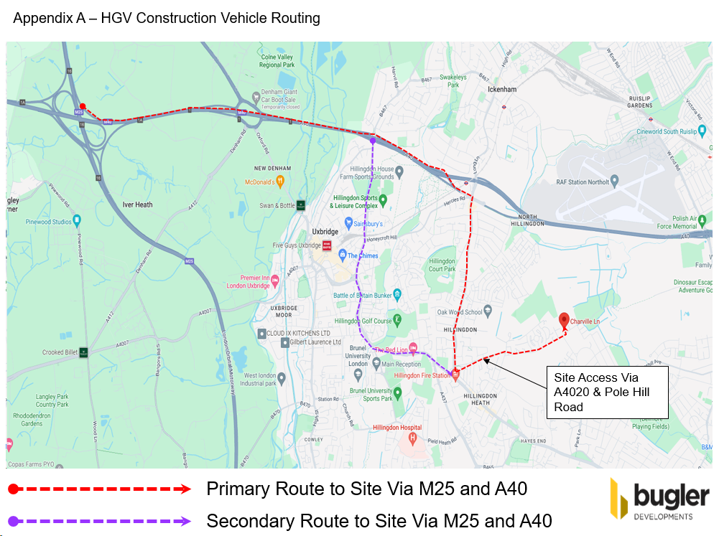

Appendix B – On Site Logistics Including Material Storage
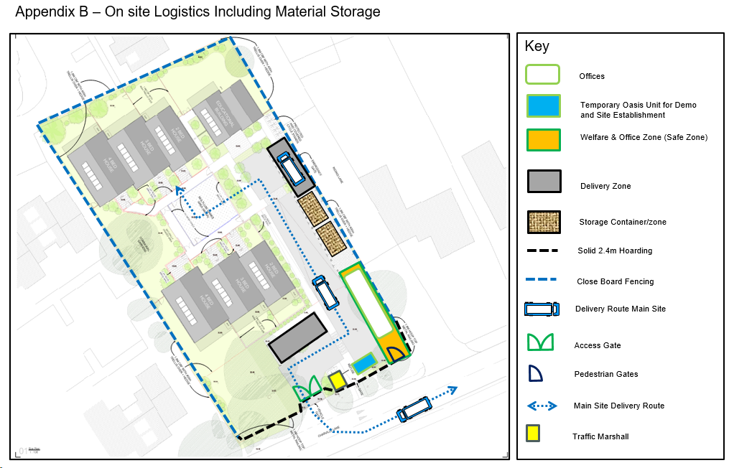

Appendix C – Summary Construction Programme
